Game Design Document

Fill up the following document

1. Write the title of your project.

Earth vs Aliens

1. What is the goal of the game?

To save the Earth and kill the aliens.

1. Write a brief story of your game.

Aliens from another planet try to invade Earth, but the mighty people

of Earth unite to protect their planet and sent you as the captain of

the warship to fight the aliens. Protect the planet by killing the aliens.

1. Which are the playing characters of this game?

* Playing characters are the ones who respond to the user based on the input from the user.
* Cars, monkeys, dinos, wizards, etc., are the playing characters in the game.

|  |  |  |
| --- | --- | --- |
| Number | Character Name | What can this character do? |
| 1 | Spaceship | It can move and fire bullets. |
| 2 |  |  |
| 3 |  |  |
| 4 |  |  |
| 5 |  |  |
| 6 |  |  |
| 7 |  |  |
| 8 |  |  |

1. Which are the Non-Playing Characters of this game?

* Non-Playing characters are the ones that don't have an action or behavior when the user interacts with the game.
* Hurdles, stones, bananas, coins, etc., are non-playing characters in the game.

|  |  |  |
| --- | --- | --- |
| Number | Character Name | What can this character do? |
| 1 | Alien spaceships | Destroy the Earth |
| 2 | Asteroids | Be obstacle |
| 3 |  |  |
| 4 |  |  |
| 5 |  |  |
| 6 |  |  |
| 7 |  |  |
| 8 |  |  |

Draw your imagination of this game. What does this game look like?

* Draw the game either on your computer or on paper.
* Add images of the game scenes to show each of the playing and non-playing characters at least once.

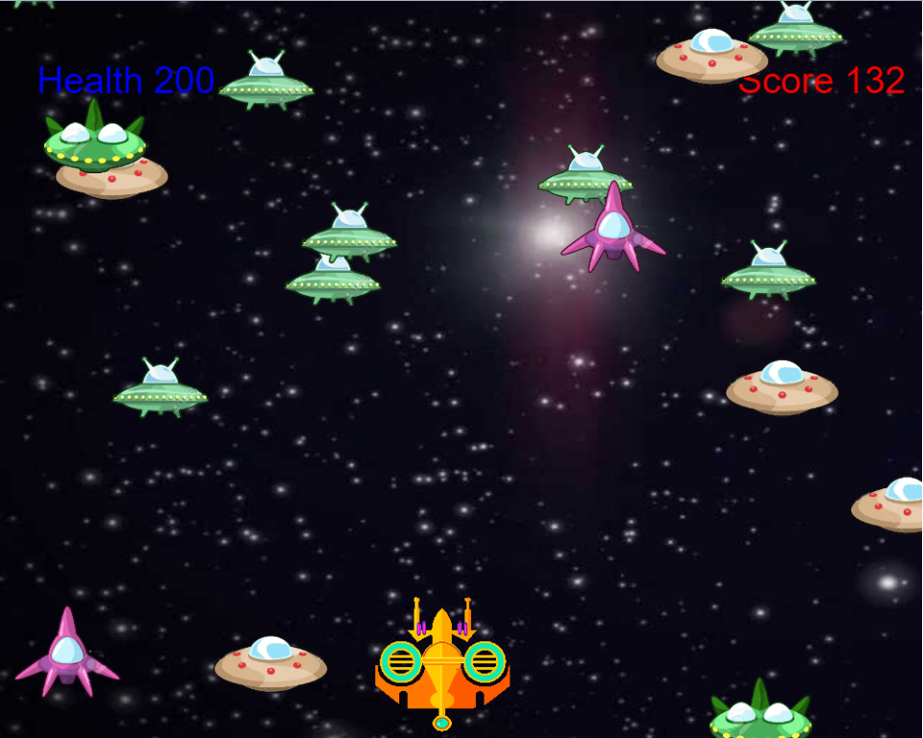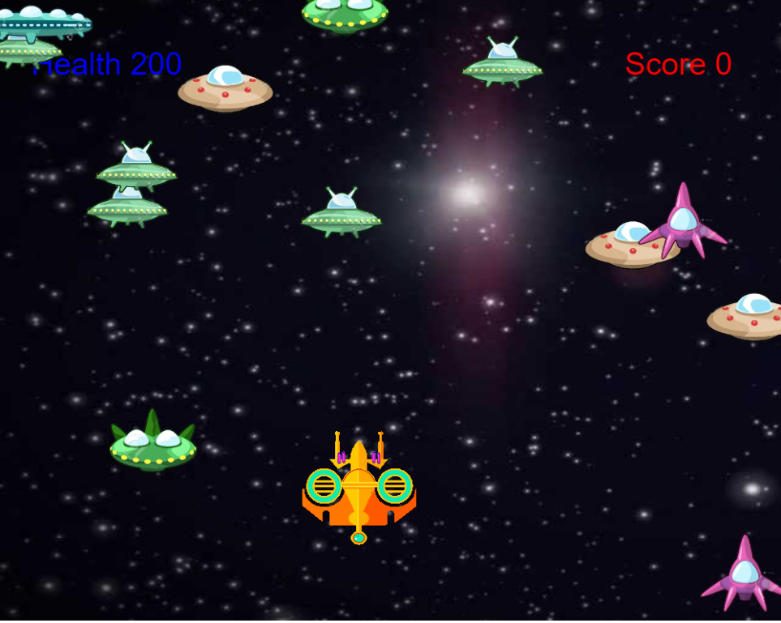

How do you plan to make your game engaging?

By adding different animations and sound effects.