**CSCI 1100 – Fall 2015**

**Assignment 1**

**Name: Yide Ge**

**Student ID:** yge (B00639491)

|  |  |  |
| --- | --- | --- |
| **Declaration: Please complete this declaration** | | |
| 1 | “This document is entirely my own work.” | Yes |
| 2 | I obtained help to complete this document (e.g., from a TA). | Yes,from Ta |
| 3 | This document contains some guidance from the Internet or another document or file or program (e.g., java's API). | no. |

**Question 1.**

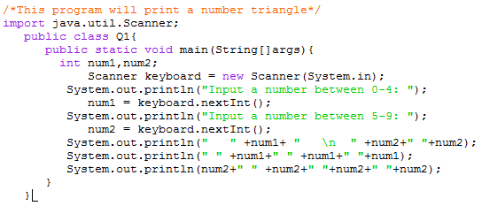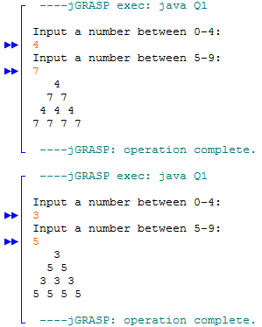

**Question 2.**

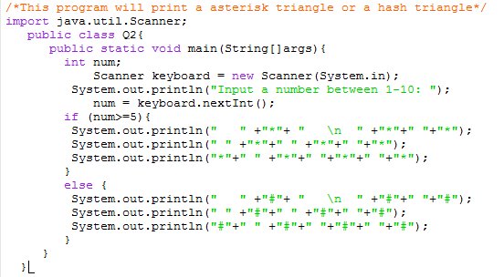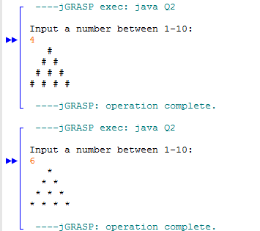

**Question 3.**

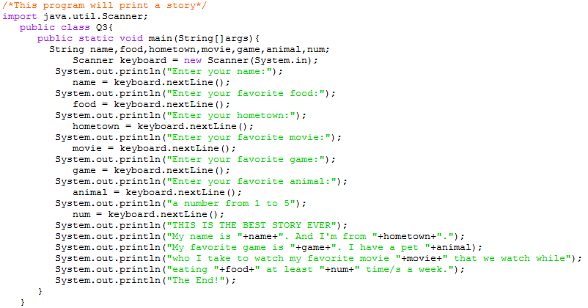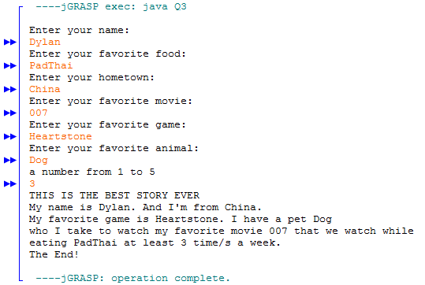

**Question 4.**

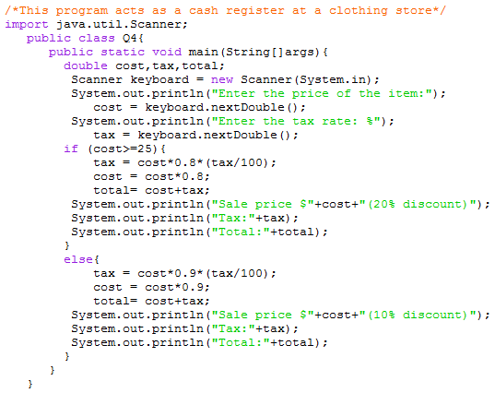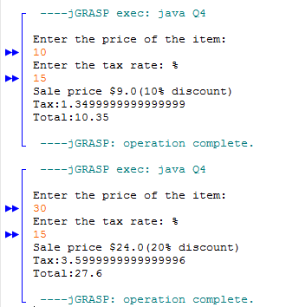

**Question 5**.

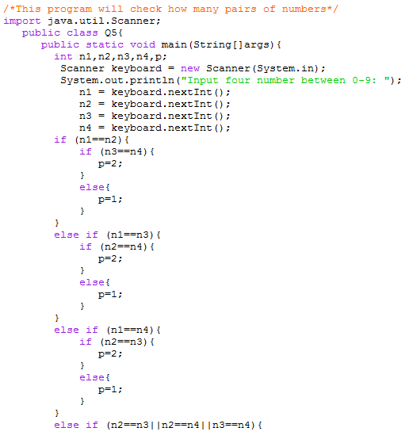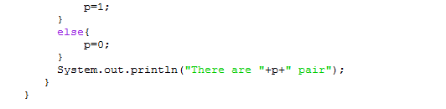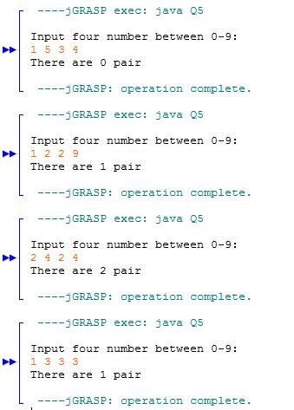

**Question 6.**

