**CSCI 1100 – September 2015**

Marks

**Laboratory Report 5**

**Name: Yide Ge**

**Student ID:** yge

|  |  |
| --- | --- |
| **Please mark your lab** | |
| **T 5:30 L143** |

|  |  |  |
| --- | --- | --- |
| **Declaration: Please complete this declaration** | | |
| 1 | This document is entirely my own work. | Yes |
| 2 | I obtained some help to complete this document. | NO |
| 3 | This document contains some material copied or cut and pasted from the internet or another document or file or program. | NO |

**Exercise 1.**

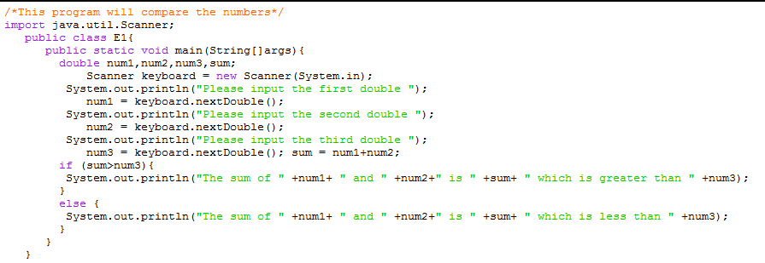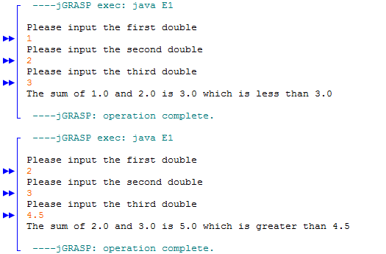

**Exercise 2.**

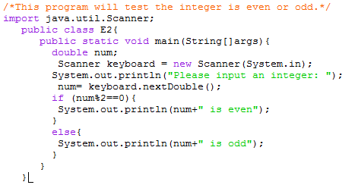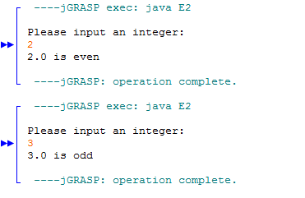

**Exercise 3.**

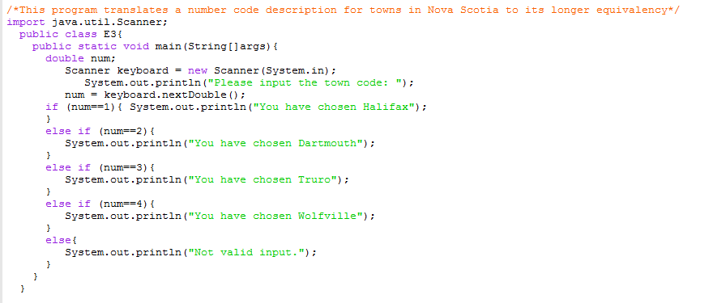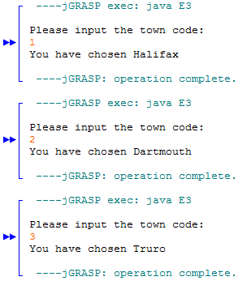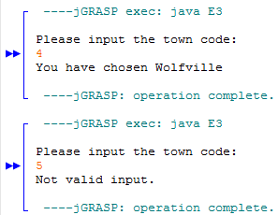

**Question 4.**

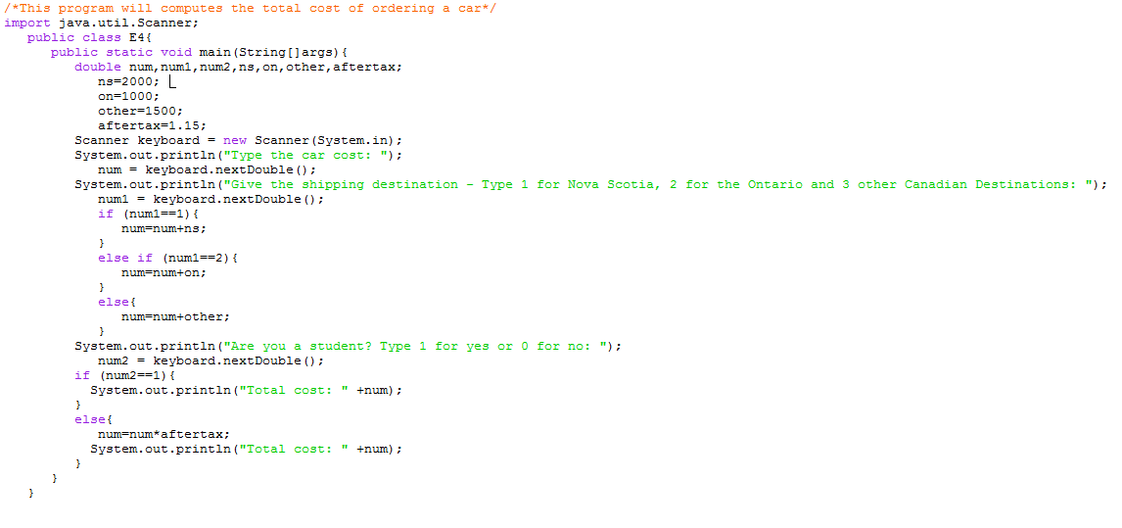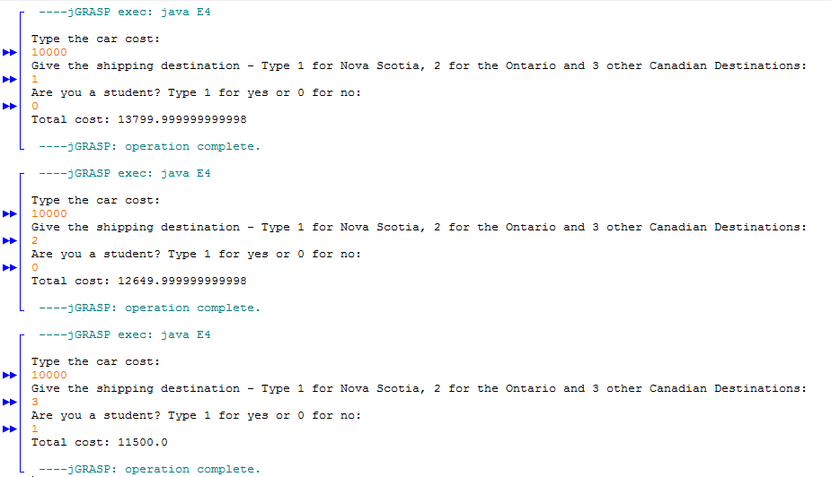

**Question 5.**

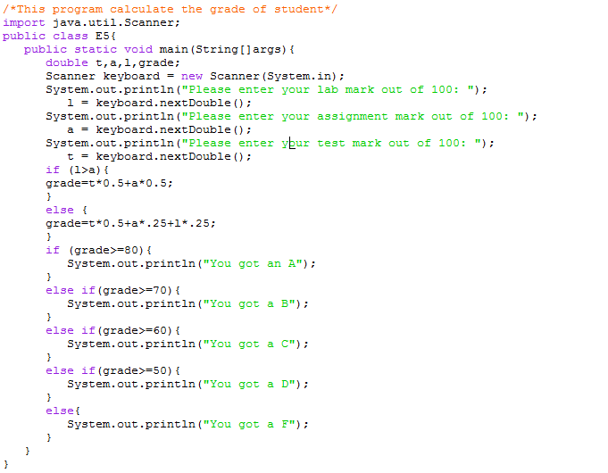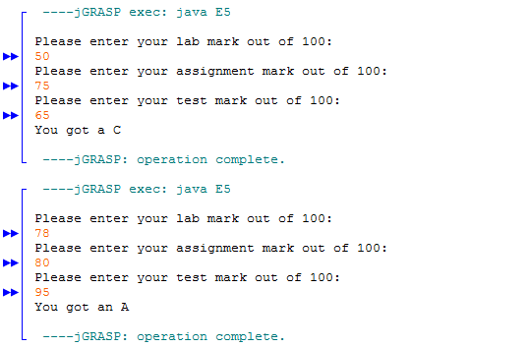

**Question 6.**

