**CSCI 3136 Assignment 1**

|  |  |  |  |
| --- | --- | --- | --- |
| **Name** | **CS ID** | **Student Number** | **Signature** |
| Andre Cui | fcui | B00652308 |  |
| Ziyue He | zhe | B00692565 |  |
| Yide Ge | Yge | B00639491 |  |

**Question 1.**

1. The Lexical analysis phase will be needed to implement this functionality. Because this is the phase that tokenize the keyword, and after some part of the keyword is been typed, this part of the compiler can guess the whole word user might looking for.
2. In this situation, we will need to adjust syntax analysis phase, semantic analysis phase and lexical analysis phase. We will need to adjust syntax analysis phase to determine the current context (whether user is fill a method or a variable name), adjust semantic analysis phase to let it determine the type of input needed to auto complete and use lexical analysis phase to determine the current input.

**Question 2.**

1. {(a | e | i | o | u | y).*(a | e | i | o |u| y)}
2. {0*1*}
3. {([0-9]*[1,3,5,7,9][2,6]|([0-9]*[0,2,4,6,8][0,4,8])|[0,4,8]}
4. {1*(0*111*)*0*1*}

**Question 3.**

a). Finite, Regular,

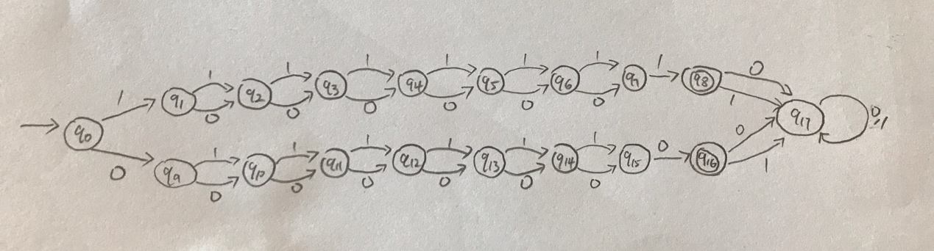

b). Infinite, nonregular, because we will need to keep count the total number of even/odd digits to determine if string fit language description, since there is no limit on the length of the string, therefore we might have infinite of digits.

c). Infinite, Regular.

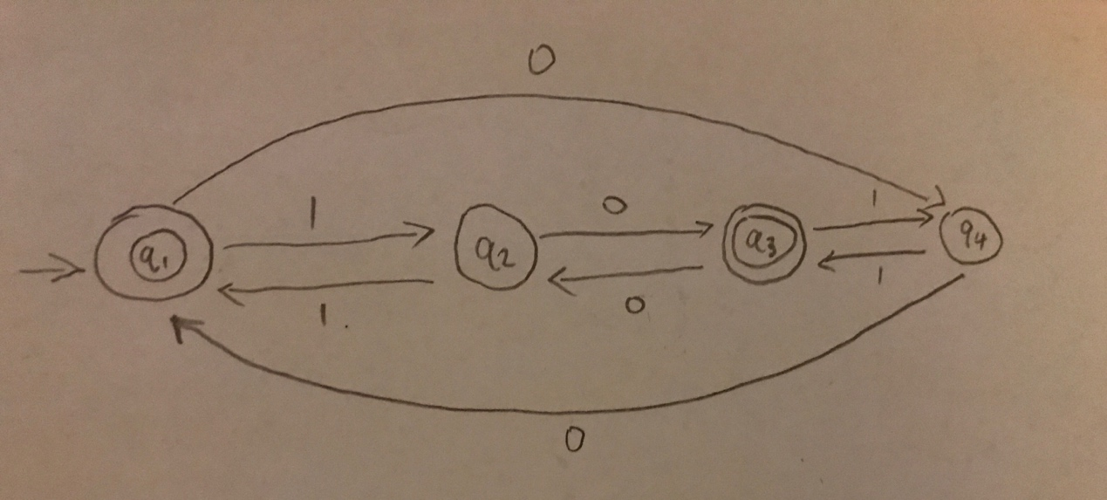

d) Infinite, Regular.

