An Analysis of Reported Crime Incidents in Chicago (2001 to 2020)

Authors: Jerry Petty, Erik Pacheco, Mayowa Toyinbo, Francisco Figueroa, Gerardo Camarena, Eric Ventura
Department of Information Systems, California State University
Los Angeles
e-mails : epachec2@calstatela.edu , mtoyinb@calstatela.edu , jpetty4@calstatela.edu , eventu30@calstatela.edu , ffigue10@calstatela.edu

Abstract: Our group has worked on analyzing a data set that recorded reported crimes in Chicago from January 1st all the way to July 22nd, 2020. We used Hadoop, Hive, and Tableau to sort the data and create visualizations that show the different types of crimes throughout the city. By understanding the data and determining trends, we can better understand how the Chicago area can be helped.

1. Introduction
The crime reports that were recorded in the data set are valuable to study because they can help Chicago prevent crimes and protect its citizens. By analyzing over 20 years of crime statistics, we can determine trends using tempo-spatial infographics and bar and time graphs. Our team used Hadoop to manage the files, and Hive and Tableau to create visualizations and sort the data.

2. Related Work
Our data mainly focuses on the crimes reported in the city of Chicago. Similarly, the violence reduction dashboard [2] dataset consists of the victim counts and comparison in all community areas. While both can help mitigate the violent crimes in the city of Chicago, the violence reduction dashboard is more convenient because it compares the number of victimizations in the selected period to the prior year for a different type of crime and it is updated daily. This makes it clear to the viewer if the violence in that area is increasing or decreasing. With the information of the greatest average of serious victimizations, the mayor’s office will know where to implement the interventions and programs.
Another work related to our data set is the Crime Data Explorer [3]. This data consists of the crime data for the nation and a national incident-based reporting system. Instead of just focusing on the crimes of one city this data focuses on the crimes recorded nationwide. With visuals, they can provide insight into the trend of violent crime from 2012 to 2022 in each state of the United States. This dataset can also compare the violent offenses by population, it compares the state violent crime vs the United States population. This dataset is related to ours because it provides information to help mitigate violent crimes and informs us which locations are being the most affected. This dataset can be categorized by the crime reported like how our dataset was also categorized. This helps the viewer know what type of crimes are being committed more often in a specific location.
3. Data Description
Data Name: Chicago Crime (01JAN2001-22JUL2020)
Source: Chicago P.D.
Size: 1.7GB
Format: CSV
Dataset URL:
https://www.kaggle.com/datasets/n3v375/chicago-crime-from-01jan2001-to-22jul2020
Github URL:
https://github.com/FranXavier12/Tempo-Spatial-Analysis-of-Chicago-Crime-Data
Description: This data records incidents of crime recognized by the Chicago Police Department, including location, time, and categorical reasoning for each incident.

4. Implementation Flowchart
Initially, the raw dataset was downloaded from a trusted source. The data manipulation process is shown in the flowchart below.

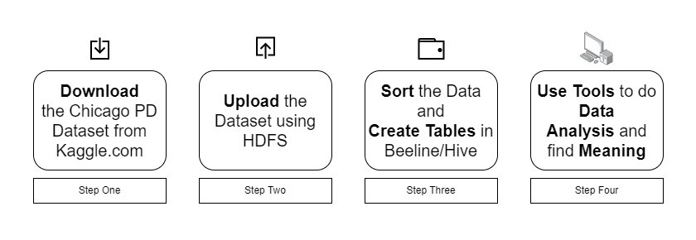Figure 1: Top 15 Causes of Incidents Visualization
HiveQL was used to create tables, clean data, and create summary tables. The summary tables were downloaded as CSV and TXT files and were uploaded to Tableau and Power BI.
In Tableau, we renamed header columns and reformatted data types for easier analysis. We visualized the data by creating bar graphs, line charts, and other interactive visuals to draw insights. Power BI was used for geospatial analysis and heatmap analysis to show the concentration and distribution of crimes across Chicago.
5. Analysis and Visualization
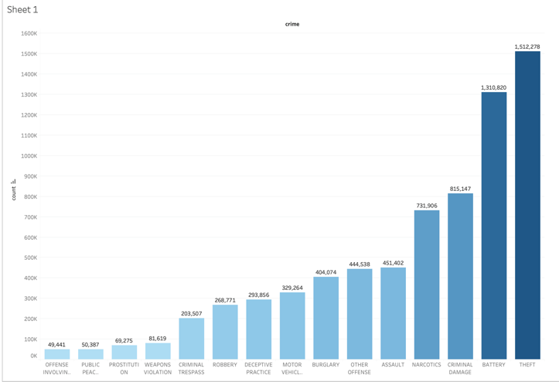
Figure 2: Top 15 Causes of Incidents Visualization

This figure made in Tableau displays, in a bar graph format, shows the different types of crimes reported, and their overall count. As we can see, theft, battery, criminal damage, narcotics, and assault are prevalent. Understanding the frequency of these crimes can help prioritize law enforcement efforts and allocate resources effectively.

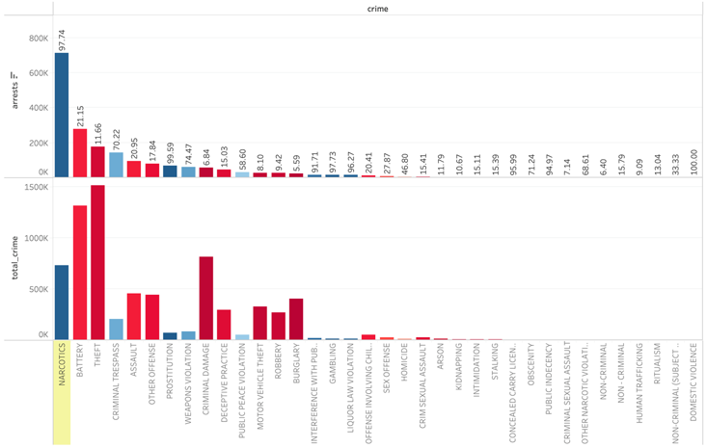Figure 3: Arrests Analysis by Crime Type

This figure tells the story of the ammount of call/reports, and the actual percentage of calls that lead to arrests. This graph may be the most important of all because it highlights which crimes are ignored and which victims are underserved.
A lower arrest percentage for certain crimes suggests potential areas for improving law enforcement responsiveness and effectiveness.

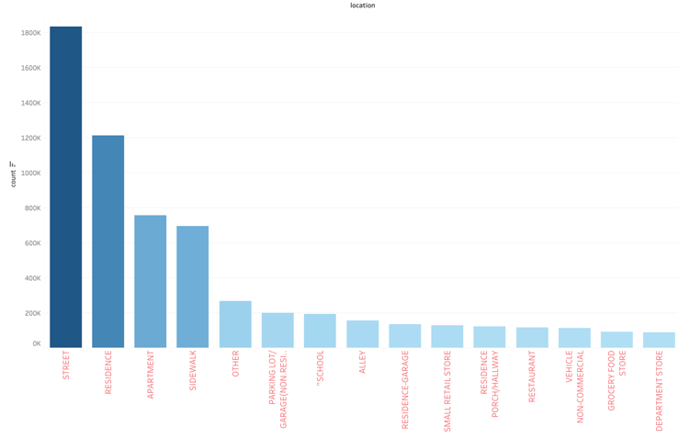Figure 4: Crime by Location

This figure shows the count of different crimes by their location type. As we can see, violence on occurs most often on the street, followed by private residences and appartments. Sidewalks and parking lots are also the most common crime locations.

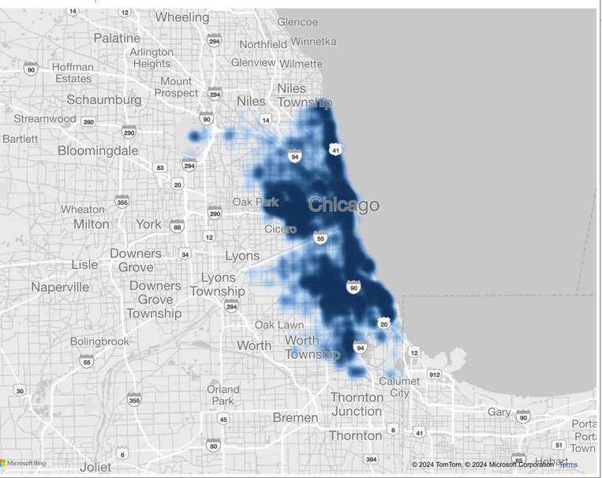Figure 5: Geo-Spatial Analysis Heatmap

This figure satisfied the geo-spatial analysis of the report, it is here where we see which paticular parts of Chicago are most crime-ridden. In this case, we can see that coastal areas are hotspots for incidents, as is parts of the interior of the city. City managers can use this data to help protect citizens in places where crime to too common.

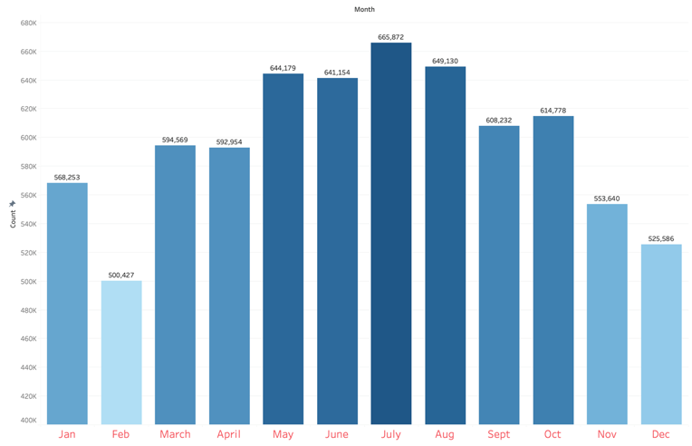Figure 6: Temporal Analysis Crime Count by Month

This chart satisfies the temp-analysis requirement for the project. It is in this chart where we can observe an entire year’s worth of crimes committed in the city, and see that crime is more common in the Summer months. Citizens can be warned to be more dilligent during those months.

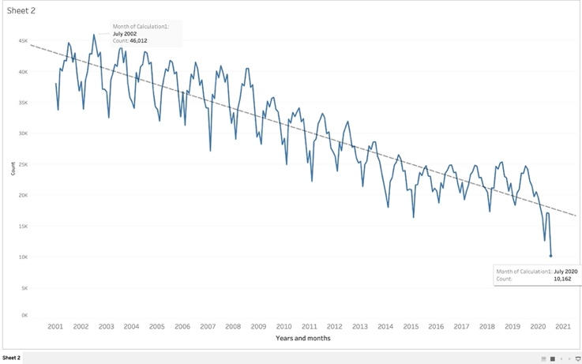Figure 7: Temporal Analysis Crime Count by Year

This figure presents a temporal analysis of crime in Chicago from 2001 to 2020.
A peak in crime incidents is observed in July 2002, with a count of 46,012 reported cases.
Despite fluctuations, there is an overall trend of declining crime rates over the observed period.
The overall decline in crime rates suggests that past interventions may be effective, but continuous monitoring and adaptation are necessary.

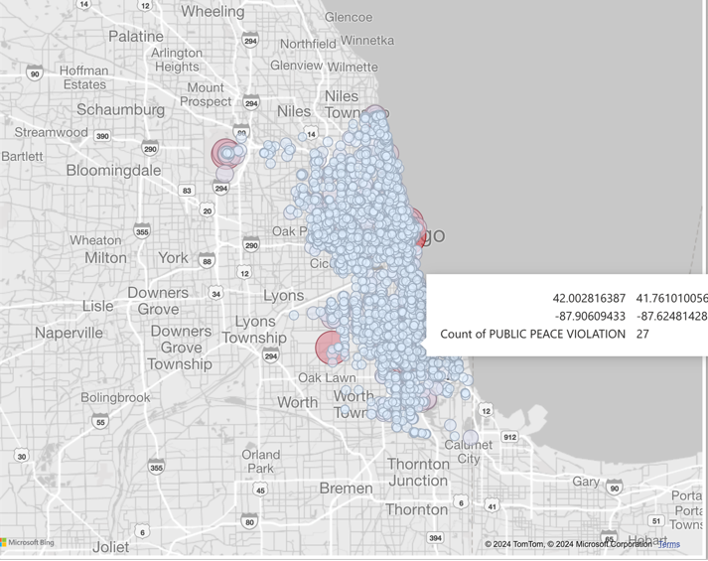
Figure 8: Geo-Spatial Analysis Bubbles

This visualization focuses on the exact location of incidents/public peace violations. Each bubble in the infographic visualization contains the exact coordinates (over time) and the count of violations committed in that specific reported area. This information is helpful because is shows not only the spread of crime throughout the city, but also the areas specifically where crime statistics might be higher than ususal.

Civilians could use visualizations like Figure 4, 5, or 8, in order to determine for themselves whether the places they plan to go, or perhaps park their car, or decide to work, is safe, by their own standard of measure. Basically, it is better for people to be able to view the statistics themselves and make informed decisions about where to live, travel, visit, and work, by having all the relevant safety information.

People interested in visiting Chicago might be interested in in Figure 6 because it shows the rates of crime thoughout the year. Tourists might consider traveling to Chicago in February where crime seems to be at its lowest; and they might also consider avoiding the city in the summer-time when crime is at it’s peak.

In that vein, Figures 2 and 4 show the types of crime and the types of locations where crimes are more likely to occur/have occured. Citizens and tourists alike could browse that information along with the tempo-spatial visualizations to determine which streets and sidewalks are safer than others, when deciding on routes to work for example. Other uses might be deciding on where to send your children to school, which schools, and the routes they should take to arrive to their campus. There are countless positive uses for these studies.

6. Conclusion
In conclusion, our analysis of the Chicago crime dataset from 2001 to 2020 provides valuable insights into the prevalence, types, and locations of crimes within the city. The visualizations highlight the most common crimes, arrest rates, and geographical hotspots, allowing for a comprehensive understanding of crime trends. These findings can guide law enforcement and city officials in making data-driven decisions to enhance public safety. Continuous monitoring and targeted interventions based on this analysis can help mitigate crime and improve the quality of life for Chicago residents.

The study of these kinds of statistics are valuable because they not only identify locations in Chicago that are more prone to crime, (with the intended effect of crime prevention), but more importantly, Chicago’s governing forces will be able to protect their citizens more efficiently.
Using tempo-spatial visualizations, Chicago’s governing forces can determine not only locations in the city, but also times of the day and times of the year, that crime is more likely to occur. By understanding those trends, Chicago police can increase patrolling in areas where crimes are more likely to occur.

This type of analysis is good intentioned and does not veer into totalitarian territory. This analysis does not identify specific individuals, nor does it make any assumptions about the victims of the crimes, their perpetrators, or the guilt of anyone specifically.

For that reason, both the citizens of Chicago, and their governing officials should consider the use of statistical analysis in their work/fight to defend their city from crime. By understanding when in the year, where, and what kind of crimes are more likely to occur, the safety of Chicago’s citizens is likely to increase.

References
[1]Chicago Crime Dataset. Kaggle. Retrieved from https://www.kaggle.com/datasets/n3v375/chicago-crime-from-01jan2001-to-22jul2020
[2]Violence Reduction Dashboard, Retrieved from
https://www.chicago.gov/city/en/sites/vrd/home.html
[3]Crime Data Explorer, Federal Bureau of Invedtigation, Retrieved from, https://cde.ucr.cjis.gov/LATEST/webapp/#/pages/explorer/crime/crime-trend

