EXPERIMENTAL RESEARCH REPORT
RELIABILITY ASSESSMENT OF UNIT TESTS
AUTOMATICALLY GENERATED BY LARGE LANGUAGE MODELS (LLMs)
Comparing 6 LLMs on a bilingual Java–Python dataset (646 verified functions)
Data scope: functions_java_VERIFIED.jsonl · functions_python_VERIFIED.jsonl · master_result.xlsx
Analysis tools: Google Colab (Python — pandas, scipy, seaborn)
August 2026

TABLE OF CONTENTS
1. PROBLEM STATEMENT
1.1. What is a unit test and its role in software development
1.2. Applying LLMs to generate unit tests: benefits and trade-offs
1.3. Research questions
2. DATA AND EXPERIMENTAL METHOD
2.1. Source function dataset
2.2. Unit test generation process via API Gateway
2.3. Measurement and result-aggregation process
2.4. Supporting tooling
3. DATA RELIABILITY CHECK
3.1. Integrity of the merged data
3.2. Points to note when interpreting the results
4. ANALYSIS RESULTS
4.1. Overview by model
4.2. Ok Rate by model and by language
4.3. Breakdown of error types
4.4. Branch Coverage distribution
4.5. “Coverage cliff”: the effect of function complexity
4.6. Number of test cases and efficiency
4.7. Asymmetry between Java and Python
4.8. Correlation between variables
4.9. Statistical testing
4.10. Case study: universally hard functions and highly divergent functions
4.11. Analyses implemented in Colab
5. DISCUSSION: CAN LLM-GENERATED UNIT TESTS BE TRUSTED?
6. LIMITATIONS OF THE STUDY
7. CONCLUSION AND FUTURE DIRECTIONS
7.1. Conclusion
7.2. Future directions

1. PROBLEM STATEMENT

1.1. What is a unit test and its role in software development
A unit test is an automated test that targets the smallest independently verifiable unit in the source code — typically a function or a method. Each unit test sets up specific inputs, calls the function under test, and then compares the returned result (or the resulting state/exception) against the expected outcome. A good unit test suite checks not only the “happy path” but also covers conditional branches, edge-case values, and error scenarios.
In the software development process, unit tests play several core roles:
- Catching bugs early, at the level of a single unit of code, before they propagate to other components or reach the production environment.
- Acting as a “safety net” for refactoring: allowing internal implementation to change while still trusting that external behavior is not broken.
- Serving as living documentation, describing a function's expected behavior through concrete, readable examples — much easier to read than descriptive text.
- Being a prerequisite for measuring code coverage — among which branch coverage is one of the metrics that most closely reflects how “thorough” a test suite is, since it requires both the true and false branches of every condition to be executed at least once.
However, writing unit tests manually takes a great deal of developer time, is easily skipped under tight deadlines, and its quality depends heavily on the author's experience. This is precisely the motivation behind using LLMs to automatically generate unit tests — a direction that has drawn wide interest in recent years.

1.2. Applying LLMs to generate unit tests: benefits and trade-offs

Benefits
- Speed: an LLM can generate test suites for hundreds of functions within minutes, instead of hours or days of manual effort.
- Low startup cost: gives projects lacking unit tests (legacy code) a starting point to build up coverage, rather than starting from zero.
- Ability to cover many edge cases that a developer might miss, thanks to the LLM being trained on a large volume of source code and existing test patterns.
- Can be integrated into a CI/CD pipeline as a suggestion step, for developers to review and refine further.

Trade-offs to consider
- There is no guarantee that LLM-generated tests will compile, run, or — more importantly — correctly verify the function's intended behavior; a “passing” test does not necessarily check the right thing.
- Quality can vary greatly across models, across programming languages, and across functions of differing complexity.
- A high number of test cases does not equate to high coverage — this needs to be measured empirically rather than assumed.
- Randomness (generation temperature > 0) means results can fluctuate across different runs of the same model on the same function.
Because of these trade-offs, the question of “whether LLM-generated unit tests can be trusted” cannot be answered by intuition alone, but requires a quantitative empirical study — measured on a verified set of source functions, across multiple models, and across multiple metrics (success rate, branch coverage, number of test cases, and the statistical significance of observed differences).

1.3. Research questions
This report was built to directly answer the following questions, based on empirical data obtained from running 6 LLMs on 646 verified functions (327 Java + 319 Python):
- RQ1 — Can LLM-generated unit tests be trusted, and to what extent? (measured by the proportion of functions whose tests successfully compile/run/pass — Ok Rate — and the branch coverage achieved among those successful tests)
- RQ2 — Among the 6 models tested, which one produces the most reliable results, and are the differences between models statistically significant or just random noise?
- RQ3 — How does function complexity (cyclomatic complexity) affect an LLM's ability to generate fully covering tests?
- RQ4 — Does generating more test cases mean higher coverage, or does the quality of each individual test matter more?
- RQ5 — Is a model's capability consistent between Java and Python, or is there significant asymmetry?
- RQ6 — Is the empirical data reliable enough to draw the above conclusions, and what limitations should be kept in mind when interpreting the results?

2. DATA AND EXPERIMENTAL METHOD

2.1. Source function dataset
The set of source functions used to generate unit tests is stored in two verified (VERIFIED) JSON Lines files — meaning each function was confirmed to compile/run and exhibit clear behavior before being included in the experiment, to ensure that any error observed at a later step stems from the LLM's test-generation process, not from an issue in the source code itself:
Data file | Language | # functions | Main data fields
functions_java_VERIFIED.jsonl | Java | 327 | id, class_name, target_method, source_code
functions_python_VERIFIED.jsonl | Python | 319 | id, function_name, source_code
Table 2.1 — The two source-function files used as input to the unit-test generation pipeline.
A total of 646 functions were passed through the pipeline. Each function has a pre-computed cyclomatic complexity (cc) score, reflecting the number of independent conditional branches in its execution flow — the higher the cc, the more branches a function has that need to be covered to reach 100% branch coverage.
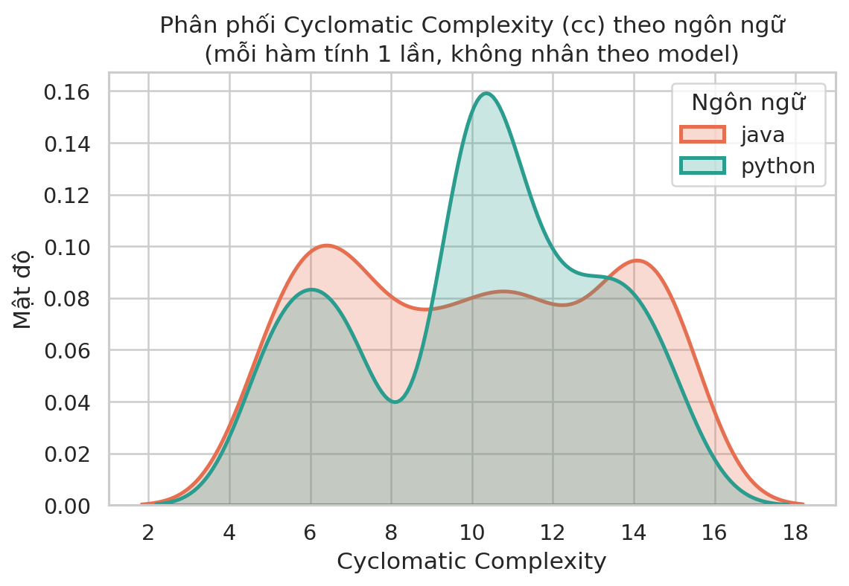
Figure 2.1 — Cyclomatic Complexity distribution by language.
Descriptive statistics show that the complexity distributions of the two languages are fairly similar (Java: mean 10.02, standard deviation 3.37; Python: mean 10.10, standard deviation 2.97; both ranging from cc = 5 to cc = 15). This is important because it rules out the possibility that one language performs better simply because its functions are structurally “easier” — any observed difference between Java and Python (Section 4.7) is more likely to come from a model's test-generation capability for that particular language, rather than from the inherent difficulty of the function set.

2.2. Unit test generation process via API Gateway
Calling the 6 different LLMs to generate tests was done through intermediary API gateways (OpenRouter, Groq, etc.) rather than calling each provider's proprietary API directly, which helped unify a common request/response format across the entire pipeline regardless of which provider a model came from. The general process for each (source function, model) pair was as follows:
- Build the prompt: insert the source_code of the function under test into a fixed prompt template, requiring the model to generate a complete unit test (including imports, the test class/function, and edge cases) following the convention of the corresponding language (JUnit for Java, pytest/unittest for Python).
- Call the API through the gateway: send a request to the gateway's chat completion endpoint, specifying the model (e.g. gemini-3.7-flash, gpt-oss-120b, etc.), with text-generation parameters held fixed across models to ensure a fair comparison — with the maximum output token limit (max_tokens) set to 8092, large enough to hold a complete test suite for highly complex functions without wasting resources.
- Extract & save the file: parse the code portion of the response (stripping any natural-language explanation, if present), and save it as a standalone test file following a naming convention (e.g. java_final_XXXX_<Name>Test.java, test_py_final_XXXX_<function_name>.py) inside a results folder specific to each model.
- Log API call errors: timeouts, rate limits, or gateway errors were logged separately to distinguish them from failures caused by the model's test-generation quality (reflected via the status = timeout / error labels in the aggregated data).
The actual results folder structure (result.zip) shows that data was collected through several different gateways depending on the model — for example the folders openrouter-gemini-3.7-flash, GROQ-GPT_OSS_120b — correctly reflecting the “one unified gateway, multiple providers” approach described above.

2.3. Measurement and result-aggregation process
After a test file exists for each function, an automated evaluation pipeline is run to turn that test file into quantitative figures, consisting of the following steps:
- Compile/prepare the runtime environment: for Java, the test file is compiled together with the corresponding source class; for Python, the module containing the function is imported directly (there is no separate compilation step — this is why the compile_error label only exists for Java; see also Section 3.2).
- Run the tests: execute every test case in the file, recording pass/fail.
- Measure branch coverage: use JaCoCo for Java and coverage.py for Python to measure the percentage of the original function's conditional branches that the test suite exercises.
- Assign a status label to each (function, model) pair: ok (test passes and coverage is measurable), test_failed (test runs but has an assertion failure), compile_error (Java fails to compile), coverage_error (Python fails while measuring coverage), error/timeout (system error/timed out), no_data / no_test_generated (no test was generated).
- Count test cases: count the number of @Test/@ParameterizedTest/@RepeatedTest methods (Java) or def test_* functions (Python) in the corresponding test file.
- Merge: all results from the 8 original CSV/XLSX files (one file per model, with some files mixing Java+Python separated by an id prefix) were merged into a single unified data table — the Raw_Data sheet in master_result.xlsx — with 3,876 rows, exactly matching 6 models × 646 functions.
The final output of this step is a structured data table with columns [id, language, model, cc, branch_coverage, status, status_detail, testcase_count] — which is the direct input to all the statistical analysis presented in Section 4.

2.4. Supporting tooling
Building the batch API-calling pipeline, normalizing the response format across different gateways, writing automated compile/run-test scripts for both Java and Python, and merging 8 heterogeneous data sources into one clean table represented a significant amount of engineering work. The research team used an LLM assistant (Claude) to help write and debug these scripting components (API calls, the code-extraction parser, the data-merging script, and the analysis notebook on Google Colab), which substantially shortened the time needed to build the experimental infrastructure compared to writing everything by hand, and let the team spend more time on experimental design and result interpretation.

3. DATA RELIABILITY CHECK
Because the data was assembled from 8 different sources (multiple pipeline runs, multiple gateways), an integrity check was performed before proceeding to statistical analysis.

3.1. Integrity of the merged data
Check criterion | Result
Total number of data rows | 3,876 / 3,876 expected (6 models × 646 functions)
Full 6 models × correct function count per language | Passed — every model has exactly 327 Java rows + 319 Python rows
Duplicate rows (id, model) | 0 duplicates
Missing values (NaN) | Only 2/3,876 rows are missing branch_coverage, both under status no_test_generated (reasonable — no test means nothing to measure coverage on)
Complexity (cc) balance between the two languages | Passed — the mean and standard deviation of cc are nearly equivalent between Java and Python (Section 2.1)
Table 3.1 — Data integrity check results (performed on the Raw_Data sheet).
Overall, the data is clean, with no sign of duplication or sample-size imbalance across models — sufficient to enable a fair comparison of the 6 models using the statistical tests in Section 4.9.

3.2. Points to note when interpreting the results
The following two points are not data errors, but could lead to misinterpretation if overlooked:
- Asymmetric error labels between the two languages: the compile_error label only appears for Java (across 327 Java functions there are 236 compile_error cases across all 6 models, while Python has 0), which is technically correct since Python has no separate compilation step. Conversely, coverage_error only appears for Python. Therefore, when comparing the “build error rate” between the two languages, these two labels need to be merged into a single build_error group (code that fails to run) rather than compared individually — this is exactly the treatment applied consistently throughout Section 4.
- The data represents a single run for each (model, function) pair: LLM text generation is stochastic (temperature > 0 under most gateways' default configuration), so in principle, if the same (model, function) pair were run again multiple times, the results (especially test_failed vs. ok and branch_coverage) could fluctuate. This is the most important limitation of this study and is discussed in detail in Section 6.

4. ANALYSIS RESULTS
All analysis in this section was performed on Google Colab (the detailed workflow within Colab is presented in Section 4.11), using the single Raw_Data table that passed the integrity check in Section 3.

4.1. Overview by model
Model | Ok Rate (%) | Avg. Coverage (ok only, %) | Avg. Test Case Count | Build Error Rate (%) | test_failed Rate (%)
Gemini-3.7-Flash | 79.88 | 90.39 | 11.84 | 7.12 | 10.22
GPT-5.6-Luna | 69.81 | 86.41 | 12.14 | 3.25 | 26.78
Gemma-4-31B-IT | 54.80 | 95.76 | 9.92 | 6.97 | 37.62
Gemini-3.5-Flash-Lite | 45.36 | 94.41 | 7.59 | 17.03 | 37.00
Gemma-4-26B-A4B-IT | 44.89 | 94.85 | 9.82 | 13.93 | 40.71
GPT-OSS-120B | 31.27 | 94.45 | 8.58 | 19.50 | 48.92
Table 4.1 — Summary by model, combining Java and Python (646 functions/model). Sorted by descending Ok Rate.
Ok Rate — the proportion of functions whose generated test suite compiles, runs, and fully passes — is a “raw output quality” metric, reflecting a model's ability to produce a usable test suite with no further fixes needed. By this metric, Gemini-3.7-Flash leads clearly (79.88%), followed by GPT-5.6-Luna (69.81%); the remaining three models (Gemma-4-31B-IT, Gemini-3.5-Flash-Lite, Gemma-4-26B-A4B-IT) sit at an average of 45–55%, and GPT-OSS-120B is lowest (31.27%).
However, an important observation is that the two models with the highest Ok Rate actually have the lowest average coverage (computed over their “ok” functions) among all 6 models — Gemini-3.7-Flash reaches 90.39% and GPT-5.6-Luna only 86.41%, while the other 4 models all exceed 94%. In other words, Gemini-3.7-Flash and GPT-5.6-Luna “pass” more functions, but those passing test suites on average cover fewer conditional branches than those of the other models. This is a real quantity-versus-quality trade-off, which the report will analyze further in the following sections.

4.2. Ok Rate by model and by language
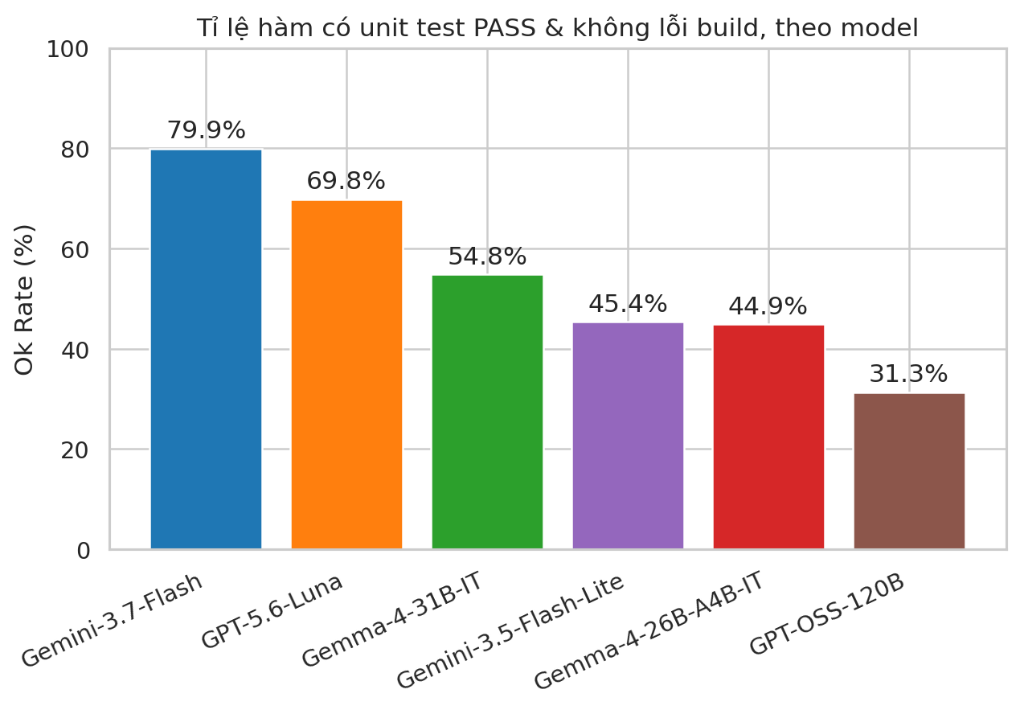
Figure 4.1 — Proportion of functions with a successfully compiling/running/passing unit test (Ok Rate), by model.
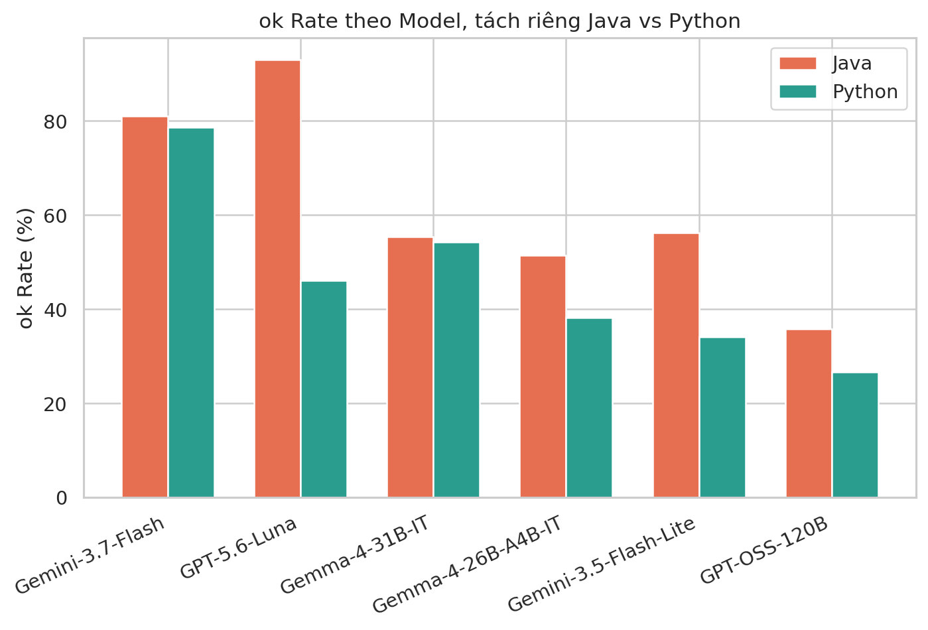
Figure 4.2 — Ok Rate by Model × Language.
Splitting by language reveals an uneven picture across models (full analysis in Section 4.7): GPT-5.6-Luna achieves a very high Ok Rate in Java (92.97%) but drops sharply in Python (46.08%) — a gap of nearly 47 percentage points; in contrast, Gemini-3.7-Flash and Gemma-4-31B-IT maintain a relatively balanced Ok Rate between the two languages.

4.3. Breakdown of error types
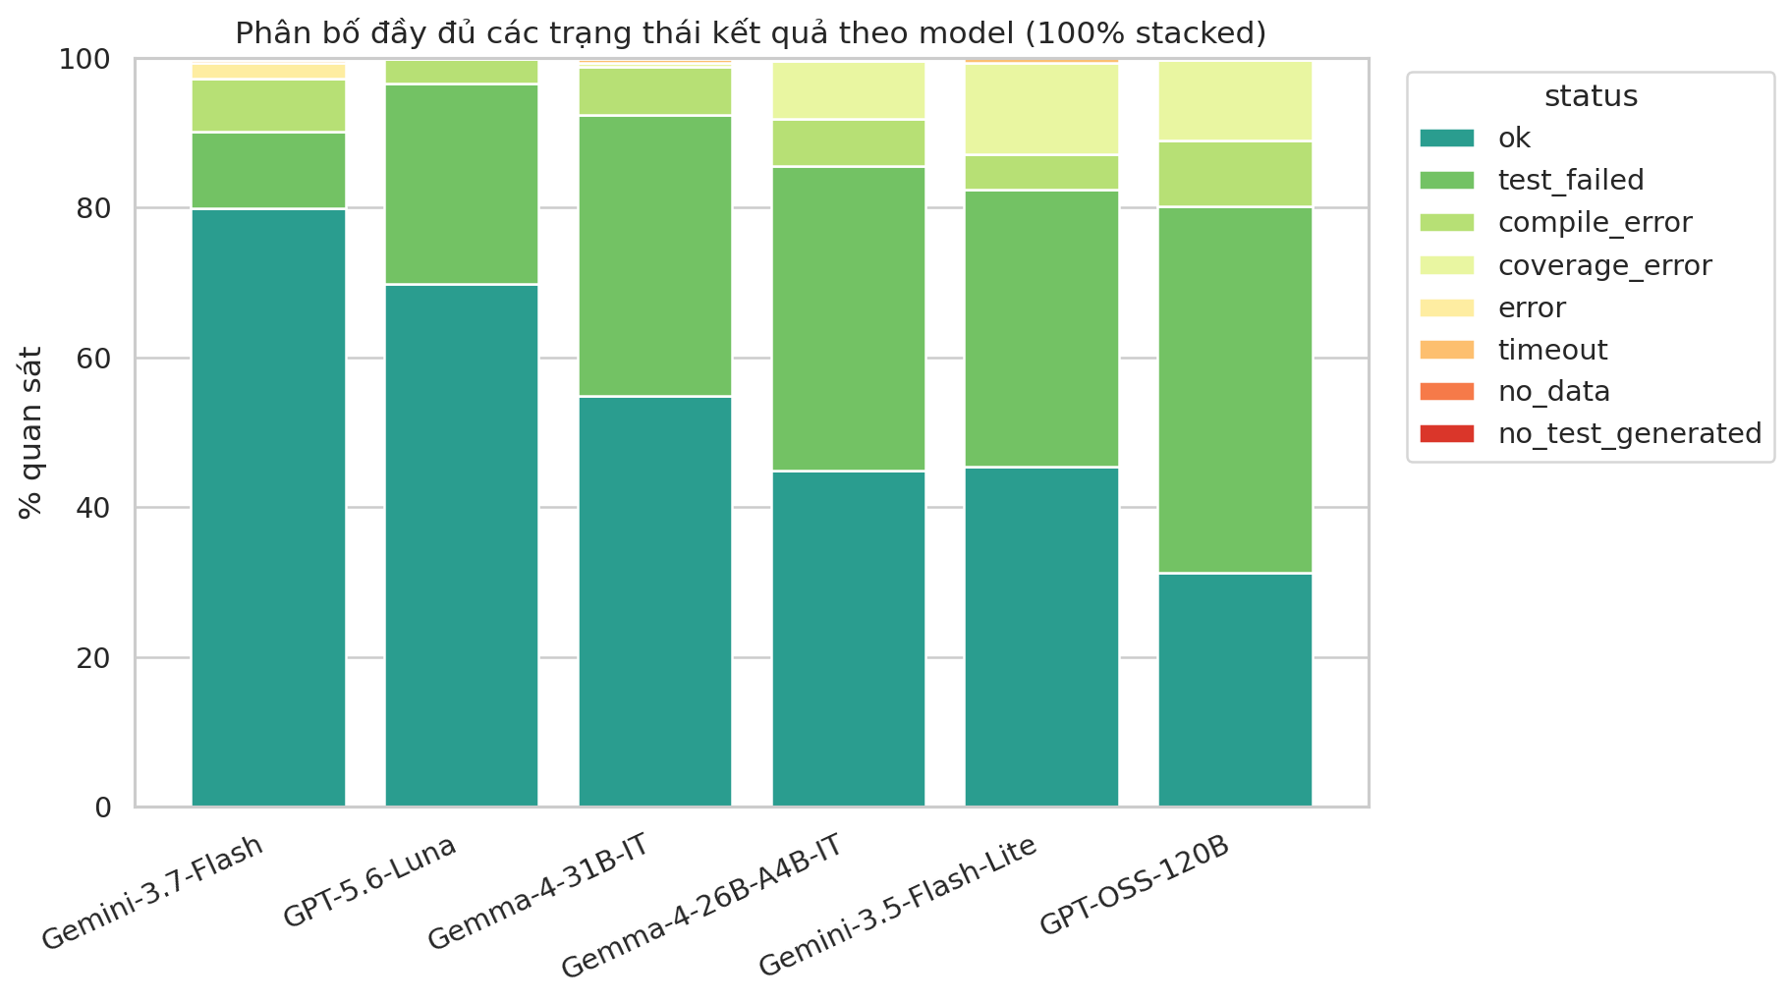
Figure 4.3 — Full distribution of status types (ok / test_failed / compile_error / ...) by model.
Looking deeper into the “not ok” portion: the dominant cause of failure differs clearly across models. For GPT-OSS-120B and Gemini-3.5-Flash-Lite, most failures come from test_failed (48.92% and 37.00%) — meaning the model misunderstood the function's behavior and wrote an assertion that doesn't match the actual result, a “logic” error that is harder to accept than a syntax error. Meanwhile GPT-5.6-Luna has the lowest build-error rate (3.25%, i.e. it almost always generates syntactically valid code) but a fairly high test_failed rate (26.78%). This distinction matters because build (syntax) errors are usually much easier to fix than incorrect test logic.

4.4. Branch Coverage distribution
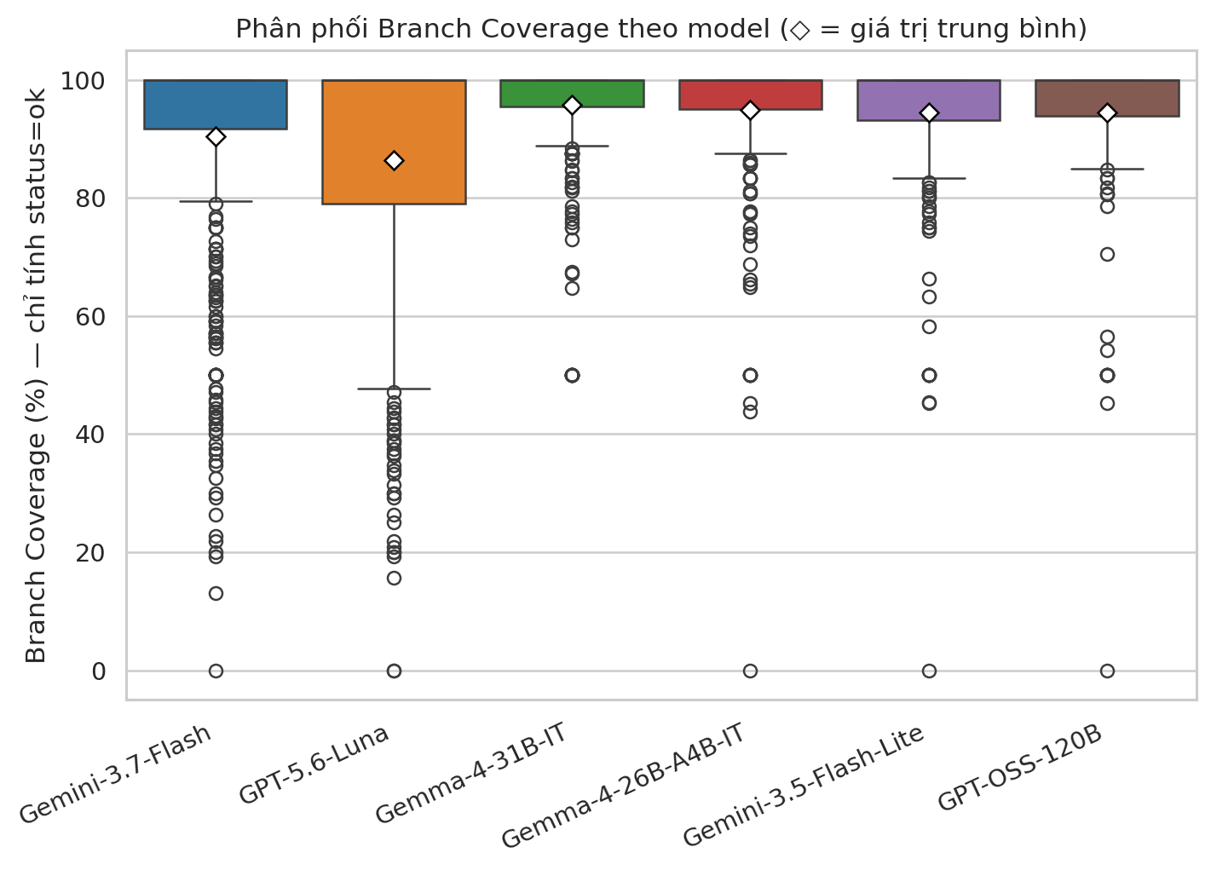
Figure 4.4 — Branch Coverage distribution by model (status = ok functions only; ◇ = mean value).
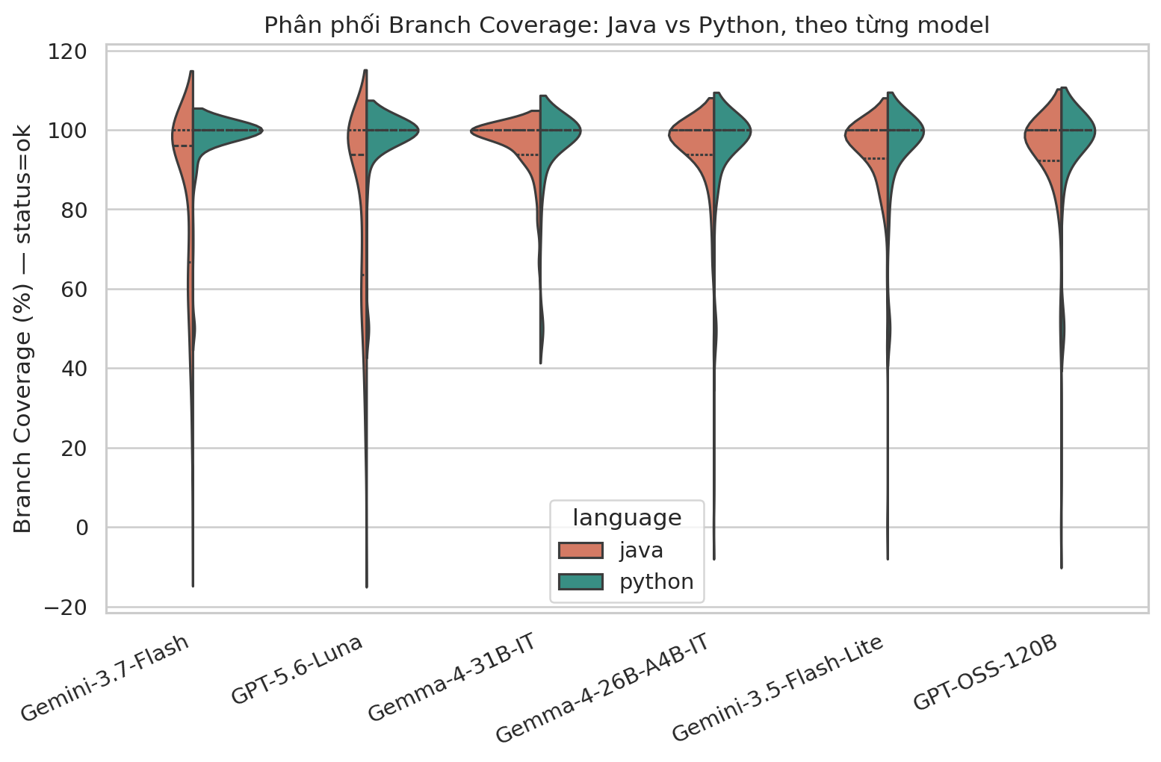
Figure 4.5 — Branch Coverage distribution: Java vs. Python, by model.
The median branch coverage across all 6 models reaches 100% — meaning that in most “ok” cases, once a model has generated a passing test suite, that suite typically covers every conditional branch. The differences between models mainly lie in the tail of the distribution (low-coverage functions pull the mean down) and in whether a model achieves “ok” status for many functions in the first place (Section 4.1), rather than in individual test cases varying widely in quality.

4.5. “Coverage cliff”: the effect of function complexity
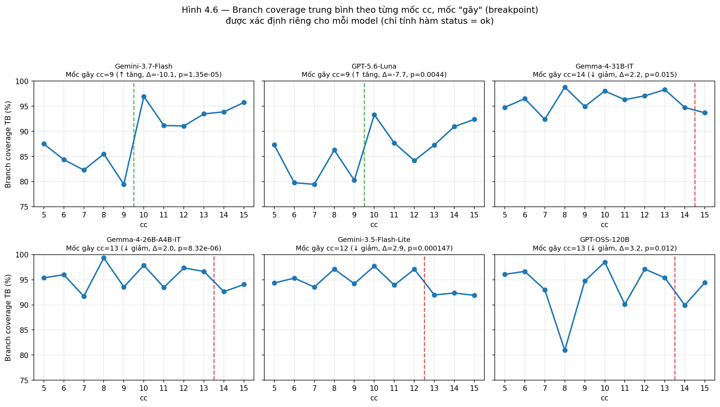
Figure 4.6 — Average branch coverage by cc level, with a “breakpoint” determined separately for each model (status = ok functions only).
The initial hypothesis was that the more complex a function is, the harder it is for an LLM to generate tests that cover it fully (a “coverage cliff”). An initial analysis split cc into 3 common levels (tertiles) shared across all 6 models, but this approach obscured an important detail: each model may “break” at a different cc point. To find the correct breakpoint for each model, the team swept every cc threshold from 6 to 14, split each model's “ok” functions into 2 groups (cc ≤ threshold / cc > threshold), computed the average coverage difference and ran a Mann-Whitney U test, then selected the threshold with the largest |difference| that was statistically significant (Figure 4.6, Table 4.6a).
Model | Breakpoint (cc) | Avg. Coverage, lower-cc group (%) | Avg. Coverage, higher-cc group (%) | p-value | Direction
Gemini-3.7-Flash | 9 | 84.16 (cc≤9) | 94.21 (cc>9) | 1.35e-05 | ↑ increase (reverse cliff)
GPT-5.6-Luna | 9 | 82.16 (cc≤9) | 89.90 (cc>9) | 0.0044 | ↑ increase (reverse cliff)
Gemma-4-31B-IT | 14 | 95.89 (cc≤14) | 93.69 (cc>14) | 0.015 | ↓ decrease (true cliff)
Gemma-4-26B-A4B-IT | 13 | 95.21 (cc≤13) | 93.20 (cc>13) | 8.32e-06 | ↓ decrease (true cliff)
Gemini-3.5-Flash-Lite | 12 | 95.03 (cc≤12) | 92.13 (cc>12) | 0.000147 | ↓ decrease (true cliff)
GPT-OSS-120B | 13 | 94.75 (cc≤13) | 91.60 (cc>13) | 0.012 | ↓ decrease (true cliff)
Table 4.6a — cc breakpoint by model, determined via threshold sweep + Mann-Whitney U test (status = ok functions only).
The results show the 6 models splitting into 2 clearly distinct groups, unlike the “one shared breakpoint for all” picture from the initial analysis. The first group — precisely the two models with the highest Ok Rate (Gemini-3.7-Flash, GPT-5.6-Luna) — breaks at cc = 9, but in the opposite direction: coverage in the cc≤9 group is markedly lower than in the cc>9 group (a −10.05-point gap for Gemini-3.7-Flash, −7.75 points for GPT-5.6-Luna, p < 0.01 for both). This is exactly the sample-selection effect (survivorship bias) mentioned earlier: for these two models, many complex functions are filtered out of the “ok” set before the coverage-measurement step, so the complex functions that remain in “ok” are the cases the model handled best. The second group — the remaining 4 models (Gemma-4-31B-IT, Gemma-4-26B-A4B-IT, Gemini-3.5-Flash-Lite, GPT-OSS-120B) — show a genuine “coverage cliff” (coverage decreases as cc increases), but the breakpoint occurs much later than the original tertile assumption — between cc = 12 and cc = 14 — and the drop is very small, only 2.0–3.2 percentage points (p < 0.05). In other words, for most models, the “coverage cliff” only really appears among very complex functions (cc ≥ 12–14), not starting from an “average” level as the old tertile split implied.
A Spearman test over the full dataset (Section 4.9) confirms that the correlation between cc and branch coverage is statistically significant but very weak (rho ≈ −0.06) — consistent with the breakpoint analysis above: the “coverage cliff” effect is real for most models but weak and only apparent at high cc, while for the two best models the effect is even reversed due to sample selection — a model's Ok Rate (Section 4.1) remains a far larger source of difference than function complexity itself.

Additional finding: “reliable” coverage versus “overall” coverage.
A notable point when re-examining the data at a finer grain: a large number of functions labeled test_failed (test runs but the assertion is wrong — Section 2.3) still achieve very high branch coverage, because the coverage-measurement tools (JaCoCo/coverage.py) record which code branches were executed regardless of whether the final assertion was correct or not. Specifically, out of the full 1,300 test_failed functions (across all 6 models combined), 1,077 functions (82.8%) have coverage ≥ 80%, and 682 functions reach exactly 100%. This creates two coverage figures with different meanings: “reliable” coverage (ok functions only — tied to a test that has confirmed correct behavior; this is the figure used throughout Table 4.1 and Sections 4.2–4.9) and “overall” coverage (combining both ok and test_failed — reflecting whether the code was “touched” at all, regardless of whether the assertion was right or wrong).
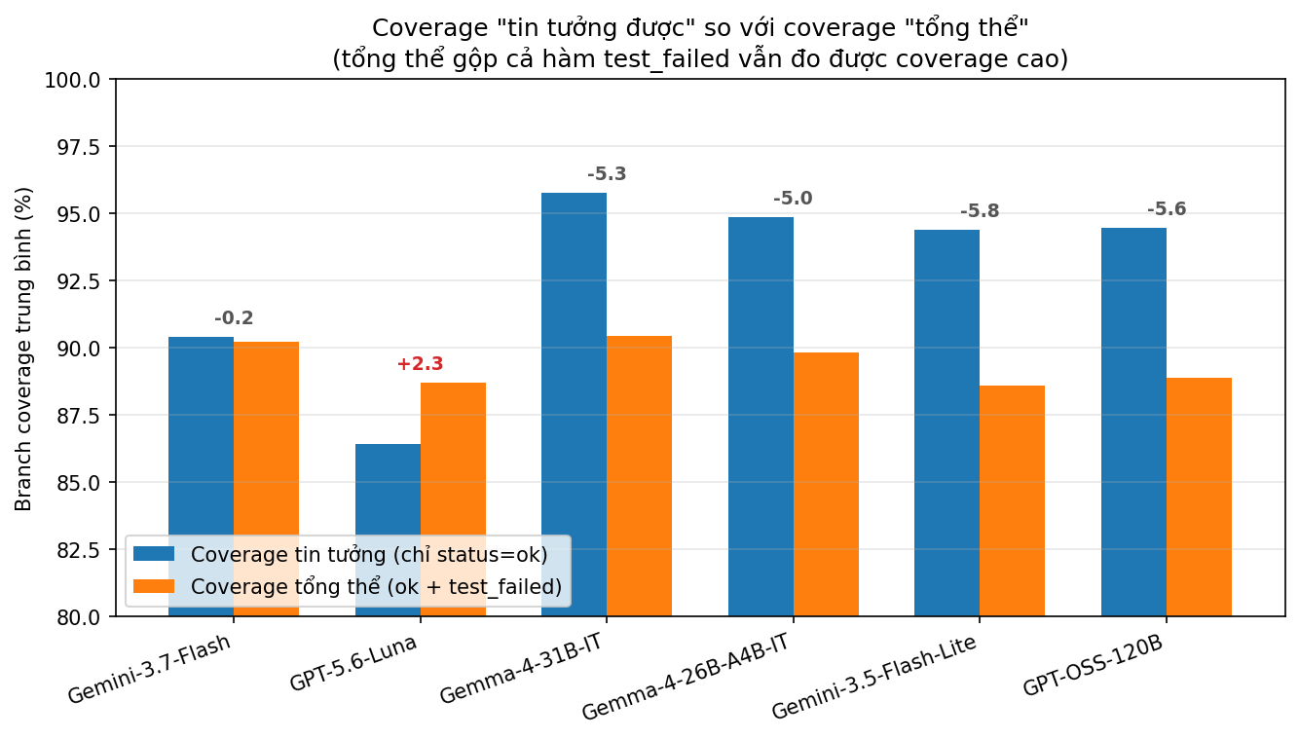
Figure 4.6b — Comparison of “reliable” coverage (ok only) and “overall” coverage (ok + test_failed) by model.
Model | Reliable Coverage (ok only, %) | Overall Coverage (ok+test_failed, %) | Difference | # test_failed functions
Gemini-3.7-Flash | 90.39 | 90.23 | -0.17 | 66
GPT-5.6-Luna | 86.41 | 88.71 | +2.30 | 173
Gemma-4-31B-IT | 95.76 | 90.43 | -5.33 | 243
Gemma-4-26B-A4B-IT | 94.85 | 89.83 | -5.02 | 263
Gemini-3.5-Flash-Lite | 94.41 | 88.59 | -5.81 | 239
GPT-OSS-120B | 94.45 | 88.87 | -5.58 | 316
Table 4.6b — “Reliable” coverage (ok only) versus “overall” coverage (ok + test_failed) by model.
Table 4.6b shows that 5 of 6 models have lower overall coverage than reliable coverage (a −5.0 to −5.8 point gap) — which makes sense, since adding in test_failed functions tends to pull the average down slightly. The one exception is GPT-5.6-Luna: its overall coverage (88.71%) is higher than its reliable coverage (86.41%) by +2.30 points — meaning this model's failing tests still touch code branches very well; they simply assign the wrong assertion value, rather than being generated carelessly. This result somewhat softens the conclusion in Section 4.1 that GPT-5.6-Luna has the lowest average coverage among the 6 models: that observation only holds when filtering by “ok” status; looking at branch-execution capability in general (regardless of whether the assertion is right or wrong), GPT-5.6-Luna is not inferior to the other models at all. Practically, this is also a hint for choosing a test-generation model: when a test suite ends up test_failed, it should not be discarded outright — the coverage it achieves can still be reused as a test skeleton, requiring only a fix to the expected values in the assertions rather than a rewrite from scratch.

4.6. Number of test cases and efficiency
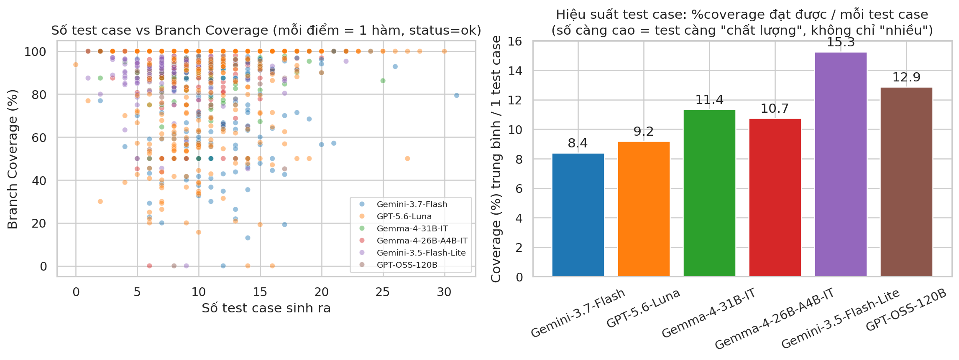
Figure 4.7 — (left) Number of test cases generated versus Branch Coverage achieved; (right) Average efficiency per test case (coverage / number of test cases) by model.
Model | Avg. Test Case Count | Avg. Coverage (%) | Avg. Efficiency (coverage/test) | Coverage Rank | Efficiency Rank
Gemini-3.7-Flash | 11.82 | 90.39 | 8.41 | 5 | 6
GPT-5.6-Luna | 11.24 | 86.41 | 9.20 | 6 | 5
Gemma-4-31B-IT | 9.63 | 95.76 | 11.35 | 1 | 3
Gemma-4-26B-A4B-IT | 9.72 | 94.85 | 10.74 | 2 | 4
Gemini-3.5-Flash-Lite | 7.61 | 94.41 | 15.26 | 4 | 1
GPT-OSS-120B | 8.55 | 94.45 | 12.87 | 3 | 2
Table 4.2 — Test case count, coverage, and per-test-case efficiency by model (status = ok functions only).
The results directly answer the question “does generating more test cases help”: the Spearman correlation between testcase_count and branch_coverage over the full dataset is essentially zero (rho = −0.001, p = 0.95 — not statistically significant). The two models that generate the most test cases (GPT-5.6-Luna ~11–12 tests/function, Gemini-3.7-Flash ~12 tests/function) actually rank lowest in efficiency per test case (rank 5 and 6 of 6), while Gemini-3.5-Flash-Lite — which generates the fewest test cases (7.59 tests/function) — achieves the highest efficiency. In other words, test case count is a confounding metric if used to judge quality: a model that generates few tests but “hits the right branches” can still achieve coverage equal to or higher than a model that generates many tests but repeats similar cases.

4.7. Asymmetry between Java and Python
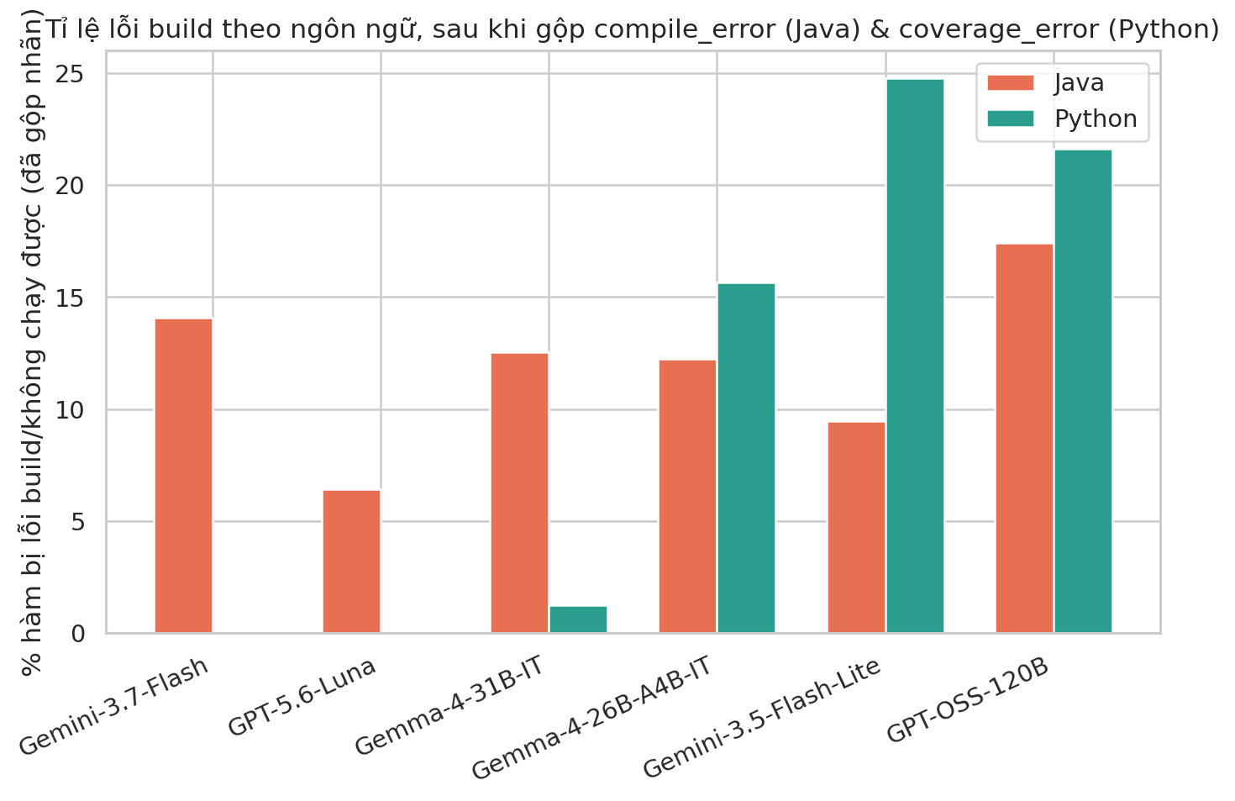
Figure 4.8 — Build error rate (compile_error + coverage_error combined) by Model × Language.
Model | Avg. Coverage — Java (%) | Avg. Coverage — Python (%) | Difference (Python − Java) | Statistically significant? (p < 0.05)
Gemini-3.7-Flash | 83.3 | 97.9 | +14.6 | Yes (p ≈ 5.9×10⁻²⁶)
GPT-5.6-Luna | 81.1 | 97.4 | +16.3 | Yes (p ≈ 1.7×10⁻²⁰)
GPT-OSS-120B | 93.8 | 95.3 | +1.5 | Yes (p ≈ 0.0011)
Gemini-3.5-Flash-Lite | 94.0 | 95.1 | +1.2 | Yes (p ≈ 0.0006)
Gemma-4-26B-A4B-IT | 94.5 | 95.3 | +0.7 | Yes (p ≈ 0.0015)
Gemma-4-31B-IT | 96.0 | 95.5 | −0.6 | Yes (p ≈ 0.0023)
Table 4.3 — Comparison of average Branch Coverage between Java and Python by model (Mann-Whitney U test, status = ok functions only).
All 6 models show a statistically significant coverage difference between Java and Python (p < 0.05, due to the large sample size), but the effect size differs completely between two groups of models. For 4 models (GPT-OSS-120B, Gemini-3.5-Flash-Lite, Gemma-4-26B-A4B-IT, Gemma-4-31B-IT), the coverage gap between the two languages is only within ±1.5 percentage points — practically negligible. In contrast, Gemini-3.7-Flash and GPT-5.6-Luna — the two models with the highest Ok Rate — show a very large gap (+14.6 and +16.3 percentage points, with Python coverage consistently and clearly higher than Java). Combined with the fact that GPT-5.6-Luna has a very high Java Ok Rate (92.97%) but a much lower Python Ok Rate (46.08%, Section 4.2), it can be concluded that these two models show markedly uneven capability between the two languages, and should be considered separately depending on the intended language of use (see Section 5).

4.8. Correlation between variables
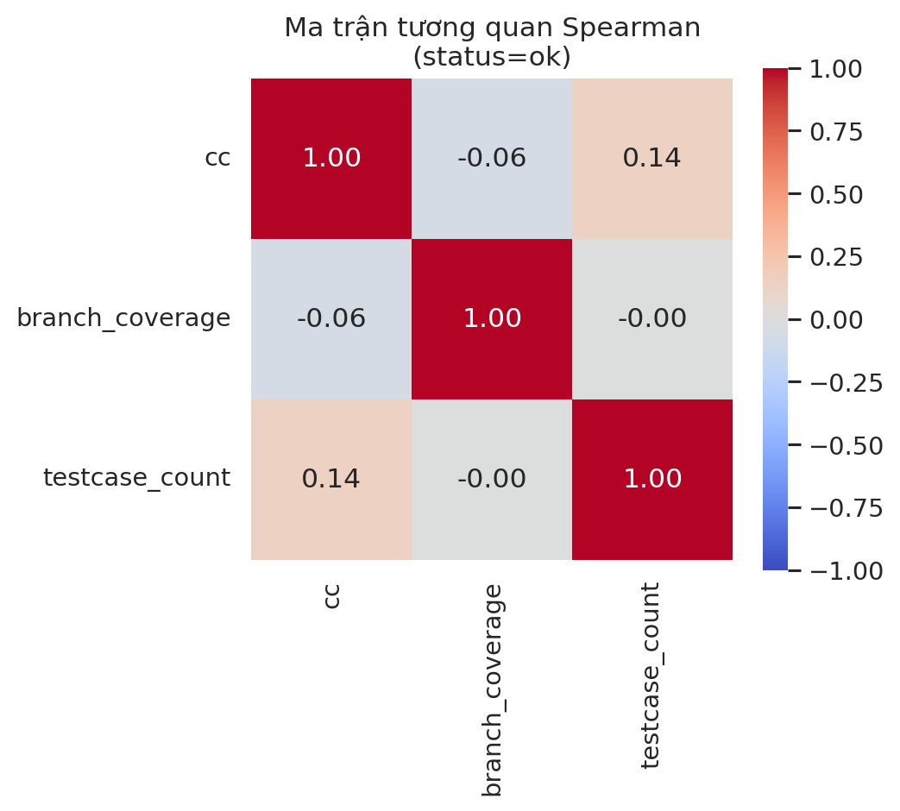
Figure 4.9 — Spearman correlation matrix between cc, branch_coverage, and testcase_count (status = ok functions only).
The correlation matrix reinforces the two observations noted above: (i) cc and branch_coverage are negatively correlated but very weakly (rho ≈ −0.06); (ii) testcase_count and branch_coverage are essentially uncorrelated (rho ≈ −0.001); (iii) cc and testcase_count show a weak but statistically significant positive correlation (rho ≈ 0.14, p < 0.001) — i.e. models tend to write somewhat more test cases for more complex functions, but not enough of an increase to raise coverage correspondingly.

4.9. Statistical testing
Descriptive charts give an intuitive sense of the differences between models, but to confirm that those differences are real (not due to random noise in the sample), the team used non-parametric tests — appropriate since branch_coverage is bounded within [0, 100] and heavily clustered near 100%, and does not follow a normal distribution.

a) Kruskal-Wallis — do the 6 models' average coverage differ significantly?
H = 33.959; p ≈ 2.43 × 10⁻⁶ (p < 0.05) → At least 2 of the 6 models have a statistically significantly different branch coverage distribution.

b) Post-hoc pairwise Mann-Whitney U (Bonferroni-corrected, threshold 0.05/15 ≈ 0.0033)
Of the 15 pairwise comparisons, only 4 pairs remain significant after Bonferroni correction — all of them involving GPT-5.6-Luna:
- GPT-5.6-Luna vs Gemma-4-31B-IT: 86.4% vs 95.8% (p ≈ 1.2×10⁻⁷)
- GPT-5.6-Luna vs Gemma-4-26B-A4B-IT: 86.4% vs 94.8% (p ≈ 1.8×10⁻⁴)
- GPT-5.6-Luna vs GPT-OSS-120B: 86.4% vs 94.5% (p ≈ 4.0×10⁻⁴)
- Gemini-3.7-Flash vs GPT-5.6-Luna: 90.4% vs 86.4% (p ≈ 2.0×10⁻³)
The remaining pairs — including ones with score gaps that look sizeable on the chart, e.g. Gemini-3.7-Flash vs Gemma-4-31B-IT (90.4% vs 95.8%, p ≈ 0.017) — are no longer significant after correcting for multiple comparisons. The cautious conclusion is: GPT-5.6-Luna has significantly lower average coverage than 3 other models and than Gemini-3.7-Flash; differences among the remaining models likely fall within the sample's natural variation.

c) Chi-square — does the status type depend on the model?
χ² = 669.17; degrees of freedom = 35; p ≈ 2.72 × 10⁻¹¹⁸ (p < 0.05) → a highly statistically significant dependency. However, Cramer's V = 0.186 (a “weak-to-moderate” level), meaning this very strong statistical significance partly comes from the large sample size (3,876 rows); in terms of practical magnitude, the relationship between model and error type is moderate rather than absolute — there is still considerable overlap between models.

d) Spearman — correlation between complexity (cc) and Branch Coverage
Full dataset: rho = −0.061 (p ≈ 0.0054, statistically significant but very weak). Split by language: Java rho = −0.089 (p ≈ 0.0020, weakly significant); Python rho = 0.029 (p ≈ 0.39, not statistically significant). This result reinforces the observation in Section 4.5: the “coverage cliff” effect by complexity is real but weak, and more pronounced in Java than in Python.

4.10. Case study: universally hard functions and highly divergent functions
To add a qualitative perspective alongside the aggregate figures, the team identified two special groups of functions across the full set of 646:
- Universally hard functions: 45/646 functions (7.0%) fail to reach “ok” status with any of the 6 models — meaning all 6 models failed (though for possibly different reasons: build errors, test_failed, etc.). This group has an average cc of 11.93, noticeably higher than the average cc of the full dataset (10.06) — the highest-cc functions in this group (cc = 14–15) are concentrated in Java, consistent with Spearman's rho being more strongly negative in Java than in Python (Section 4.9d). This is a good candidate for deeper qualitative analysis (e.g. reading the source code of these functions directly to understand why all 6 models struggled).
- Functions causing strong divergence between models: 61/646 functions (9.4%), by contrast, were successfully handled (ok status) by all 6 models. Alongside this, there is a group of functions where results differ enormously between models (a coverage standard deviation across the 6 models of roughly 50–55 percentage points) — for example functions where 3 models reach 100% coverage while the other 3 reach 0% (complete failure). This group matters because it shows a genuine difference in capability between models, rather than the function itself simply being too hard (since clearly some model was able to handle it).

4.11. Analyses implemented in Colab
All the content of Sections 3 and 4 was carried out in a single Google Colab notebook (Phan_tich_LLM_Unit_Test_Coverage.ipynb), following a clear 9-step sequence to ensure the analysis is reproducible:
- Step 1 — Load data: read the Raw_Data sheet directly from master_result.xlsx (not reusing the original scattered CSV files in each results folder, since some of those files were found to mix data from different runs — detected and excluded during manual review).
- Step 2 — Check data integrity: cross-check row counts by model × language, look for missing values, look for duplicate rows, and verify the assumption that the cc distribution is balanced between the two languages (Section 3.1).
- Step 3 — Preprocessing & auxiliary variables: create a build_error column (merging compile_error and coverage_error for a fair comparison between the two languages), a complexity_level column (splitting cc into 3 Low/Medium/High levels by tertile), and a coverage_efficiency column (branch_coverage / testcase_count, computed only when status = ok).
- Step 4 — Overview descriptive statistics: compute a summary table of Ok Rate, mean/median coverage, and average test case count by model and by model × language (Table 4.1).
- Step 5 — Visualization: generate 11 charts (Ok Rate by model, by model × language, status breakdown, coverage boxplot/violin, coverage cliff by complexity, test-case-count vs. coverage scatter, build error rate by language, correlation matrix) — all saved to a figures/ folder in PNG format, 110–180 dpi.
- Step 6 — Statistical testing: Kruskal-Wallis (comparing 6 models), post-hoc Mann-Whitney U with Bonferroni correction (pairwise model comparison), Mann-Whitney U for Java vs. Python within each model, Chi-square + Cramer's V (dependency between status type and model), Spearman (correlation between cc and coverage).
- Step 7 — Deep-dive analysis: identify universally hard functions / functions causing strong divergence between models (case study), and a test-case efficiency ranking table (coverage/test case).
- Step 8 — Export tables & charts: package all summary tables (Summary_by_Model, Summary_by_Model_Language, Coverage_by_Complexity, Posthoc_Model_Pairs, Java_vs_Python, Testcase_Efficiency, Top_Divergent_Functions) and all images into one Excel file plus one downloadable ZIP file — namely the two files bao_cao_tong_hop.xlsx and bao_cao_ket_qua.zip used as the data source for this report.
- Step 9 — Suggested presentation outline: the notebook auto-generates a reference report outline, mapped directly to the analyzed sections — the current report structure was built from that suggestion, with adjustments and reordering for better logic and balance.
Main libraries used in the notebook: pandas and numpy (data processing), matplotlib and seaborn (visualization), scipy.stats (non-parametric statistical testing) — all available by default on the Google Colab environment, with no additional installation required.

5. DISCUSSION: CAN LLM-GENERATED UNIT TESTS BE TRUSTED?
Combining the results from Section 4, the research questions raised in Section 1.3 can now be answered directly:

Answering RQ1 — To what extent can they be trusted?
The answer is “conditionally,” not an absolute “yes” or “no.” When an LLM-generated test suite reaches ok status (compiles, runs, passes), its median branch coverage is 100% across all 6 models — meaning that, technically, the tests that “survive” tend to be quite thorough. The issue lies in the rate of reaching that ok status in the first place: ranging from 31.27% (GPT-OSS-120B) to 79.88% (Gemini-3.7-Flash) depending on the model. In other words, LLM output should not be used directly without review — even with the best model, roughly 1 in 5 functions still yields a problematic test suite (build error or wrong assertion).

Answering RQ2 — Which model should be trusted?
No model “wins outright” on every criterion — the choice depends on priorities: if prioritizing the rate of generating immediately usable tests (Ok Rate) and language is not a major concern, Gemini-3.7-Flash is the best choice, with a clear statistically significant edge over GPT-5.6-Luna. If prioritizing coverage quality on functions that already passed (average coverage) and per-test-case efficiency, Gemma-4-31B-IT and Gemini-3.5-Flash-Lite are worth considering more, despite their lower Ok Rate. GPT-5.6-Luna is a special case worth noting: very strong in Java (Ok Rate 92.97%) but clearly weak in Python — it should only be considered if the intended use is limited to Java. It is also worth noting (Section 4.5): the 86.41% coverage figure that makes GPT-5.6-Luna look “worst” only holds when filtering by ok status — looking at overall coverage (including test_failed functions), this model is not inferior to the others at all, showing that GPT-5.6-Luna's real weakness lies in assigning wrong assertions, not in its ability to execute code branches.

Answering RQ3 — Effect of complexity?
There is an effect, but it is weak and inconsistent across models (Section 4.5). Finding a separate breakpoint for each model shows that the two models with the highest Ok Rate (Gemini-3.7-Flash, GPT-5.6-Luna) do not show a genuine “coverage cliff” at all — their coverage actually rises sharply from cc = 9 upward due to a sample-selection effect (weak, complex functions are filtered out of the “ok” set before the coverage-measurement step). The remaining four models show a genuine cliff, but it only appears late, at very high complexity (cc = 12–14), with a small magnitude (2.0–3.2 percentage points). Overall, function complexity is not the main determinant of coverage quality in this experiment — differences between models play a much larger role.

Answering RQ4 — Does the number of test cases matter?
No. The correlation between test case count and coverage is essentially zero. This is a notable finding for prompt design: asking an LLM to “write more test cases” does not automatically improve coverage — what matters more is guiding the LLM to target specific conditional branches that have not yet been covered.

Answering RQ5 — Is there asymmetry between Java and Python?
Yes, and the degree varies by model. For most models (4/6), capability is fairly balanced between the two languages (coverage gap under 2 percentage points). But for the two models leading in Ok Rate, the asymmetry is substantial — suggesting that when choosing a model for a specific project, it should be evaluated separately by the project's primary language rather than relying only on the combined figure across both languages.

Answering RQ6 — Is the data reliable enough?
In terms of integrity (no missing data, no duplicates, balanced sample size), the data is reliable (Section 3.1). In terms of representing a model's “true capability,” the data has important limitations that must be stated clearly — detailed in Section 6.

6. LIMITATIONS OF THE STUDY
- Single run: each (model, function) pair was run only once. Due to the stochastic nature of LLM text generation, results — especially the test_failed/ok label and branch coverage — could fluctuate if rerun. The figures in this report should be understood as a point estimate from a single experimental run, not an average over multiple repetitions.
- Generation parameters (temperature) and prompt versions were not controlled across models: the report assumes the models were called with comparable available configurations via the gateway, but there is no recorded evidence that temperature/top_p were exactly identical across providers — a potential source of noise when directly comparing models.
- Cost (tokens/money) and latency were not measured: the study only evaluates output quality, without trading it off against API call cost or response time — two important factors when choosing a model in real production use.
- Branch coverage is not the sole measure of test quality: a test suite can reach 100% branch coverage while still having weak assertions (e.g. only calling the function without carefully checking the return value). Concrete evidence for this exists right in the data: 82.8% of functions labeled test_failed (wrong assertion) still achieve branch coverage ≥ 80% (Section 4.5) — proving that high coverage does not equate to a correct test. The study did not measure additional metrics such as mutation testing score — which more closely reflects a test's real ability to “catch bugs.”
- The sample of 646 functions belongs to relatively self-contained algorithmic/utility problems: it has not been validated on complex business source code with external dependencies (I/O, database, network) — a context in which LLM-based unit test generation is typically much harder than for the purely algorithmic functions in this dataset.
- Only 6 models at a single point in time: LLMs are continuously updated; the results reflect the capability of the specific model versions at the time of data collection, and are not guaranteed to still hold for later model versions.

7. CONCLUSION AND FUTURE DIRECTIONS

7.1. Conclusion
An empirical study on 646 verified Java/Python functions, using 6 LLMs, shows that LLM-generated unit tests can achieve high quality (median branch coverage of 100% across all models, among passing tests), but overall reliability depends heavily on the rate of generating an immediately usable test (Ok Rate ranging 31–80% depending on the model) — meaning current LLMs are best suited to an acceleration role, generating draft tests for developers to review and refine, rather than fully replacing manual testing without a review step.
No model is absolutely superior on every criterion: Gemini-3.7-Flash leads in success rate and is stable across both languages; models such as Gemma-4-31B-IT and Gemini-3.5-Flash-Lite, despite a lower Ok Rate, achieve higher coverage and per-test-case efficiency once successful; GPT-5.6-Luna shows very uneven capability between Java and Python. The number of generated test cases is not a reliable indicator of coverage quality, and function complexity has only a weak effect on coverage within this dataset.

7.2. Future directions
- Run repeated trials (multiple runs) on a subsample to estimate each model's variance, as a basis for assessing stability (not just average performance).
- Add a mutation testing score metric alongside branch coverage, to assess a test's real ability to detect bugs rather than just executing code branches.
- Additionally measure cost (tokens consumed, estimated cost by API pricing) and response latency, to analyze the performance–cost trade-off when choosing a model for a real CI/CD pipeline.
- Expand the dataset to business source code with external dependencies (I/O, database, mocks/stubs), and to additional programming languages.
- Experiment with different prompting strategies (e.g. asking the LLM to focus on branches not yet covered, based on the coverage report from a prior test-generation round) to test whether this improves coverage more effectively than simply increasing the number of test cases.

