数据库设计

# 概念设计

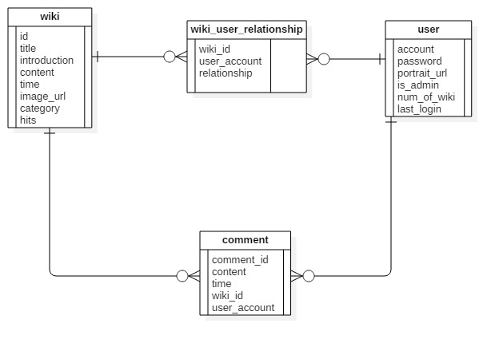

# 逻辑设计

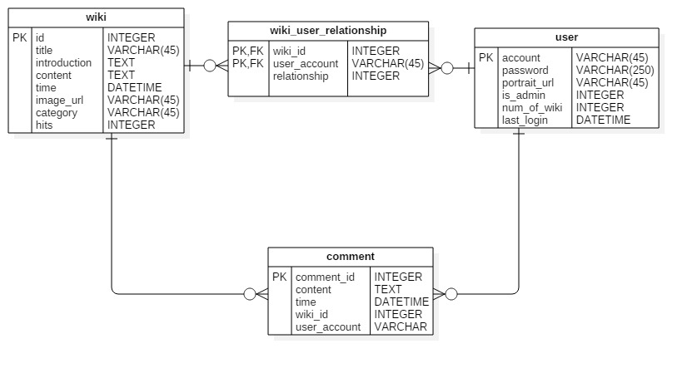

# 物理设计

## 表wiki:

|  |  |  |  |  |  |
| --- | --- | --- | --- | --- | --- |
| Field | Type | Null | Key | Default | Extra |
| id | int(11) | NO | PRI | NULL | Auto_increment |
| title | varchar(45) | YES |  | NULL |  |
| Introduction | text | YES |  | NULL |  |
| content | text | YES |  | NULL |  |
| status | int(11) | NO |  | 0 |  |
| Time | datetime | YES |  | NULL |  |
| Img_url | varchar(45) | YES |  | NULL |  |
| category | varchar(45) | YES |  | NULL |  |
| Hits | int(11) | YES |  | 0 |  |

## 表user

|  |  |  |  |  |  |
| --- | --- | --- | --- | --- | --- |
| Field | Type | Null | Key | Default | Extra |
| account | varchar(45) | NO | PRI | NULL |  |
| password | varchar(250) | YES |  | NULL |  |
| Last_login | datetime | YES |  | NULL |  |
| portrait_url | varchar(45) | YES |  | NULL |  |
| Is_admin | varchar(45) | YES |  | NULL |  |
| num_of_hits | int(11) | NO |  | NULL |  |

## 表user_wiki_relationship

|  |  |  |  |  |  |
| --- | --- | --- | --- | --- | --- |
| Field | Type | Null | Key | Default | Extra |
| wiki | int(11) | NO | PRI | NULL |  |
| user_account | varchar(45) | NO | PRI | NULL |  |
| relationship | int(11) | YES |  | NULL |  |

## 表comment

|  |  |  |  |  |  |
| --- | --- | --- | --- | --- | --- |
| Field | Type | Null | Key | Default | Extra |
| comment_id | int(11) | NO | PRI | NULL | Auto_increment |
| User_account | varchar(45) | YES |  | NULL |  |
| content | text | YES |  | NULL |  |
| time | datetime | YES |  | NULL |  |
| wiki_title | varchar(45) | YES |  | NULL |  |