**FPT UNIVERSITY  
CLASS:** SE1902 **COURSE:** DBI202 **LECTURER:** Nguyễn Thị Hồng Nhung

**PROJECT REPORT**

**PROJECT REPORT - Group 1  
Grocery Store Management System**

# **1.** Group Members:

* **Leader:** Nguyễn Hồ Phước An - CE190747
* **Members:**
  + Đinh Công Phúc - CE190770
  + Vũ Minh Khang - CE191371
  + Lê Thiện Trí - CE191249
  + Phan Đức Thọ - CE191246

# **2.** Task Allocation:

* Nguyễn Hồ Phước An: Responsible for creating Triggers, Procedures, and Functions.
* Đinh Công Phúc: In charge of designing the ERD diagram.
* Vũ Minh Khang: In charge of designing the ERD diagram.
* Lê Thiện Trí: Responsible for creating database tables.
* Phan Đức Thọ: Responsible for creating database tables.

# 3. Project Objectives:

The Grocery Store Management System project aims to develop an efficient system for managing a grocery store, facilitating product management, order processing, customer management, and other business activities in a convenient and accurate manner.

# 4. Database Structure:

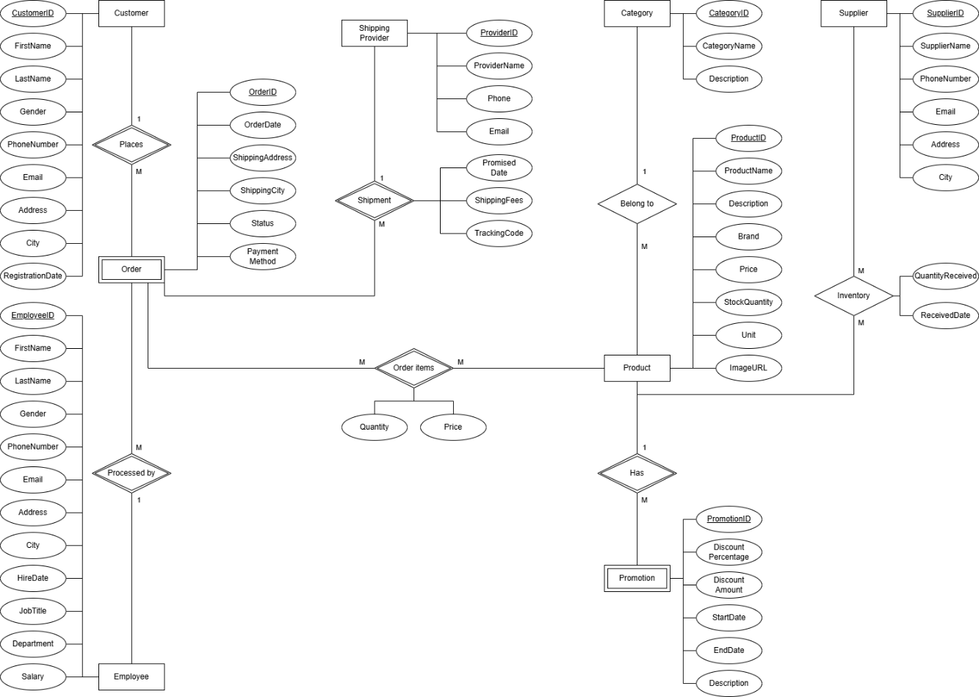

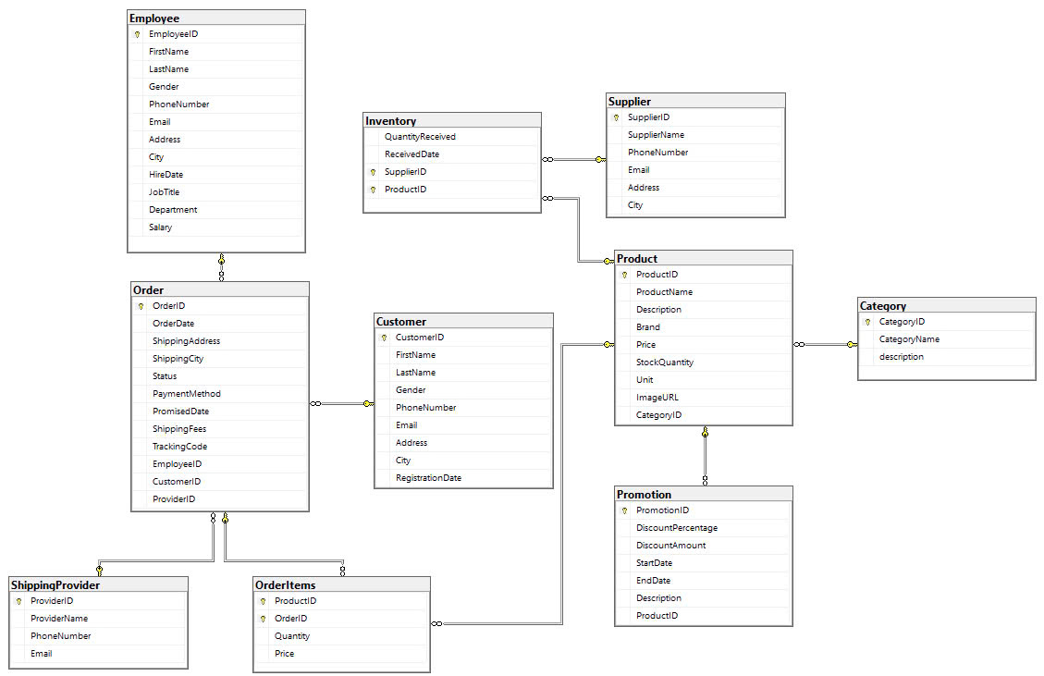

# 5. Database Operations (CRUD):

* Create: Add new suppliers, customers, employees, products, and orders.
* Read: Retrieve lists and details from database tables.
* Update: Modify supplier, customer, employee, and product information.
* Delete: Remove data when necessary.

# 6. Expected Outcomes:

* Develop a stable and efficient grocery store management system.
* Ensure that data is well-structured, easily accessible, and updatable.
* Integrate essential features such as product management, invoicing, customer, and supplier management.