**FPT UNIVERSITY**

**Semester:** SP25

**Class:** SE1902

**Course:** DBI202

**Lecturer:** Nguyễn Thị Hồng Nhung

**PROJECT REPORT - Group 1**

**Grocery Store Management System**

# Group Members

|  |  |  |  |
| --- | --- | --- | --- |
| Full name | Roll number | Task allocation | Note |
| Nguyễn Hồ Phước An | CE190747 | Creating triggers, stored procedures, and functions | Leader |
| Đinh Công Phúc | CE190770 | Designing the ERD |  |
| Vũ Minh Khang | CE191371 | Designing the ERD |  |
| Lê Thiện Trí | CE191249 | Creating database tables |  |
| Phan Đức Thọ | CE191246 | Creating database tables |  |

# Database Structure

## ERD: [Link to draw.io](https://viewer.diagrams.net/?tags=%7B%7D&lightbox=1&highlight=0000ff&edit=_blank&layers=1&nav=1&title=GroceryStoreManagementSystem.drawio&dark=auto#Uhttps%3A%2F%2Fdrive.google.com%2Fuc%3Fid%3D1Ms0tB1UqzFX2BHGdjD5lBZ4RGpiR9U14%26export%3Ddownload)

[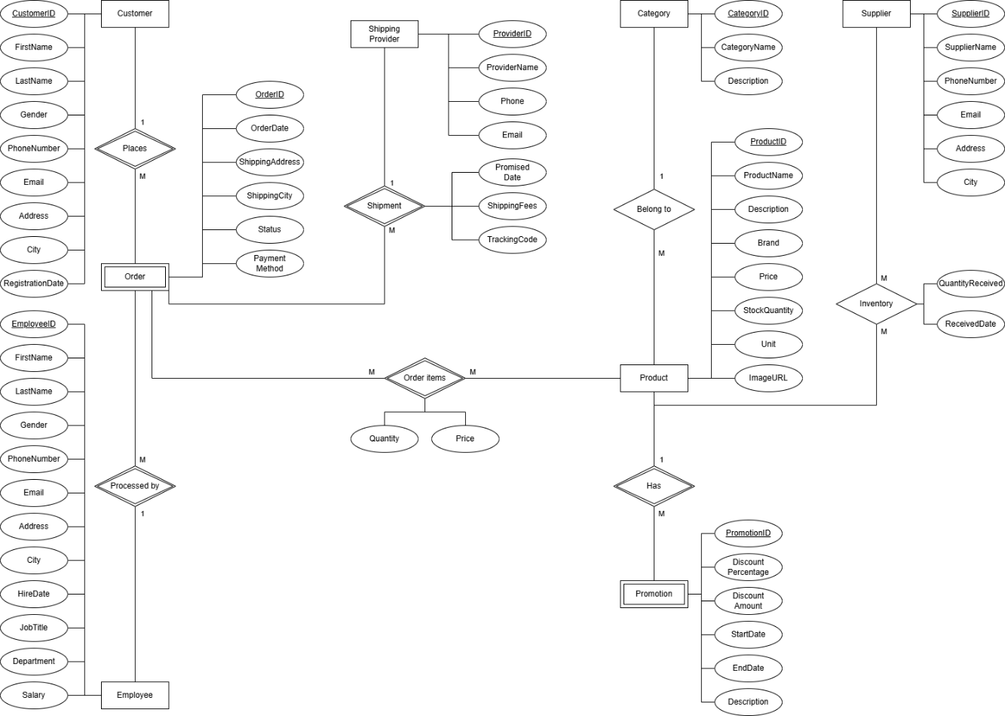](ERD.png)

## Database schema

](DatabaseSchema.jpg)