**4003 Assgn – submit this annotated document in Bb.**

1) Enter 3 integers, find the product of the three numbers, display the result.

**screen shot of output goes here**

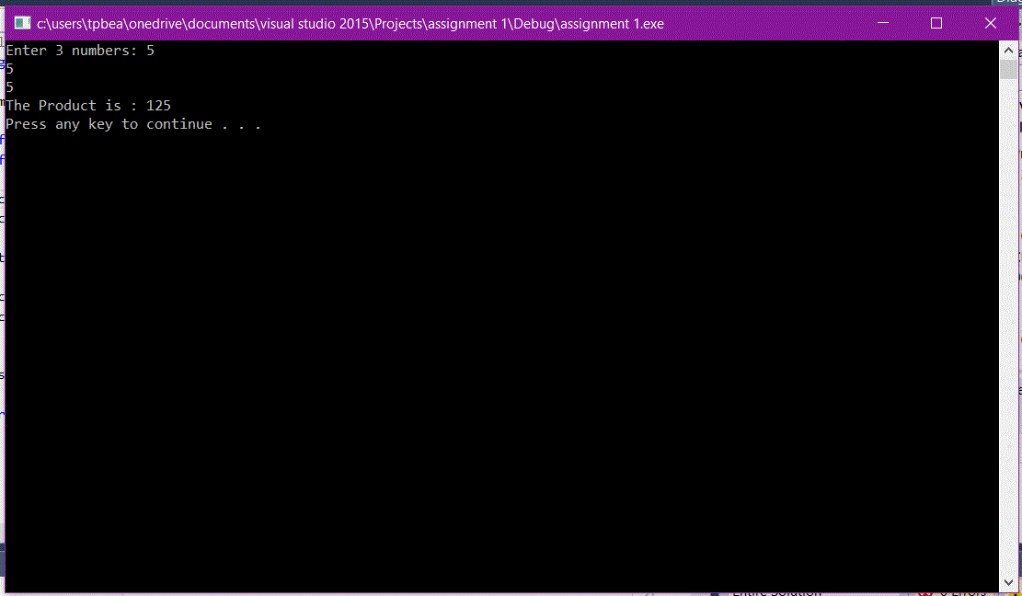

**Source code goes here (not a screen shot)**

#include <iostream>

using namespace std;

int main()

{

float num1, num2, num3;

float total;

cout << "Enter 3 numbers: ";

cin >> num1 >> num2 >> num3;

total = num1 * num2 * num3;

cout << "The Product is : " << total;

cout << endl;

system("pause");

return 0;

}

2) Division A of the company generates 63.8% of revenue. Let the user enter the total revenue for the company, and display how much is attributed to Division A.

**Screen shot of output goes here**

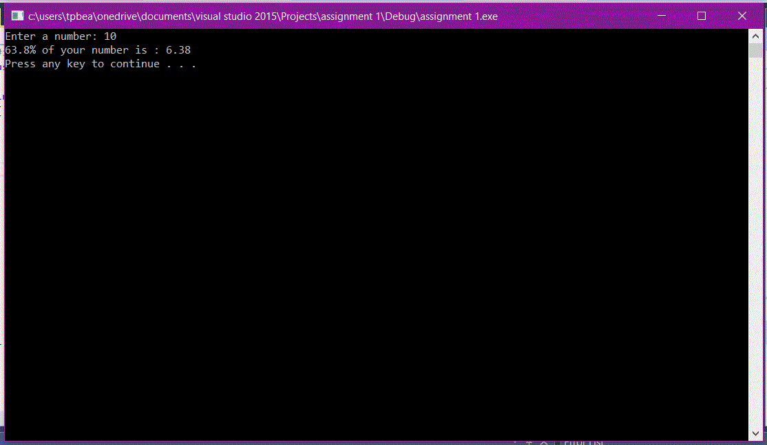

**Source code goes here (not a screen shot)**

#include <iostream>

using namespace std;

int main()

{

float num1;

float total;

cout << "Enter a number: ";

cin >> num1;

total = num1 * .638;

cout << "63.8% of your number is : " << total;

cout << endl;

system("pause");

return 0;

}

3) Enter 4 numbers with a decimal point, display the average.

**Screen shot of output goes here**

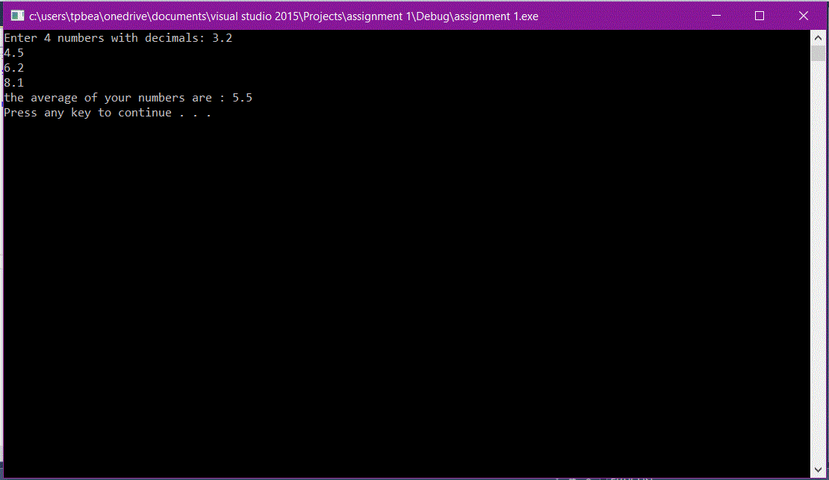

**Source code goes here (not a screen shot)**

#include <iostream>

using namespace std;

int main()

{

float num1, num2, num3, num4;

float total;

cout << "Enter 4 numbers with decimals: ";

cin >> num1 >> num2 >> num3 >> num4;

total = (num1 + num2 + num3 + num4)/4;

cout << "the average of your numbers are : " << total;

cout << endl;

system("pause");

return 0;

}