**4003 Assgn – submit this annotated document in Bb.**

1) page 84/19 Annual high temperatures

**screen shot of output goes here**

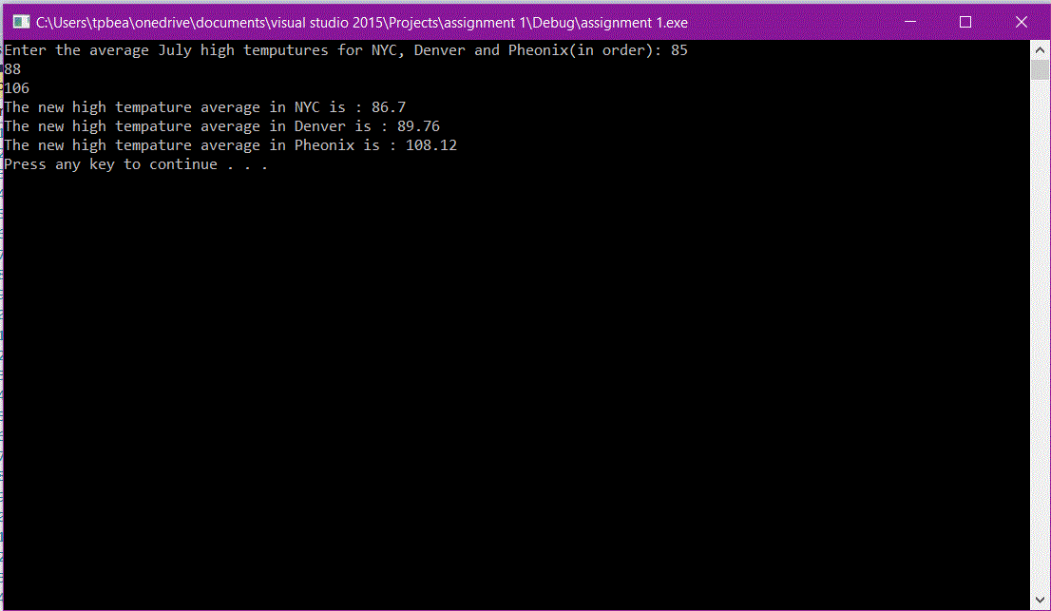

**Source code goes here (not a screen shot)**

#include <iostream>

using namespace std;

int main()

{

float NYC, Denver, Pheonix;

float totalNYC, totalDenver, totalPheonix;

cout << "Enter the average July high temputures for NYC, Denver and Pheonix(in order): ";

cin >> NYC >> Denver >> Pheonix;

totalNYC = NYC * 1.02;

totalDenver = Denver * 1.02;

totalPheonix = Pheonix * 1.02;

cout << "The new high tempature average in NYC is : " << totalNYC;

cout << endl;

cout << "The new high tempature average in Denver is : " << totalDenver;

cout << endl;

cout << "The new high tempature average in Pheonix is : " << totalPheonix;

cout << endl;

system("pause");

return 0;

}

2) page 84/20 How much paint

**Screen shot of output goes here**

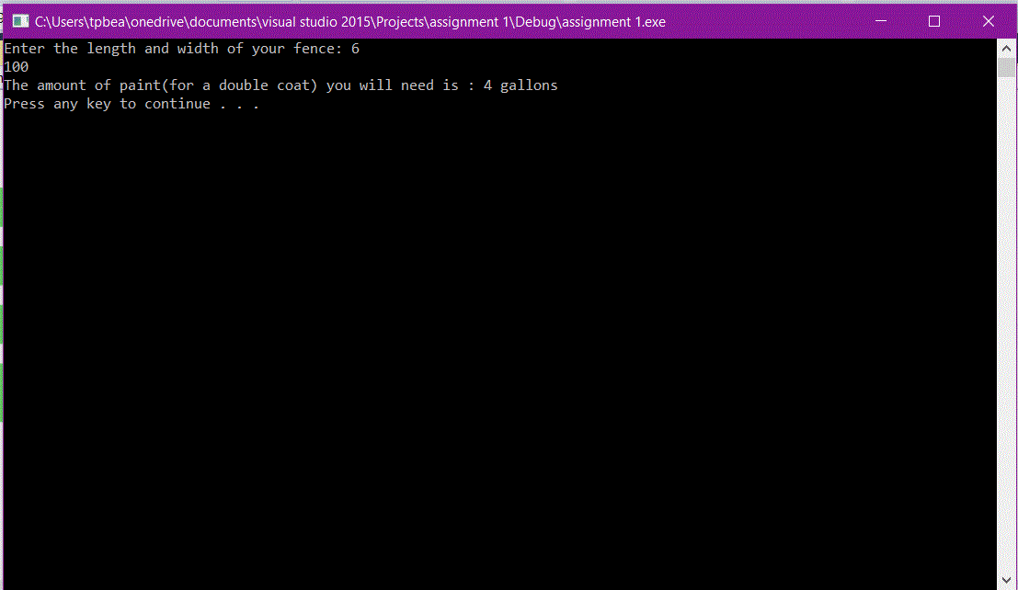

**Source code goes here (not a screen shot)**

#include <iostream>

using namespace std;

int main()

{

float Length, height;

float gallons;

cout << "Enter the length and width of your fence: ";

cin >> Length >> height;

gallons = (Length * height * 2) / 340;

gallons = int(gallons) + 1;

cout << "The amount of paint(for a double coat) you will need is : " << gallons << " gallons";

cout << endl;

system("pause");

return 0;

}