**Assgn C4003 – submit this annotated document in bb.**

A)Unless otherwise noted: assume an 8 bit data word. Fill in the table with the appropriate representations. Assume all binary and hex are in si+ma.

Binary(si+ma) (2's) Hex Decimal

1 33 dec. Ans: _____0010 0001_ Ans:__ 0010 0001 Ans:__21__ (nothing here)

2. -20 dec. Ans: ___1001 0100 Ans:__1110 1100_ Ans:_94___ (nothing here)

3. 46 dec. Ans: _0010 1110____ Ans:_ 0010 1110_ Ans:__2E__ (nothing here)

4. 1110 1101 bin. (nothing here) Ans:_1001 0011_ Ans:__ED__ Ans: __-109_____

5. 0101 0101 bin. (nothing here) Ans:_0101 0101___ Ans:__55__ Ans: ____85_____

6. 1011 1101 bin. (nothing here) Ans:_1100 0011 Ans:__BD__ Ans: ___-61____

HEX TABLE (for reference)

Dec Hex Bin

0 0 0000

1 1 0001

2 2 0010

3 3 0011

4 4 0100

5 5 0101

6 6 0110

7 7 0111

8 8 1000

9 9 1001

10 A 1010

11 B 1011

12 C 1100

13 D 1101

14 E 1110

15 F 1111

B) Page 147/18 Interest Earned (ch 3)

**Screen shot of output goes here**

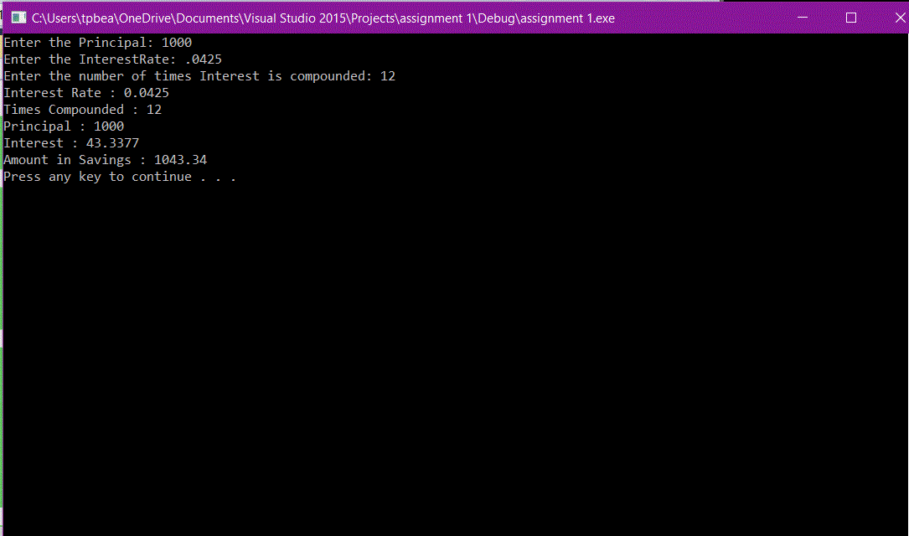

**Source code goes here (not a screen shot)**

#include <iostream>

using namespace std;

int main()

{

double Principal, InterestRate;

int TimesCompounded;

double Interest, AmountSavings;

cout << "Enter the Principal: ";

cin >> Principal;

cout << "Enter the InterestRate: ";

cin >> InterestRate;

cout << "Enter the number of times Interest is compounded: ";

cin >> TimesCompounded;

AmountSavings = 1 + (InterestRate / TimesCompounded);

AmountSavings = pow (AmountSavings, TimesCompounded);

AmountSavings = AmountSavings*Principal;

Interest = AmountSavings - Principal;

cout << "Interest Rate : " << InterestRate;

cout << endl;

cout << "Times Compounded : " << TimesCompounded;

cout << endl;

cout << "Principal : " << Principal;

cout << endl;

cout << "Interest : " << Interest;

cout << endl;

cout << "Amount in Savings : " << AmountSavings;

cout << endl;

system("pause");

return 0;

}

C) Page 149/24 Planting Grapevines (ch 3)

**Screen shot of output goes here**

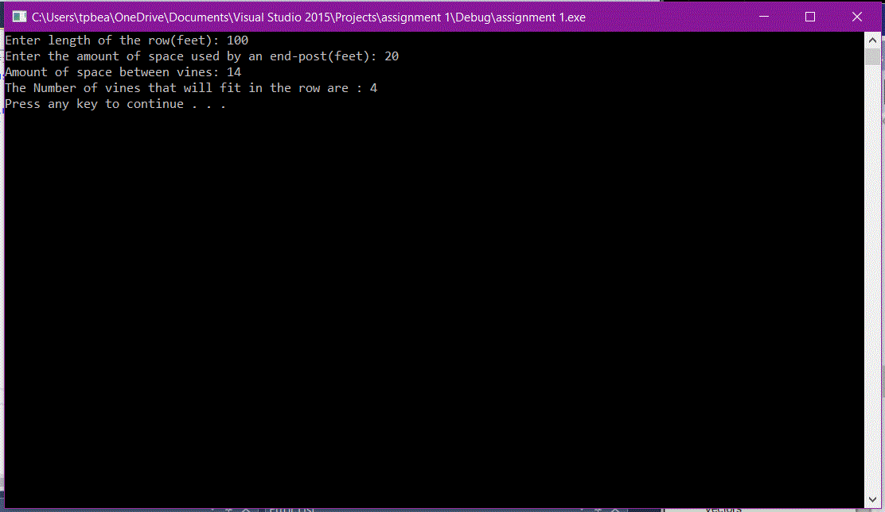

**Source code goes here (not a screen shot)**

#include <iostream>

using namespace std;

int main()

{

int V,R,E,S;

cout << "Enter length of the row(feet): ";

cin >> R;

cout << "Enter the amount of space used by an end-post(feet): ";

cin >> E;

cout << "Amount of space between vines: ";

cin >> S;

V = (R-(2*E))/S;

cout << "The Number of vines that will fit in the row are : " << V;

cout<< endl;

system("pause");

return 0;

}