**Assgn C4003 – show your work to the instructor for credit.**

1) Page 222/2 Roman Numeral Converter (ch 4)

**Screen shot of output goes here**

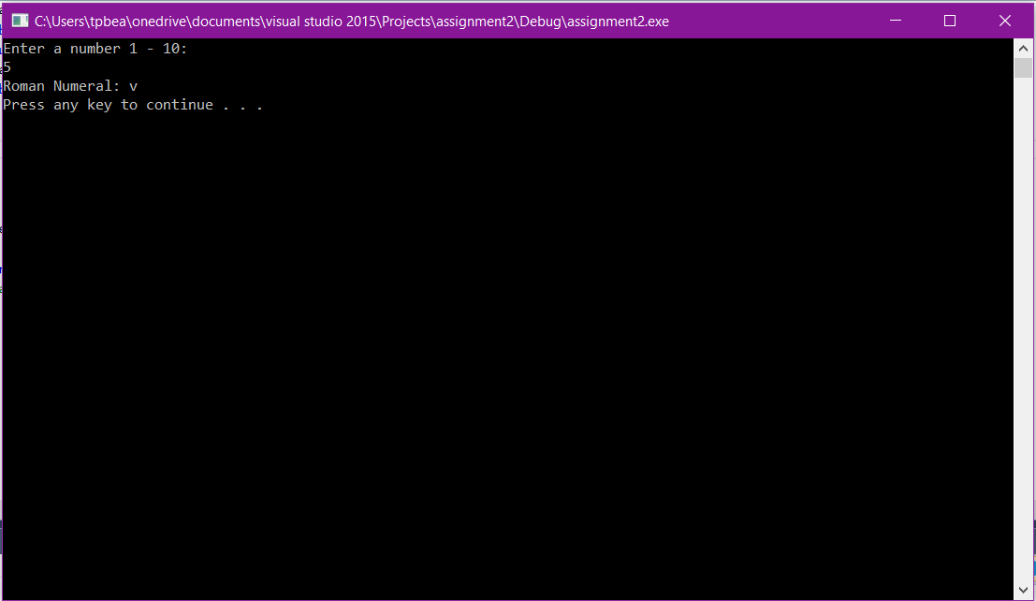

**Source code goes here (not a screen shot)**

#include "stdafx.h"

#include <iostream>

#include <string>

using namespace std;

int main()

{

string aStr;

int number;

cout << "Enter a number 1 - 10:" << endl;

cin >> number;

switch (number) {

case 1:

aStr = 'i';

break;

case 2:

aStr = 'ii';

break;

case 3:

aStr = 'iii';

break;

case 4:

aStr = 'iv';

break;

case 5:

aStr = 'v';

break;

case 6:

aStr = 'vi';

break;

case 7:

aStr = 'vii';

break;

case 8:

aStr = 'viii';

break;

case 9:

aStr = 'ix';

break;

case 10:

aStr = 'x';

break;

default:

aStr = 'nope';

break;

}

cout << "Roman Numeral: " << aStr << endl;

system("pause");

return 0;

}//end main

2) Page 222/3 Magic Dates (ch 4)

**Screen shot of output goes here**

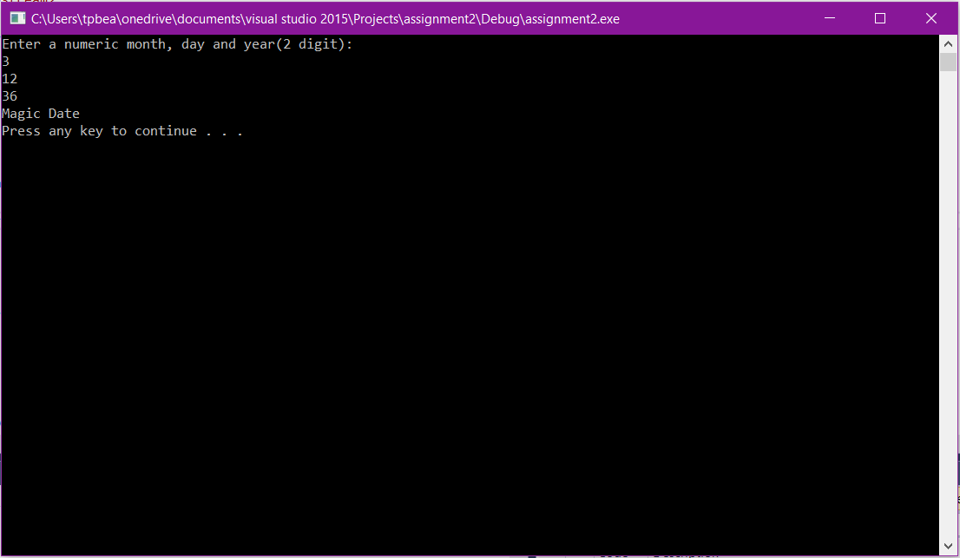

**Source code goes here (not a screen shot)**

#include "stdafx.h"

#include <iostream>

#include <string>

using namespace std;

int main()

{

int month, day, year, total;

cout << "Enter a numeric month, day and year(2 digit):" << endl;

cin >> month;

cin >> day;

cin >> year;

total = day*month;

if(total == year) {

cout << "Magic Date" << endl;

}

else {

cout << "Not Magic Date" << endl;

}

system("pause");

return 0;

}//end main