**Assgn C4003 – show your work to the instructor for credit.**

1) In class work - modify the guessing game program in Class 8 notes.

Let the computer pick the winning number.

Have the program write to a file:

(one iteration per line on the file)

the number of picks the computer took, did it get it right, what was the winning number.

have the computer do this 1,000 times, and keep a running total of the successes. Finally write to the file the success rate, such as: Success Rate: 98.20%

**Screen shot of output goes here**

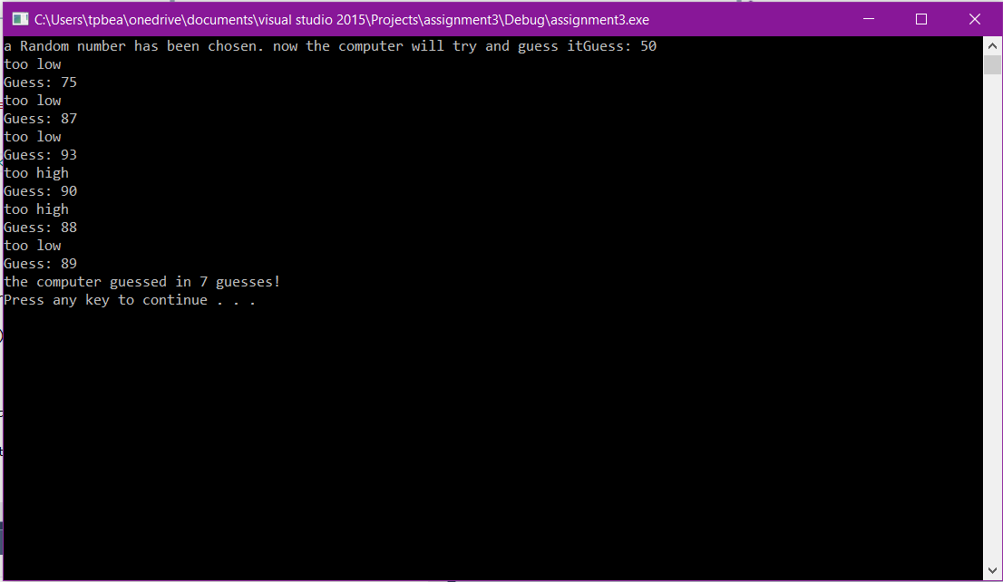

**Source code goes here (not a screen shot)**

#include "stdafx.h"

#include <iostream>

#include <cstdlib>

#include <ctime>

using namespace std;

int main() {//begin main

//get system time

unsigned seed = time(0); //

int guesses = 0;

int guess = 50;

int maxGuesses = 7;

int winNum;

int highest = 100;

int lowest = 1;

bool winYN = false;

srand(seed);

winNum = 1 + rand() % 100;

cout << "a Random number has been chosen. now the computer will try and guess it";

do

{//make a guess

cout << "Guess: " << guess << endl;

guesses++;

if (guess == winNum) {

winYN = true;

}

else if (guess > winNum)

{

cout << "too high" << endl;

highest = guess;

guess = (guess + lowest) / 2;

}

else {

cout << "too low" << endl;

lowest = guess;

guess = (guess + highest) / 2;

}

} while (!winYN);

if (winYN == true)

cout << "the computer guessed in " << guesses << " guesses! " << endl;

system("pause");

return 0;

}//end main