**Assgn C4003 – show your work to the instructor for credit.**

1 Page 375/11 Lowest Score Drop (ch 6)

Screen shot of output goes here**

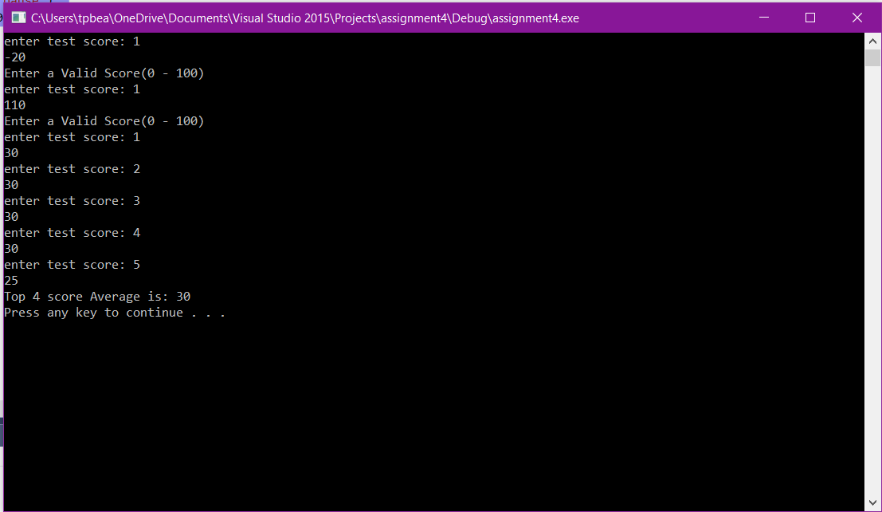

**Source code goes here (not a screen shot)**

#include "stdafx.h"

#include <iostream>

using namespace std;

int scores[5];

int lowest;

void getScore(int day)

{

int score;

int count = 0;

while (count < 1) {

cout << "enter test score: " << day + 1 << endl;

cin >> score;

if (score >= 0 && score <= 100)

{

count = 3;

}

else {

cout << "Enter a Valid Score(0 - 100)" << endl;

}

}

scores[day] = score;

}

void findLowest()

{

lowest = scores[0];

for (int i = 1; i < sizeof(scores) / sizeof(scores[0]); ++i)

if (scores[i] < lowest)

lowest = scores[i];

}

void findLowest(int)

{

lowest = scores[0];

for (int i = 1; i < sizeof(scores) / sizeof(scores[0]); ++i)

if (scores[i] < lowest)

lowest = scores[i];

}

void calcAverage()

{

int average;

findLowest();

average = (scores[0] + scores[1] + scores[2] + scores[3] + scores[4] - lowest) / 4;

cout << "Top 4 score Average is: " << average << endl;

}

int main()

{

getScore(0);

getScore(1);

getScore(2);

getScore(3);

getScore(4);

calcAverage();

system("pause");

return 0;

}

2 Page 376/13 Days Out (ch 6)

**Screen shot of output goes here**

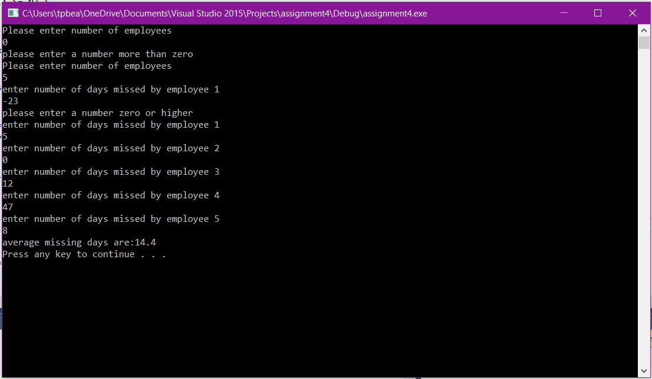

**Source code goes here (not a screen shot)**

#include "stdafx.h"

#include <iostream>

using namespace std;

int numEmployees()

{

int x = 0;

while (x <= 0) {

cout << "Please enter number of employees" << endl;

cin >> x;

if (x <= 0) {

cout << "please enter a number more than zero" << endl;

}

}

return x;

}

int missDays(int x) {

int y = 0;

int z;

int zz = 0;

while (y < x)

{

z = -1;

while (z < 0) {

cout << "enter number of days missed by employee " << y + 1 << endl;

cin >> z;

if (z < 0) {

cout << "please enter a number zero or higher" << endl;

}

}

zz = zz + z;

y++;

}

return zz;

}

double AvgmissCalc(int x, int y) {

double z;

z = (double)x / (double)y;

return z;

}

int main()

{

int employees;

int missed;

double avgmissed;

employees = numEmployees();

missed = missDays(employees);

avgmissed = AvgmissCalc(missed, employees);

cout << "average missing days are:" << avgmissed << endl;

system("pause");

}