**Assgn C4003 – there is nothing to submit on bb.**

**Please show your work to the instructor for credit.**

1) class work from class 11

Create a program to read integers from a file.

Write 2 methods, 1 to read the data from a file and return the list in an array. In this method (function), allow the user to enter the filename (read in a string). Also return the count of items read in (no more than 100). And write a second function to display the items.

**Screen shot of output goes here**

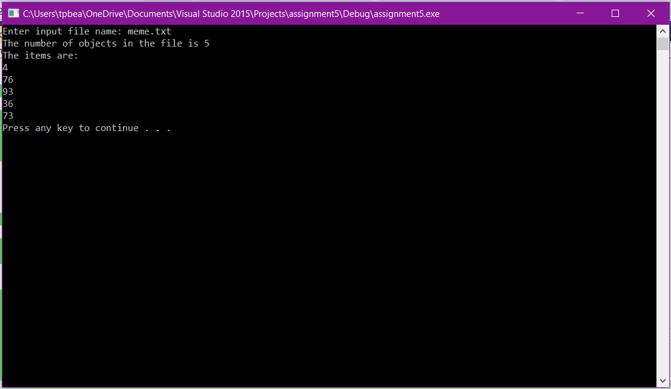

**Source code goes here (not a screen shot)**

#include "stdafx.h"

#include <iostream>

#include <fstream>

#include <string>

using namespace std;

int counter = 0;

double thing[100];

void countfile() {

ifstream infile;

string filename;

double buffer;

cout << "Enter input file name: ";

cin >> filename;

infile.open(filename.c_str()); //convert to C style string

infile >> buffer;

while (buffer != -99 && counter <100) {

thing[counter] = buffer;

counter++;

//read next item

infile >> buffer;

} //end while

cout << "The number of objects in the file is " << counter << endl;

infile.close();

}

void readfile() {

int p = 0;

cout << "The items are: " << endl;

while (p < counter) {

cout << thing[p] << endl;

p++;

}

}

//end main

int main() {

countfile();

readfile();

system("pause");

}