**Assgn C4003 – submit this annotated document in bb.**

1. page 371/37 getNumber function

void getnumber(int& a) {

cout << "enter a number 1-100" << endl;

cin >> a;

if (a < 1 || a > 100) {

cout << "number is not between 1 and 100" << endl;

}

else {

cout << "good number" << endl;

}

}

2) Write a function named biggest that receives 3 integer arguments and returns the largest of the 3 values.

void biggest() {

int x, y, z;

cout << "enter 3 numbers" << endl;

cin >> x;

cin >> y;

cin >> z;

if(x > y) {

if(x > z) {

cout << x << " is the greatest number" << endl;

}

else if(z > x) {

cout << z << " is the greatest number" << endl;

}

}else if(y > x) {

if(y > z) {

cout << y << " is the greatest number" << endl;

}

else if(z > y) {

cout << z << " is the greatest number" << endl;

}

}

}

1. page 372/56 find the errors – total

The function is returning a value so the function should start with int not void.

There should be an int before each parameter

1. page 372/57 find the errors – average

average needs to be returned as a double

order of operations is wrong

1. page 372/58 find the errors – area

length should be declared in the definition of the function.

Void should be changed to int

1. page 372/59 find the errors – getValue

the value variable should not be a parameter but should be declared in the definition. Then the value should be returned as int or double and have the header switch the void to the corresponding int or double

7) page 374/5 Falling Distance (2pts)

**Screen shot of output goes here**

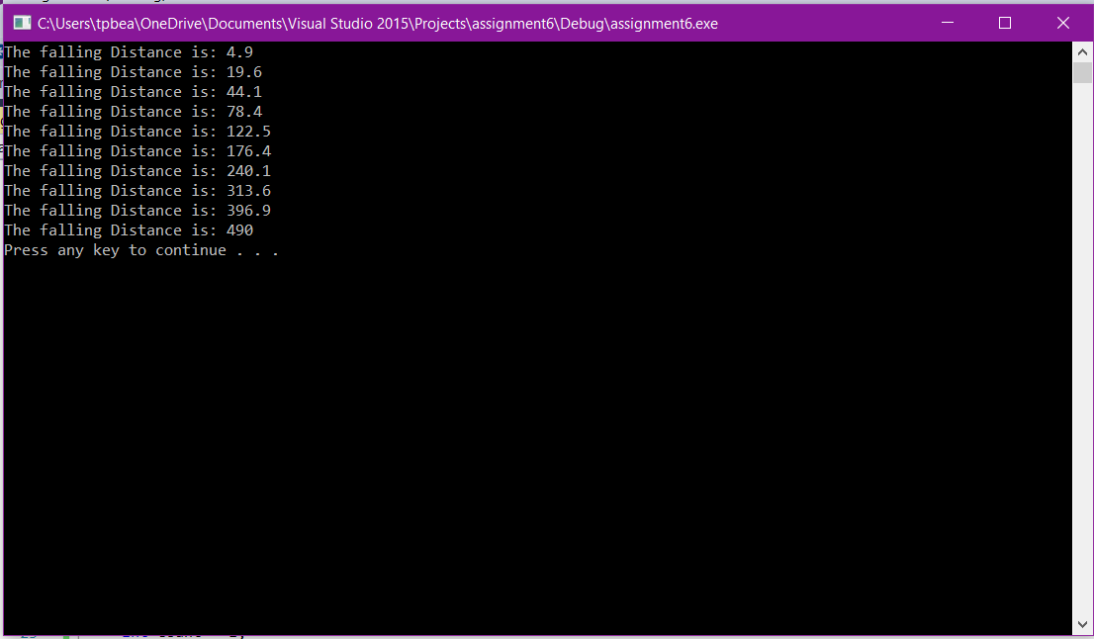

**Source code goes here (not a screen shot)**

#include "stdafx.h"

#include <iostream>

#include <fstream>

#include <math.h>

using namespace std;

void fallingDistance(int x) {

double distance;

x = pow(x, 2);

distance = (x*9.8) / 2;

cout << "The falling Distance is: " << distance << endl;

}

int main()

{

int count = 1;

while (count < 11) {

fallingDistance(count);

count++;

}

system("pause");

}