**Assgn C4003 – show your work to the instructor for credit. There is nothing to submit on bb.**

**Group work encouraged, not required.**

1) page 3733 Winning Division

**Screen shot of output goes here**

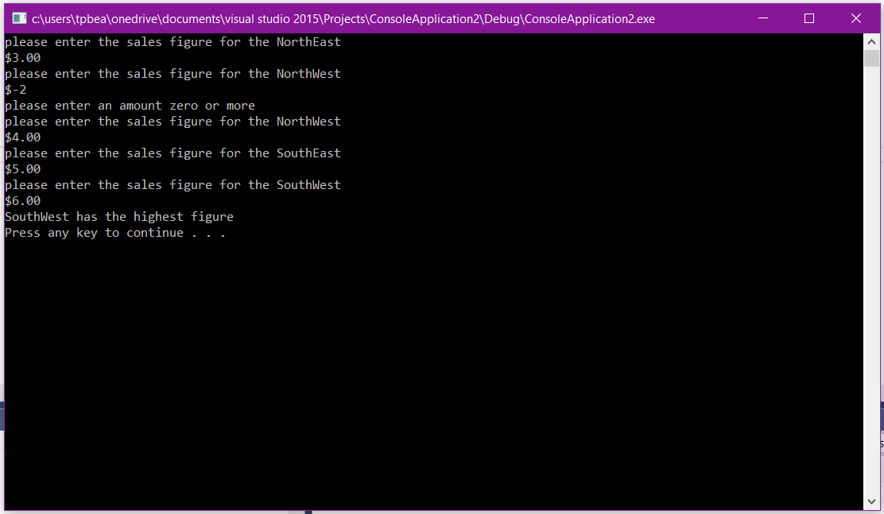

**Source code goes here (not a screen shot)**

// ConsoleApplication2.cpp : Defines the entry point for the console application.

//

#include "stdafx.h"

#include <iostream>

#include <fstream>

#include <string>

using namespace std;

double getSales(string x) {

double figure = -1.0;

while (figure < 0.0) {

cout << "please enter the sales figure for the " << x << endl;

cout << "$";

cin >> figure;

if (figure < 0.0) {

cout << "please enter an amount zero or more" << endl;

}

}

return figure;

}

void Highest(double NEL, double NWL, double SEL, double SWL)

{

if (NEL > NWL)

{

if (NEL > SEL)

{

if (NEL > SWL)

{

cout << "NorthEast has the highest figure" << endl;

}

else

{

cout << "SouthWest has the highest figure" << endl;

}

}

else

{

if (SEL > SWL)

{

cout << "SouthEast has the highest figure" << endl;

}

else

{

cout << "SouthWest has the highest figure" << endl;

}

}

}

else

{

if (NWL > SEL)

{

if (NWL > SWL)

{

cout << "NorthWest has the highest figure" << endl;

}

else

{

cout << "SouthWest has the highest figure" << endl;

}

}

else

{

if (SEL > SWL)

{

cout << "SouthEast has the highest figure" << endl;

}

else

{

cout << "SouthWest has the highest figure" << endl;

}

}

}

}

int main()

{

string NE = "NorthEast";

string NW = "NorthWest";

string SE = "SouthEast";

string SW = "SouthWest";

double NEF = getSales(NE);

double NWF = getSales(NW);

double SEF = getSales(SE);

double SWF = getSales(SW);

Highest(NEF, NWF, SEF, SWF);

system("pause");

return 0;

}

2) page 376/12 Star search

**Screen shot of output goes here**

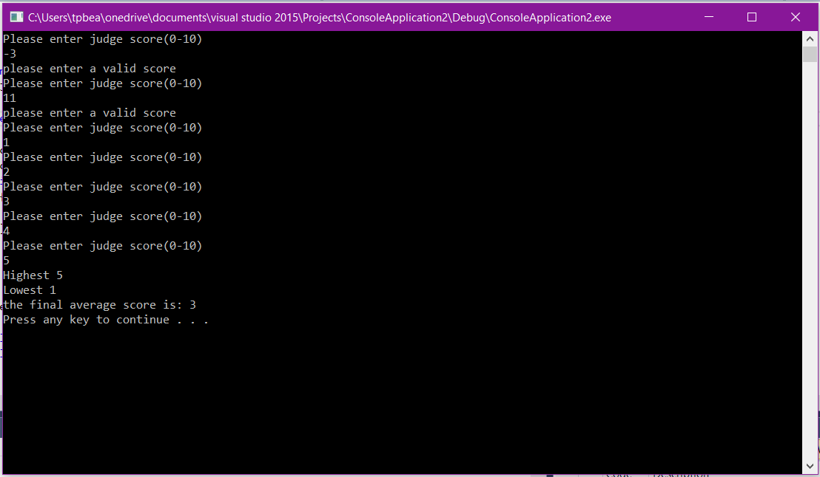

**Source code goes here (not a screen shot)**

#include "stdafx.h"

#include <iostream>

using namespace std;

void getJudgeData(double& i)

{

while (i < 0 || i > 10)

{

cout << "Please enter judge score(0-10)" << endl;

cin >> i;

if (i < 0 || i > 10)

{

cout << "please enter a valid score" << endl;

}

}

}

double getHighest(double A, double B, double C, double D, double E)

{

double highest = 0.0;

double array[5] = { A, B, C, D, E };

for (int i = 0; i<5; i++)

{

if (array[i]>highest)

highest = array[i];

}

cout << "Highest " << highest << endl;

return highest;

}

double getLowest(double A, double B, double C, double D, double E)

{

double lowest = 100.0;

double array[5] = { A, B, C, D, E };

for (int i = 0; i<5; i++)

{

if (array[i]<lowest)

lowest = array[i];

}

cout << "Lowest " << lowest << endl;

return lowest;

}

void calcScore(double a, double b, double c, double d, double e)

{

double score;

double high = getHighest(a, b, c, d, e);

double low = getLowest(a, b, c, d, e);

score = (a + b + c + d + e - high - low) / 3;

cout << "the final average score is: " << score << endl;

}

int main()

{

double one = -1.0;

double two = -1.0;

double three = -1.0;

double four = -1.0;

double five = -1.0;

getJudgeData(one);

getJudgeData(two);

getJudgeData(three);

getJudgeData(four);

getJudgeData(five);

calcScore(one, two, three, four, five);

system("pause");

return 0;

}

3) page 379/22 isPrime function

**Screen shot of output goes here**

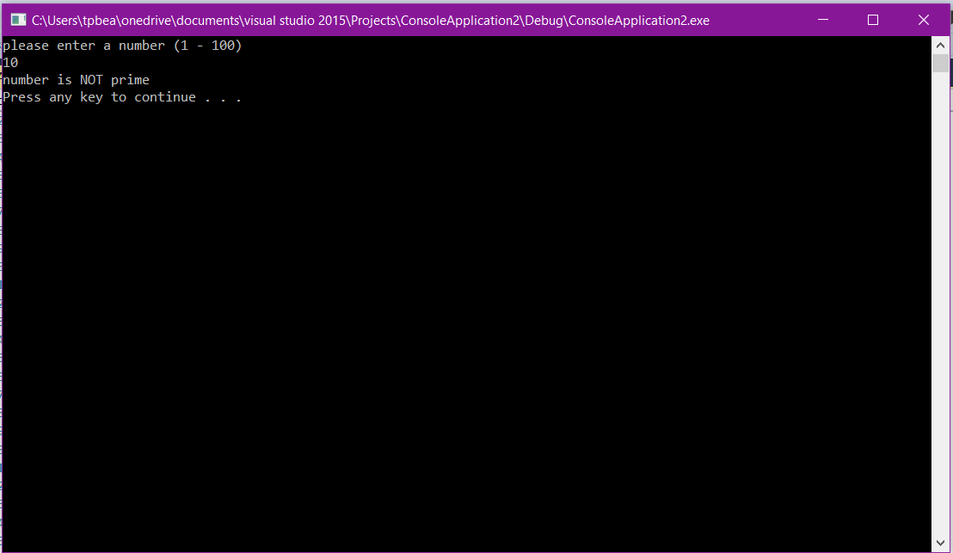

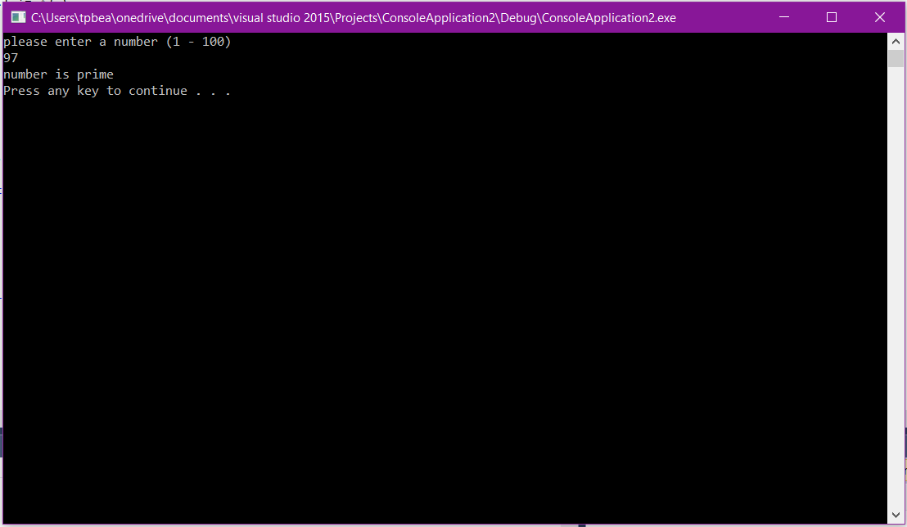

**Source code goes here (not a screen shot)**

#include "stdafx.h"

#include <iostream>

using namespace std;

bool isPrime(int x)

{

double remainder;

int i = 2;

while (i < 101)

{

if (i != x) {

remainder = x % i;

if (remainder == 0)

{

return false;

}

}

i++;

}

return true;

}

int main()

{

int num = 0;

while (num < 1 || num > 100) {

cout << "please enter a number (1 - 100)" << endl;

cin >> num;

if (num < 1 || num > 100)

{

cout << "please enter a valid number" << endl;

}

}

bool prime = isPrime(num);

if (prime == true)

{

cout << "number is prime" << endl;

}

else

{

cout << "number is NOT prime" << endl;

}

system("pause");

return 0;

}