SGD, learning rate=1E-3 (inner layer: 512, 512)

SGD, learning rate=1E-4 (inner layer: 512, 512)

Adam, learning rate=1E-3 (inner layer: 512, 512)

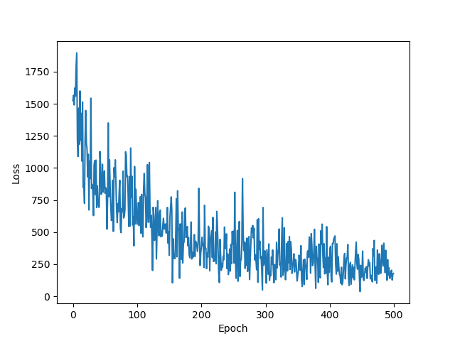

Adam, learning rate=1E-4 (inner layer: 512, 512)

Adam, learning rate=1E-3 (inner layer: 256, 256)

Adam, learning rate=1E-3 (inner layer: 256, 256, 256)

