Zimski ispitni rok iz Operacijskih istraživanja 2013/2014 (90 min)

1. Solve using primal/dual simplex (10b)  
     
   max z=2x1 +3x2  
   1x1-2x2<=6  
   3x1+5x2>=8  
   x1,x2>=0
2. Solve using primal/dual simplex(10b)

min z =2x1+3x2  
1x1+2x2>=6  
3x1+5x2<=8

x1,x2>=0

1. Solve using primal/dual simplex(10b)  
     
   min z=2x1+3x2  
   1x1+2x2<=6  
   3x1+5x2>=12  
   x1>=-2, x2>=0
2. Formulate the underlying function f(x) as a separable function using binary variables (10b):

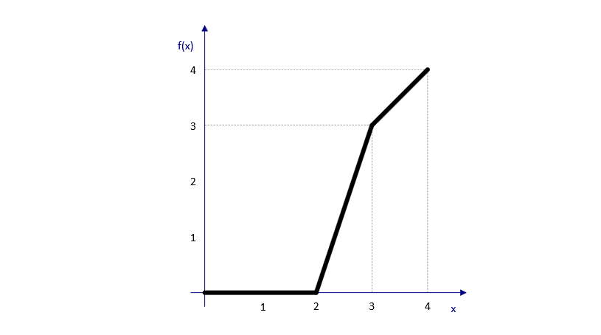

1. Based on the results of sensitivity analysis where the goal function is contribution, determine:

|  |  |  |  |  |  |
| --- | --- | --- | --- | --- | --- |
| No | Column | Activity | Lower bound | Decreased act. | Unit  cost |
| In | ∆t | Objective Coef. | Upper bound | Increased act. |
| 55 | x1 | 89. | 30 | 10. | -2.0 |
| 3 | b | 5. | 250 | 50. | -3.0 |

1. Is it advisable to invest in advertising to increase the quantity sold of the article produced at an optimum quantity of x1? (2b)
2. What is the financial effect of diminished production and to what decreased level it remains valid? (2b)
3. What is the financial effect of increased production and to what increased level it remains valid? (2b)
4. If all the other data remain unchanged, what is the possible maximum decrease of the selling price for article assigned by x1, before the optimum quantity of production requires „draging“ (valjda, rukupis). (2b)
5. If all the other dana remain unchanged, what is the necessary increase in the selling price for article assigned by x1, in order to cause increase of its production? (2b)
6. Four tasks A,B,C,D are to be distributed on four machines, The cost for completion of every task on each machine is given :

|  |  |  |  |  |
| --- | --- | --- | --- | --- |
|  | 1 | 2 | 3 | 4 |
| A | 9 | 2 | 1 | 5 |
| B | 4 | 5 | 6 | 7 |
| C | 2 | 1 | 3 | 6 |
| D | 5 | 3 | 9 | 4 |

* 1. Formulate the problem as a transportation model (create the initial table for the MODI method) (10b)
  2. Perform one iteration over transportation problem using dual costs. (10b)