Python Team Project Report

Baron Chiang, Tanmay Deshmukh, Leo Cohen
LC5: Team 25
ENGR 13300: Transforming Ideas to Innovation For EPICS/VIP
Professor Ahmad Samuel
10/19/2026

Project Motivation
Write your project motivation section here. Discuss how image processing and classification techniques are used in your chosen engineering discipline, citing at least three appropriate references.

Project Overview and Methods
Write your project overview and methods section here. This includes a description of algorithms, a summary of background research, and evidence to support the methods chosen for each of the processing steps.
For Task 1 For The Checkpoint 1, the main purpose of the script is to convert an image from a RGB format to a HSV format for an image. This is important for our project as HSV separates the color of a pixel from the intensity of the pixel, while RGB has all of the color and saturation information mixed into the color information. This makes it easier for a computer to understand the information from the pixel and makes it easier for object detection algorithms. We would do this through a few different functions: load_img, resize_image, pad_image, rgb_to_hsv, and convert_to_hsv. The load_img function will load an image from a file directory, the resize_image function will resize the image to a specified size, the pad_image will add pixels to the image so the image doesn’t stretch, the rgb_to_hsv function will convert the RGB values of a single pixel to HSV, and the convert_to_hsv function will convert a whole image from RGB to HSV. For each of the methods chosen here, they were verified against the autograder and the sample outputs within the ENGR 13300 website.

Discussion of Algorithm Design
Write a detailed discussion of your algorithm here. Be sure to include properly labeled flowcharts of the overall program and user-defined functions and design rationale for modularizing code.
For Task 1 of Checkpoint 1, we created several functions that work together to convert an image from an RGB format to an HSV format. The first function that we created was the rgb_to_hsv function. In this function we first got the input of r, g, b into the function. We then divided each one of these by 255.0 to make sure they are all from 0 to 1. Then we got the max and min of r, g, and b and placed them into c_max and c_min to calculate HSV later. We then calculated the difference of c_max and c_min and stored it into a variable named delta. We then make a set of if and elif statements seeing if delta was 0 first. If it was, then the hue would be 0, which means that there is no color in the image. Next we asked if the c_max was equal to r_p, g_p, or none of these. If they were, then we calculated h using equation 7.3 from the ENGR 13300 website. Next, we had an if statement asking if c_max was 0, and if it was, then s would equal 0. If not, then it is equal to delta divided by c_max. We then set v to c_max. Then we return all of these values multiplied by 255.0, except for h which we additionally divide by 360.0. We made sure to stick to the equations so that no floating point errors were introduced into our code.
The next function that we created was the convert_to_hsv function. In this function, we essentially looped through each pixel using nested for loops for the row and column and converted each pixel to HSV using the rgb_to_hsv function. At the end of the code, we added the HSV values to a blank array to make sure that we are using memory efficiently. We additionally added 1e-9 to make sure that we wouldn’t lose any precision when we turned the pixels into an integer. The load_img, resize_image, and pad_image functions are originally from Python 5 Team Task 3 and placed into our script verbatim.
For the main function, we ask the user to input an image file directory, then we find the image from that directory. We then convert it to 255 and as an int8. The if statement within the main is to make sure that we aren’t losing any precision when we pad and resize the image and that the final image meets the target image width and height. We made the two different functions to make our main function smaller, as we use convert_to_hsv when we are displaying the converted HSV image and the rgb_to_hsv for a single pixel coordinate. We made all of these different functions to reduce the amount of lines within the script and reduce complexity as well. By creating separate functions, we were able to check for errors within a single function instead of trying to check for errors in one large script.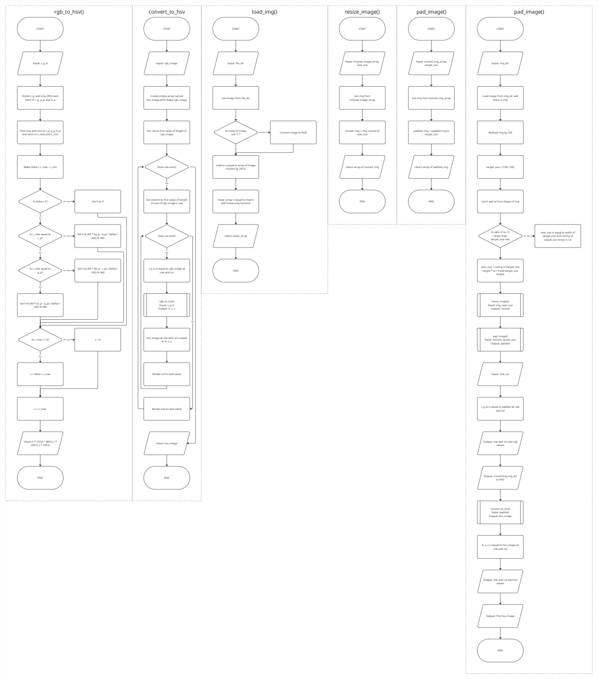

References
List your references here using the MLA format. See Purdue OWL for help with formatting.
van Rossum, G. (2026, October 1). Python 3.13 documentation. Python documentation. https://docs.python.org/3.13/

Appendix
- User manual
This should be a guide for operating the program along with sample inputs and outputs (including pictures).
- Project management plan (Team members’ contribution)
Summary of the contributions of each member of the team to the project. Describe your team's methods for collaboration that facilitated active participation and learning by all team members. Include a discussion of opportunities for improvement for future team projects.
- Discussion of design process (Approach to the design process)
Description of how your team followed the design process, which is defined as "a process of devising a system, component, or process, to meet desired needs within constraints. It is an iterative, creative, decision-making process that involves developing requirements, performing analysis and synthesis, generating multiple solutions, evaluating solutions against requirements, considering risks, and making trade-offs”.
- Code
The team should upload the Python files, but they should also include the code as an appendix in the report. Code should be well commented to increase readability for future users of the algorithm.

