LAB03_Server Install
Create a new VM:
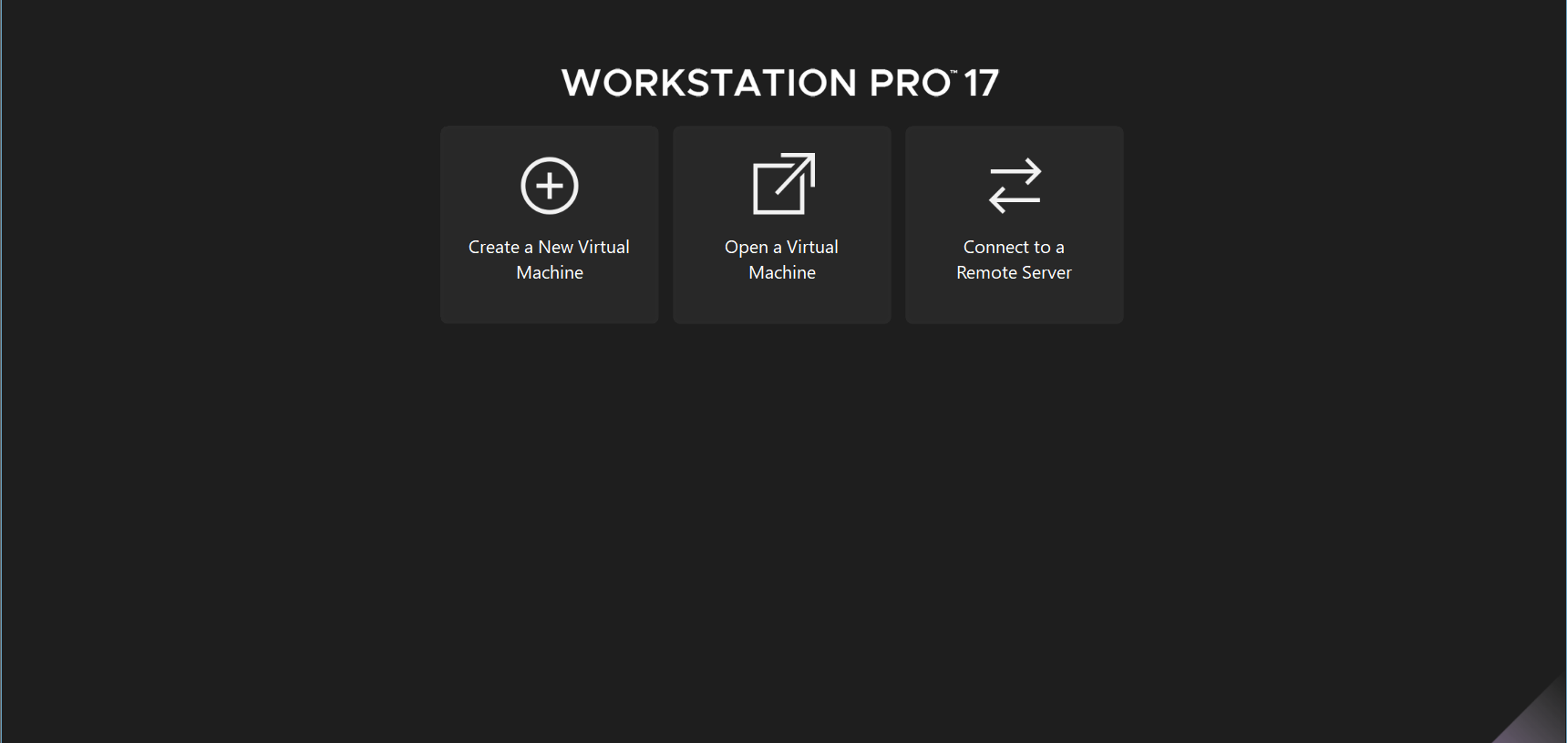

Select typical:
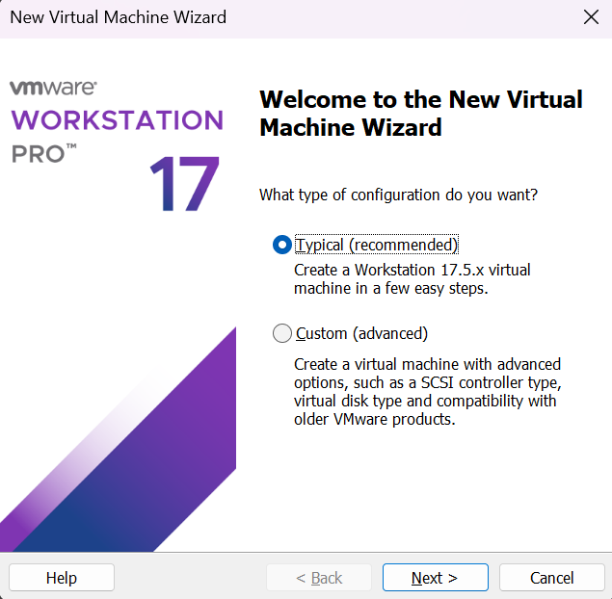

Install OS later:
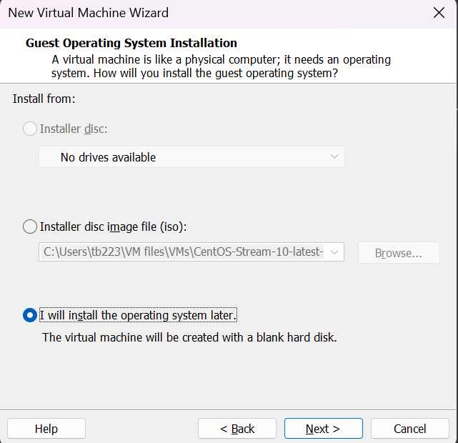

Select CentOS:
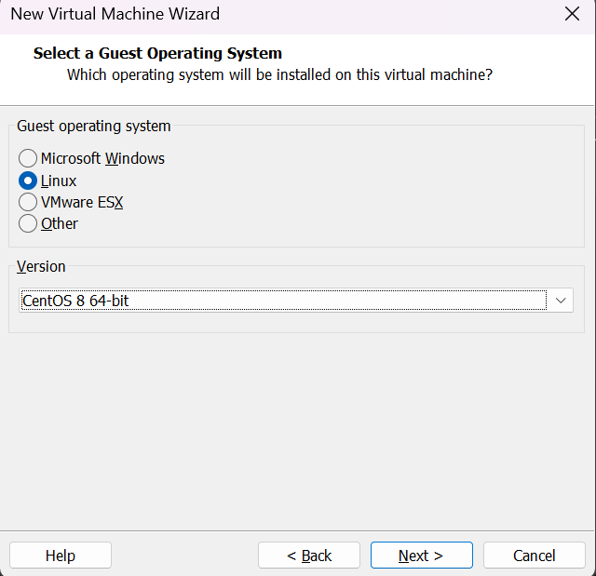

Give the VM a meaningful name:
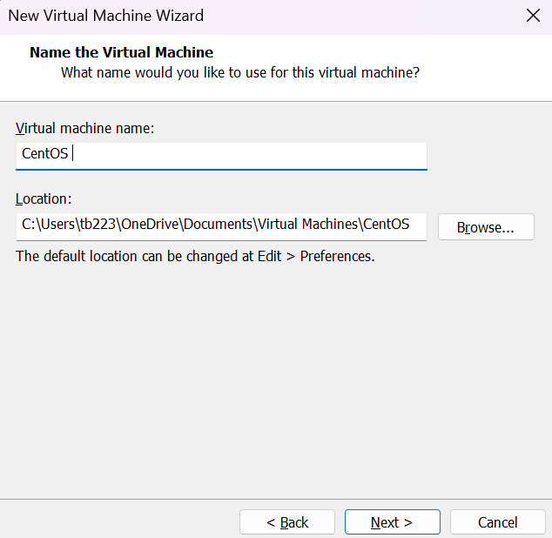
Configure disk size for VM:
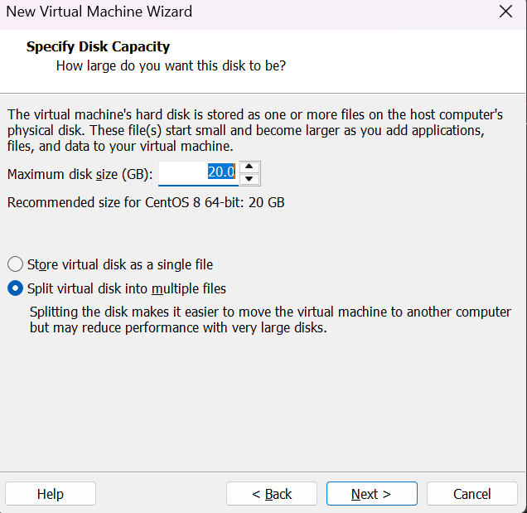

Click customize hardware:
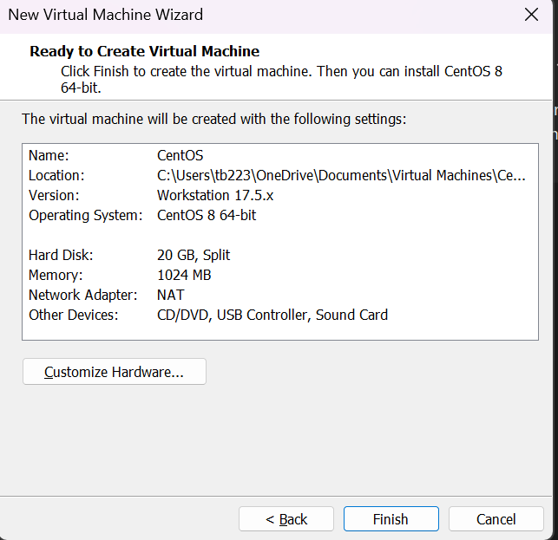

Set the memory which the VM will have access to I used 2GB since that’s what’s recommended from the site:
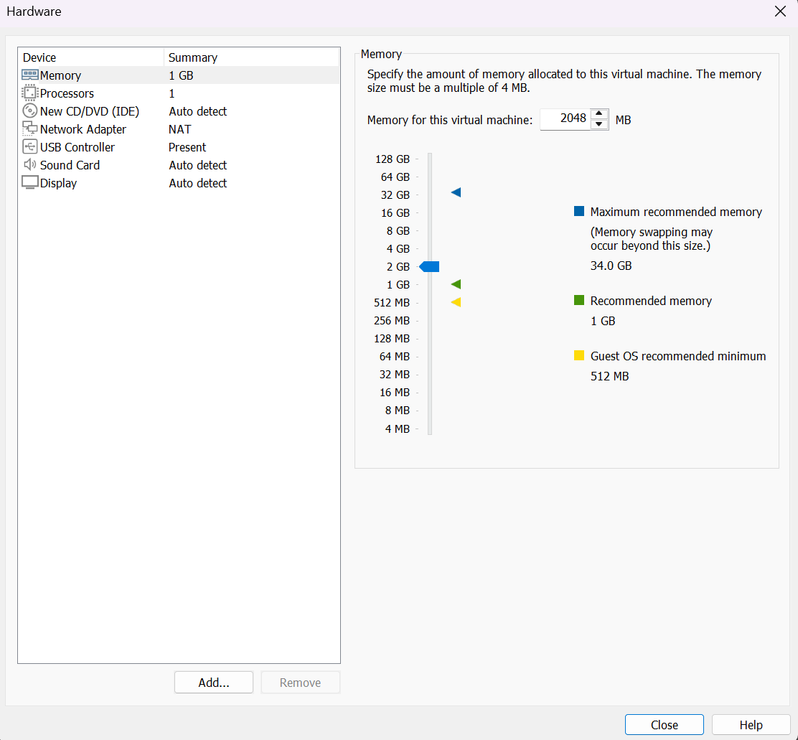

Configure CPU resources the VM will have access to:
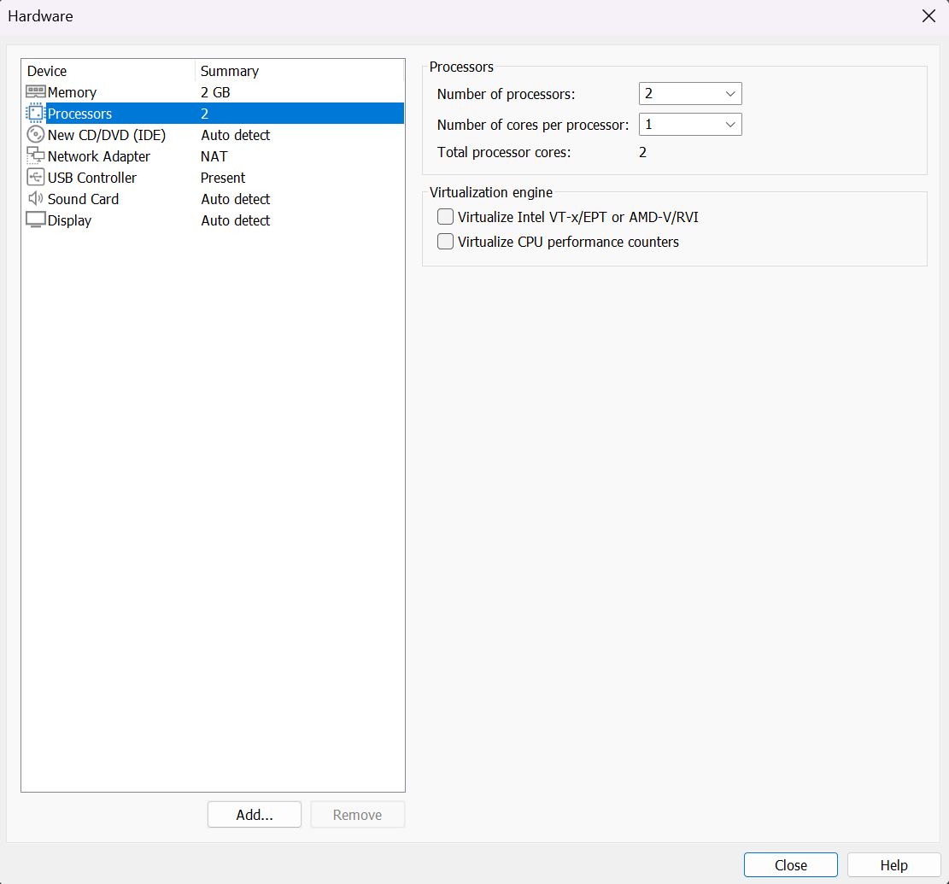

Now CentOS is in our list of VMs but does not have any ISO file to install onto it so we need to add the ISO file:
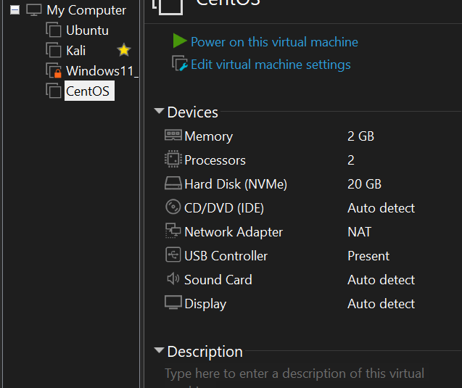
In the VM settings add the ISO file:
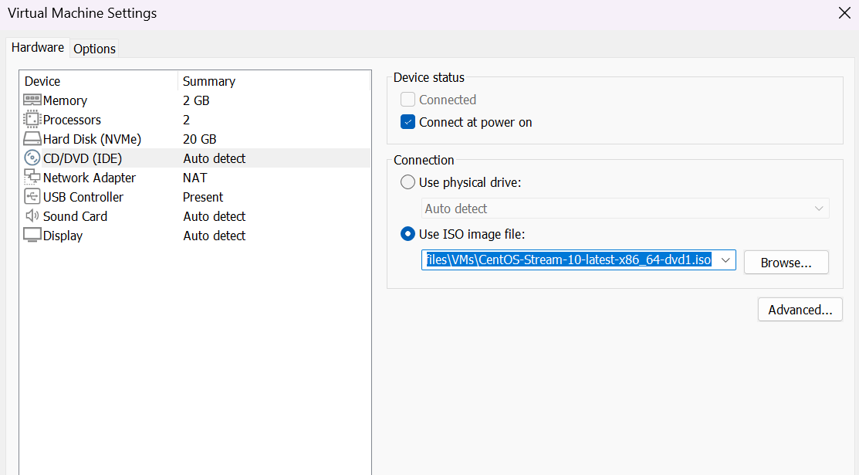

Now we can start the VM and select install CentOS to begin installing:
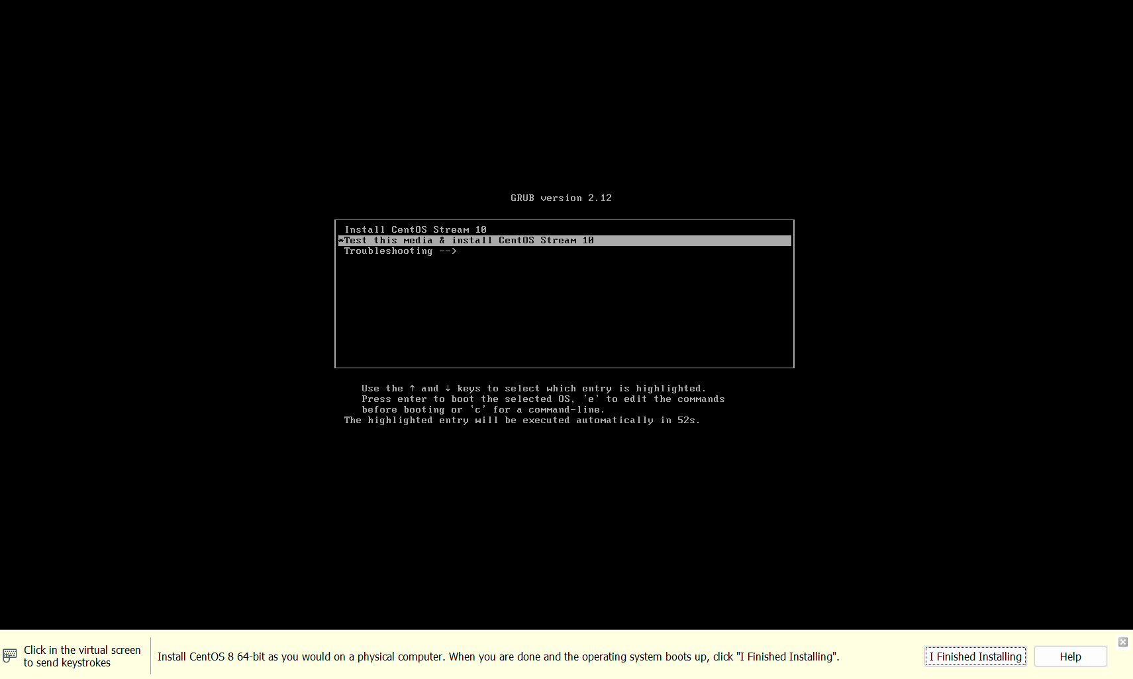

We are now in the installer so we can follow along with the steps it provides:
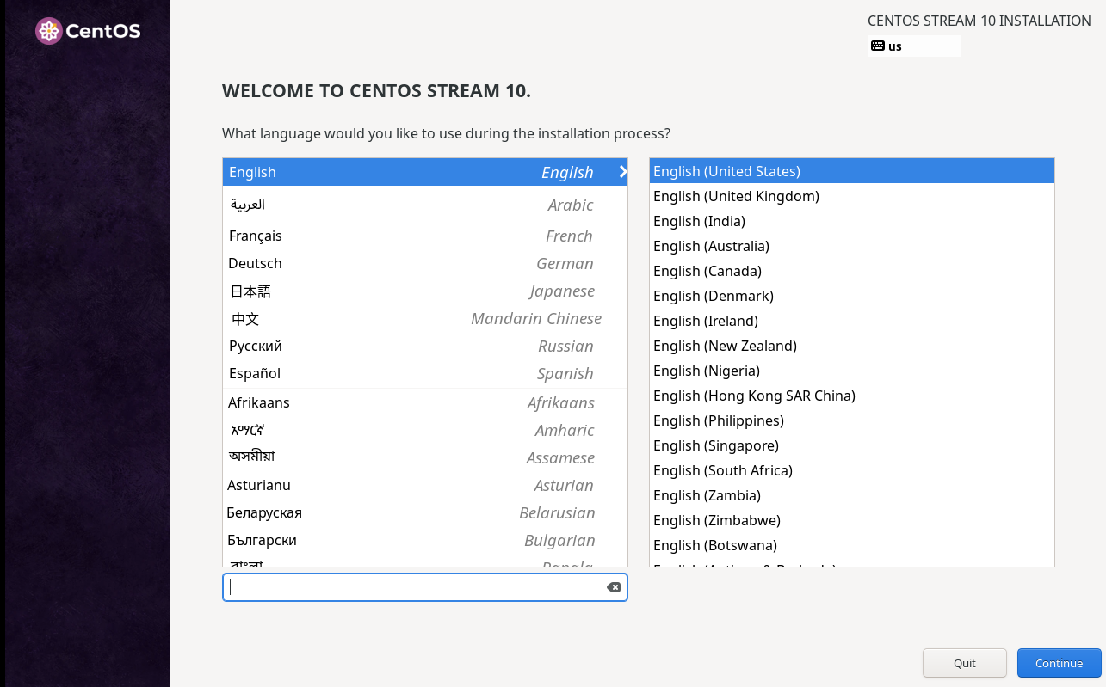
Now we need to set up a user since otherwise no user will be able to login:
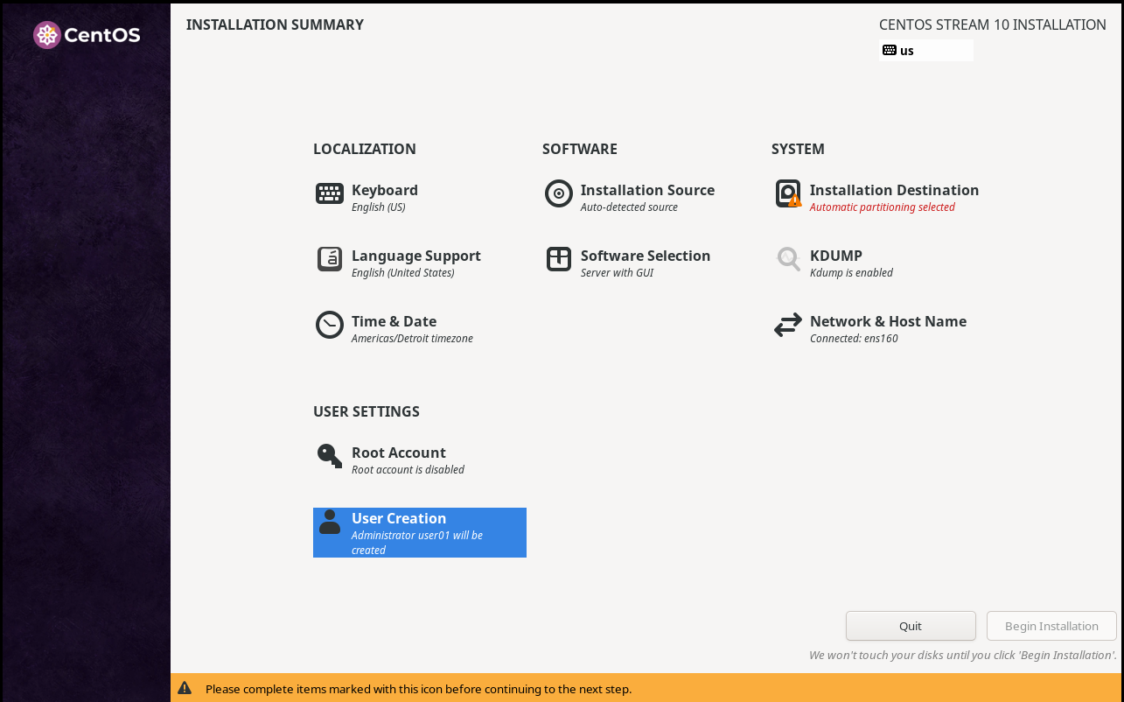
I’m setting up a user called user01 with the password password:
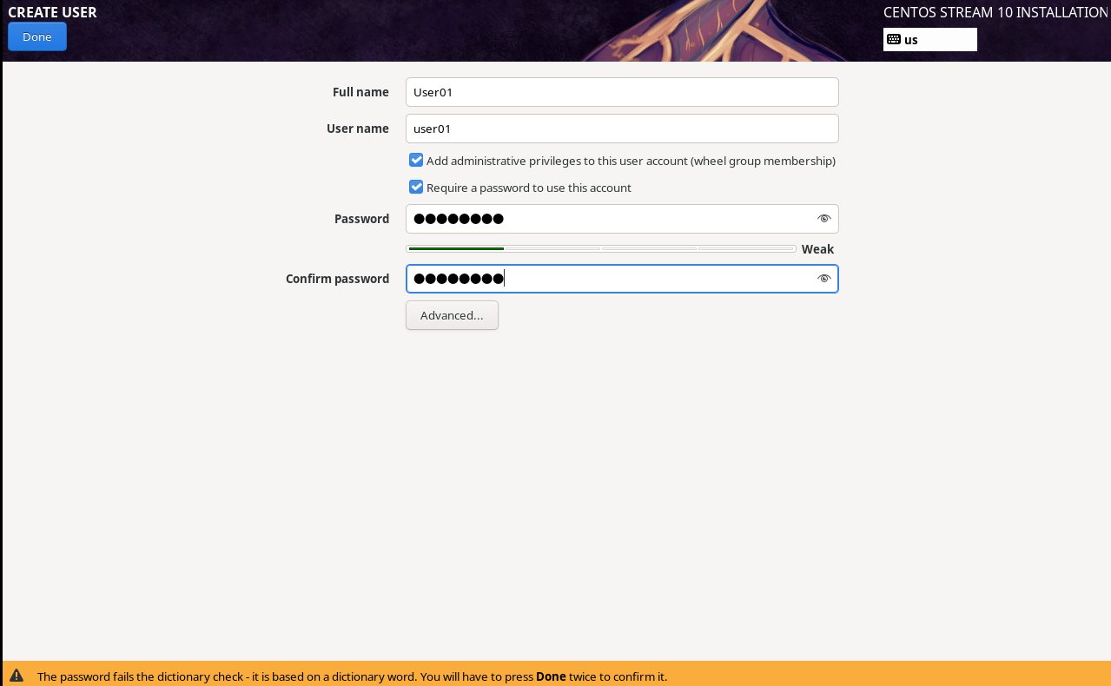
Now we’ll setup the disk partitioning for this install:
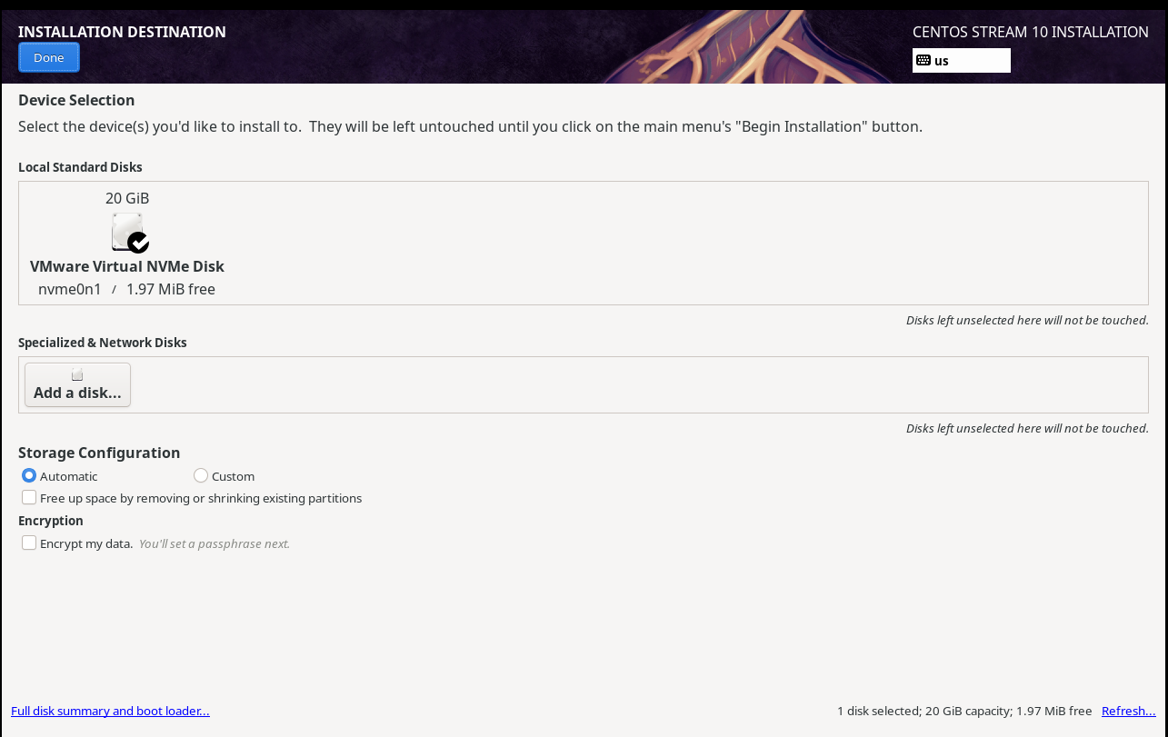

Now we have all of the necessary things setup to install so we can begin the installation:
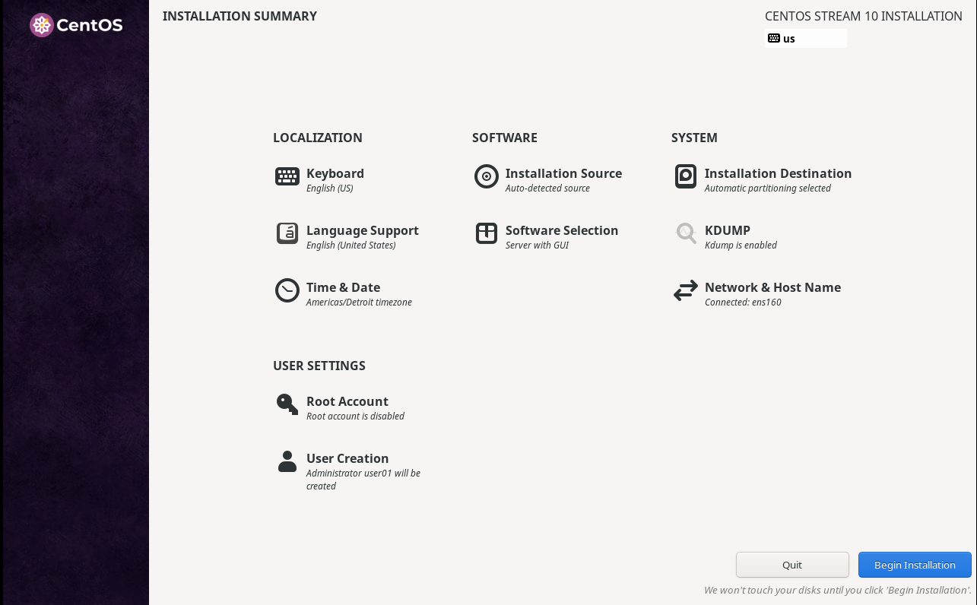

Now that the installation is complete we should be able to reboot and login to the newly installed OS:
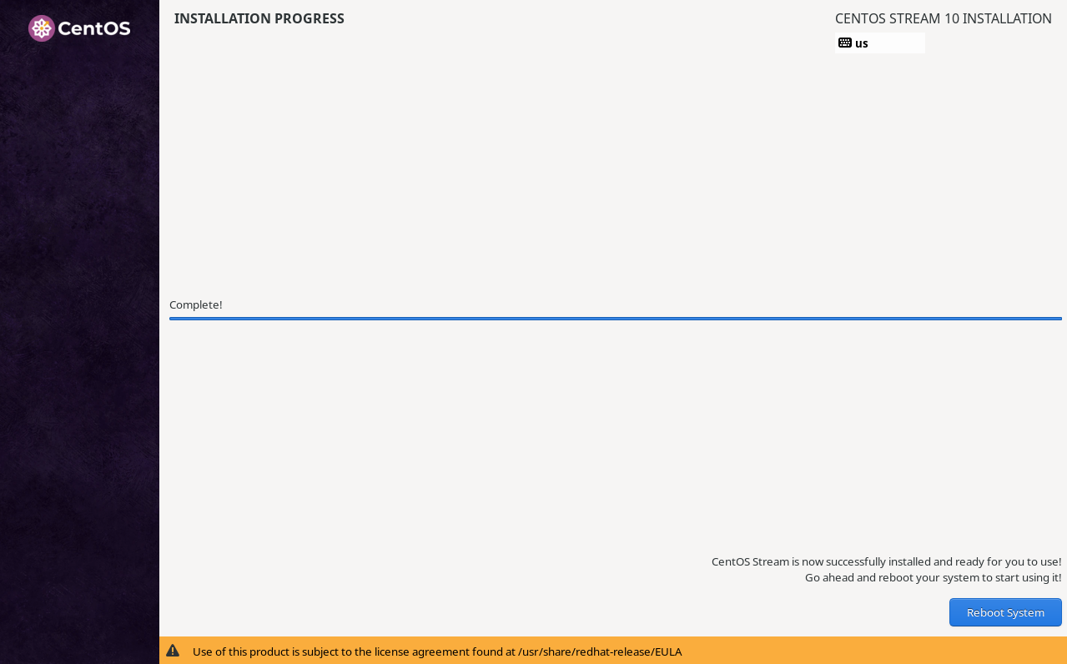
We can now login:
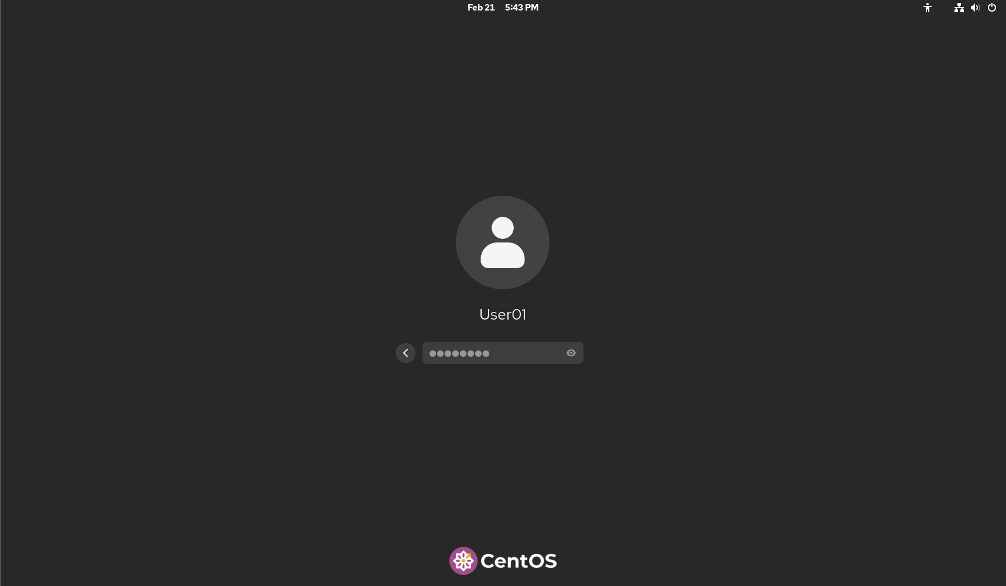

And see the desktop for this new OS:
