Table of Contents
Low-cost phone control protocol 2
1 Message structure 2
2 Message type 2
3 Message data 3
3.1 TRANSPORT_COOKIE_IND 3
3.2 DEVICE_INIT_RESP 3
3.3 KEEP_ALV_SET_CMD 3
3.4 RTP_OPEN_CMD 3
3.5 RTP_CLOSE_CMD 4
3.6 DATAGRAM_CMD / DATAGRAM_IND 4
CorNet-TS.Lite protocol 5
1 Message structure 5
2 Message type 5
3 Message data 6
3.1 DSP_TEXT_CMD 6
3.2 LED_SET_CMD 6
3.3 AU_CONTROL_CMD 6
3.4 AU_VOLUME_CMD 6
3.5 KBD_DOWN_IND / KBD_UP_IND 6
Low-cost phone description file 7
Scenarios flowcharts 10
1 UDP transport 10
1.1 Client MAC known on server 10
1.2 Client IP known on server 10
1.3 Server IP known on client 11
2 WebSocket transport 11

Low-cost phone control protocol

Message structure
Message type
Request ID (only for req./resp.)
Data 0
...
Data n

Message type
 |  | Direction
8 7 6 5 4 3 2 1 |  | S -> C | S <- C
0 0 . . . . . . | Request
. . 0 0 0 0 0 1 | DEVICE_INIT_REQ | X | -
. . 1 0 0 0 1 0 | RTP_PORT_ALLOC_CMD | X | -
0 1 . . . . . . | Response
. . 0 0 0 0 0 1 | DEVICE_INIT_RESP | - | X
. . 1 0 0 0 1 0 | RTP_PORT_ALLOC_RESP | - | X
1 0 . . . . . . | Command
. . 0 0 0 0 1 0 | KEEP_ALV_SET_CMD | X | -
. . 1 0 0 0 0 0 | RTP_OPEN_CMD | X | -
. . 1 0 0 0 0 1 | RTP_CLOSE_CMD | X | -
. . 1 0 0 0 1 1 | RTP_PORT_RELEASE_CMD | X | -
. . 1 1 0 0 0 0 | DATAGRAM_CMD | X | -
1 1 . . . . . . | Indication
. . 0 0 0 0 0 0 | TRANSPORT_COOKIE_IND | - | X
. . 0 0 0 0 0 1 | DEVICE_RELEASE_IND | X | X
. . 0 0 0 0 1 0 | KEEP_ALV_IND | X | X
. . 1 1 0 0 0 0 | DATAGRAM_IND | - | X

Message data
Messages not mentioned below do not contain any data.

TRANSPORT_COOKIE_IND

Octet | Value | Description
Data 0 | ASCII char. | Cookie
... |  | Cookie
Data n | ASCII char. | Cookie

DEVICE_INIT_RESP

Octet | Value | Description
Data 0 | 0 | Flags (for future use)
Data 1 | 0 .. 255 | Version - major
Data 2 | 0 .. 255 | Version – minor
Data 3 | 0 .. 255 | Version - release
Data 4 | ASCII char. | Phone ID  „Sachnummer“
... |  | Phone ID  „Sachnummer“
Data 23 | ASCII char. | Phone ID  „Sachnummer“

KEEP_ALV_SET_CMD
Sets interval of sending KEEP_ALV_IND from client to server and informs client how often will be KEEP_ALV_IND sent back. Each n-th incoming KEEP_ALV_IND triggers outgoing KEEP_ALV_IND.

Octet | Value | Description
Data 0 | 0 .. 255 | Required interval val*125ms (0-disabled)
Data 1 | 0 .. 255 | Frequency sending back (0-disabled)

RTP_OPEN_CMD

Octet | Value | Description
Data 0 | 0 .. 255 | Stream ID
Data 1 | 0 .. 255 | Codec number
Data 2 | 0 .. 255 | Payload type
Data 3 | 0 .. 65535 | Local port - high
Data 4 | 0 .. 65535 | Local port - low
Data 5 | 0 .. 65535 | Remote port – high
Data 6 | 0 .. 65535 | Remote port – low
Data 7 | IPv4 address  or  IPv6 address | Remote IP address
… | IPv4 address  or  IPv6 address | Remote IP address
… | IPv4 address  or  IPv6 address | Remote IP address
Data 10/22 | IPv4 address  or  IPv6 address | Remote IP address

RTP_CLOSE_CMD

Octet | Value | Description
Data 0 | 0 .. 255 | Stream ID

DATAGRAM_CMD / DATAGRAM_IND

Octet | Value | Description
Data 0 | 0x0B | Protocol: 0x0B – CorNet-TS.Lite
Data 1 | 0 .. 255 | Transported message
... |  | Transported message
Data n | 0 .. 255 | Transported message

CorNet-TS.Lite protocol

Message structure
Message type
Data 0
...
Data n

Message type
8 7 6 5 4 3 2 1
0 . . . . . . . | Downstream commands
. 0 0 1 0 0 0 0 | DSP_TEXT_CMD
. 0 1 0 0 0 0 0 | LED_SET_CMD
. 0 1 1 0 0 0 0 | AU_CONTROL_CMD
. 0 1 1 0 0 0 1 | AU_VOLUME_CMD
1 . . . . . . . | Upstream indications
. 0 0 1 0 0 0 0 | KBD_DOWN_IND
. 0 0 1 0 0 0 1 | KBD_UP_IND

Message data
Messages not mentioned below do not contain any data.

DSP_TEXT_CMD

Octet | Value | Description
Data 0 | 0 .. 255 | Display number
Data 1 | 0 .. 255 | Row
Data 2 | 0 .. 255 | Column
Data 3 | 0 .. 255 | Length to be cleared
Data 4 | 0 | Attributes (for future use)
Data 5 | ASCII char. | Text
... |  | Text
Data n | ASCII char. | Text

LED_SET_CMD

Octet | Value | Description
Data 0 | 0 .. 255 | Led number
Data 1 | 0 .. 7 | 0 – off, 1 – on, (2..7 – cadencies)

AU_CONTROL_CMD

Octet | Value | Description
Data 0 | 0 .. 255 | Stream ID
Data 1 | 0 .. 8 | Input device  0 – no input device connected  1..8 – audio device number
Data 2 | 0 .. 0xFF | Output devices  0 – no output device connected  ≠0 – bitmap with (n-1)^{th} bit set for audio device number n connected

AU_VOLUME_CMD

Octet | Value | Description
Data 0 | 1 .. 8 | Output device  1..8 – audio device number
Data 1 | 0 .. 255 | Volume level number

KBD_DOWN_IND / KBD_UP_IND

Octet | Value | Description
Data 0 | 0 .. 255 | Key number

Low-cost phone description file

The file lcp-<phoneId>.xml (where the <phoneId> is the string from the DEVICE_INIT_RESP message) describes phone capabilities, key/led codes etc.

Example:

<!-- lcp-PROTO_VUT_01.xml -->
<!--
definition for prototype implemetation of Low-cost phone
-->

<LcphoneDefinition>

<!-- Keyboard
kbd:key_number => key_name

key_number – key number used in KBD_DOWN_IND/KBD_UP_IND messages
(arbitrary numbers can be which meet phone implementation)
key_name – key functionality, all possible names are below

-->

<!—-
phone with hook detector
KBD_DOWN_IND is hook on
KBD_UP_IND is hook off
-->
<Property name="kbd:64" value="hook" />

<!—-
phone with separated onhook and offhook keys
-->
<Property name="kbd:65" value="hook:off" />
<Property name="kbd:66" value="hook:on" />

<!—- dial pad -->
<Property name="kbd:1" value="dial:1" />
<Property name="kbd:2" value="dial:2" />
<Property name="kbd:3" value="dial:3" />
<Property name="kbd:4" value="dial:4" />
<Property name="kbd:5" value="dial:5" />
<Property name="kbd:6" value="dial:6" />
<Property name="kbd:7" value="dial:7" />
<Property name="kbd:8" value="dial:8" />
<Property name="kbd:9" value="dial:9" />
<Property name="kbd:10" value="dial:0" />
<Property name="kbd:11" value="dial:star" />
<Property name="kbd:12" value="dial:hash" />

<!—- volume keys -->
<Property name="kbd:13" value="volume:up" />
<Property name="kbd:14" value="volume:down" />

<!—- menu navigation -->
<Property name="kbd:15" value="menu:back" />
<Property name="kbd:16" value="menu:next" />
<Property name="kbd:17" value="menu:select" />

<!—- function keys -->
<Property name="kbd:18" value="fk:1" />
<Property name="kbd:19" value="fk:2" />
<Property name="kbd:20" value="fk:3" />
<Property name="kbd:21" value="fk:4" />

<Property name="kbd:22" value="fk:5" />
<Property name="kbd:23" value="fk:6" />
<Property name="kbd:24" value="fk:7" />
<Property name="kbd:25" value="fk:8" />
<Property name="kbd:26" value="fk:9" />
<Property name="kbd:27" value="fk:10" />
<Property name="kbd:28" value="fk:11" />
<Property name="kbd:29" value="fk:12" />

<!-- LED
led:led_number => led_name

led_number – LED number used in LED_SET_CMD message
(arbitrary numbers can be which meet phone implementation)
led_name – LED functionality, all possible names are below

-->

<!— ringer visual signalization -->
<Property name="led:64" value="ringer" />

<!— code addressing all LEDs -->
<Property name="led:0" value="all" />

<!—- LEDs at function keys -->
<Property name="led:18" value="fk:1" />
<Property name="led:19" value="fk:2" />
<Property name="led:20" value="fk:3" />
<Property name="led:21" value="fk:4" />

<Property name="led:22" value="fk:5" />
<Property name="led:23" value="fk:6" />
<Property name="led:24" value="fk:7" />
<Property name="led:25" value="fk:8" />
<Property name="led:26" value="fk:9" />
<Property name="led:27" value="fk:10" />
<Property name="led:28" value="fk:11" />
<Property name="led:29" value="fk:12" />

<!-- LCD
lcd:lcd_name => lcd_number:rows:cols
-->
<!—- main display -->
<Property name="lcd:main" value="0:2:24" />

<!-- key labels -->
<Property name="lcd:fk:1" value="1:1:12" />
<Property name="lcd:fk:2" value="2:1:12" />

<Property name="lcdCharset" value="US-ASCII" />

<!—- Audio devices
aout:device_number => function[,function]*
ain:device_number => function[,function]*

device_number – 1-8
function – ringer|speaker|microphone|handset|headset|*
-->

<Property name="aout:1" value="ringer,speaker" />
<Property name="ain:1" value="microphone" />
<Property name="aout:2" value="handset" />
<Property name="ain:2" value="handset" />

<!—- Audio volumes
volume:aout:device_number => volume_numbers

volume_nmuber – list of volume numbers volume_number[:volume_number]* from low to high
or
range of volume numbers volume_number-volume_number
-->

<Property name="volume:aout:1" value="1:2:4:8:16:32:64:128" />

<Property name="volume:aout:2" value="1-16" />

<!-- RTP -->
<Property name="rtpPort" value="18066" />
<!-- codec:number => codec_description -->
<Property name="codec:1" value="G711A:20" />
<Property name="codec:2" value="G711A:30" />
<Property name="codec:5" value="G711U:20" />

</LcphoneDefinition>

Scenarios flowcharts

UDP transport

UDP transport uses port 4066 on both (client and server) sides. UDP transport is just for prototype and will be superseded by SCTP or TCP in real products.

Client MAC known on server
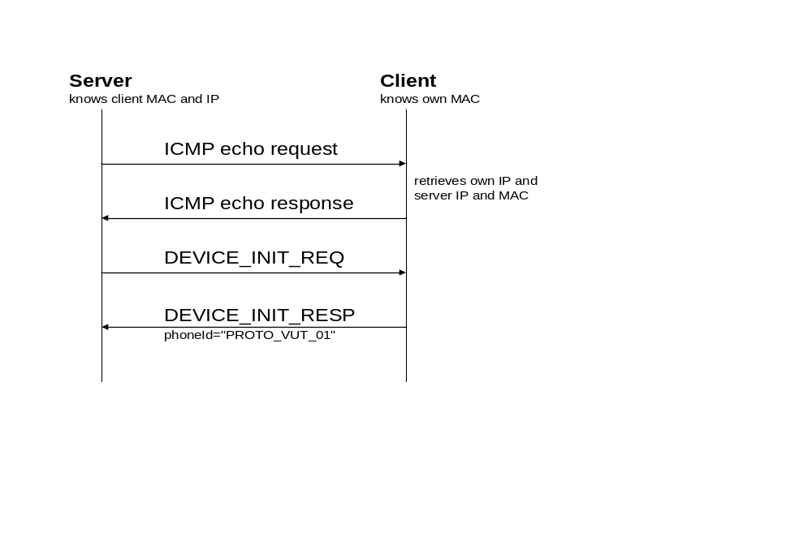

Client IP known on server
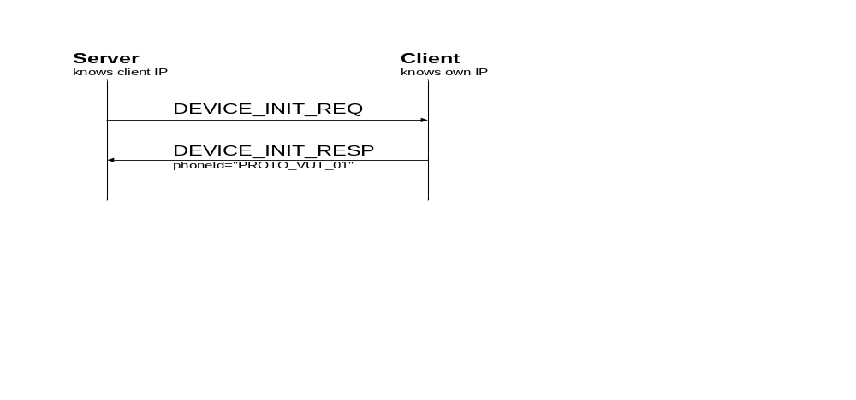

Server IP known on client
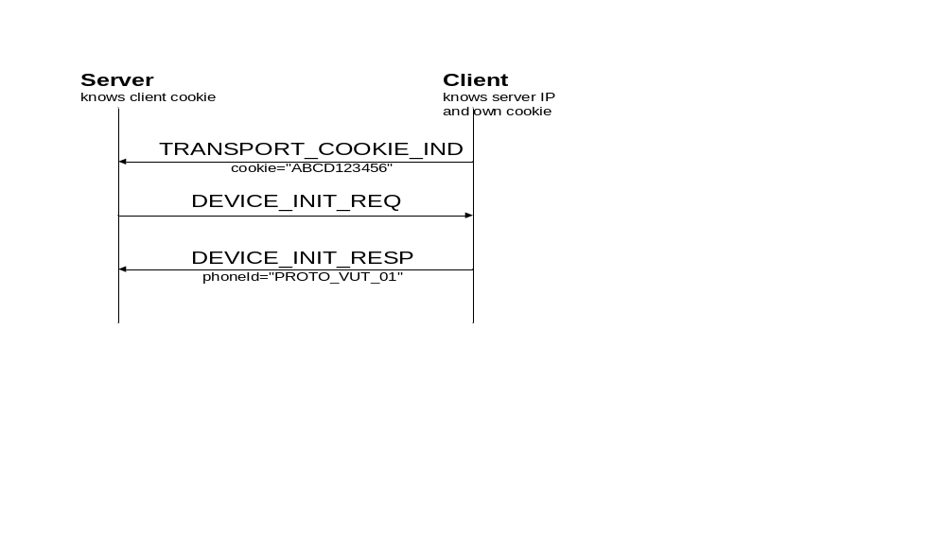

WebSocket transport

WebSocket transport uses TCP port 4088.

