HANOI UNIVERSITY OF SCIENCE AND TECHNOLOGY

School of Information and Communication Technology

──────── * ───────

**Mini Project**

SUBJECT: OBJECT-ORIENTED PROGRAMMING LAB

**Simple RPG Game**

Student Name - ID : Trần Việt Anh Phương– 20163255

Đoàn Cao Thanh Long– 20162513

Bùi Đức Hiếu– 20167174

Nguyễn Minh Hiếu- 20161546

Class : **ICT – K61**

Instructor : **MSc.** **Nguyễn Mạnh Tuấn**

***Hanoi, May 26th 2019***

# TABLE OF CONTENT

TABLE OF CONTENT 2

INTRODUCTION 3

CHAPTER 1: RESEARCHING AND MODELLING THE PROJECT 4

1.1. Project’s requirements 4

1.2. Use case diagram 5

CHAPTER 2: DESIGN ANALYSIS 6

2.1. Design database 6

2.2. Sequence diagram 6

2.3. Class diagram 7

CHAPTER 3: TECHNOLOGIES AND ALGORITHMS 8

CHAPTER 4: DEMO APPLICATION 9

4.1. Result after running the application 9

4.2. User interface of the application 9

CONCLUSION AND DEVELOPMENTS PATTERNS 10

REFERENCE 11

APPENDIX 12

# INTRODUCTION

In the 21st century, videogames industry is proving itself as one of the biggest markets out there. As a result, many developers have taken the part of creating their own games. But to reach the top, we must start somewhere. Taken this project as an opportunity, we’ve decided to choose “**Simple RPG game”** to implement the knowledge we have learn throughout the course to create a game.

RPG, short for role playing game, is a game genre for people who love a more complex take for a game. We must control the character to explore the world in-game and complete certain task given by NPC. However, as we approach the project, there’re a couple of problems we have encountered:

* There are too many ideas for a 3-week project
* Difficulty in implement the packages for making a user interface and for graphic of the game
* Work distribution between member
* Lack of assets for the game
* Game mechanic

To solve these problems, first we drew the use case diagram to decide how we approach the game. Follow that, the team has look up some game on the internet have a grasp of the game we are doing and to create a base of the application. Then, we look for sprite and assets to make the map of the game and the characters. After that we apply the movement and actions for the player to use. We also draw the class diagram and sequence diagram to control the flow of the game.

The game we created is easy to approach by everyone. Its main goal is to explore the map and defeat monster. However, since the time is limited we didn’t implement too much mechanic on the game. So, sit back and enjoy the game!

# Chapter 1:

# RESEARCHING AND MODELLING THE PROJECT

## Project’s requirements

The project required student to create a game with some main function for the system and the player.

For user:

* Start game: The system should generate the map, items, player, monster from the assets file when player press “Start”.
* Exit game: Close Application when user press “Exit”.
* Move: Player should have access to arrow key to move.
* Attack: Player can attack the monster.
* Retreat: Player can run from the monster.
* Use potion: Player can refill their HP when called.

For system:

* Generate map: The System should be able to read from the map file.
* Win/lose: Declare when the player defeat all monster or have no HP left.
* The system should keep track of the location of monster left and the player stats.

## Use case diagram

General use case diagram

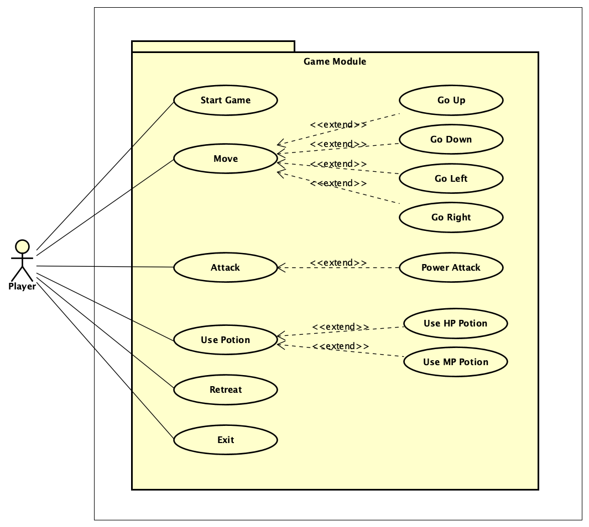

The use case diagram above shows an overview of the player interaction with the game

# Chapter 2:

# DESIGN ANALYSIS

## 2.1. Design database

This project does not include a database.

## 2.2. Sequence diagram

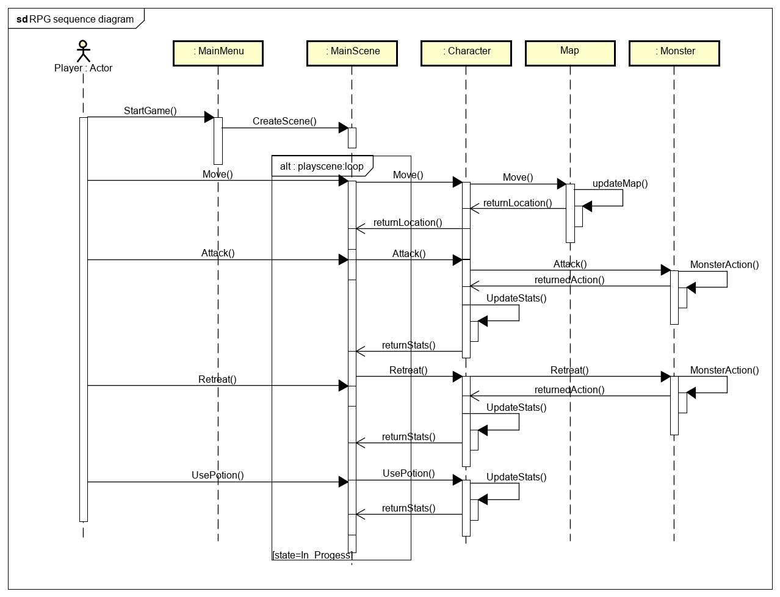

## 2.3. Class diagram

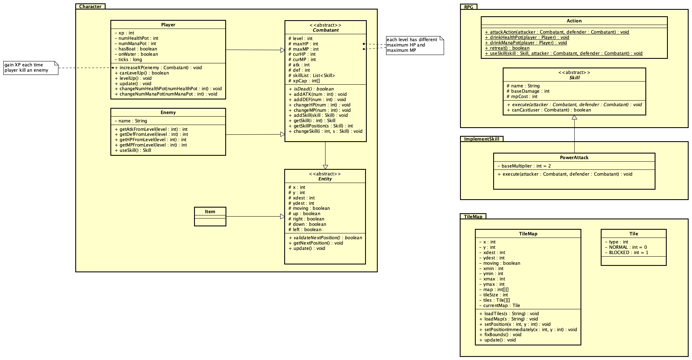

**Detail:**

# Chapter 3:

# TECHNOLOGIES AND ALGORITHMS

We mainly use Java.awt for most of our components in the project, including the UI and the functions in the application.

# Chapter 4:

# DEMO APPLICATION

## 4.1. Result after running the application

## 4.2. User interface of the application

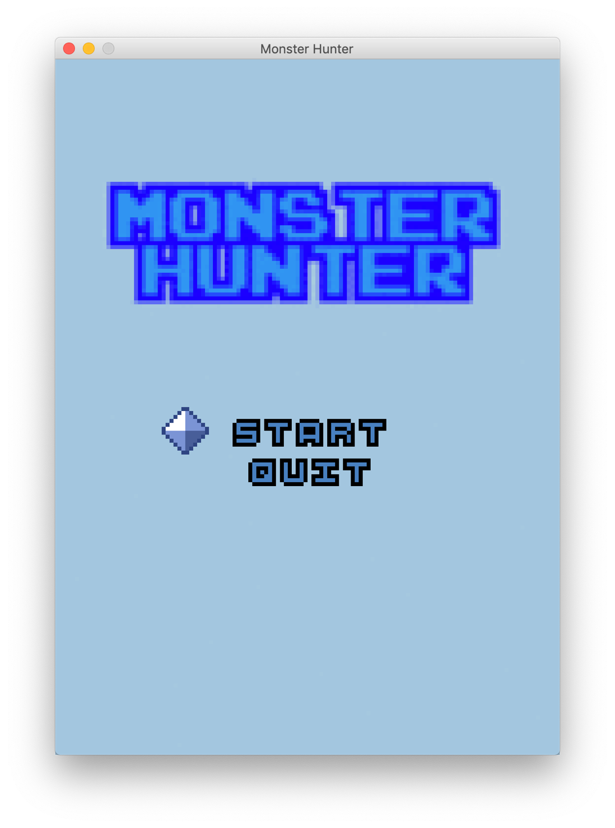

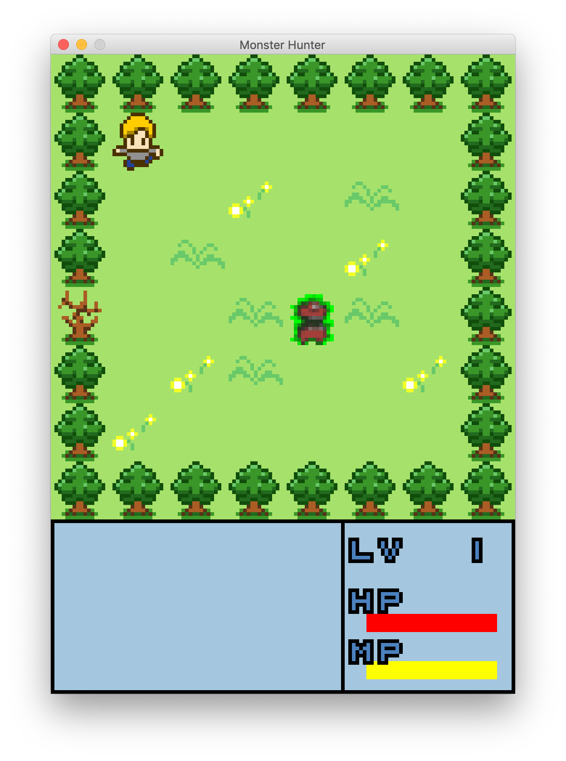

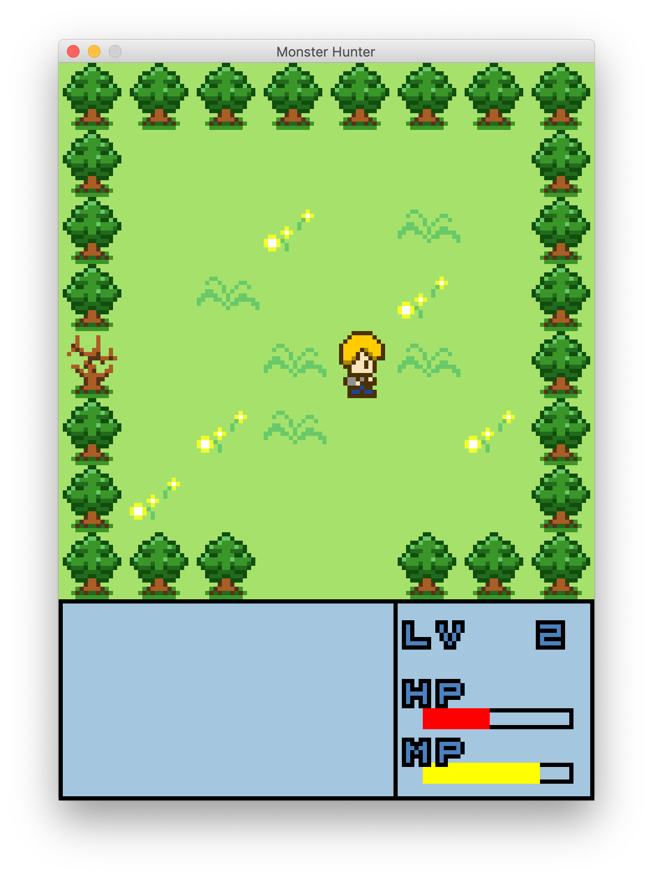

# CONCLUSION AND DEVELOPMENTS PATTERNS

All in all, although there are still some problem within the project, we are happy with the result we archived. This game was built step by step, from a simple concept to be relatively functional. We have to re – analyse and re – draw UML a couple of time during the project time to get the final product. We were able to create a game with java.awt which run smoothly with some combat. However, the game is very basic, as there are only 2 types of attack and the monster don’t have a pattern of attack or any kind of strategy.

For future developments, we will add more type of monster and attack to the game, thus making the control more smoothly. This will add depth to the game and make it more fun and challenging.

# REFERENCE

[1] Object-Oriented Programming Theory and Lab – Ph.D Nguyen Thi Thu Trang and MSc. Nguyen Manh Tuan

[2] <https://www.tutorialspoint.com/awt/>

[3] <https://assetstore.unity.com/>

# APPENDIX

1. Download JRE (Java Runtime Environment)

2. Extract the .rar file

3. Type “java -jar javaRPG.jar” in terminal or double click the file javaRPG.jar