**Database Analytics**

Project

Anurag Singh

041056292

**Part 1: Two SQL Queries:**

1. Write SQL queries in SQL Developer to list:
   1. (Query 1) Pub_id, Genre, and Revenue, with revenue grouped for:
      1. all (or overall, total),
      2. each pub_id,
      3. each genre, and

each pub_id-genre combination

**Ans:** I used Group by Cube clause to solve this problem.

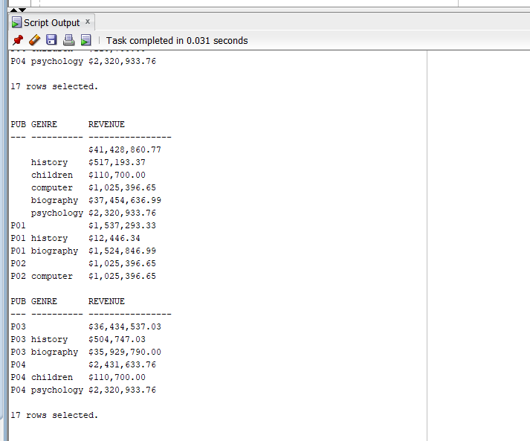

**

1. (Query 2): Genre revenue by year_month and a year-month previous.

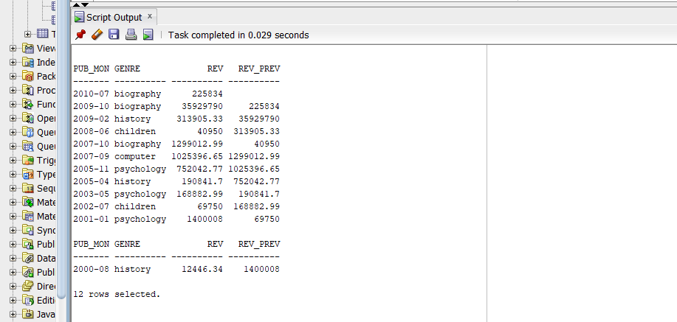

1. **Part 2: Exporting an Oracle Table to MS Power BI:**
   1. Export the Fehily *Titles* table from your user ‘*Anu@1234*’ schema **using SQL Developer as JSON files**.

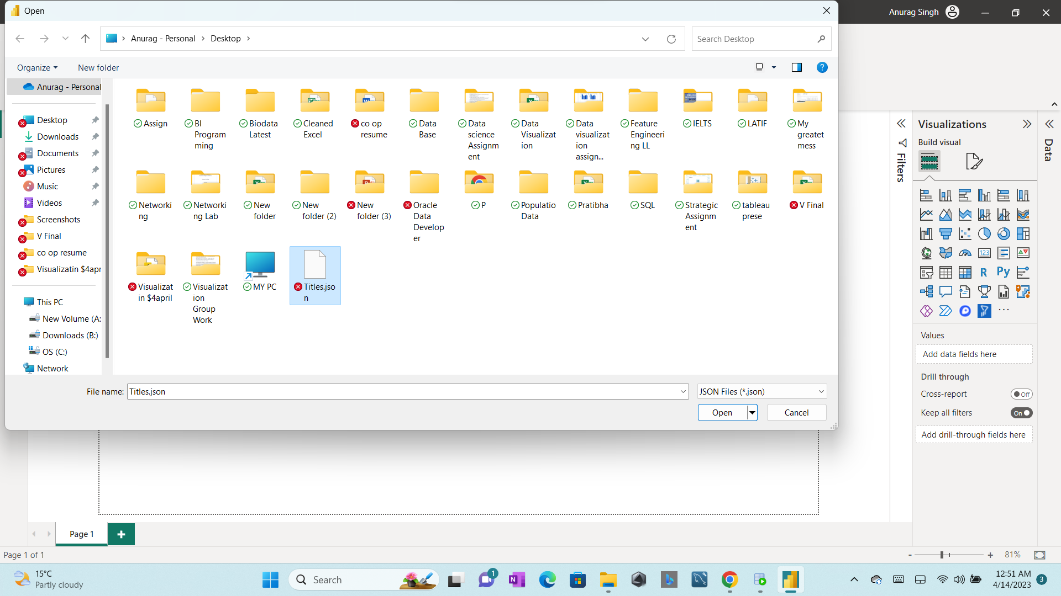

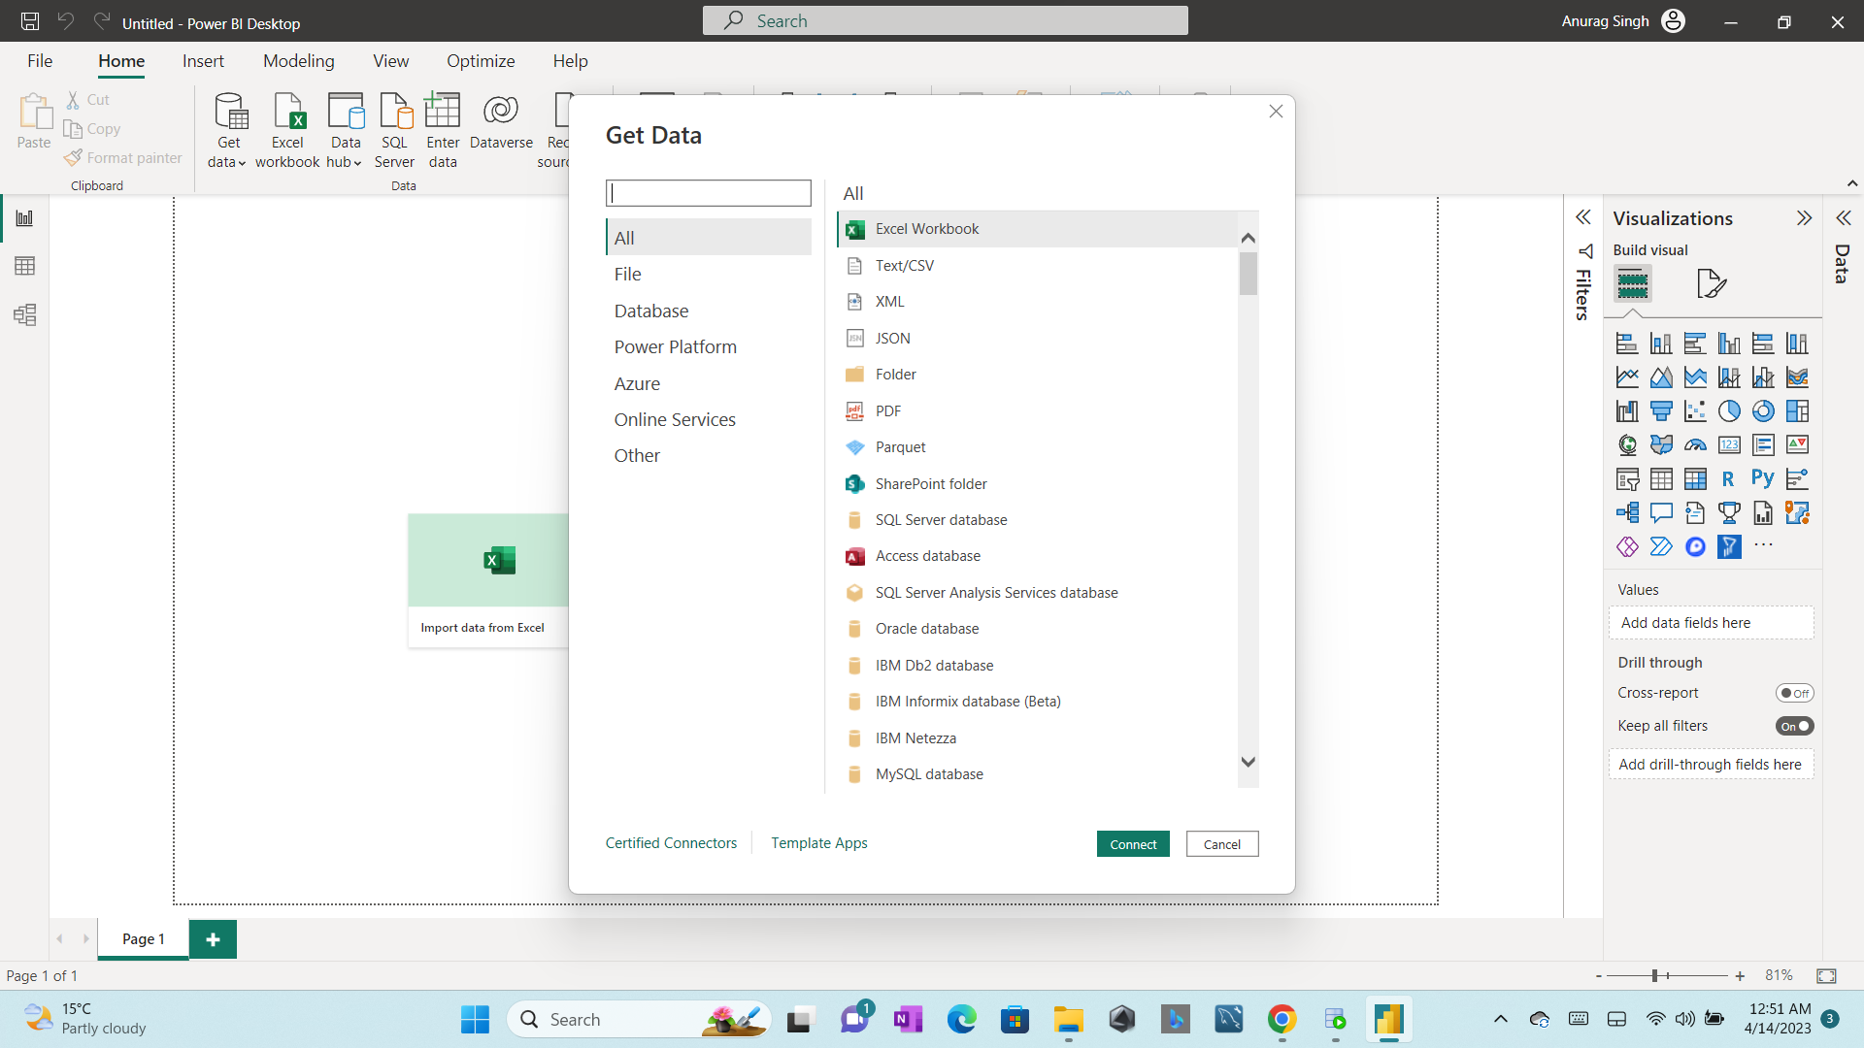

B.Within MS Power BI, ‘GET’ the JSON file and convert the data into a table.

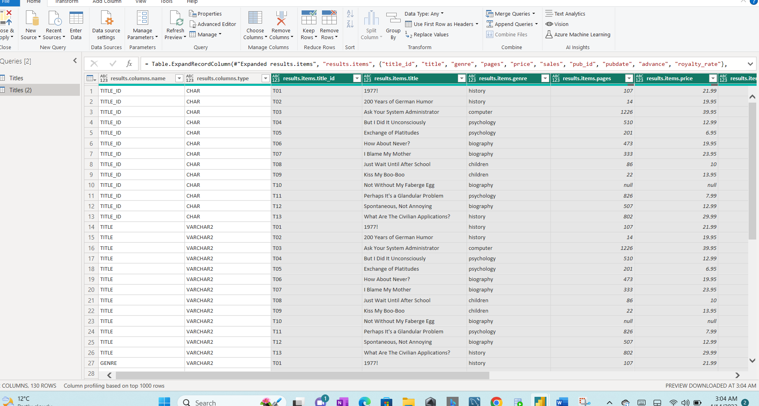

C. Produce the same aggregation groupings as shown in step 1 and display the results within an appropriate MS PBI visualization.

Created a revenue column then selected the visuals.

