Supporting Information
Table S1. E. coli IC residue compositions at cutoff = 0.95.
 | ecDHFR residues
IC1 | 13,23,25,27,32,39,55,63,71,107,133,153
IC2 | 7,14,15,31,35,42,43,44,46,49,53,54,57,59,94,95,96,100,113,122,126
IC3 | 21,22,24,50,52,64,81,121,
IC4 | 5,6,11,18,40,45,47,51,92,111,125,

Table S2. Within variant p-values from Mann-Whitney U tests of dynamic correlations.
Comparison Całegory | 3QL3 | 3QLO
IC1 vs No IC | 0.11780 | 0.74632
IC2 vs No IC | 4.57248E-11 | 0.39920
IC3 vs No IC | 0.12111 | 0.59298
IC4 vs No IC | 0.02640 | 0.02156
IC1 vs Not in Same IC | 0.08413 | 0.39950
IC2 vs Not in Same IC | 2.23752E-10 | 0.89636
IC3 vs Not in Same IC | 0.15424 | 0.41011
IC4 vs Not in Same IC | 0.04020 | 0.05310
Any IC vs No IC | 8.03962E-08 | 2.69767E-04
Not in Same IC vs No IC | 0.25586 | 5.37196E-04

Table S3. Across variant p-values from Mann-Whitney U tests of dynamic correlations.
Comparison Category | Comparison
IC1 (3QL3) vs IC1 (3QL0) | 0.6576
IC2 (3QL3) vs IC2 (3QL0) | 6.92E-08
IC3 (3QL3) vs IC3 (3QL0) | 0.24081
IC4 (3QL3) vs IC4 (3QL0) | 3.93E-04
Any IC (3QL3) vs Any IC (3QL0) | 6.52E-23
No IC (3QL3) vs No IC (3QL0) | 2.45E-12
Not in Same IC (3QL3) vs Not in Same IC (3QL0) | 4.62E-58

Table S4. Human DHFR IC residue compositions at cutoff = 0.95.
 | Human DHFR residues
IC1 | 15,26,28,30,35,47,49,68,76,85,128,156,179
IC2 | 9,16,17,34,38,52,53,54,56,59,66,67,70,72,115,116,117,121,136,145,149
IC3 | 23,24,27,60,65,77,96,144
IC4 | 7,8,13,20,50,55,57,61,113,134,148

TableS5. Proteins for which the Met20 Pro-Pro motif was present in our original alignment and which did not possess either the Gly20 mutation or the exact 61-PEKN-65 mutation. PFAM protein accession numbers are in the first column with common or scientific names available in the second column.
PFAM accession | Name | Gly20 | Met20  Loop motif | P61-N65
R7UI73 | Capitella teleta  (Polychaete worm) | C | PP | GEEE
U6GUT1 | Eimeria acervulina  (Coccidian parasite) | N | PP | empty
S7NYA8 | brandts bat | G | PP | PKKN
G1QES9 | little brown bt | G | PP | PKKN
L5KJI5 | black flying fox | G | PP | PKKN
S7NHW6 | brandts bat | G | PP | PKKN
M1VWK3 | claviceps purpurea (ergot) | G | PP | PPSF
A0A2Z5U771 | Rhinolophus gammaherpesvirus 1 (from greater horshoe bat) | G | PP | PTKS
A0A3L8S6E8 | Chloebia gouldiae  (Gouldian finch) | G | PP | PEKS
U3IIA3 | Anas platyrhynchos platyrhynchos  (Northern mallard) | G | PP | PEKH

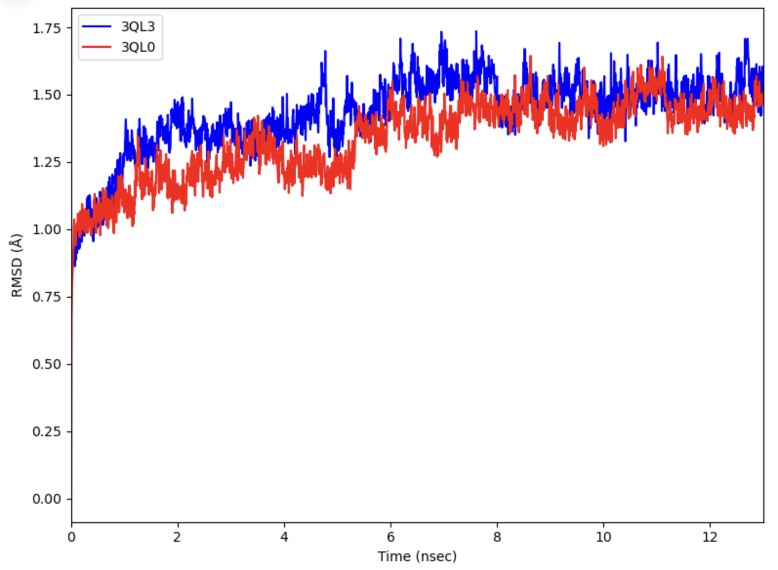
Figure S1. The root-mean squared deviation (RMSD) of wild-type (3QL3, blue) and mutant (3QL0, red) DHFR with respect to the initial structure over the duration of 13 ns simulation.

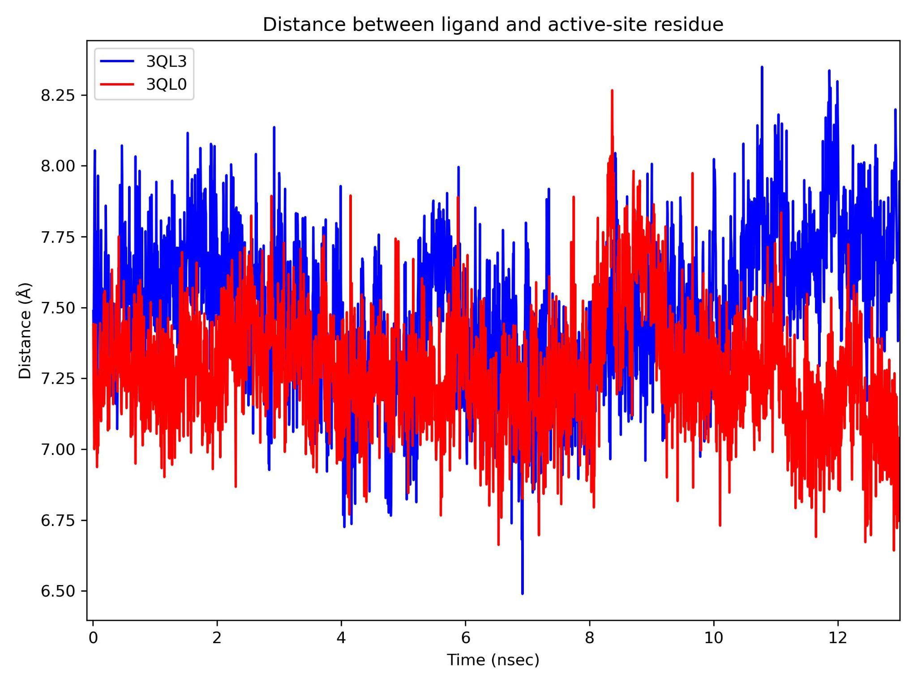
Figure S2. The distance between the folate ligand and Asp residue in the active site of wild-type (blue) and mutant (red) DHFR over the course of simulation.

Simulation stability.
Figure S1 monitors the RMSD of the proteins with respect to the first frame of the trajectory over the simulation time. Simulations of the wild-type and mutant DHFR are shown to be reasonably stable, with fluctuations gradually increasing then stabilizing at approximately 1.5 Å starting at around 6 ns. Distance between the folate ligand and a residue in the DHFR active site (D27 in 3QL3 and D28 in 3QL0) from center of mass was also calculated to monitor the stability of the ligand-amino acid interaction during the simulation. Figure S2 shows this distance averages at around 7.4 Å and fluctuations are within a range of 2 Å for both the wild-type and mutant DHFR, suggesting relative stability of this interaction throughout the simulation.

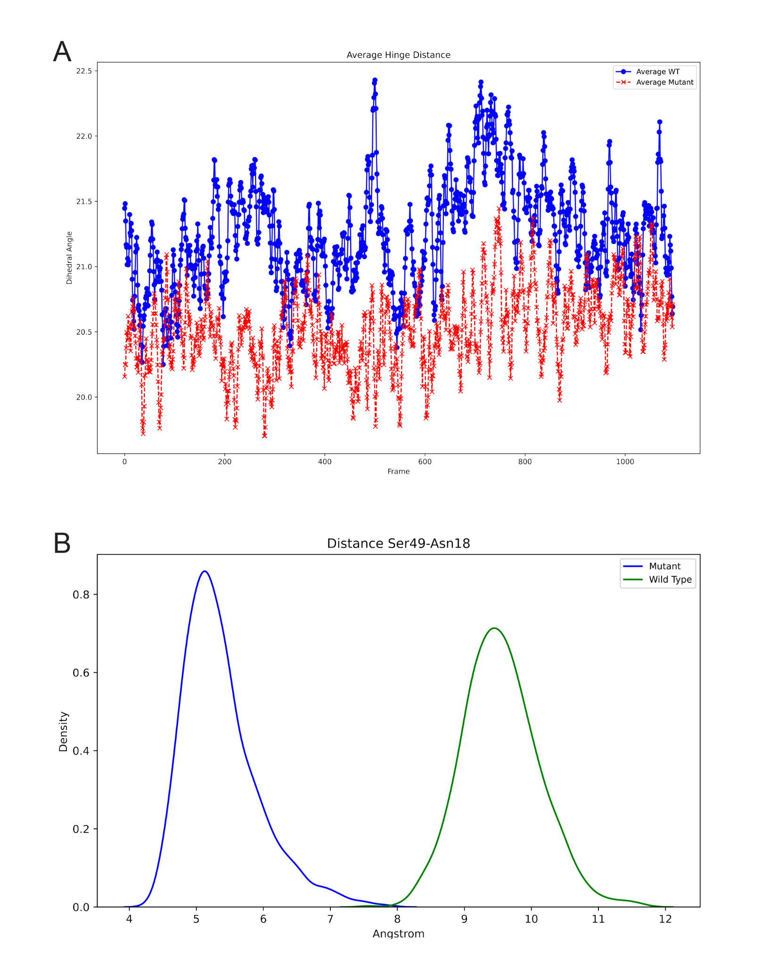
Figure S3. (A) shows the average hinge distance for wild-type and mutant DHFR. Wild-type hinge distance (blue) is the average distance between positions 22-53, 23-53 and 24-53 while mutant hinge distance (red) is the average of the distance between positions 22-54, 23-54 and 25-54. (B) shows the kernel density estimate of the distance between Ser49 and Asn18 in wild-type (green) and mutant (blue). All measurements were taken at the alpha carbon and measured for simulation frames 1500-2600.

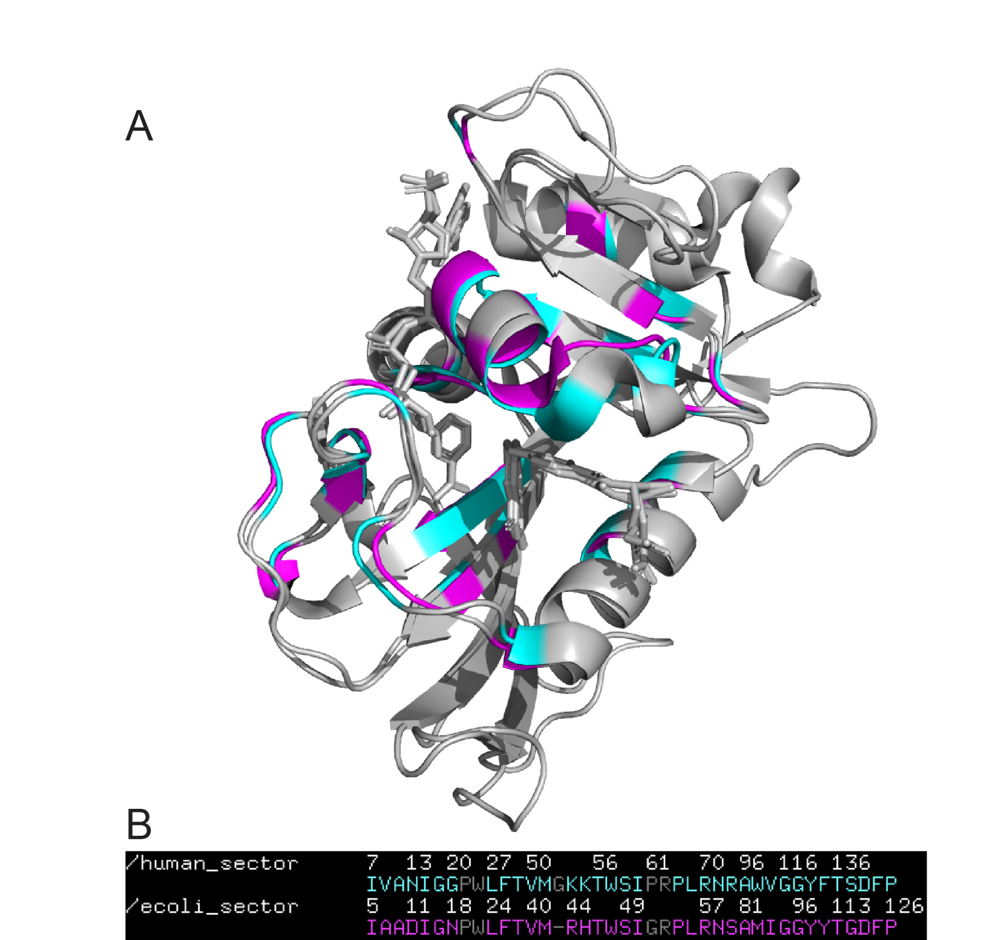
Figure S4. Overlaid PDB structures for human (PDB:4M6K) and E. coli (PDB:3QL3) DHFR (A) along with the structure-based alignment of their sectors (ICs 2-4) (B). The RMSD for the structure-based alignment was 0.853Å after 5 cycles with a total of 42 rejected atoms. Numbering is only accurate for the amino acid over which it appears and is meant as a reference for the others.

