User Requirements Specification

I B, Tudor Rusu, E P, V K

Fontys University of Applied Science

Tutor: Chung Kuah

18th February 2024

Contents

Agreements with Client 2

Functional Requirements 3

Moscow Prioritization Table 4

Use Cases 5

Wireframes 14

Management view 14

Administrative Employee view 16

Shop Floor Employees 21

# Agreements with Client

From the interview provided in the project reader and the live interview with the client, the following agreements have been made between the “SystemTechies” and the “Media Bazaar” representative Stan van Hartingsveldt:

* GUI tailored to clients’ preferences, red theme with black accents and white text.
* Managerial and Administrative employees should be able to see statistics of floor employee performance and growth as well as department and product sales growth statistics.
* The schedule for employees should be generated (preferably automatically).
* Administration should be able to add, remove and update employee data.
* Application window size for Managers and Administrative employees should be windowed, floor employees should have a full screen view.
* There should be an option to add new products to the product database.

In addition, the client requested a website to be made for floor employees to be able to access their data and make changes. Employees should also have an option to select schedule preferences and there should be a way to systematically process restock requests. However, these functions will not be implemented during the first 6 weeks of the project.

# Functional Requirements

Since there are 3 user groups: Managerial, Administrative and Floor employees. Each employee should be provided with a unique login and password to allow differentiate accessibility of certain functions within the application. Furthermore, each user group requires the functions listed below:

#### Floor employee:

FR01FE: Should be able to see personal schedule.

*New schedule is only visible for a week in advance.*

FR02FE: Option to handle stock replenishment request.

*Will be discussed in more detail with the client in week 7.*

FR03FE Option to update product stock level (stock replenishment/depletion).

*Incrementing stock level when products are sold or discarded.*

*Decrement stock level when stock replenished.*

FR04FE: Information panel about stock changes (between Administrative and Floor employees)

*Since Floor Employees are unable to add new products, this information reaches them in a side panel from Administration.*

#### Administrative employee:

FR01AE: CRUD functions for employee database data manipulation (adding new, reading, updating and deactivating existing employee account data).

*When adding new employee DB must be checked if the data inputted already exists in the database.*

*Deactivated employees are not deleted from the database.*

FR02AE: Option to automatically generate rotating shift assignment.

*Will be implemented in the second phase of the project.*

FR03AE: Option to make changes to automatically generated schedule (if employees are unavailable, on holiday or sick leave).

*Will also enable Administrative employee to create schedule manually for the time being.*

*System should not accept selecting morning shift after having evening shift on the previous day.*

FR04AE: Options to add and update product information.

*Only product description and price can be updated.*

FR05AE: Information panel about stock changes (between Administrative and Floor employees).

*Only Administrative Employee has the ability to add new products to the Product DB, when this happens information is sent to the Floor Employee.*

FR06AE: Announcement tab to inform Floor employees about new or replenished product updates.

FR07AE: Ability to see employee performance overview.

*If no data is available, an empty chart will be generated.*

#### Managerial employee:

FR01ME: Sales overview option per product and per department.

*If no data is available, an empty chart will be generated.*

FR02ME: Ability to see employee performance statistics overall as well as per department.

*If no data is available, an empty chart will be generated.*

FR03ME: Option to see employee growth overview per department.

*If no data is available, an empty chart will be generated.*

## Moscow Prioritization Table

# Use Cases

#### Case 1: Logging in to a personal user account.

Actor: Floor, Administration or Managerial Employee

Main Success Scenario:

1. Employee opens the application.
2. Application initializes, requests a username and password.
3. Employee inputs his credentials and confirms.
4. Application opens the appropriate access view (per user level: Floor, Administration, Managerial).

Extensions:

3a. Incorrect username/password provided.

1. System displays error message
2. Return to step 3.

#### Case 2: Checking personal schedule.

Actor: Floor Employee

Precondition: User is logged in (see Case 1).

Main Success Scenario:

1. Floor Employee chooses to see his schedule.
2. System displays weekly schedule.

Extensions:

2a. Schedule has not been generated yet.

1. System displays empty schedule.
2. End of use case

#### Case 3: Updating stock level (counts towards depletion).

Actor: Floor Employee

Precondition: User is logged in (see Case 1).

Trigger: The product is either sold or written-off (as i.e. damaged, spoiled, outdated, lost)

Main Success Scenario:

1. Floor Employee accesses product data.
2. System displays product information.
3. Floor employee reduces the quantity of the product and confirms.
4. System updates the current stock level

Extensions:

3a. The inputted amount is invalid.

1. System displays error message and rejects the change.
2. Return to step 3.

#### Case 4: Updating stock level (counts towards replenishment).

Actor: Floor Employee

Precondition: User is logged in (see Case 1).

Trigger: The product is marked for replenishment (by Administration) or is returned (as i.e. cleared from damage, was missing)

Main Success Scenario:

1. Floor Employee accesses product data.
2. System displays product information.
3. Floor employee increases the quantity of the product and confirms.
4. System updates the current stock level.

Extensions:

3a. The inputted amount is invalid.

1. System displays error message and rejects the change.
2. Return to step 3.

#### Case 5: Updating product data

Actor: Administrative Employee

Precondition: User is logged in (see Case 1).

Main Success Scenario:

1. Administrative Employee selects the product.
2. All previously inputted data is displayed.
3. Floor Employee modifies product description or/and price and confirms.
4. System overwrites the data.

Extensions

3a. One or more mandatory fields are empty or invalid

1. System displays error message and discards changes.
2. Return to step 3.

#### Case 6: Adding a new product

Actor: Administrative Employee

Precondition: User is logged in (see Case 1).

Main Success Scenario:

1. Administrative employee accesses the add new product section.
2. System displays options for adding new product.
3. Administrative employee fills in all the required information and confirms.
4. System adds the new product to the database.

Extensions:

3a. One or more mandatory fields are empty or invalid.

1. System displays error message and discards changes.
2. Return to step 3.

#### Case 7: Adding a new employee/user

Actor: Administration Employee

Precondition: User is logged in (see Case 1).

Main Success Scenario:

1. Administrative employee accesses the add new employee section.
2. System displays options for adding new product.
3. Administrative Employee fills in all the required information and confirms.
4. System generates username and password and sends it in an email.

Extensions:

3a. One or more mandatory fields are empty or invalid

1. System displays error message.
2. Return to step 3.

#### Case 8: Updating employee/user data

Actor: Administration Employee

Precondition: User is logged in (see Case 1).

Main Success Scenario:

1. Administrative employee accesses the update employee data section and selects the department.
2. System displays employee accounts per department.
3. Administrative Employee selects the account to edit.
4. All previously inputted data is displayed in the fields.
5. Administrative Employee modifies the desired data and confirms.
6. System overwrites the data.

Extensions:

5a. One or more mandatory fields are empty or invalid

1. System displays error message and discards changes.
2. Return to step 3.

#### Case 9: Deactivating employee/user account

Actor: Administration Employee

Precondition: User is logged in (see Case 1).

Main Success Scenario:

1. Administrative employee accesses the deactivate employee account section and selects the department.
2. System displays employee accounts per department.
3. Administrative Employee selects the account to deactivate and confirms.
4. System finds the account in the database.
5. Administrative Employee provides reasons for deactivation and confirms.
6. System deactivates the account.

Extensions:

5a. Reason is not provided

1. System displays error message.
2. Return to step 5.

#### Case 10: Manual shift assignment.

Actor: Administration Employee

Precondition: User is logged in (see Case 1).

Main Success Scenario:

1. Administrative employee accesses the schedule section.
2. System displays empty schedule per department.
3. Administrative employee selects department, week and day to create the schedule and confirms.
4. System generates the list of employees for the selection.
5. Administrative employee selects employees from the list for each shift.
6. System registers the changes.
7. Administrative employee repeats the process for each day.
8. System saves the schedule per day.

Extensions:

5a Employee selected had an evening shift on the previous day.

1. System displays error message.
2. Return to step 5.

7a Employee selected had an evening shift on the previous day.

1. System displays error message.
2. Return to step 7.

#### Case 11: Adjusting automatically generated schedule (if employees are unavailable).

Actor: Administration Employee

Precondition: User is logged in (see Case 1).

Trigger: Administrative Employee is informed about employee unavailability

Main Success Scenario:

1. Administrative Employee accesses the schedule.
2. System displays the current schedule.
3. Administrative Employee selects schedule editing.
4. System provides options to edit employees’ names per day.
5. Administrative Employee applies changes and confirms.
6. System updates the schedule.

Extensions:

5a. Shift is left opened

1. System displays error message.
2. Return to step 5.

5b. Shift is invalid (not compliant to regulations)

1. System displays error message
2. Return to step 5.

#### Case 12: Checking employee performance overview.

Actor: Administration Employee

Precondition: User is logged in (see Case 1).

Main Success Scenario:

1. Administrative Employee choses to see performance overview.
2. System displays different options (per department, per employee, overall).
3. Administrative Employee choses one of the options.
4. System displays the data of the selected choice.

3a No data available.

1. System generates empty chart.
2. End of case.

#### Case 13: Make announcements to floor employees.

Actor: Administrative Employee

Precondition: User is logged in (see Case 1).

Trigger: The product is selected for replenishment

Main Success Scenario:

1. Administrative Employee accesses the announcement section.
2. System displays the options to write message.
3. Administrative Employee writes an announcement and submits.
4. System saves the announcement to the database.

Extensions:

3a. One or more mandatory fields are empty or invalid

1. System displays an error message.
2. Return to step 3.

#### Case 14: Checking sales overview per product.

Actor: Managerial Employee

Precondition: User is logged in (see Case 1).

Main Success Scenario:

1. Managerial Employee choses to see the sales overview.
2. System displays different options (per department).
3. Managerial Employee choses the desired option.
4. System displays all the products.
5. Managerial Employee selects a product.
6. System displays product statistics.

Extensions:

5a No data available.

1. System generates empty chart.
2. End of case.

#### Case 15: Checking sales overview per department.

Actor: Managerial Employee

Precondition: User is logged in (see Case 1).

Main Success Scenario:

1. Managerial Employee choses to see sales overview.
2. System displays different options (per department, per employee).
3. Managerial Employee choses the desired option.
4. System displays all the departments.
5. Managerial Employee selects a department.
6. System displays department sales statistics.

5a No data available.

1. System generates empty chart.
2. End of case.

#### Case 16: Checking employee performance statistics overall.

Actor: Managerial Employee

Precondition: User is logged in (see Case 1).

Main Success Scenario:

1. Managerial Employee choses to see performance overview.
2. System displays different options (per department, per employee, overall).
3. Managerial Employee choses the overall option.
4. System displays the data.

3a No data available.

1. System generates empty chart.
2. End of case.

#### Case 17: Checking employee performance statistics per department.

Actor: Managerial Employee

Precondition: User is logged in (see Case 1).

Main Success Scenario:

1. Managerial Employee choses to see performance overview.
2. System displays different options (per department, per employee, overall).
3. Managerial Employee choses the desired option.
4. System displays all departments.
5. Managerial Employee selects department.
6. System displays the data.

5a No data available.

1. System generates empty chart.
2. End of case.

#### Case 18: Checking overall employee growth.

Actor: Managerial Employee

Precondition: User is logged in (see Case 1).

Main Success Scenario:

1. Managerial Employee choses to see growth overview.
2. System displays different options (per department, overall).
3. Managerial Employee choses the overall overview option.
4. System displays data.

3a No data available.

1. System generates empty chart.
2. End of case.

#### Case 19: Checking employee growth per department.

Actor: Managerial Employee

Precondition: User is logged in (see Case 1).

Main Success Scenario:

1. Managerial Employee choses to see growth overview.
2. System displays different options (per department, overall).
3. Managerial Employee choses the department option.
4. System displays all departments.
5. Managerial Employee selects department.
6. System displays the data.

5a No data available.

1. System generates empty chart.
2. End of case.

# Wireframes

In order to provide an idea what the application will look like, several sketches of wireframes have been made. This serves as a transfer of the earlier mentioned functionality into graphical look for the user.

When running the application, the first thing any user needs to do is login. Therefore, a login form (see figure below) is unified for all users and serves as a gateway to provide different access (functions) for each user (Managers, Administration employees and Floor employees).

* 1. 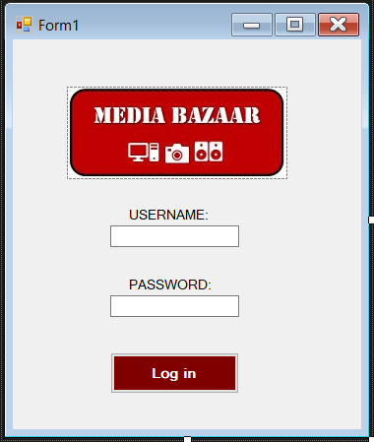

Figure 1.Login form layout

## Management view

If a user is a Manager, after submitting his credentials, the form with different statistics options will appear. Each option will generate appropriate graph based on the selection made.

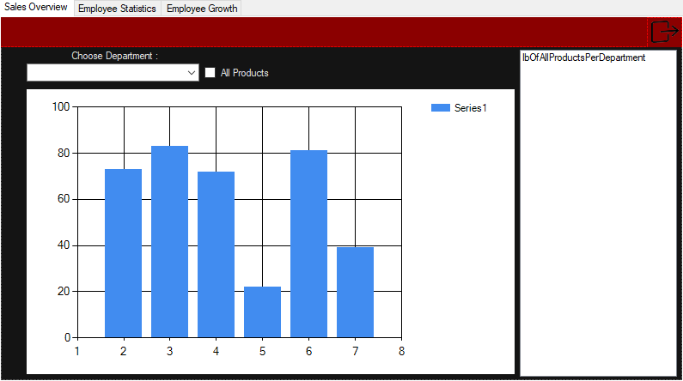

Figure 2.Sales overview section representing product sales growth

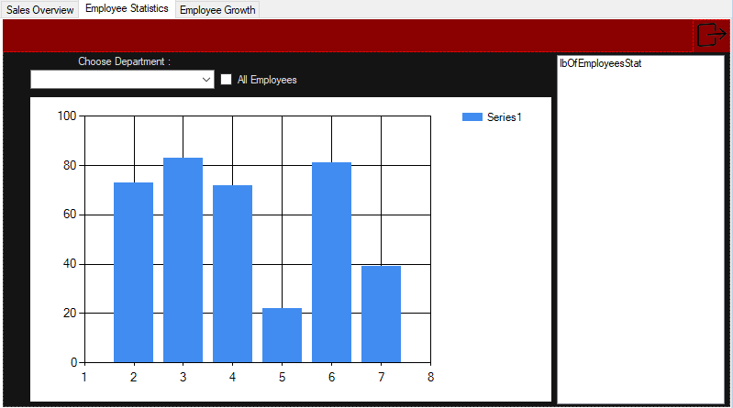

Figure 3. Employee Performance statistics representing employee attendance

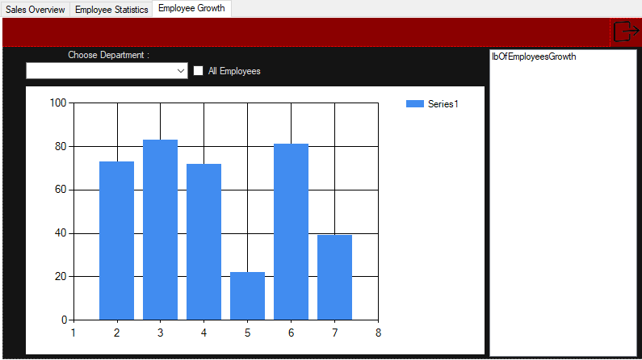

Figure 4. Employee growth

## Administrative Employee view

If a user is an Administrative employee, below menu will appear first. Each option provides different features.

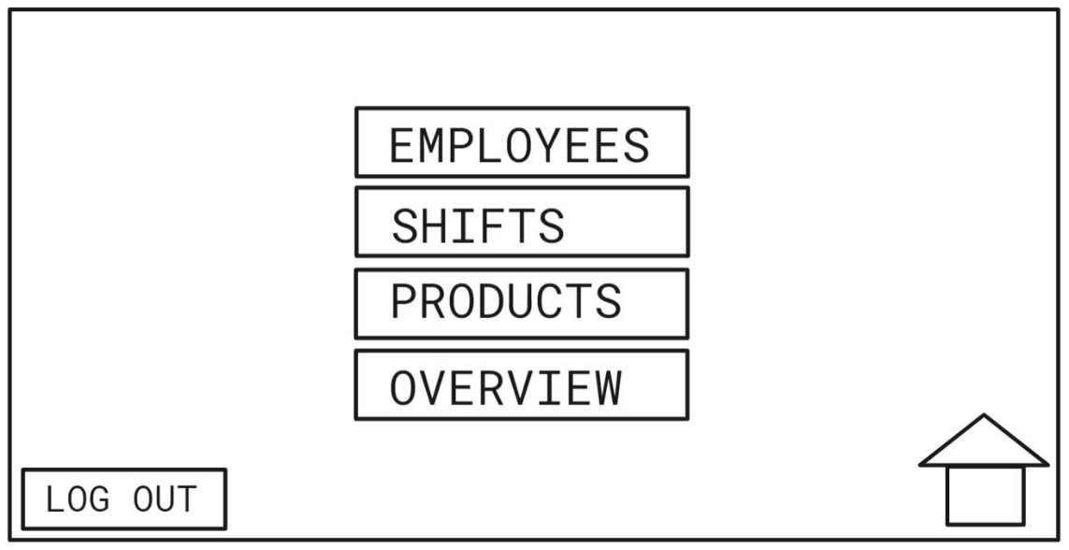

Figure 5. Administrative employee view menu option

Employees Section allows Administrative employee to add new hires. The username details will eventually be automatically sent to the employees’ email address.

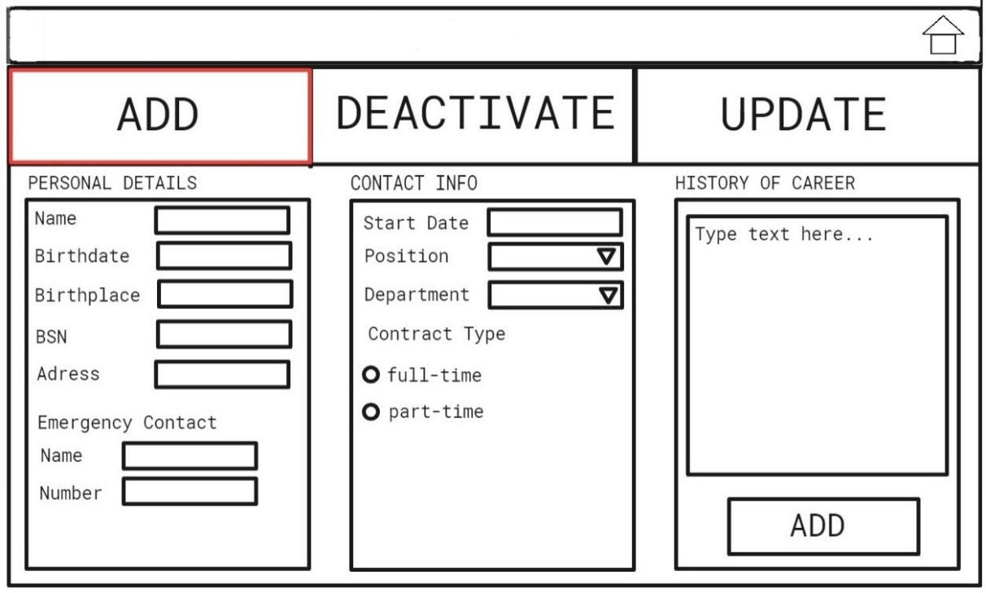

Figure 6. Option to add a new employee

The update tab enables Administrative employee to update information about an already existing employee.

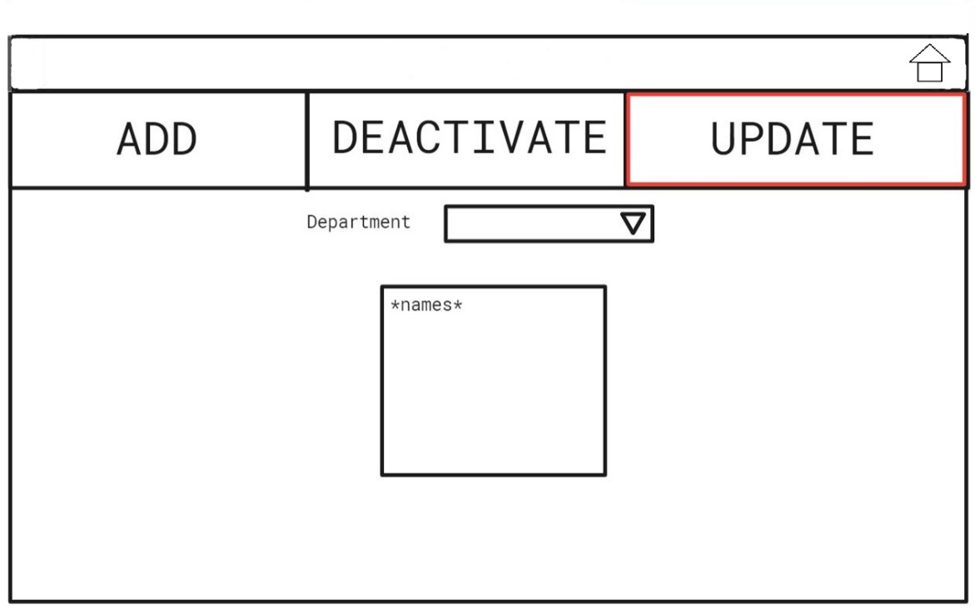

Figure 7. Option to update employee account, filtering employees per department

After selecting the employee from the department (double-click) the child form will appear with the view below. It allows to edit any fields about the employee and updates the database.

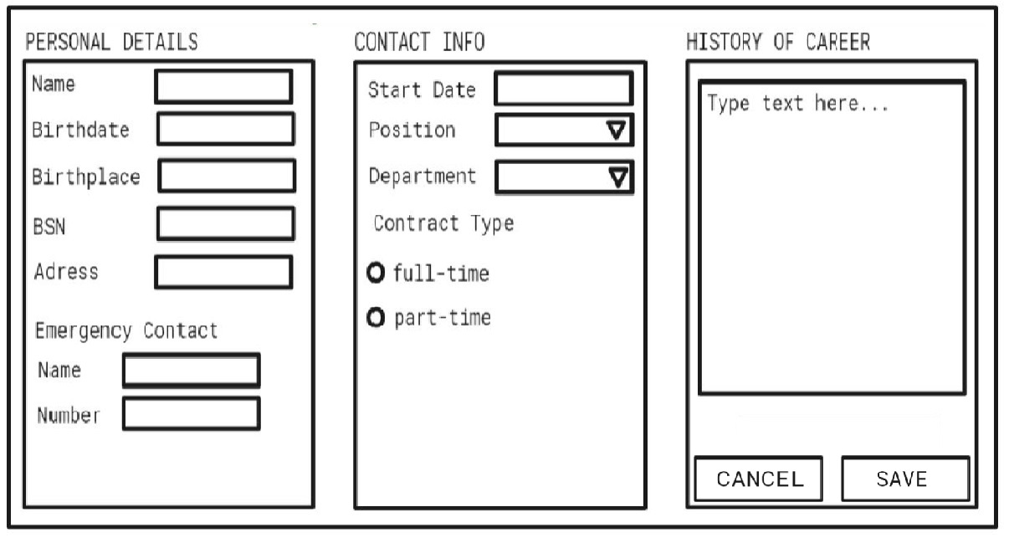

Figure 8. Child form to apply changes to an existing account

The Deactivate tab allows to disable employee account in case of employee retiring, quitting or getting fired.

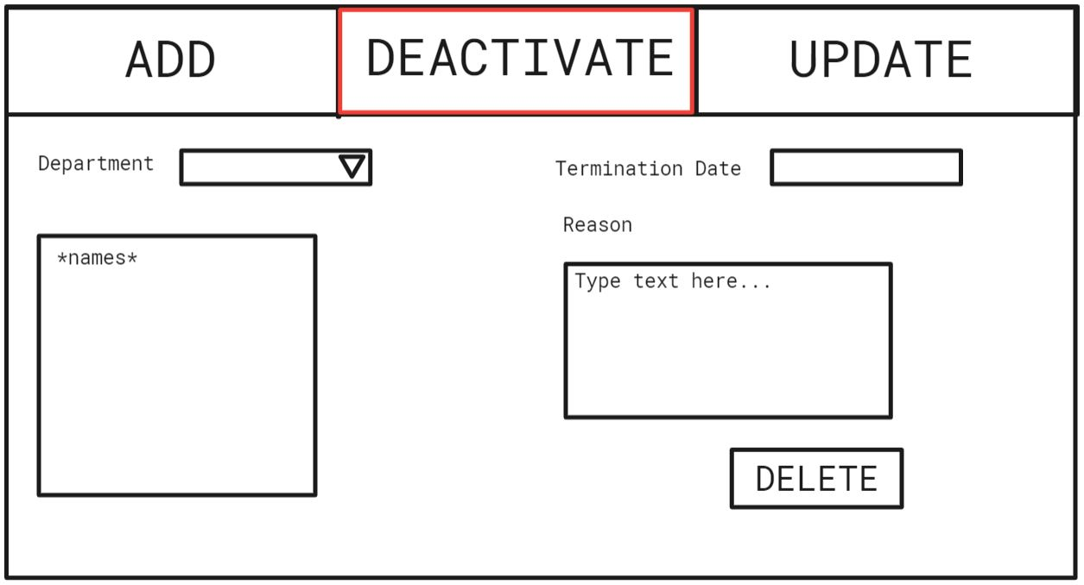

Figure 9. Option to deactivate an existing employee account

In the Shifts section Administrative employee can generate schedule for Floor employees per department one day at a time.

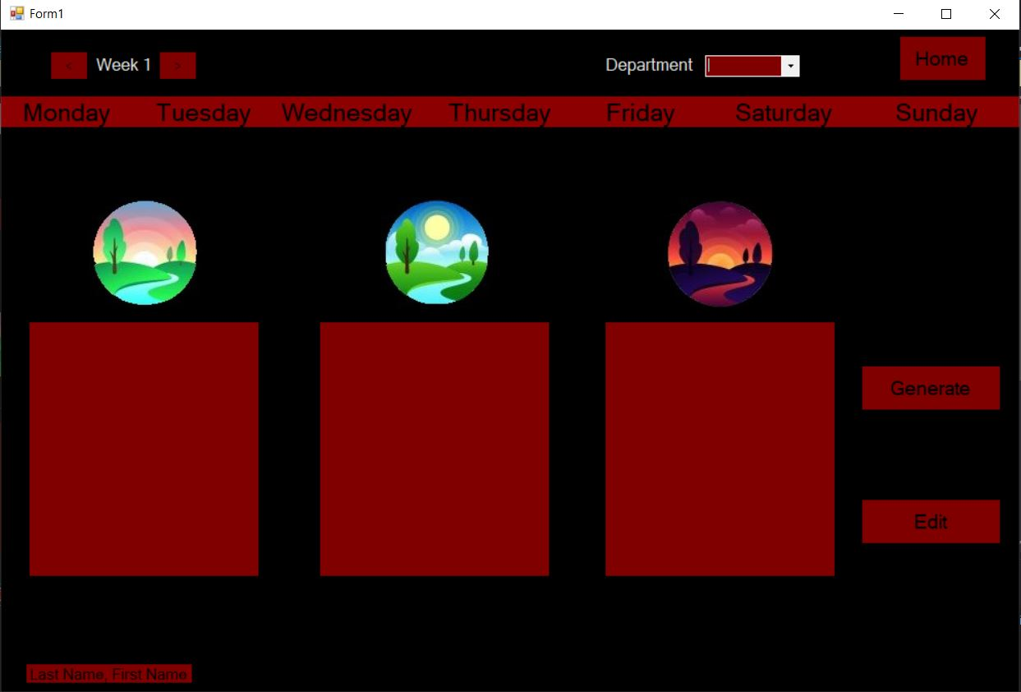

Figure 10. Option to generate schedule

The Products section enables adding new products to the database. When the new product is added an automated notification is send to Floor employees view. The right-side panel shows how employees managed the notifications sent by Administration team (i.e. whether the stock has been replenished, message received, any action taken regarding the notification).

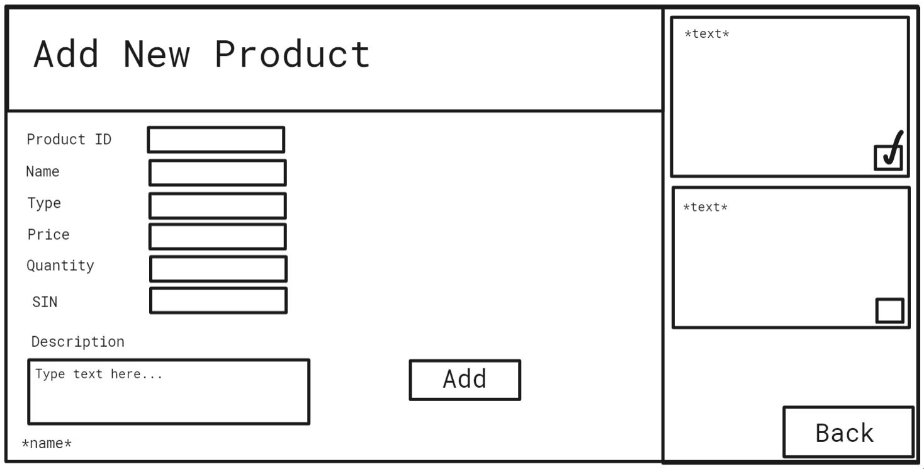

Figure 11. Option to add new products

Overview section is for employee performance statistics only. It has option to view the chart per department and per employee.

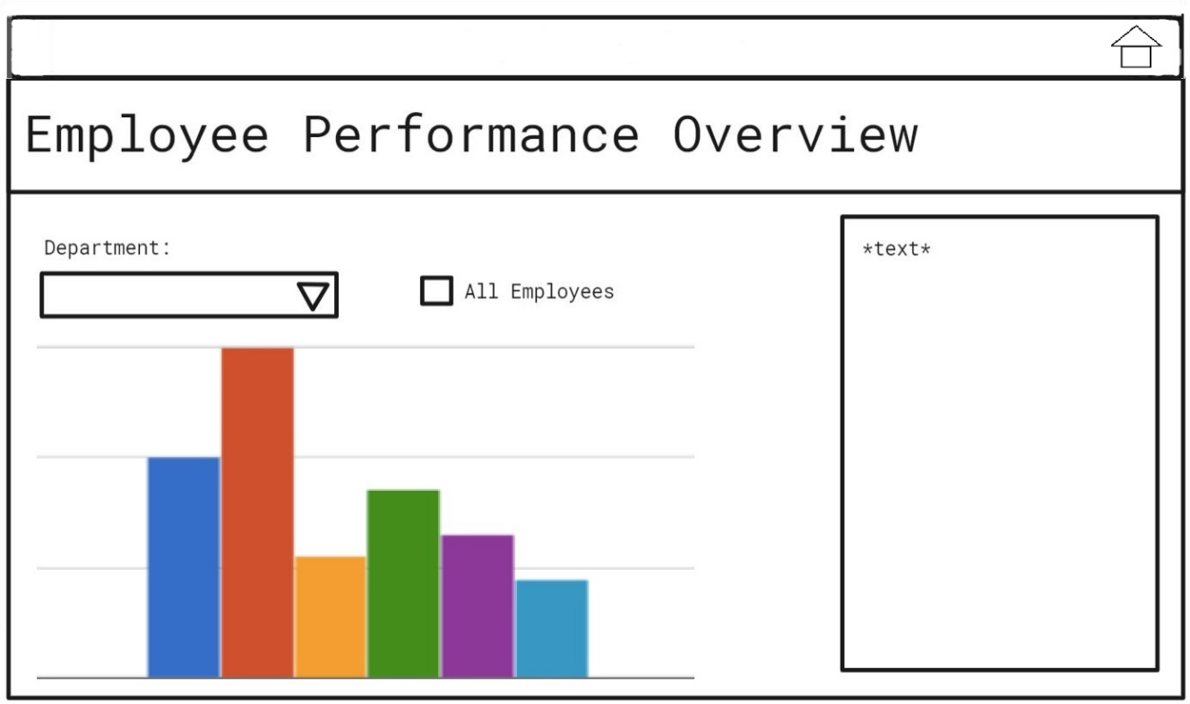

Figure 12. Employee Performance overview option

## Shop Floor Employees

Last view is for the shop Floor workers to perform their daily duties. First, they can pick the department they are stationed to work at. In the same section they can access their schedule.

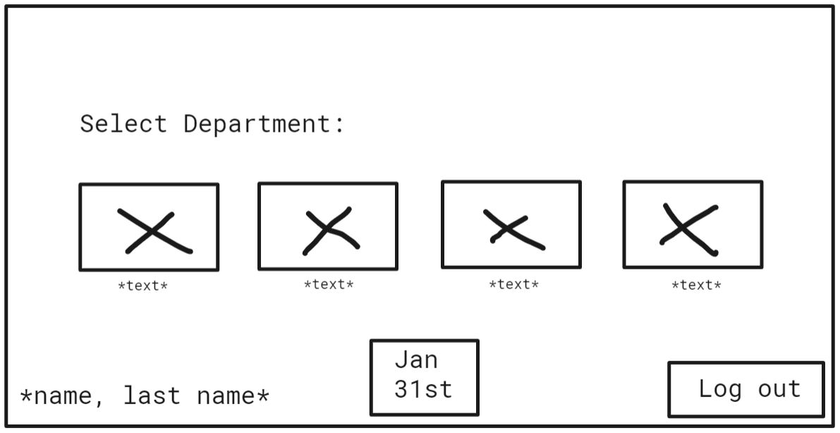

Figure 13. Floor employee view menu

After choosing the department the employee has access to product update section (to update product depletion and replenishment) and see messages from Administrative employees regarding any product changes (right side).

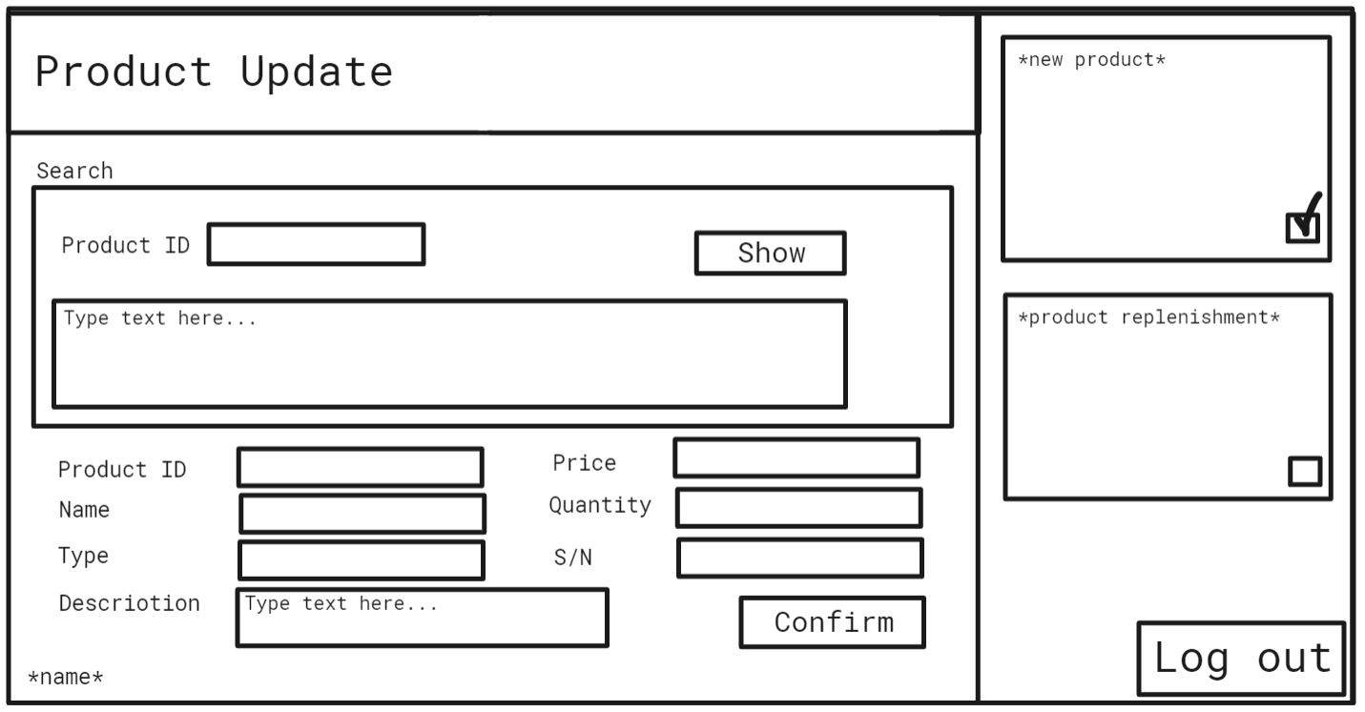

Figure 14. Product update for Floor Employees