Nguyễn Hồ Trường Tam_1150080156_Lap4_Buổi 6

Thực hành 1

Tạo kết nối giữa Winform và CSDL.
Mở SQL Server
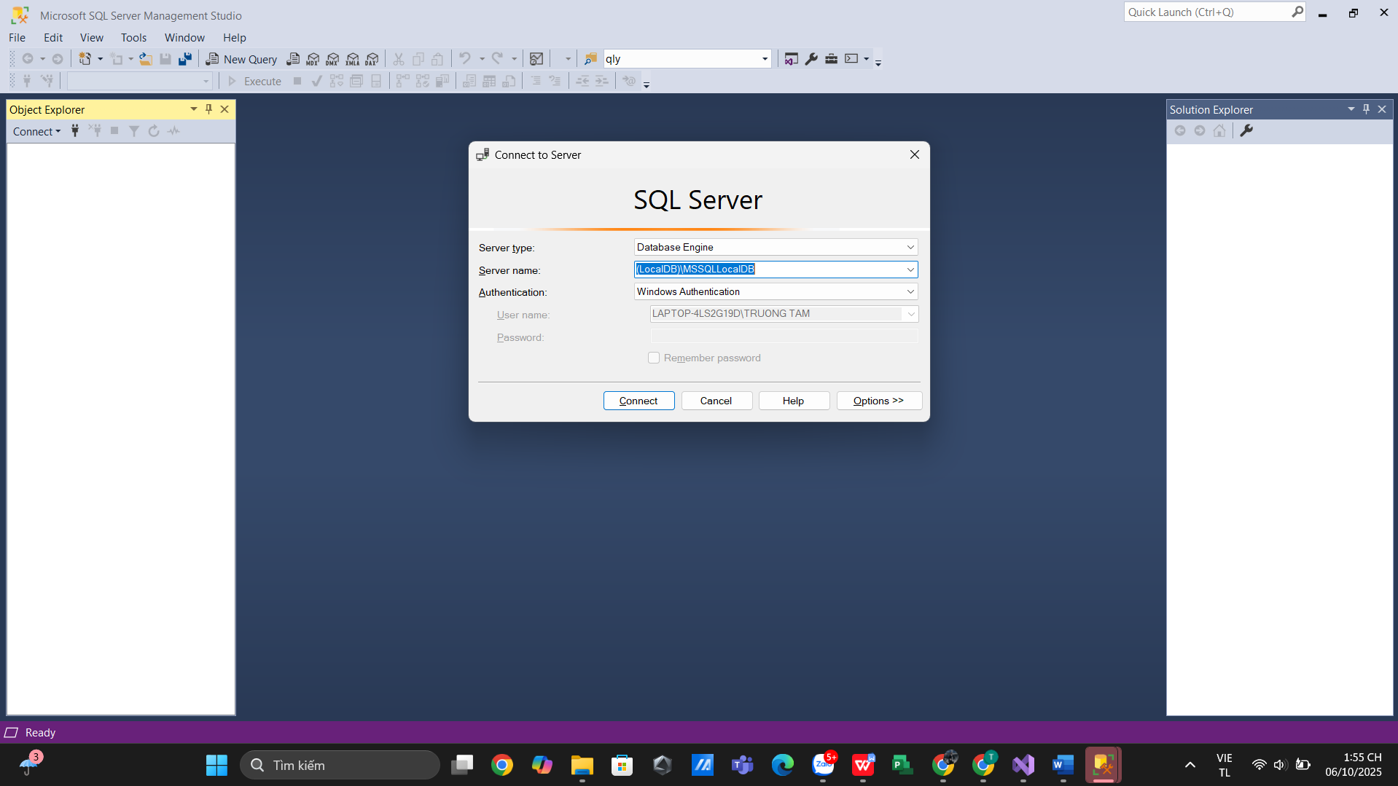
Tạo project Winform
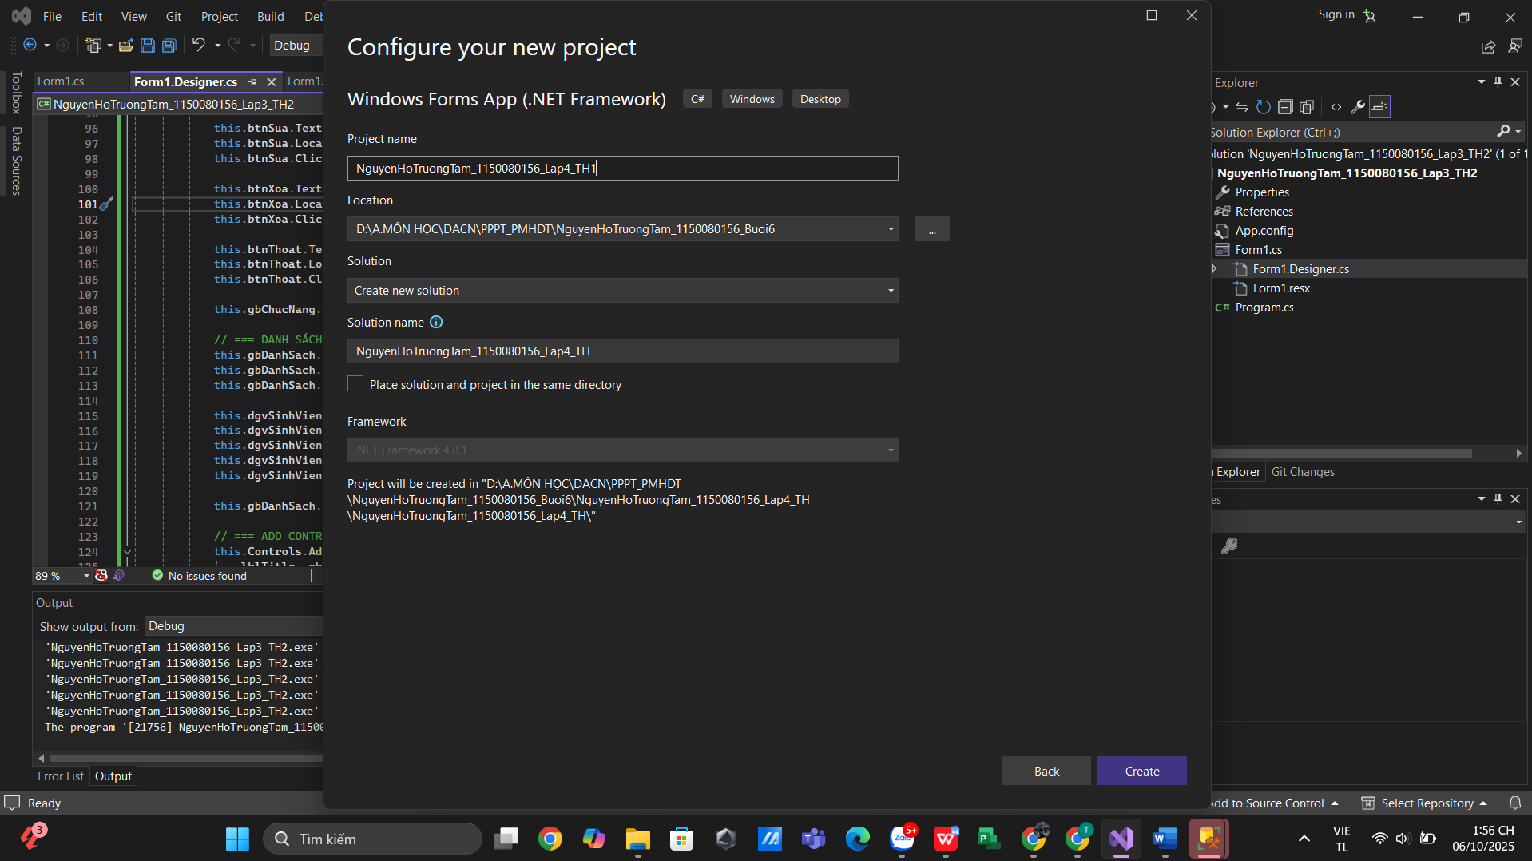
Kết Nối DataBase
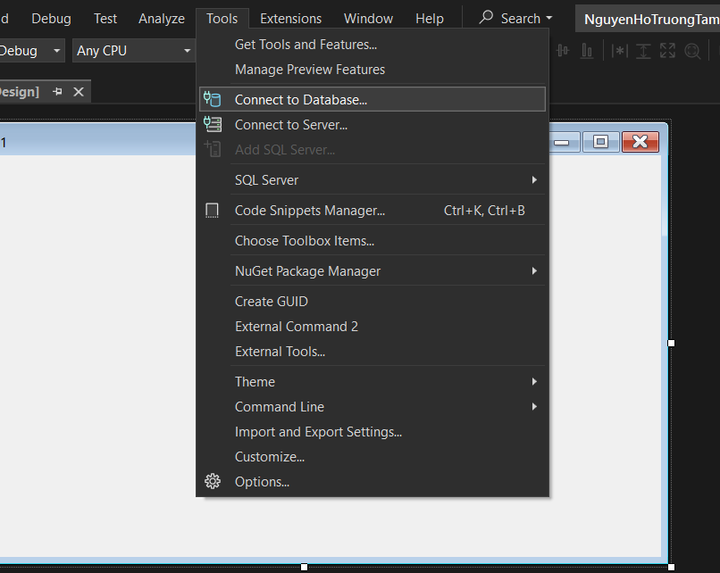
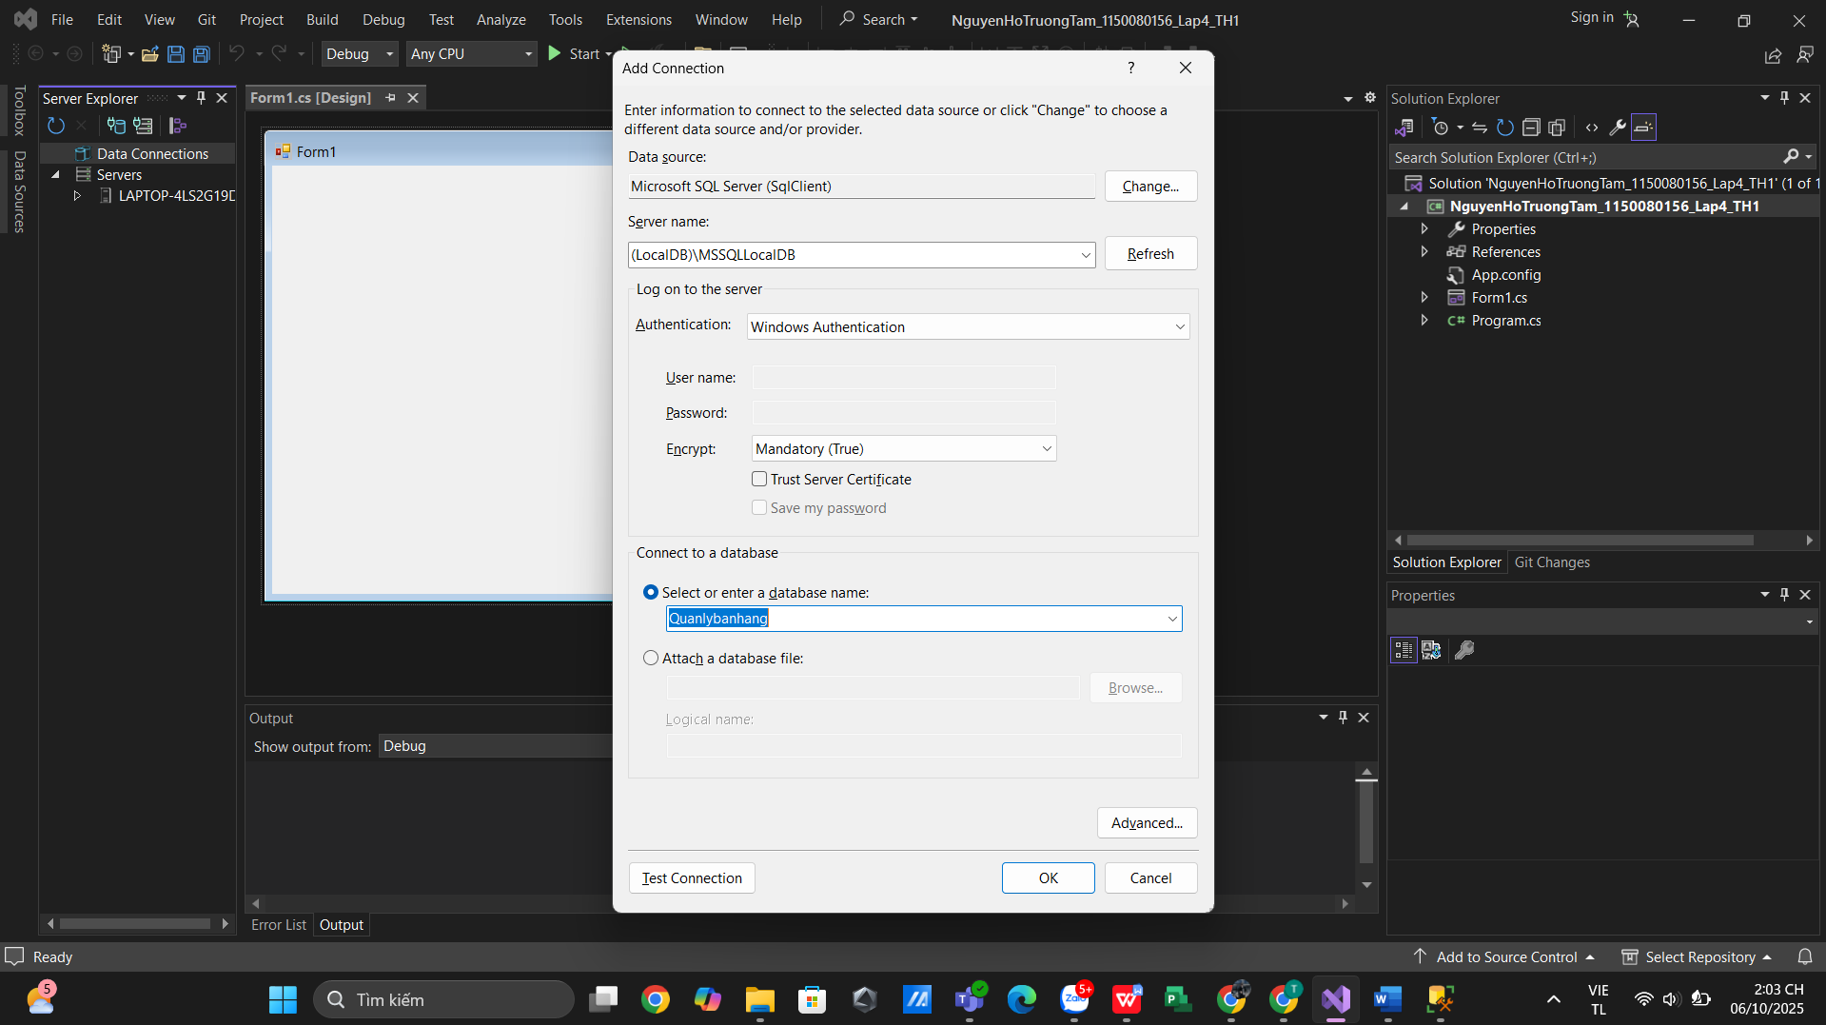
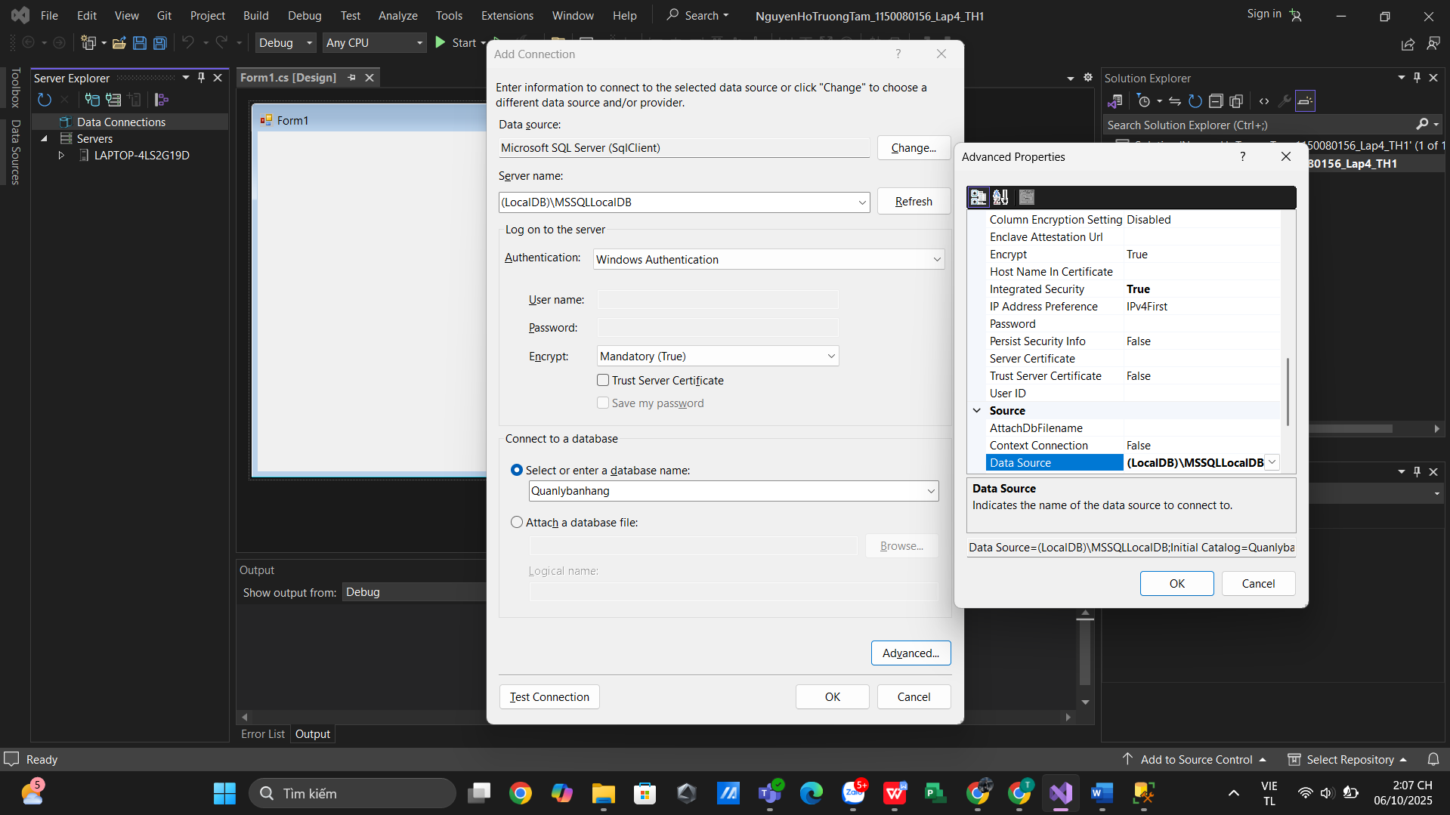
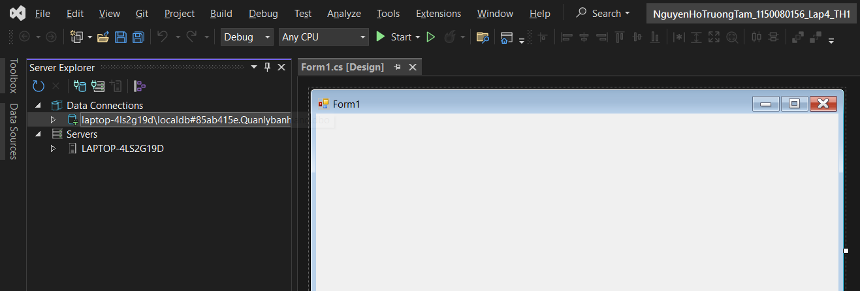

Mở kết nối

- Code Form1.cs
using System;
using System.Data;
using System.Data.SqlClient;
using System.Windows.Forms;

namespace NguyenHoTruongTam_1150080156_Lap4_TH1
{
public partial class Form1 : Form
{
// Chuỗi kết nối tới SQL Server
private string strCon = @"Data Source=(LocalDB)\MSSQLLocalDB;Initial Catalog=Quanlybanhang;Integrated Security=True";

// Biến kết nối dùng chung cho cả form
private SqlConnection sqlCon = null;

public Form1()
{
InitializeComponent();
}

private void Form1_Load(object sender, EventArgs e)
{
// Sự kiện load form (chưa cần code gì ở đây)
}

// Nút Mở kết nối
private void btnMoKetNoi_Click(object sender, EventArgs e)
{
try
{
if (sqlCon == null)
{
sqlCon = new SqlConnection(strCon);
}

if (sqlCon.State == ConnectionState.Closed)
{
sqlCon.Open();
MessageBox.Show("Kết nối thành công!", "Thông báo", MessageBoxButtons.OK, MessageBoxIcon.Information);
}
else
{
MessageBox.Show("Kết nối đã được mở rồi!", "Thông báo", MessageBoxButtons.OK, MessageBoxIcon.Warning);
}
}
catch (Exception ex)
{
MessageBox.Show("Lỗi khi kết nối: " + ex.Message, "Lỗi", MessageBoxButtons.OK, MessageBoxIcon.Error);
}
}

// Nút Đóng kết nối
private void btnDongKetNoi_Click(object sender, EventArgs e)
{
try
{
if (sqlCon != null && sqlCon.State == ConnectionState.Open)
{
sqlCon.Close();
MessageBox.Show("Đóng kết nối thành công!", "Thông báo", MessageBoxButtons.OK, MessageBoxIcon.Information);
}
else
{
MessageBox.Show("Chưa tạo kết nối hoặc kết nối đã đóng!", "Thông báo", MessageBoxButtons.OK, MessageBoxIcon.Warning);
}
}
catch (Exception ex)
{
MessageBox.Show("Lỗi khi đóng kết nối: " + ex.Message, "Lỗi", MessageBoxButtons.OK, MessageBoxIcon.Error);
}
}
}
}
- Code Form1.Designer.cs
namespace NguyenHoTruongTam_1150080156_Lap4_TH1
{
partial class Form1
{
/// <summary>
/// Required designer variable.
/// </summary>
private System.ComponentModel.IContainer components = null;

/// <summary>
/// Clean up any resources being used.
/// </summary>
/// <param name="disposing">true if managed resources should be disposed; otherwise, false.</param>
protected override void Dispose(bool disposing)
{
if (disposing && (components != null))
{
components.Dispose();
}
base.Dispose(disposing);
}

#region Windows Form Designer generated code

/// <summary>
/// Required method for Designer support - do not modify
/// the contents of this method with the code editor.
/// </summary>
private void InitializeComponent()
{
this.btnMoKetNoi = new System.Windows.Forms.Button();
this.btnDongKetNoi = new System.Windows.Forms.Button();
this.SuspendLayout();
//
// btnMoKetNoi
//
this.btnMoKetNoi.Location = new System.Drawing.Point(100, 100);
this.btnMoKetNoi.Name = "btnMoKetNoi";
this.btnMoKetNoi.Size = new System.Drawing.Size(150, 40);
this.btnMoKetNoi.TabIndex = 0;
this.btnMoKetNoi.Text = "Mở kết nối";
this.btnMoKetNoi.UseVisualStyleBackColor = true;
this.btnMoKetNoi.Click += new System.EventHandler(this.btnMoKetNoi_Click);
//
// btnDongKetNoi
//
this.btnDongKetNoi.Location = new System.Drawing.Point(300, 100);
this.btnDongKetNoi.Name = "btnDongKetNoi";
this.btnDongKetNoi.Size = new System.Drawing.Size(150, 40);
this.btnDongKetNoi.TabIndex = 1;
this.btnDongKetNoi.Text = "Đóng kết nối";
this.btnDongKetNoi.UseVisualStyleBackColor = true;
this.btnDongKetNoi.Click += new System.EventHandler(this.btnDongKetNoi_Click);
//
// Form1
//
this.AutoScaleDimensions = new System.Drawing.SizeF(8F, 16F);
this.AutoScaleMode = System.Windows.Forms.AutoScaleMode.Font;
this.ClientSize = new System.Drawing.Size(600, 300);
this.Controls.Add(this.btnDongKetNoi);
this.Controls.Add(this.btnMoKetNoi);
this.Name = "Form1";
this.Text = "Lab 4 - Kết nối SQL Server";
this.Load += new System.EventHandler(this.Form1_Load);
this.ResumeLayout(false);

}

#endregion

private System.Windows.Forms.Button btnMoKetNoi;
private System.Windows.Forms.Button btnDongKetNoi;
}
}
- Kết quả
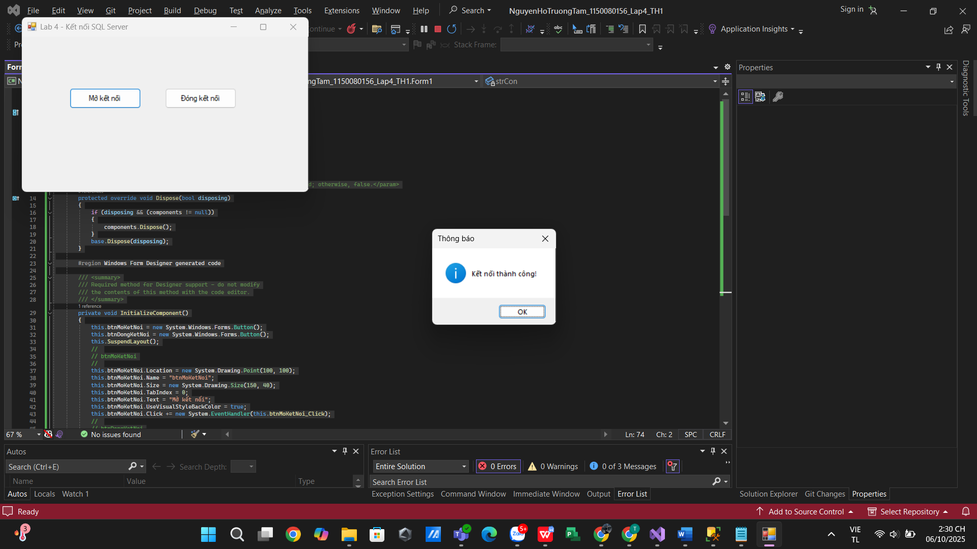

Thực hành 2

Truy vấn lấy 1 giá trị
  - Để truy vấn lấy 1 giá trị, ta dùng hàm ExecuteScalar.
  - Ví dụ: Đếm số lượng sinh viên trong bảng SinhVien

Chuẩn bị trong Form1.cs
- Bước 0.1 – using
using System;
using System.Data;
using System.Data.SqlClient;
using System.Windows.Forms;

- Bước 0.2 – biến toàn cục
// Chuỗi kết nối
private string strCon =
@"Data Source=DESKTOP-5HM23KN\SQLEXPRESS;Initial Catalog=Quanlybanhang;Integrated Security=True;TrustServerCertificate=True";

// Kết nối dùng chung
private SqlConnection sqlCon = null;

// Helper: bảo đảm đã mở kết nối
private bool EnsureOpen()
{
try
{
if (sqlCon == null) sqlCon = new SqlConnection(strCon);
if (sqlCon.State == ConnectionState.Closed) sqlCon.Open();
return true;
}
catch (Exception ex)
{
MessageBox.Show("Không mở được kết nối: " + ex.Message);
return false;
}
}

Thiết kế giao diện
Thêm Button vào Form
+ Name: btnCount
+ Text: Số lượng sinh viên
Nhấp đúp btnCount để tạo hàm xử lý Click.

Code xử lý btnCount_Click

private void btnCount_Click(object sender, EventArgs e)
{
if (!EnsureOpen()) return;

// Dùng ExecuteScalar để lấy 1 giá trị
using (var sqlCmd = new SqlCommand("SELECT COUNT(*) FROM SinhVien", sqlCon))
{
int soLuongSV = (int)sqlCmd.ExecuteScalar();
MessageBox.Show("Số lượng sinh viên là: " + soLuongSV);
}
}

Kết quả
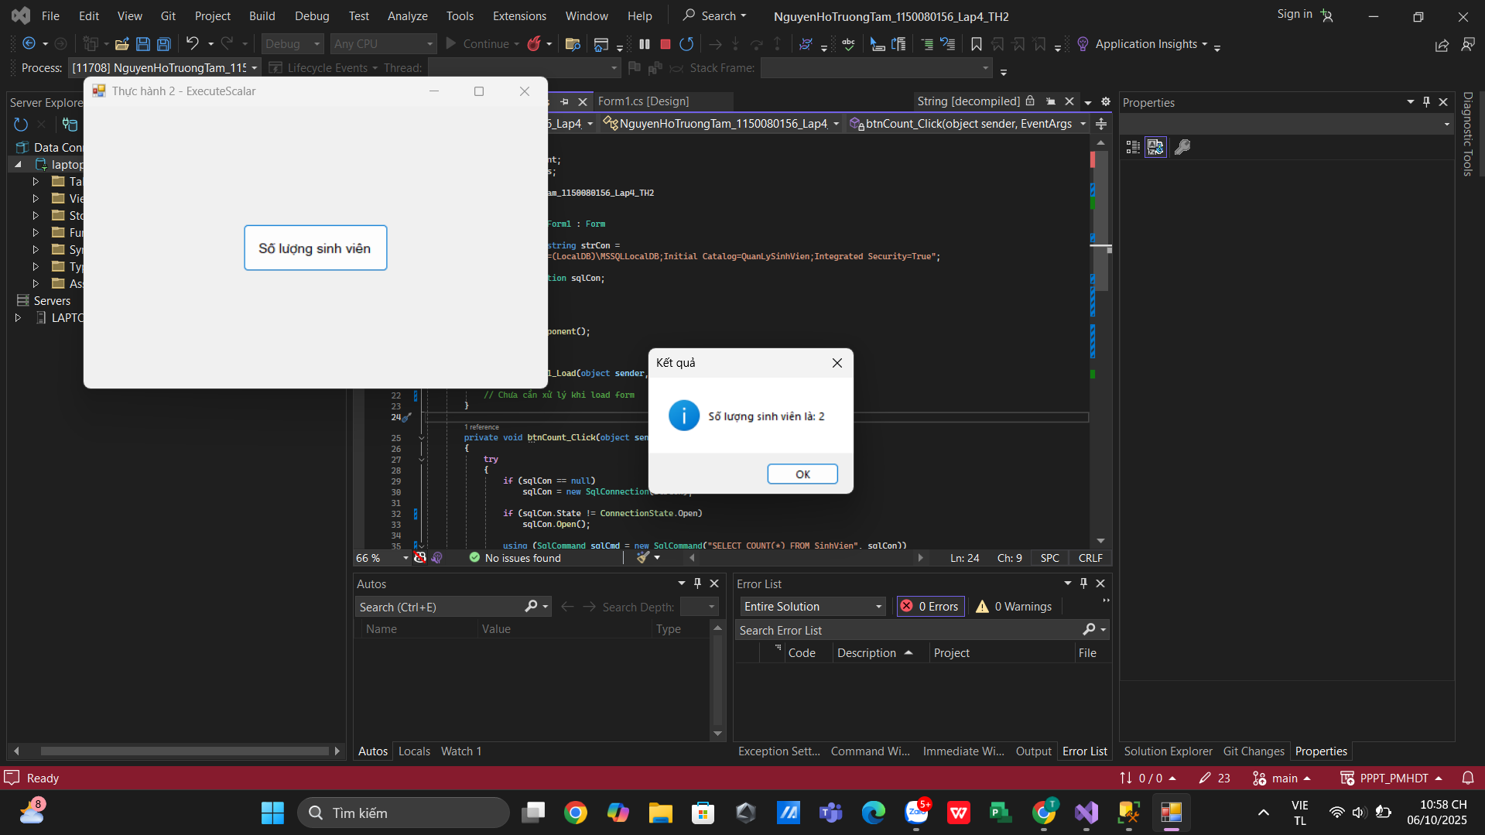

Code Form1.cs
using System;
using System.Data;
using System.Data.SqlClient;
using System.Windows.Forms;

namespace NguyenHoTruongTam_1150080156_Lap4_TH2
{
public partial class Form1 : Form
{
private readonly string strCon =
@"Data Source=(LocalDB)\MSSQLLocalDB;Initial Catalog=QuanLySinhVien;Integrated Security=True";

private SqlConnection sqlCon;

public Form1()
{
InitializeComponent();
}

private void Form1_Load(object sender, EventArgs e)
{
// Chưa cần xử lý khi load form
}

private void btnCount_Click(object sender, EventArgs e)
{
try
{
if (sqlCon == null)
sqlCon = new SqlConnection(strCon);

if (sqlCon.State != ConnectionState.Open)
sqlCon.Open();

using (SqlCommand sqlCmd = new SqlCommand("SELECT COUNT(*) FROM SinhVien", sqlCon))
{
int soLuongSV = (int)sqlCmd.ExecuteScalar();
MessageBox.Show($"Số lượng sinh viên là: {soLuongSV}",
"Kết quả", MessageBoxButtons.OK, MessageBoxIcon.Information);
}
}
catch (Exception ex)
{
MessageBox.Show("Lỗi: " + ex.Message, "Thông báo lỗi",
MessageBoxButtons.OK, MessageBoxIcon.Error);
}
finally
{
if (sqlCon != null && sqlCon.State == ConnectionState.Open)
sqlCon.Close();
}
}
}
}

Code Form1.Designer.cs
using System;
using System.Windows.Forms;

namespace NguyenHoTruongTam_1150080156_Lap4_TH2
{
partial class Form1
{
/// <summary>
/// Required designer variable.
/// </summary>
private System.ComponentModel.IContainer components = null;

/// <summary>
/// Clean up any resources being used.
/// </summary>
protected override void Dispose(bool disposing)
{
if (disposing && (components != null))
components.Dispose();
base.Dispose(disposing);
}

#region Windows Form Designer generated code

private void InitializeComponent()
{
this.btnCount = new System.Windows.Forms.Button();
this.SuspendLayout();
//
// btnCount
//
this.btnCount.Font = new System.Drawing.Font("Microsoft Sans Serif", 10F);
this.btnCount.Location = new System.Drawing.Point(220, 150);
this.btnCount.Name = "btnCount";
this.btnCount.Size = new System.Drawing.Size(200, 60);
this.btnCount.TabIndex = 0;
this.btnCount.Text = "Số lượng sinh viên";
this.btnCount.UseVisualStyleBackColor = true;
this.btnCount.Click += new System.EventHandler(this.btnCount_Click);
//
// Form1
//
this.AutoScaleDimensions = new System.Drawing.SizeF(8F, 16F);
this.AutoScaleMode = System.Windows.Forms.AutoScaleMode.Font;
this.ClientSize = new System.Drawing.Size(640, 360);
this.Controls.Add(this.btnCount);
this.Name = "Form1";
this.Text = "Thực hành 2 - ExecuteScalar";
this.Load += new System.EventHandler(this.Form1_Load);
this.ResumeLayout(false);
}

#endregion

private System.Windows.Forms.Button btnCount;
}
}
- Truy vấn lấy 1 dòng dữ liệu

Kết quả
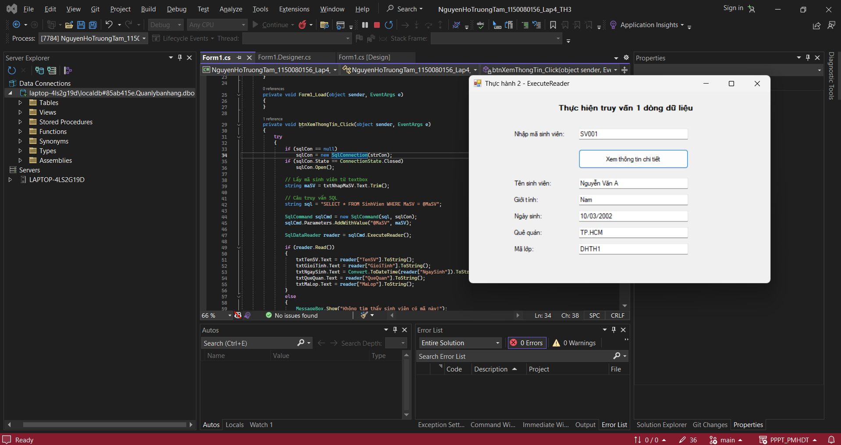

Code Form1.cs
using System;
using System.Collections.Generic;
using System.ComponentModel;
using System.Data;
using System.Data.SqlClient;
using System.Drawing;
using System.Linq;
using System.Text;
using System.Threading.Tasks;
using System.Windows.Forms;

namespace NguyenHoTruongTam_1150080156_Lap4_TH3
{
public partial class Form1 : Form
{
private string strCon =
@"Data Source=(LocalDB)\MSSQLLocalDB;Initial Catalog=QuanLySinhVien;Integrated Security=True";
private SqlConnection sqlCon = null;

public Form1()
{
InitializeComponent();
}

private void Form1_Load(object sender, EventArgs e)
{
}

private void btnXemThongTin_Click(object sender, EventArgs e)
{
try
{
if (sqlCon == null)
sqlCon = new SqlConnection(strCon);
if (sqlCon.State == ConnectionState.Closed)
sqlCon.Open();

// Lấy mã sinh viên từ textbox
string maSV = txtNhapMaSV.Text.Trim();

// Câu truy vấn SQL
string sql = "SELECT * FROM SinhVien WHERE MaSV = @MaSV";

SqlCommand sqlCmd = new SqlCommand(sql, sqlCon);
sqlCmd.Parameters.AddWithValue("@MaSV", maSV);

SqlDataReader reader = sqlCmd.ExecuteReader();

if (reader.Read())
{
txtTenSV.Text = reader["TenSV"].ToString();
txtGioiTinh.Text = reader["GioiTinh"].ToString();
txtNgaySinh.Text = Convert.ToDateTime(reader["NgaySinh"]).ToString("dd/MM/yyyy");
txtQueQuan.Text = reader["QueQuan"].ToString();
txtMaLop.Text = reader["MaLop"].ToString();
}
else
{
MessageBox.Show("Không tìm thấy sinh viên có mã này!");
ClearFields();
}

reader.Close();
sqlCon.Close();
}
catch (Exception ex)
{
MessageBox.Show("Lỗi: " + ex.Message);
}
}

private void ClearFields()
{
txtTenSV.Clear();
txtGioiTinh.Clear();
txtNgaySinh.Clear();
txtQueQuan.Clear();
txtMaLop.Clear();
}

private void Form1_Load_1(object sender, EventArgs e)
{

}
}
}

Code Form1.Designer.cs
namespace NguyenHoTruongTam_1150080156_Lap4_TH3
{
partial class Form1
{
private System.ComponentModel.IContainer components = null;

protected override void Dispose(bool disposing)
{
if (disposing && (components != null))
components.Dispose();
base.Dispose(disposing);
}

private void InitializeComponent()
{
this.lblTitle = new System.Windows.Forms.Label();
this.lblMaSV = new System.Windows.Forms.Label();
this.txtNhapMaSV = new System.Windows.Forms.TextBox();
this.btnXemThongTin = new System.Windows.Forms.Button();
this.lblTenSV = new System.Windows.Forms.Label();
this.lblGioiTinh = new System.Windows.Forms.Label();
this.lblNgaySinh = new System.Windows.Forms.Label();
this.lblQueQuan = new System.Windows.Forms.Label();
this.lblMaLop = new System.Windows.Forms.Label();
this.txtTenSV = new System.Windows.Forms.TextBox();
this.txtGioiTinh = new System.Windows.Forms.TextBox();
this.txtNgaySinh = new System.Windows.Forms.TextBox();
this.txtQueQuan = new System.Windows.Forms.TextBox();
this.txtMaLop = new System.Windows.Forms.TextBox();
this.SuspendLayout();
//
// lblTitle
//
this.lblTitle.AutoSize = true;
this.lblTitle.Font = new System.Drawing.Font("Microsoft Sans Serif", 10F, System.Drawing.FontStyle.Bold);
this.lblTitle.Location = new System.Drawing.Point(160, 20);
this.lblTitle.Name = "lblTitle";
this.lblTitle.Size = new System.Drawing.Size(288, 20);
this.lblTitle.TabIndex = 0;
this.lblTitle.Text = "Thực hiện truy vấn 1 dòng dữ liệu";
//
// lblMaSV
//
this.lblMaSV.AutoSize = true;
this.lblMaSV.Location = new System.Drawing.Point(80, 70);
this.lblMaSV.Name = "lblMaSV";
this.lblMaSV.Size = new System.Drawing.Size(120, 16);
this.lblMaSV.TabIndex = 1;
this.lblMaSV.Text = "Nhập mã sinh viên:";
//
// txtNhapMaSV
//
this.txtNhapMaSV.Location = new System.Drawing.Point(200, 67);
this.txtNhapMaSV.Name = "txtNhapMaSV";
this.txtNhapMaSV.Size = new System.Drawing.Size(200, 22);
this.txtNhapMaSV.TabIndex = 2;
//
// btnXemThongTin
//
this.btnXemThongTin.Location = new System.Drawing.Point(200, 105);
this.btnXemThongTin.Name = "btnXemThongTin";
this.btnXemThongTin.Size = new System.Drawing.Size(200, 35);
this.btnXemThongTin.TabIndex = 3;
this.btnXemThongTin.Text = "Xem thông tin chi tiết";
this.btnXemThongTin.UseVisualStyleBackColor = true;
this.btnXemThongTin.Click += new System.EventHandler(this.btnXemThongTin_Click);
//
// lblTenSV
//
this.lblTenSV.AutoSize = true;
this.lblTenSV.Location = new System.Drawing.Point(80, 160);
this.lblTenSV.Name = "lblTenSV";
this.lblTenSV.Size = new System.Drawing.Size(89, 16);
this.lblTenSV.TabIndex = 4;
this.lblTenSV.Text = "Tên sinh viên:";
//
// lblGioiTinh
//
this.lblGioiTinh.AutoSize = true;
this.lblGioiTinh.Location = new System.Drawing.Point(80, 190);
this.lblGioiTinh.Name = "lblGioiTinh";
this.lblGioiTinh.Size = new System.Drawing.Size(57, 16);
this.lblGioiTinh.TabIndex = 5;
this.lblGioiTinh.Text = "Giới tính:";
//
// lblNgaySinh
//
this.lblNgaySinh.AutoSize = true;
this.lblNgaySinh.Location = new System.Drawing.Point(80, 220);
this.lblNgaySinh.Name = "lblNgaySinh";
this.lblNgaySinh.Size = new System.Drawing.Size(70, 16);
this.lblNgaySinh.TabIndex = 6;
this.lblNgaySinh.Text = "Ngày sinh:";
//
// lblQueQuan
//
this.lblQueQuan.AutoSize = true;
this.lblQueQuan.Location = new System.Drawing.Point(80, 250);
this.lblQueQuan.Name = "lblQueQuan";
this.lblQueQuan.Size = new System.Drawing.Size(68, 16);
this.lblQueQuan.TabIndex = 7;
this.lblQueQuan.Text = "Quê quán:";
//
// lblMaLop
//
this.lblMaLop.AutoSize = true;
this.lblMaLop.Location = new System.Drawing.Point(80, 280);
this.lblMaLop.Name = "lblMaLop";
this.lblMaLop.Size = new System.Drawing.Size(51, 16);
this.lblMaLop.TabIndex = 8;
this.lblMaLop.Text = "Mã lớp:";
//
// txtTenSV
//
this.txtTenSV.Location = new System.Drawing.Point(200, 157);
this.txtTenSV.Name = "txtTenSV";
this.txtTenSV.Size = new System.Drawing.Size(200, 22);
this.txtTenSV.TabIndex = 9;
//
// txtGioiTinh
//
this.txtGioiTinh.Location = new System.Drawing.Point(200, 187);
this.txtGioiTinh.Name = "txtGioiTinh";
this.txtGioiTinh.Size = new System.Drawing.Size(200, 22);
this.txtGioiTinh.TabIndex = 10;
//
// txtNgaySinh
//
this.txtNgaySinh.Location = new System.Drawing.Point(200, 217);
this.txtNgaySinh.Name = "txtNgaySinh";
this.txtNgaySinh.Size = new System.Drawing.Size(200, 22);
this.txtNgaySinh.TabIndex = 11;
//
// txtQueQuan
//
this.txtQueQuan.Location = new System.Drawing.Point(200, 247);
this.txtQueQuan.Name = "txtQueQuan";
this.txtQueQuan.Size = new System.Drawing.Size(200, 22);
this.txtQueQuan.TabIndex = 12;
//
// txtMaLop
//
this.txtMaLop.Location = new System.Drawing.Point(200, 277);
this.txtMaLop.Name = "txtMaLop";
this.txtMaLop.Size = new System.Drawing.Size(200, 22);
this.txtMaLop.TabIndex = 13;
//
// Form1
//
this.ClientSize = new System.Drawing.Size(550, 350);
this.Controls.Add(this.lblTitle);
this.Controls.Add(this.lblMaSV);
this.Controls.Add(this.txtNhapMaSV);
this.Controls.Add(this.btnXemThongTin);
this.Controls.Add(this.lblTenSV);
this.Controls.Add(this.lblGioiTinh);
this.Controls.Add(this.lblNgaySinh);
this.Controls.Add(this.lblQueQuan);
this.Controls.Add(this.lblMaLop);
this.Controls.Add(this.txtTenSV);
this.Controls.Add(this.txtGioiTinh);
this.Controls.Add(this.txtNgaySinh);
this.Controls.Add(this.txtQueQuan);
this.Controls.Add(this.txtMaLop);
this.Name = "Form1";
this.Text = "Thực hành 2 - ExecuteReader";
this.Load += new System.EventHandler(this.Form1_Load_1);
this.ResumeLayout(false);
this.PerformLayout();

}

private System.Windows.Forms.Label lblTitle;
private System.Windows.Forms.Label lblMaSV;
private System.Windows.Forms.Label lblTenSV;
private System.Windows.Forms.Label lblGioiTinh;
private System.Windows.Forms.Label lblNgaySinh;
private System.Windows.Forms.Label lblQueQuan;
private System.Windows.Forms.Label lblMaLop;
private System.Windows.Forms.TextBox txtNhapMaSV;
private System.Windows.Forms.TextBox txtTenSV;
private System.Windows.Forms.TextBox txtGioiTinh;
private System.Windows.Forms.TextBox txtNgaySinh;
private System.Windows.Forms.TextBox txtQueQuan;
private System.Windows.Forms.TextBox txtMaLop;
private System.Windows.Forms.Button btnXemThongTin;
}
}

- Truy vấn lấy nhiều dòng dữ liệu

Kết quả
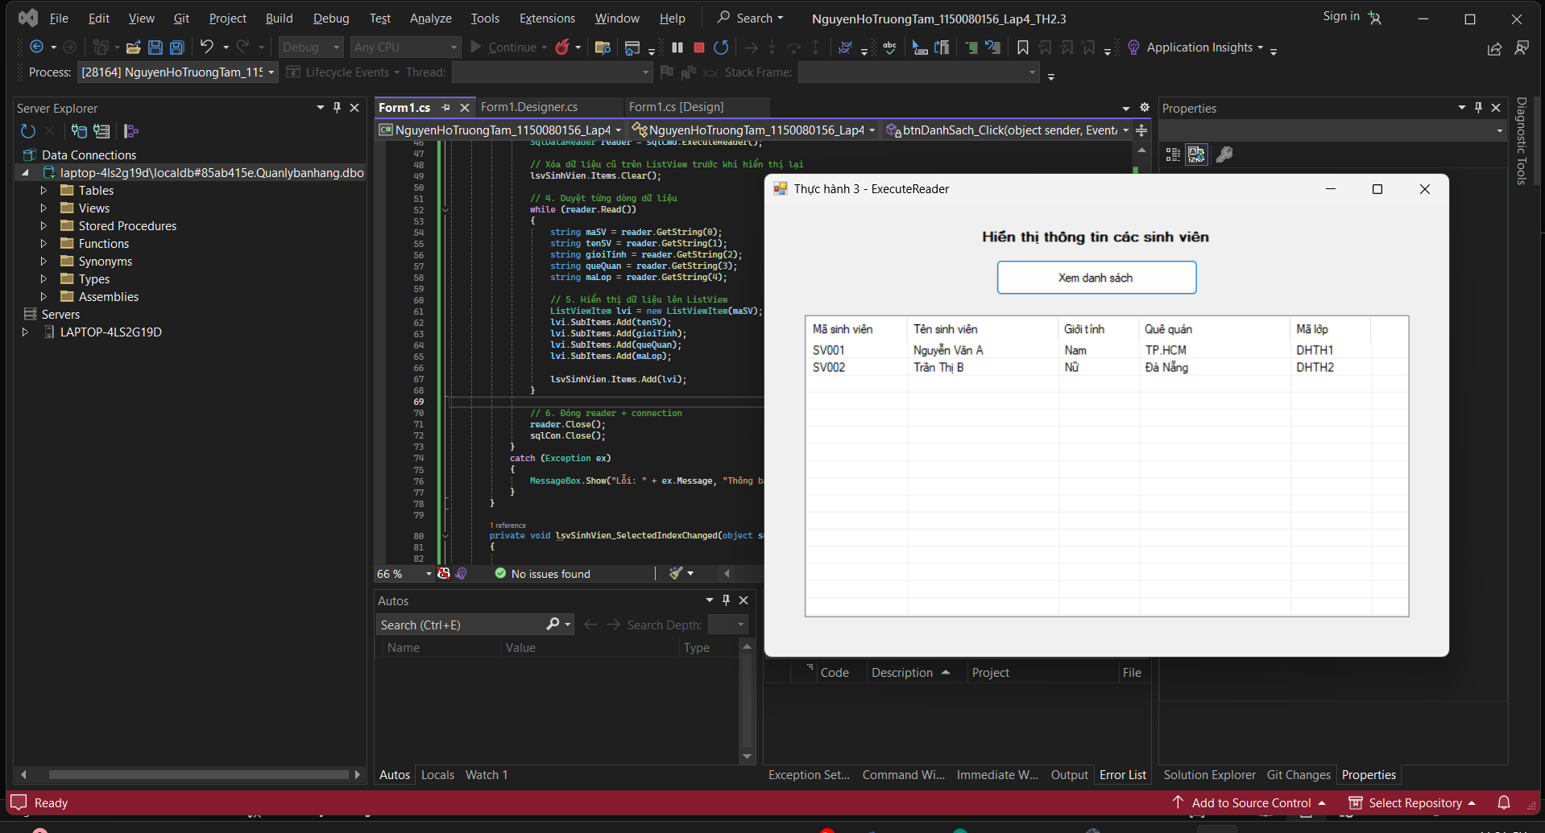

Code Form1.cs
using System;
using System.Collections.Generic;
using System.ComponentModel;
using System.Data;
using System.Data.SqlClient;
using System.Drawing;
using System.Linq;
using System.Text;
using System.Threading.Tasks;
using System.Windows.Forms;

namespace NguyenHoTruongTam_1150080156_Lap4_TH2._3
{
public partial class Form1 : Form
{
private string strCon =
@"Data Source=(LocalDB)\MSSQLLocalDB;Initial Catalog=QuanLySinhVien;Integrated Security=True";
private SqlConnection sqlCon = null;

public Form1()
{
InitializeComponent();
}

private void Form1_Load(object sender, EventArgs e)
{
}

private void btnDanhSach_Click(object sender, EventArgs e)
{
try
{
// 1. Mở kết nối
if (sqlCon == null)
sqlCon = new SqlConnection(strCon);
if (sqlCon.State == ConnectionState.Closed)
sqlCon.Open();

// 2. Tạo đối tượng thực thi truy vấn
SqlCommand sqlCmd = new SqlCommand();
sqlCmd.CommandType = CommandType.Text;
sqlCmd.CommandText = "SELECT MaSV, TenSV, GioiTinh, QueQuan, MaLop FROM SinhVien";
sqlCmd.Connection = sqlCon;

// 3. Thực thi truy vấn và đọc dữ liệu
SqlDataReader reader = sqlCmd.ExecuteReader();

// Xóa dữ liệu cũ trên ListView trước khi hiển thị lại
lsvSinhVien.Items.Clear();

// 4. Duyệt từng dòng dữ liệu
while (reader.Read())
{
string maSV = reader.GetString(0);
string tenSV = reader.GetString(1);
string gioiTinh = reader.GetString(2);
string queQuan = reader.GetString(3);
string maLop = reader.GetString(4);

// 5. Hiển thị dữ liệu lên ListView
ListViewItem lvi = new ListViewItem(maSV);
lvi.SubItems.Add(tenSV);
lvi.SubItems.Add(gioiTinh);
lvi.SubItems.Add(queQuan);
lvi.SubItems.Add(maLop);

lsvSinhVien.Items.Add(lvi);
}

// 6. Đóng reader + connection
reader.Close();
sqlCon.Close();
}
catch (Exception ex)
{
MessageBox.Show("Lỗi: " + ex.Message, "Thông báo lỗi");
}
}

private void lsvSinhVien_SelectedIndexChanged(object sender, EventArgs e)
{

}
}
}

Code Form1.Designer.cs
namespace NguyenHoTruongTam_1150080156_Lap4_TH2._3
{
partial class Form1
{
private System.ComponentModel.IContainer components = null;

protected override void Dispose(bool disposing)
{
if (disposing && (components != null))
components.Dispose();
base.Dispose(disposing);
}

private void InitializeComponent()
{
this.labelTitle = new System.Windows.Forms.Label();
this.btnDanhSach = new System.Windows.Forms.Button();
this.lsvSinhVien = new System.Windows.Forms.ListView();
this.colMaSV = ((System.Windows.Forms.ColumnHeader)(new System.Windows.Forms.ColumnHeader()));
this.colTenSV = ((System.Windows.Forms.ColumnHeader)(new System.Windows.Forms.ColumnHeader()));
this.colGioiTinh = ((System.Windows.Forms.ColumnHeader)(new System.Windows.Forms.ColumnHeader()));
this.colQueQuan = ((System.Windows.Forms.ColumnHeader)(new System.Windows.Forms.ColumnHeader()));
this.colMaLop = ((System.Windows.Forms.ColumnHeader)(new System.Windows.Forms.ColumnHeader()));
this.SuspendLayout();
//
// labelTitle
//
this.labelTitle.Font = new System.Drawing.Font("Microsoft Sans Serif", 10F, System.Drawing.FontStyle.Bold);
this.labelTitle.Location = new System.Drawing.Point(180, 20);
this.labelTitle.Name = "labelTitle";
this.labelTitle.Size = new System.Drawing.Size(300, 23);
this.labelTitle.TabIndex = 0;
this.labelTitle.Text = "Hiển thị thông tin các sinh viên";
this.labelTitle.TextAlign = System.Drawing.ContentAlignment.MiddleCenter;
//
// btnDanhSach
//
this.btnDanhSach.Location = new System.Drawing.Point(230, 55);
this.btnDanhSach.Name = "btnDanhSach";
this.btnDanhSach.Size = new System.Drawing.Size(200, 35);
this.btnDanhSach.TabIndex = 1;
this.btnDanhSach.Text = "Xem danh sách";
this.btnDanhSach.UseVisualStyleBackColor = true;
this.btnDanhSach.Click += new System.EventHandler(this.btnDanhSach_Click);
//
// lsvSinhVien
//
this.lsvSinhVien.Columns.AddRange(new System.Windows.Forms.ColumnHeader[] {
this.colMaSV,
this.colTenSV,
this.colGioiTinh,
this.colQueQuan,
this.colMaLop});
this.lsvSinhVien.FullRowSelect = true;
this.lsvSinhVien.GridLines = true;
this.lsvSinhVien.HideSelection = false;
this.lsvSinhVien.Location = new System.Drawing.Point(40, 110);
this.lsvSinhVien.Name = "lsvSinhVien";
this.lsvSinhVien.Size = new System.Drawing.Size(600, 300);
this.lsvSinhVien.TabIndex = 2;
this.lsvSinhVien.UseCompatibleStateImageBehavior = false;
this.lsvSinhVien.View = System.Windows.Forms.View.Details;
this.lsvSinhVien.SelectedIndexChanged += new System.EventHandler(this.lsvSinhVien_SelectedIndexChanged);
//
// colMaSV
//
this.colMaSV.Text = "Mã sinh viên";
this.colMaSV.Width = 100;
//
// colTenSV
//
this.colTenSV.Text = "Tên sinh viên";
this.colTenSV.Width = 150;
//
// colGioiTinh
//
this.colGioiTinh.Text = "Giới tính";
this.colGioiTinh.Width = 80;
//
// colQueQuan
//
this.colQueQuan.Text = "Quê quán";
this.colQueQuan.Width = 150;
//
// colMaLop
//
this.colMaLop.Text = "Mã lớp";
this.colMaLop.Width = 80;
//
// Form1
//
this.ClientSize = new System.Drawing.Size(680, 450);
this.Controls.Add(this.lsvSinhVien);
this.Controls.Add(this.btnDanhSach);
this.Controls.Add(this.labelTitle);
this.Name = "Form1";
this.Text = "Thực hành 3 - ExecuteReader";
this.Load += new System.EventHandler(this.Form1_Load);
this.ResumeLayout(false);

}

private System.Windows.Forms.Label labelTitle;
private System.Windows.Forms.Button btnDanhSach;
private System.Windows.Forms.ListView lsvSinhVien;
private System.Windows.Forms.ColumnHeader colMaSV;
private System.Windows.Forms.ColumnHeader colTenSV;
private System.Windows.Forms.ColumnHeader colGioiTinh;
private System.Windows.Forms.ColumnHeader colQueQuan;
private System.Windows.Forms.ColumnHeader colMaLop;
}
}
- Sử dụng Parameter để truy vấn dữ liệu trong C#

Kết quả
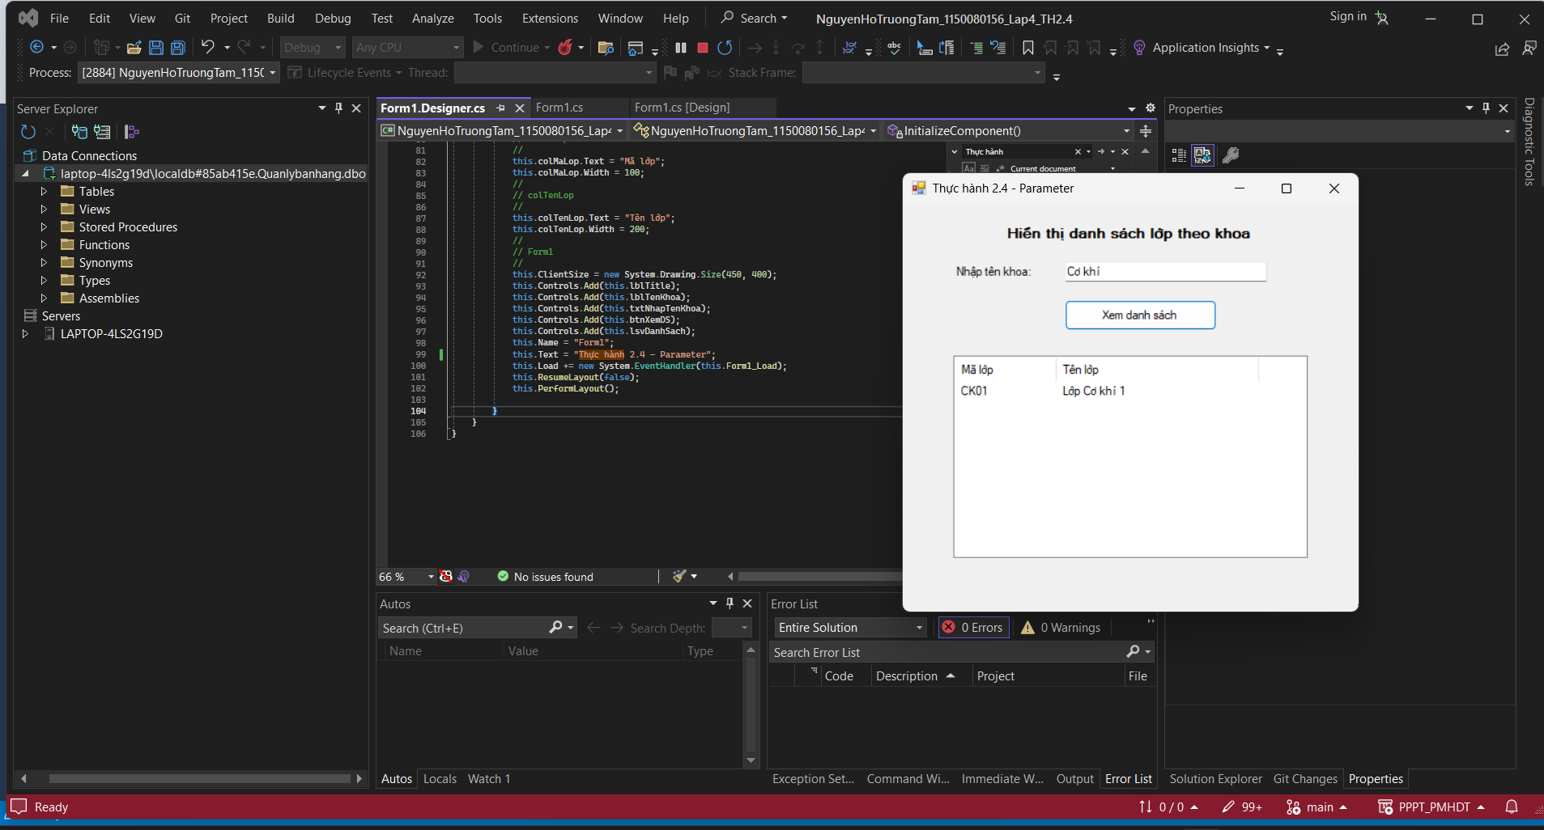

Code Form1.cs
using System;
using System.Collections.Generic;
using System.ComponentModel;
using System.Data;
using System.Data.SqlClient; // ✅ thêm dòng này
using System.Drawing;
using System.Linq;
using System.Text;
using System.Threading.Tasks;
using System.Windows.Forms;

namespace NguyenHoTruongTam_1150080156_Lap4_TH2._4
{
public partial class Form1 : Form
{
// Chuỗi kết nối đến SQL Server
private string strCon =
@"Data Source=(LocalDB)\MSSQLLocalDB;Initial Catalog=QuanLySinhVien;Integrated Security=True";

private SqlConnection sqlCon = null;

public Form1()
{
InitializeComponent();
}

private void btnXemDS_Click(object sender, EventArgs e)
{
try
{
// Mở kết nối
if (sqlCon == null)
{
sqlCon = new SqlConnection(strCon);
}
if (sqlCon.State == ConnectionState.Closed)
{
sqlCon.Open();
}

// Lấy thông tin từ textbox
string tenKhoa = txtNhapTenKhoa.Text.Trim();
string maKhoa = "";

// Gán mã khoa tương ứng
if (tenKhoa == "Công nghệ thông tin")
maKhoa = "CNTT";
else if (tenKhoa == "Cơ khí")
maKhoa = "CK";
else if (tenKhoa == "Điện tử")
maKhoa = "DT";
else if (tenKhoa == "Kinh tế")
maKhoa = "KT";
else
maKhoa = "Sai rồi";

if (maKhoa == "Sai rồi")
{
MessageBox.Show("Tên khoa không hợp lệ!", "Thông báo lỗi",
MessageBoxButtons.OK, MessageBoxIcon.Error);
return;
}

// Tạo đối tượng truy vấn
SqlCommand sqlCmd = new SqlCommand();
sqlCmd.CommandType = CommandType.Text;
sqlCmd.CommandText = "SELECT * FROM Lop WHERE MaKhoa = @maKhoa";

// Tạo parameter
SqlParameter parMaKhoa = new SqlParameter("@maKhoa", SqlDbType.Char);
parMaKhoa.Value = maKhoa;
sqlCmd.Parameters.Add(parMaKhoa);

// Gán kết nối
sqlCmd.Connection = sqlCon;

// Thực thi truy vấn
SqlDataReader reader = sqlCmd.ExecuteReader();

// Xóa dữ liệu cũ trên ListView (nếu có)
lsvDanhSach.Items.Clear();

while (reader.Read())
{
// Đọc dữ liệu trong database
string maLop = reader.GetString(0);
string tenLop = reader.GetString(1);

// Hiển thị lên ListView
ListViewItem lvi = new ListViewItem(maLop);
lvi.SubItems.Add(tenLop);
lsvDanhSach.Items.Add(lvi);
}

// Đóng DataReader
reader.Close();
}
catch (Exception ex)
{
MessageBox.Show("Lỗi: " + ex.Message, "Thông báo lỗi",
MessageBoxButtons.OK, MessageBoxIcon.Error);
}
}

private void Form1_Load(object sender, EventArgs e)
{

}
}
}

Code Form1.Designer.cs
namespace NguyenHoTruongTam_1150080156_Lap4_TH2._4
{
partial class Form1
{
private System.ComponentModel.IContainer components = null;
private System.Windows.Forms.Label lblTitle;
private System.Windows.Forms.Label lblTenKhoa;
private System.Windows.Forms.TextBox txtNhapTenKhoa;
private System.Windows.Forms.Button btnXemDS;
private System.Windows.Forms.ListView lsvDanhSach;
private System.Windows.Forms.ColumnHeader colMaLop;
private System.Windows.Forms.ColumnHeader colTenLop;

protected override void Dispose(bool disposing)
{
if (disposing && (components != null))
components.Dispose();
base.Dispose(disposing);
}

private void InitializeComponent()
{
this.lblTitle = new System.Windows.Forms.Label();
this.lblTenKhoa = new System.Windows.Forms.Label();
this.txtNhapTenKhoa = new System.Windows.Forms.TextBox();
this.btnXemDS = new System.Windows.Forms.Button();
this.lsvDanhSach = new System.Windows.Forms.ListView();
this.colMaLop = ((System.Windows.Forms.ColumnHeader)(new System.Windows.Forms.ColumnHeader()));
this.colTenLop = ((System.Windows.Forms.ColumnHeader)(new System.Windows.Forms.ColumnHeader()));
this.SuspendLayout();
//
// lblTitle
//
this.lblTitle.AutoSize = true;
this.lblTitle.Font = new System.Drawing.Font("Microsoft Sans Serif", 10F, System.Drawing.FontStyle.Bold);
this.lblTitle.Location = new System.Drawing.Point(100, 20);
this.lblTitle.Name = "lblTitle";
this.lblTitle.Size = new System.Drawing.Size(285, 20);
this.lblTitle.TabIndex = 0;
this.lblTitle.Text = "Hiển thị danh sách lớp theo khoa";
//
// lblTenKhoa
//
this.lblTenKhoa.AutoSize = true;
this.lblTenKhoa.Location = new System.Drawing.Point(50, 60);
this.lblTenKhoa.Name = "lblTenKhoa";
this.lblTenKhoa.Size = new System.Drawing.Size(97, 16);
this.lblTenKhoa.TabIndex = 1;
this.lblTenKhoa.Text = "Nhập tên khoa:";
//
// txtNhapTenKhoa
//
this.txtNhapTenKhoa.Location = new System.Drawing.Point(160, 57);
this.txtNhapTenKhoa.Name = "txtNhapTenKhoa";
this.txtNhapTenKhoa.Size = new System.Drawing.Size(200, 22);
this.txtNhapTenKhoa.TabIndex = 2;
//
// btnXemDS
//
this.btnXemDS.Location = new System.Drawing.Point(160, 95);
this.btnXemDS.Name = "btnXemDS";
this.btnXemDS.Size = new System.Drawing.Size(150, 30);
this.btnXemDS.TabIndex = 3;
this.btnXemDS.Text = "Xem danh sách";
this.btnXemDS.Click += new System.EventHandler(this.btnXemDS_Click);
//
// lsvDanhSach
//
this.lsvDanhSach.Columns.AddRange(new System.Windows.Forms.ColumnHeader[] {
this.colMaLop,
this.colTenLop});
this.lsvDanhSach.HideSelection = false;
this.lsvDanhSach.Location = new System.Drawing.Point(50, 150);
this.lsvDanhSach.Name = "lsvDanhSach";
this.lsvDanhSach.Size = new System.Drawing.Size(350, 200);
this.lsvDanhSach.TabIndex = 4;
this.lsvDanhSach.UseCompatibleStateImageBehavior = false;
this.lsvDanhSach.View = System.Windows.Forms.View.Details;
//
// colMaLop
//
this.colMaLop.Text = "Mã lớp";
this.colMaLop.Width = 100;
//
// colTenLop
//
this.colTenLop.Text = "Tên lớp";
this.colTenLop.Width = 200;
//
// Form1
//
this.ClientSize = new System.Drawing.Size(450, 400);
this.Controls.Add(this.lblTitle);
this.Controls.Add(this.lblTenKhoa);
this.Controls.Add(this.txtNhapTenKhoa);
this.Controls.Add(this.btnXemDS);
this.Controls.Add(this.lsvDanhSach);
this.Name = "Form1";
this.Text = "Thực hành 2.4 - Parameter";
this.Load += new System.EventHandler(this.Form1_Load);
this.ResumeLayout(false);
this.PerformLayout();

}
}
}

- Áp dụng Hiển thị danh sách sinh viên theo mã lớp.

Kết quả
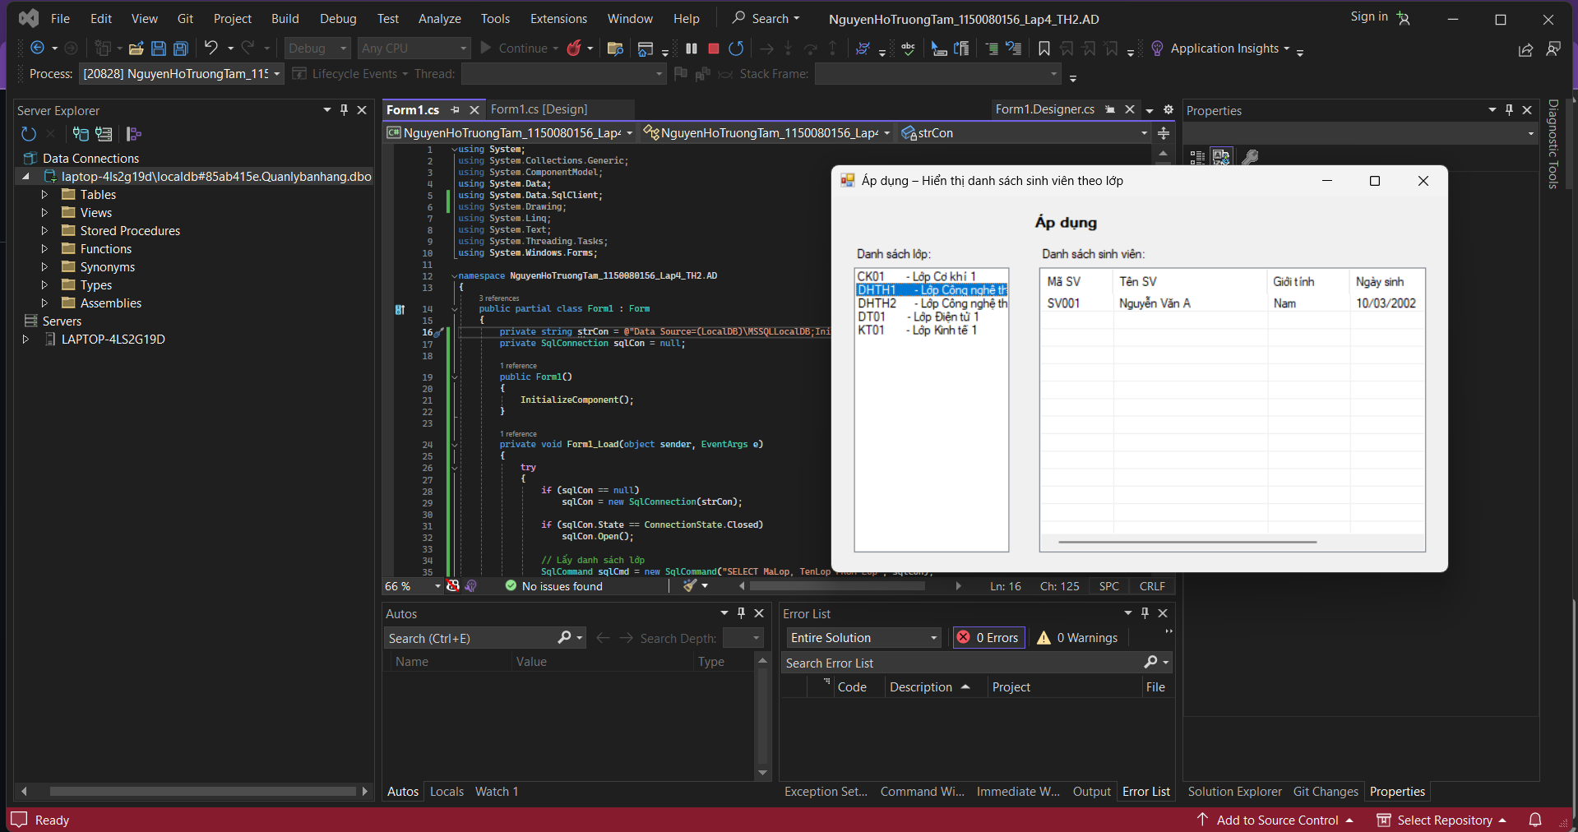

Code Form1.cs
using System;
using System.Collections.Generic;
using System.ComponentModel;
using System.Data;
using System.Data.SqlClient;
using System.Drawing;
using System.Linq;
using System.Text;
using System.Threading.Tasks;
using System.Windows.Forms;

namespace NguyenHoTruongTam_1150080156_Lap4_TH2.AD
{
public partial class Form1 : Form
{
private string strCon = @"Data Source=(LocalDB)\MSSQLLocalDB;Initial Catalog=QuanLySinhVien;Integrated Security=True";
private SqlConnection sqlCon = null;

public Form1()
{
InitializeComponent();
}

private void Form1_Load(object sender, EventArgs e)
{
try
{
if (sqlCon == null)
sqlCon = new SqlConnection(strCon);

if (sqlCon.State == ConnectionState.Closed)
sqlCon.Open();

// Lấy danh sách lớp
SqlCommand sqlCmd = new SqlCommand("SELECT MaLop, TenLop FROM Lop", sqlCon);
SqlDataReader reader = sqlCmd.ExecuteReader();

while (reader.Read())
{
string maLop = reader.GetString(0);
string tenLop = reader.GetString(1);
lsbDSLop.Items.Add($"{maLop} - {tenLop}");
}

reader.Close();
}
catch (Exception ex)
{
MessageBox.Show("Lỗi tải danh sách lớp: " + ex.Message);
}
}

private void lsbDSLop_SelectedIndexChanged(object sender, EventArgs e)
{
if (lsbDSLop.SelectedItem == null) return;

// Lấy mã lớp từ chuỗi "MaLop - TenLop"
string selected = lsbDSLop.SelectedItem.ToString();
string maLop = selected.Split('-')[0].Trim();

try
{
if (sqlCon == null)
sqlCon = new SqlConnection(strCon);

if (sqlCon.State == ConnectionState.Closed)
sqlCon.Open();

lsvDSSV.Items.Clear();

SqlCommand sqlCmd = new SqlCommand();
sqlCmd.CommandType = CommandType.Text;
sqlCmd.CommandText = "SELECT MaSV, TenSV, GioiTinh, NgaySinh, QueQuan FROM SinhVien WHERE MaLop = @MaLop";
sqlCmd.Parameters.AddWithValue("@MaLop", maLop);
sqlCmd.Connection = sqlCon;

SqlDataReader reader = sqlCmd.ExecuteReader();
while (reader.Read())
{
string maSV = reader.GetString(0);
string tenSV = reader.GetString(1);
string gioiTinh = reader.GetString(2);
string ngaySinh = reader.GetDateTime(3).ToString("dd/MM/yyyy");
string queQuan = reader.GetString(4);

ListViewItem lvi = new ListViewItem(maSV);
lvi.SubItems.Add(tenSV);
lvi.SubItems.Add(gioiTinh);
lvi.SubItems.Add(ngaySinh);
lvi.SubItems.Add(queQuan);
lsvDSSV.Items.Add(lvi);
}
reader.Close();
}
catch (Exception ex)
{
MessageBox.Show("Lỗi hiển thị sinh viên: " + ex.Message);
}
}
}
}

Code Form1.Designer.cs
namespace NguyenHoTruongTam_1150080156_Lap4_TH2.AD
{
partial class Form1
{
/// <summary>
/// Required designer variable.
/// </summary>
private System.ComponentModel.IContainer components = null;

/// <summary>
/// Clean up any resources being used.
/// </summary>
/// <param name="disposing">true if managed resources should be disposed; otherwise, false.</param>
protected override void Dispose(bool disposing)
{
if (disposing && (components != null))
{
components.Dispose();
}
base.Dispose(disposing);
}

#region Windows Form Designer generated code

/// <summary>
/// Required method for Designer support - do not modify
/// the contents of this method with the code editor.
/// </summary>
private void InitializeComponent()
{
this.lblTitle = new System.Windows.Forms.Label();
this.lblDSLop = new System.Windows.Forms.Label();
this.lblDSSV = new System.Windows.Forms.Label();
this.lsbDSLop = new System.Windows.Forms.ListBox();
this.lsvDSSV = new System.Windows.Forms.ListView();
this.colMaSV = ((System.Windows.Forms.ColumnHeader)(new System.Windows.Forms.ColumnHeader()));
this.colTenSV = ((System.Windows.Forms.ColumnHeader)(new System.Windows.Forms.ColumnHeader()));
this.colGioiTinh = ((System.Windows.Forms.ColumnHeader)(new System.Windows.Forms.ColumnHeader()));
this.colNgaySinh = ((System.Windows.Forms.ColumnHeader)(new System.Windows.Forms.ColumnHeader()));
this.colQueQuan = ((System.Windows.Forms.ColumnHeader)(new System.Windows.Forms.ColumnHeader()));
this.SuspendLayout();
//
// lblTitle
//
this.lblTitle.AutoSize = true;
this.lblTitle.Font = new System.Drawing.Font("Microsoft Sans Serif", 10F, System.Drawing.FontStyle.Bold, System.Drawing.GraphicsUnit.Point, ((byte)(0)));
this.lblTitle.Location = new System.Drawing.Point(260, 20);
this.lblTitle.Name = "lblTitle";
this.lblTitle.Size = new System.Drawing.Size(80, 20);
this.lblTitle.TabIndex = 0;
this.lblTitle.Text = "Áp dụng";
//
// lblDSLop
//
this.lblDSLop.AutoSize = true;
this.lblDSLop.Location = new System.Drawing.Point(30, 60);
this.lblDSLop.Name = "lblDSLop";
this.lblDSLop.Size = new System.Drawing.Size(86, 16);
this.lblDSLop.TabIndex = 1;
this.lblDSLop.Text = "Danh sách lớp:";
//
// lblDSSV
//
this.lblDSSV.AutoSize = true;
this.lblDSSV.Location = new System.Drawing.Point(270, 60);
this.lblDSSV.Name = "lblDSSV";
this.lblDSSV.Size = new System.Drawing.Size(112, 16);
this.lblDSSV.TabIndex = 2;
this.lblDSSV.Text = "Danh sách sinh viên:";
//
// lsbDSLop
//
this.lsbDSLop.FormattingEnabled = true;
this.lsbDSLop.ItemHeight = 16;
this.lsbDSLop.Location = new System.Drawing.Point(30, 85);
this.lsbDSLop.Name = "lsbDSLop";
this.lsbDSLop.Size = new System.Drawing.Size(200, 340);
this.lsbDSLop.TabIndex = 3;
this.lsbDSLop.SelectedIndexChanged += new System.EventHandler(this.lsbDSLop_SelectedIndexChanged);
//
// lsvDSSV
//
this.lsvDSSV.Columns.AddRange(new System.Windows.Forms.ColumnHeader[] {
this.colMaSV,
this.colTenSV,
this.colGioiTinh,
this.colNgaySinh,
this.colQueQuan});
this.lsvDSSV.FullRowSelect = true;
this.lsvDSSV.GridLines = true;
this.lsvDSSV.HideSelection = false;
this.lsvDSSV.Location = new System.Drawing.Point(270, 85);
this.lsvDSSV.Name = "lsvDSSV";
this.lsvDSSV.Size = new System.Drawing.Size(500, 340);
this.lsvDSSV.TabIndex = 4;
this.lsvDSSV.UseCompatibleStateImageBehavior = false;
this.lsvDSSV.View = System.Windows.Forms.View.Details;
//
// colMaSV
//
this.colMaSV.Text = "Mã SV";
this.colMaSV.Width = 70;
//
// colTenSV
//
this.colTenSV.Text = "Tên SV";
this.colTenSV.Width = 150;
//
// colGioiTinh
//
this.colGioiTinh.Text = "Giới tính";
this.colGioiTinh.Width = 80;
//
// colNgaySinh
//
this.colNgaySinh.Text = "Ngày sinh";
this.colNgaySinh.Width = 100;
//
// colQueQuan
//
this.colQueQuan.Text = "Quê quán";
this.colQueQuan.Width = 100;
//
// Form1
//
this.AutoScaleDimensions = new System.Drawing.SizeF(8F, 16F);
this.AutoScaleMode = System.Windows.Forms.AutoScaleMode.Font;
this.ClientSize = new System.Drawing.Size(800, 450);
this.Controls.Add(this.lsvDSSV);
this.Controls.Add(this.lsbDSLop);
this.Controls.Add(this.lblDSSV);
this.Controls.Add(this.lblDSLop);
this.Controls.Add(this.lblTitle);
this.Name = "Form1";
this.Text = "Áp dụng – Hiển thị danh sách sinh viên theo lớp";
this.Load += new System.EventHandler(this.Form1_Load);
this.ResumeLayout(false);
this.PerformLayout();

}

#endregion

private System.Windows.Forms.Label lblTitle;
private System.Windows.Forms.Label lblDSLop;
private System.Windows.Forms.Label lblDSSV;
private System.Windows.Forms.ListBox lsbDSLop;
private System.Windows.Forms.ListView lsvDSSV;
private System.Windows.Forms.ColumnHeader colMaSV;
private System.Windows.Forms.ColumnHeader colTenSV;
private System.Windows.Forms.ColumnHeader colGioiTinh;
private System.Windows.Forms.ColumnHeader colNgaySinh;
private System.Windows.Forms.ColumnHeader colQueQuan;
}
}

