Lap7

Các bước cơ bản tạo project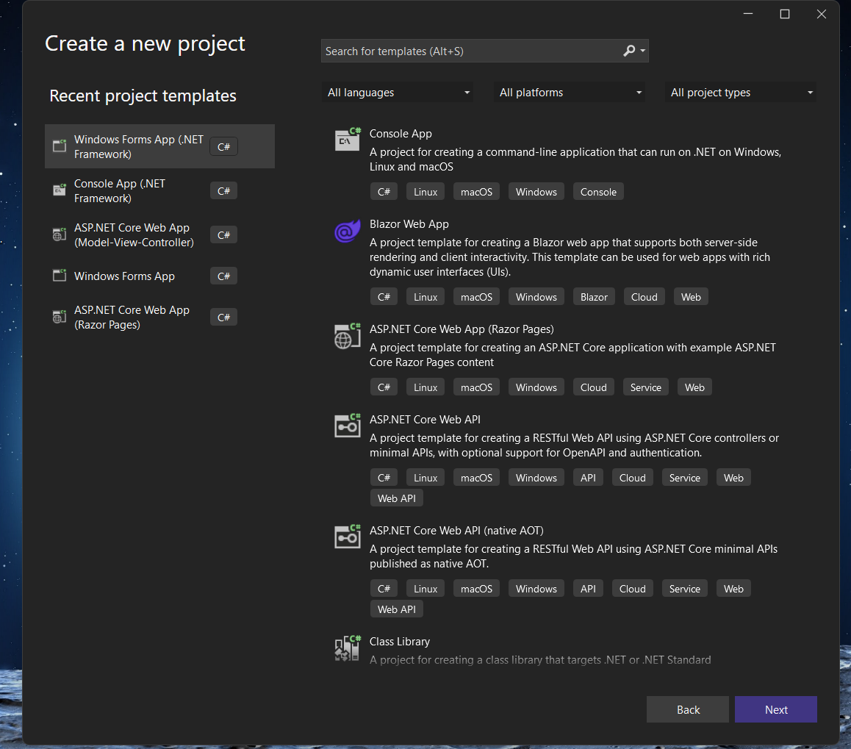
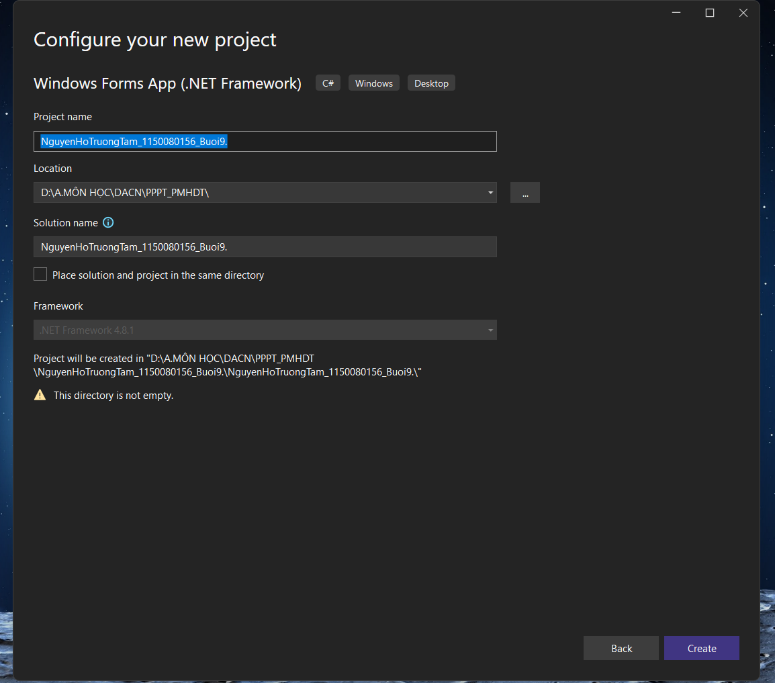

Các bước tạo Windown Form mới
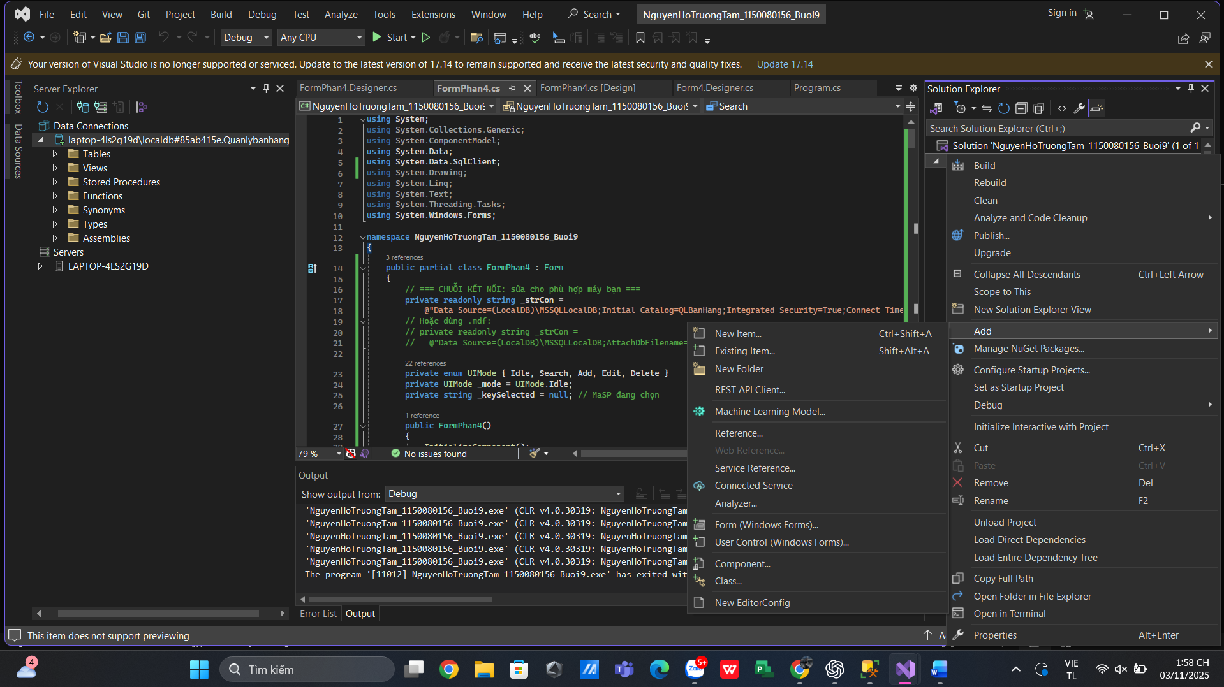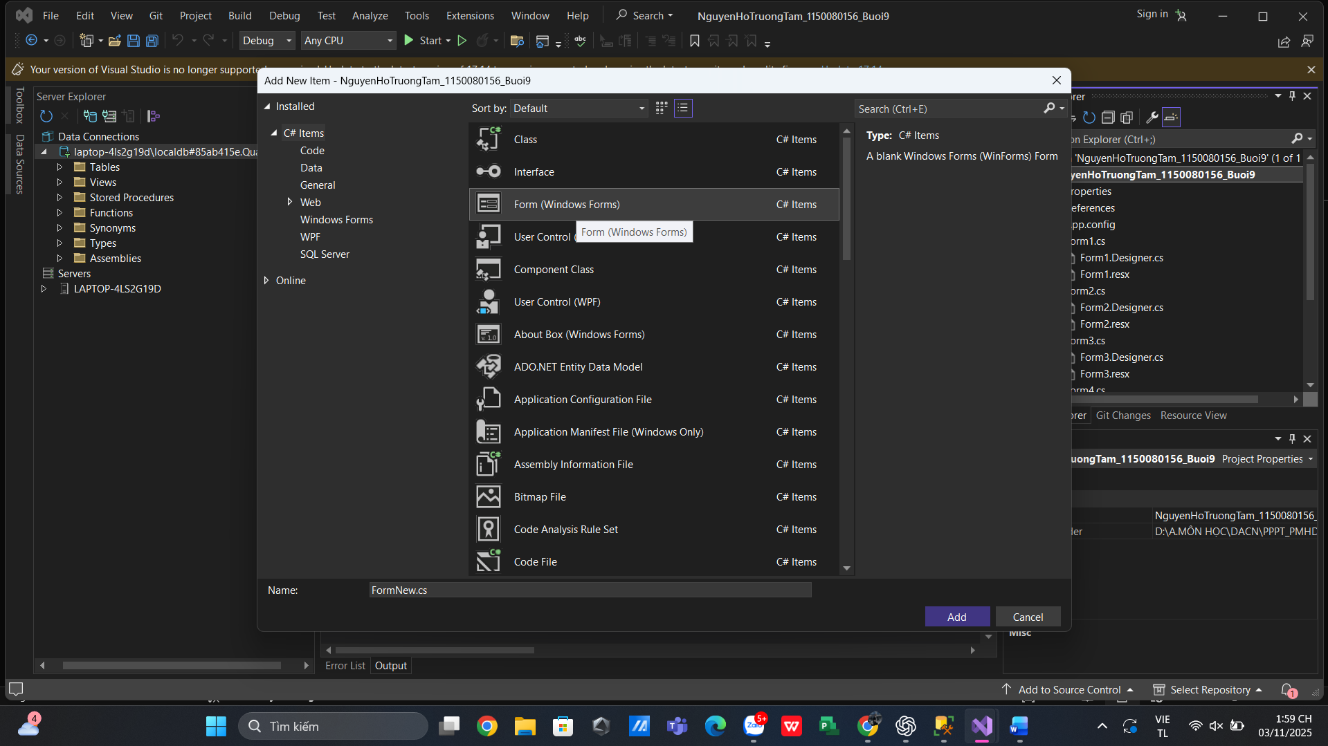

Thực hành 1: Hiển thị dữ liệu trên control DataGridView
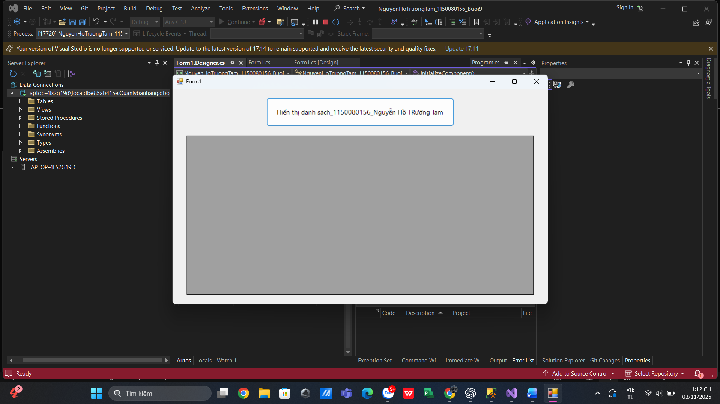

Form1.cs
using System;
using System.Collections.Generic;
using System.ComponentModel;
using System.Data;
using System.Data.SqlClient;
using System.Drawing;
using System.Linq;
using System.Text;
using System.Threading.Tasks;
using System.Windows.Forms;

namespace NguyenHoTruongTam_1150080156_Buoi9
{
public partial class Form1 : Form
{
// KẾT NỐI LocalDB – chọn 1 trong 2, mặc định dùng Initial Catalog:
private readonly string _strCon =
@"Data Source=(LocalDB)\MSSQLLocalDB;Initial Catalog=QuanLyBanSach;Integrated Security=True;Connect Timeout=30";
// private readonly string _strCon =
// @"Data Source=(LocalDB)\MSSQLLocalDB;AttachDbFilename=D:\SQL\QuanLyBanSach.mdf;Integrated Security=True;Connect Timeout=30";

private SqlConnection _conn;
private SqlDataAdapter _adp;
private DataTable _tbl;

public Form1()
{
InitializeComponent();
}

private void Form1_Load(object sender, EventArgs e)
{
CenterButton();
}

private void Form1_Resize(object sender, EventArgs e)
{
CenterButton();
}

private void CenterButton()
{
// canh giữa nút theo chiều ngang giống ảnh
btnHienThi.Left = (this.ClientSize.Width - btnHienThi.Width) / 2;
}

private void btnHienThi_Click(object sender, EventArgs e)
{
try
{
using (_conn = new SqlConnection(_strCon))
{
_conn.Open();
string sql = "SELECT MaXB, TenXB, DiaChi FROM dbo.NhaXuatBan";
_adp = new SqlDataAdapter(sql, _conn);
_tbl = new DataTable();
_adp.Fill(_tbl);
dgvNhaXB.DataSource = _tbl;
}
}
catch (Exception ex)
{
MessageBox.Show("Không tải được dữ liệu.\n" + ex.Message, "Lỗi",
MessageBoxButtons.OK, MessageBoxIcon.Error);
}
}
}
}

Form1.Designer.cs
using System.Windows.Forms;

namespace NguyenHoTruongTam_1150080156_Buoi9
{
partial class Form1
{
private System.ComponentModel.IContainer components = null;
private Button btnHienThi;
private DataGridView dgvNhaXB;

protected override void Dispose(bool disposing)
{
if (disposing && (components != null)) components.Dispose();
base.Dispose(disposing);
}

#region Windows Form Designer generated code
private void InitializeComponent()
{
this.btnHienThi = new System.Windows.Forms.Button();
this.dgvNhaXB = new System.Windows.Forms.DataGridView();
((System.ComponentModel.ISupportInitialize)(this.dgvNhaXB)).BeginInit();
this.SuspendLayout();
//
// btnHienThi
//
this.btnHienThi.Anchor = System.Windows.Forms.AnchorStyles.Top;
this.btnHienThi.Font = new System.Drawing.Font("Segoe UI", 10F, System.Drawing.FontStyle.Regular, System.Drawing.GraphicsUnit.Point);
this.btnHienThi.Location = new System.Drawing.Point(192, 20); // sẽ được canh giữa lại ở Form1_Resize
this.btnHienThi.Name = "btnHienThi";
this.btnHienThi.Size = new System.Drawing.Size(400, 60);
this.btnHienThi.TabIndex = 0;
this.btnHienThi.Text = "Hiển thị danh sách_1150080156_Nguyễn Hồ TRường Tam";
this.btnHienThi.UseVisualStyleBackColor = true;
this.btnHienThi.Click += new System.EventHandler(this.btnHienThi_Click);
//
// dgvNhaXb
//
this.dgvNhaXB.AllowUserToAddRows = false;
this.dgvNhaXB.AllowUserToDeleteRows = false;
this.dgvNhaXB.Anchor = ((System.Windows.Forms.AnchorStyles)((((System.Windows.Forms.AnchorStyles.Top | System.Windows.Forms.AnchorStyles.Bottom)
| System.Windows.Forms.AnchorStyles.Left)
| System.Windows.Forms.AnchorStyles.Right)));
this.dgvNhaXB.AutoSizeColumnsMode = System.Windows.Forms.DataGridViewAutoSizeColumnsMode.Fill;
this.dgvNhaXB.BackgroundColor = System.Drawing.SystemColors.ControlDark; // xám giống ảnh
this.dgvNhaXB.ColumnHeadersHeightSizeMode = System.Windows.Forms.DataGridViewColumnHeadersHeightSizeMode.AutoSize;
this.dgvNhaXB.Location = new System.Drawing.Point(30, 100);
this.dgvNhaXB.MultiSelect = false;
this.dgvNhaXB.Name = "dgvNhaXB";
this.dgvNhaXB.ReadOnly = true;
this.dgvNhaXB.RowHeadersVisible = false;
this.dgvNhaXB.SelectionMode = System.Windows.Forms.DataGridViewSelectionMode.FullRowSelect;
this.dgvNhaXB.Size = new System.Drawing.Size(740, 340);
this.dgvNhaXB.TabIndex = 1;
//
// Form1
//
this.AcceptButton = this.btnHienThi;
this.AutoScaleDimensions = new System.Drawing.SizeF(7F, 15F);
this.AutoScaleMode = System.Windows.Forms.AutoScaleMode.Font;
this.ClientSize = new System.Drawing.Size(800, 460);
this.Controls.Add(this.dgvNhaXB);
this.Controls.Add(this.btnHienThi);
this.Font = new System.Drawing.Font("Segoe UI", 9F);
this.MinimumSize = new System.Drawing.Size(720, 420);
this.Name = "Form1";
this.StartPosition = System.Windows.Forms.FormStartPosition.CenterScreen;
this.Text = "Form1";
this.Load += new System.EventHandler(this.Form1_Load);
this.Resize += new System.EventHandler(this.Form1_Resize); // để canh giữa nút
((System.ComponentModel.ISupportInitialize)(this.dgvNhaXB)).EndInit();
this.ResumeLayout(false);
}
#endregion
}
}

Thực hành 2: Thêm dữ liệu cho bảng Nhà xuất bản
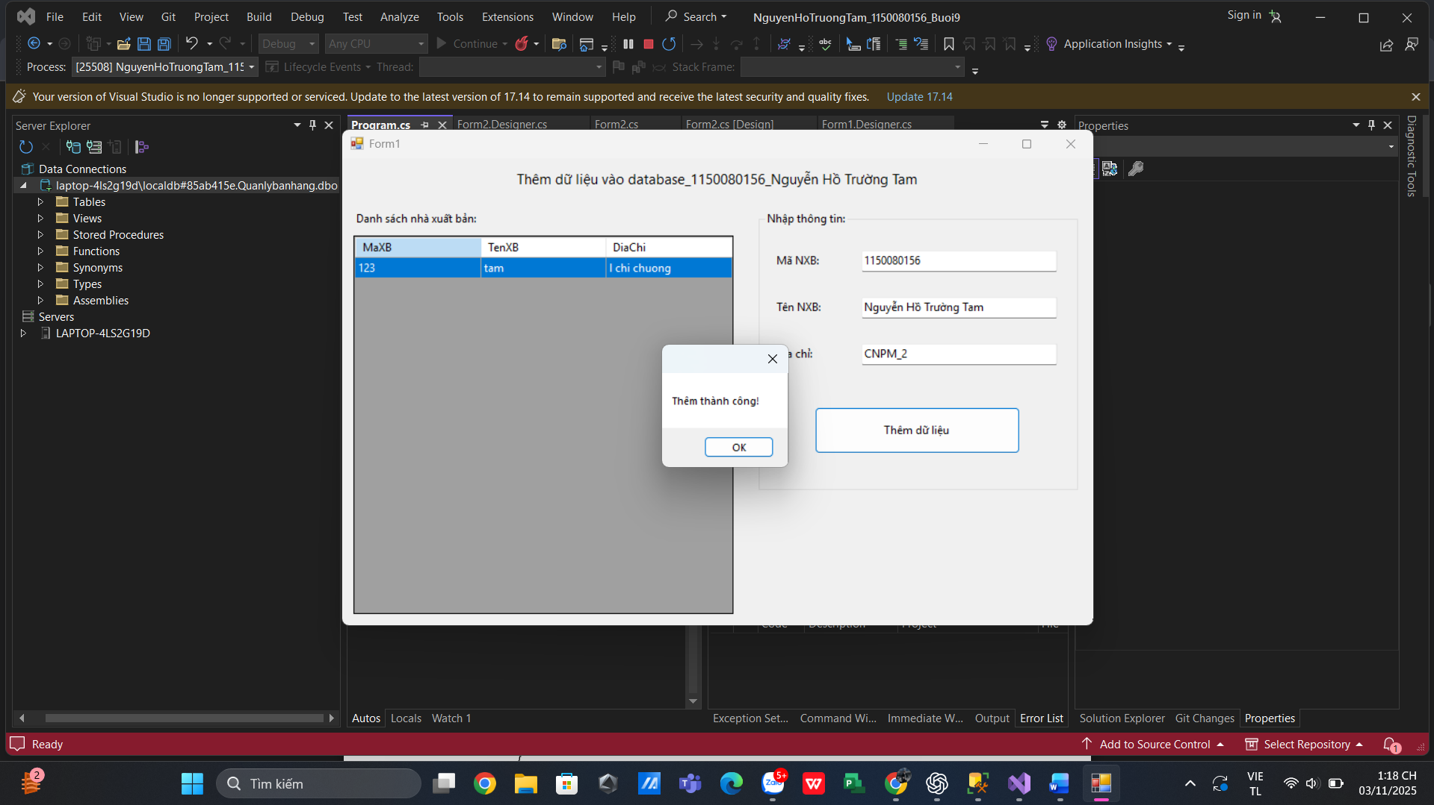

Form2.cs
using System;
using System.Collections.Generic;
using System.ComponentModel;
using System.Data;
using System.Data.SqlClient;
using System.Drawing;
using System.Linq;
using System.Text;
using System.Threading.Tasks;
using System.Windows.Forms;

namespace NguyenHoTruongTam_1150080156_Buoi9
{
public partial class Form2 : Form
{
// === Chuỗi kết nối LocalDB (sửa cho phù hợp) ===
private readonly string _strCon =
@"Data Source=(LocalDB)\MSSQLLocalDB;Initial Catalog=QuanLyBanSach;Integrated Security=True;Connect Timeout=30";
// Nếu dùng file .mdf:
// private readonly string _strCon =
// @"Data Source=(LocalDB)\MSSQLLocalDB;AttachDbFilename=D:\SQL\QuanLyBanSach.mdf;Integrated Security=True;Connect Timeout=30";

public Form2()
{
InitializeComponent();
}

// Nạp danh sách bên trái
private void Form1_Load(object sender, EventArgs e)
{
NapDanhSach();
}

private void NapDanhSach()
{
try
{
using (var conn = new SqlConnection(_strCon))
using (var adp = new SqlDataAdapter(
"SELECT MaXB, TenXB, DiaChi FROM dbo.NhaXuatBan ORDER BY MaXB", conn))
{
var tbl = new DataTable();
adp.Fill(tbl);
dgvNhaXB.DataSource = tbl;
}
}
catch (Exception ex)
{
MessageBox.Show("Không tải được danh sách.\n" + ex.Message,
"Lỗi", MessageBoxButtons.OK, MessageBoxIcon.Error);
}
}

// Xử lý nút Thêm dữ liệu (bên phải)
private void btnThem_Click(object sender, EventArgs e)
{
if (string.IsNullOrWhiteSpace(txtMaXB.Text) ||
string.IsNullOrWhiteSpace(txtTenXB.Text))
{
MessageBox.Show("Vui lòng nhập Mã NXB và Tên NXB!");
return;
}

try
{
using (var conn = new SqlConnection(_strCon))
using (var cmd = new SqlCommand(
@"INSERT INTO dbo.NhaXuatBan(MaXB, TenXB, DiaChi)
VALUES (@Ma, @Ten, @DiaChi)", conn))
{
cmd.Parameters.Add("@Ma", SqlDbType.NVarChar, 10).Value = txtMaXB.Text.Trim();
cmd.Parameters.Add("@Ten", SqlDbType.NVarChar, 100).Value = txtTenXB.Text.Trim();
cmd.Parameters.Add("@DiaChi", SqlDbType.NVarChar, 200).Value = (object)txtDiaChi.Text.Trim() ?? DBNull.Value;

conn.Open();
int n = cmd.ExecuteNonQuery();
conn.Close();

if (n > 0)
{
MessageBox.Show("Thêm thành công!");
ClearInputs();
NapDanhSach();
}
else
{
MessageBox.Show("Không có dòng nào được thêm.");
}
}
}
catch (SqlException sqlEx) when (sqlEx.Number == 2627 || sqlEx.Number == 2601)
{
MessageBox.Show("Mã NXB đã tồn tại! Vui lòng nhập mã khác.");
}
catch (Exception ex)
{
MessageBox.Show("Lỗi thêm dữ liệu:\n" + ex.Message,
"Lỗi", MessageBoxButtons.OK, MessageBoxIcon.Error);
}
}

private void ClearInputs()
{
txtMaXB.Clear();
txtTenXB.Clear();
txtDiaChi.Clear();
txtMaXB.Focus();
}
}
}

Form2.Designer.cs
using System.Windows.Forms;

namespace NguyenHoTruongTam_1150080156_Buoi9
{
partial class Form2
{
private System.ComponentModel.IContainer components = null;

private Label lblTitle;
private SplitContainer splitContainer1;

// Left
private Label lblDanhSach;
private DataGridView dgvNhaXB;

// Right
private GroupBox grpNhap;
private Label labelMa;
private Label labelTen;
private Label labelDiaChi;
private TextBox txtMaXB;
private TextBox txtTenXB;
private TextBox txtDiaChi;
private Button btnThem;

protected override void Dispose(bool disposing)
{
if (disposing && (components != null))
components.Dispose();
base.Dispose(disposing);
}

#region Windows Form Designer generated code
private void InitializeComponent()
{
this.lblTitle = new System.Windows.Forms.Label();
this.splitContainer1 = new System.Windows.Forms.SplitContainer();
this.lblDanhSach = new System.Windows.Forms.Label();
this.dgvNhaXB = new System.Windows.Forms.DataGridView();
this.grpNhap = new System.Windows.Forms.GroupBox();
this.labelMa = new System.Windows.Forms.Label();
this.labelTen = new System.Windows.Forms.Label();
this.labelDiaChi = new System.Windows.Forms.Label();
this.txtMaXB = new System.Windows.Forms.TextBox();
this.txtTenXB = new System.Windows.Forms.TextBox();
this.txtDiaChi = new System.Windows.Forms.TextBox();
this.btnThem = new System.Windows.Forms.Button();
((System.ComponentModel.ISupportInitialize)(this.splitContainer1)).BeginInit();
this.splitContainer1.Panel1.SuspendLayout();
this.splitContainer1.Panel2.SuspendLayout();
this.splitContainer1.SuspendLayout();
((System.ComponentModel.ISupportInitialize)(this.dgvNhaXB)).BeginInit();
this.grpNhap.SuspendLayout();
this.SuspendLayout();
//
// lblTitle (tiêu đề giữa form)
//
this.lblTitle.Dock = System.Windows.Forms.DockStyle.Top;
this.lblTitle.Font = new System.Drawing.Font("Segoe UI", 11F, System.Drawing.FontStyle.Regular, System.Drawing.GraphicsUnit.Point);
this.lblTitle.Location = new System.Drawing.Point(0, 0);
this.lblTitle.Name = "lblTitle";
this.lblTitle.Padding = new System.Windows.Forms.Padding(0, 10, 0, 10);
this.lblTitle.Size = new System.Drawing.Size(800, 45);
this.lblTitle.TabIndex = 0;
this.lblTitle.Text = "Thêm dữ liệu vào database_1150080156_Nguyễn Hồ Trường Tam";
this.lblTitle.TextAlign = System.Drawing.ContentAlignment.MiddleCenter;
//
// splitContainer1 (chia 2 cột như ảnh)
//
this.splitContainer1.Dock = System.Windows.Forms.DockStyle.Fill;
this.splitContainer1.Location = new System.Drawing.Point(0, 45);
this.splitContainer1.Name = "splitContainer1";
// Left panel
this.splitContainer1.Panel1.Controls.Add(this.dgvNhaXB);
this.splitContainer1.Panel1.Controls.Add(this.lblDanhSach);
// Right panel
this.splitContainer1.Panel2.Controls.Add(this.grpNhap);
this.splitContainer1.Size = new System.Drawing.Size(800, 455);
this.splitContainer1.SplitterDistance = 430; // giống tỷ lệ ảnh
this.splitContainer1.TabIndex = 1;
//
// lblDanhSach (trên DataGridView)
//
this.lblDanhSach.AutoSize = true;
this.lblDanhSach.Location = new System.Drawing.Point(12, 12);
this.lblDanhSach.Name = "lblDanhSach";
this.lblDanhSach.Size = new System.Drawing.Size(153, 20);
this.lblDanhSach.TabIndex = 0;
this.lblDanhSach.Text = "Danh sách nhà xuất bản:";
//
// dgvNhaXB (màu xám như ảnh)
//
this.dgvNhaXB.AllowUserToAddRows = false;
this.dgvNhaXB.AllowUserToDeleteRows = false;
this.dgvNhaXB.Anchor = ((System.Windows.Forms.AnchorStyles)((((System.Windows.Forms.AnchorStyles.Top | System.Windows.Forms.AnchorStyles.Bottom)
| System.Windows.Forms.AnchorStyles.Left)
| System.Windows.Forms.AnchorStyles.Right)));
this.dgvNhaXB.AutoSizeColumnsMode = System.Windows.Forms.DataGridViewAutoSizeColumnsMode.Fill;
this.dgvNhaXB.BackgroundColor = System.Drawing.SystemColors.ControlDark;
this.dgvNhaXB.ColumnHeadersHeightSizeMode = System.Windows.Forms.DataGridViewColumnHeadersHeightSizeMode.AutoSize;
this.dgvNhaXB.Location = new System.Drawing.Point(12, 38);
this.dgvNhaXB.MultiSelect = false;
this.dgvNhaXB.Name = "dgvNhaXB";
this.dgvNhaXB.ReadOnly = true;
this.dgvNhaXB.RowHeadersVisible = false;
this.dgvNhaXB.SelectionMode = System.Windows.Forms.DataGridViewSelectionMode.FullRowSelect;
this.dgvNhaXB.Size = new System.Drawing.Size(405, 405);
this.dgvNhaXB.TabIndex = 1;
//
// grpNhap (khung bên phải)
//
this.grpNhap.Anchor = ((System.Windows.Forms.AnchorStyles)(((System.Windows.Forms.AnchorStyles.Top | System.Windows.Forms.AnchorStyles.Left)
| System.Windows.Forms.AnchorStyles.Right)));
this.grpNhap.Controls.Add(this.btnThem);
this.grpNhap.Controls.Add(this.txtDiaChi);
this.grpNhap.Controls.Add(this.txtTenXB);
this.grpNhap.Controls.Add(this.txtMaXB);
this.grpNhap.Controls.Add(this.labelDiaChi);
this.grpNhap.Controls.Add(this.labelTen);
this.grpNhap.Controls.Add(this.labelMa);
this.grpNhap.Location = new System.Drawing.Point(10, 12);
this.grpNhap.Name = "grpNhap";
this.grpNhap.Size = new System.Drawing.Size(340, 300);
this.grpNhap.TabIndex = 0;
this.grpNhap.TabStop = false;
this.grpNhap.Text = "Nhập thông tin:";
//
// labelMa
//
this.labelMa.AutoSize = true;
this.labelMa.Location = new System.Drawing.Point(16, 45);
this.labelMa.Name = "labelMa";
this.labelMa.Size = new System.Drawing.Size(60, 20);
this.labelMa.TabIndex = 0;
this.labelMa.Text = "Mã NXB:";
//
// labelTen
//
this.labelTen.AutoSize = true;
this.labelTen.Location = new System.Drawing.Point(16, 95);
this.labelTen.Name = "labelTen";
this.labelTen.Size = new System.Drawing.Size(66, 20);
this.labelTen.TabIndex = 1;
this.labelTen.Text = "Tên NXB:";
//
// labelDiaChi
//
this.labelDiaChi.AutoSize = true;
this.labelDiaChi.Location = new System.Drawing.Point(16, 145);
this.labelDiaChi.Name = "labelDiaChi";
this.labelDiaChi.Size = new System.Drawing.Size(55, 20);
this.labelDiaChi.TabIndex = 2;
this.labelDiaChi.Text = "Địa chỉ:";
//
// txtMaXB
//
this.txtMaXB.Location = new System.Drawing.Point(110, 42);
this.txtMaXB.MaxLength = 10;
this.txtMaXB.Name = "txtMaXB";
this.txtMaXB.Size = new System.Drawing.Size(210, 27);
this.txtMaXB.TabIndex = 3;
//
// txtTenXB
//
this.txtTenXB.Location = new System.Drawing.Point(110, 92);
this.txtTenXB.MaxLength = 100;
this.txtTenXB.Name = "txtTenXB";
this.txtTenXB.Size = new System.Drawing.Size(210, 27);
this.txtTenXB.TabIndex = 4;
//
// txtDiaChi
//
this.txtDiaChi.Location = new System.Drawing.Point(110, 142);
this.txtDiaChi.MaxLength = 200;
this.txtDiaChi.Name = "txtDiaChi";
this.txtDiaChi.Size = new System.Drawing.Size(210, 27);
this.txtDiaChi.TabIndex = 5;
//
// btnThem (nút to giống ảnh)
//
this.btnThem.Location = new System.Drawing.Point(60, 210);
this.btnThem.Name = "btnThem";
this.btnThem.Size = new System.Drawing.Size(220, 50);
this.btnThem.TabIndex = 6;
this.btnThem.Text = "Thêm dữ liệu";
this.btnThem.UseVisualStyleBackColor = true;
this.btnThem.Click += new System.EventHandler(this.btnThem_Click);
//
// Form1
//
this.AcceptButton = this.btnThem;
this.AutoScaleDimensions = new System.Drawing.SizeF(8F, 20F);
this.AutoScaleMode = System.Windows.Forms.AutoScaleMode.Font;
this.ClientSize = new System.Drawing.Size(800, 500);
this.Controls.Add(this.splitContainer1);
this.Controls.Add(this.lblTitle);
this.Font = new System.Drawing.Font("Segoe UI", 9F);
this.MinimumSize = new System.Drawing.Size(820, 540);
this.Name = "Form1";
this.StartPosition = System.Windows.Forms.FormStartPosition.CenterScreen;
this.Text = "Form1";
this.Load += new System.EventHandler(this.Form1_Load);
this.splitContainer1.Panel1.ResumeLayout(false);
this.splitContainer1.Panel1.PerformLayout();
this.splitContainer1.Panel2.ResumeLayout(false);
((System.ComponentModel.ISupportInitialize)(this.splitContainer1)).EndInit();
this.splitContainer1.ResumeLayout(false);
((System.ComponentModel.ISupportInitialize)(this.dgvNhaXB)).EndInit();
this.grpNhap.ResumeLayout(false);
this.grpNhap.PerformLayout();
this.ResumeLayout(false);
}
#endregion
}
}

Thực hành 3: Cập nhật dữ liệu cho bảng Nhà xuất bản
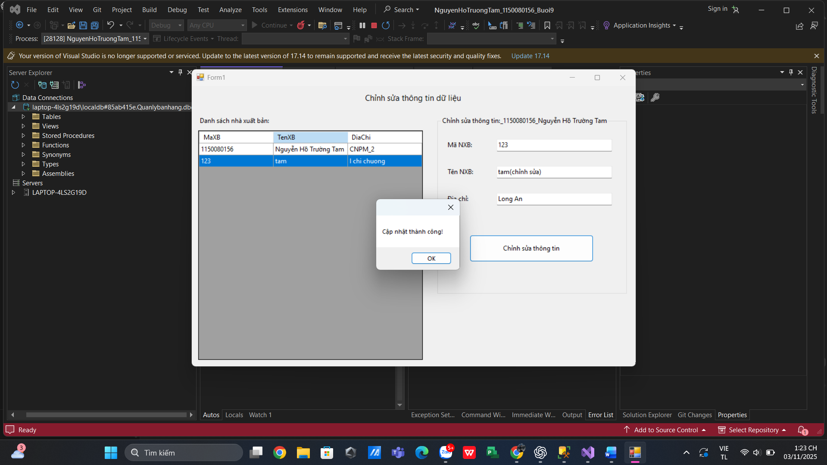

Form3.cs
using System;
using System.Collections.Generic;
using System.ComponentModel;
using System.Data;
using System.Data.SqlClient;
using System.Drawing;
using System.Linq;
using System.Text;
using System.Threading.Tasks;
using System.Windows.Forms;

namespace NguyenHoTruongTam_1150080156_Buoi9
{
public partial class Form3 : Form
{
private readonly string _strCon =
@"Data Source=(LocalDB)\MSSQLLocalDB;Initial Catalog=QuanLyBanSach;Integrated Security=True;Connect Timeout=30";
// Hoặc dùng .mdf:
// private readonly string _strCon =
// @"Data Source=(LocalDB)\MSSQLLocalDB;AttachDbFilename=D:\SQL\QuanLyBanSach.mdf;Integrated Security=True;Connect Timeout=30";

// Lưu mã gốc của bản ghi đang chọn (để update đúng hàng khi đổi MaXB trên form)
private string _maGoc = null;

public Form3()
{
InitializeComponent();
}

private void Form1_Load(object sender, EventArgs e)
{
NapDanhSach();
}

private void NapDanhSach()
{
try
{
using (var conn = new SqlConnection(_strCon))
using (var adp = new SqlDataAdapter(
"SELECT MaXB, TenXB, DiaChi FROM dbo.NhaXuatBan ORDER BY MaXB", conn))
{
var tbl = new DataTable();
adp.Fill(tbl);
dgvNhaXB.DataSource = tbl;
}
_maGoc = null;
ClearInputs();
}
catch (Exception ex)
{
MessageBox.Show("Không tải được danh sách.\n" + ex.Message,
"Lỗi", MessageBoxButtons.OK, MessageBoxIcon.Error);
}
}

private void dgvNhaXB_CellClick(object sender, DataGridViewCellEventArgs e)
{
if (e.RowIndex < 0 || dgvNhaXB.CurrentRow == null) return;

var row = dgvNhaXB.Rows[e.RowIndex];
txtMaXB.Text = row.Cells["MaXB"].Value?.ToString();
txtTenXB.Text = row.Cells["TenXB"].Value?.ToString();
txtDiaChi.Text = row.Cells["DiaChi"].Value?.ToString();

_maGoc = txtMaXB.Text; // lưu khóa hiện tại
}

private void btnChinhSua_Click(object sender, EventArgs e)
{
if (_maGoc == null)
{
MessageBox.Show("Vui lòng chọn một dòng ở danh sách để chỉnh sửa.");
return;
}
if (string.IsNullOrWhiteSpace(txtMaXB.Text) ||
string.IsNullOrWhiteSpace(txtTenXB.Text))
{
MessageBox.Show("Mã NXB và Tên NXB không được để trống!");
return;
}

try
{
using (var conn = new SqlConnection(_strCon))
using (var cmd = new SqlCommand(
@"UPDATE dbo.NhaXuatBan
SET MaXB = @MaMoi, TenXB = @Ten, DiaChi = @DiaChi
WHERE MaXB = @MaGoc", conn))
{
cmd.Parameters.Add("@MaMoi", SqlDbType.NVarChar, 10).Value = txtMaXB.Text.Trim();
cmd.Parameters.Add("@Ten", SqlDbType.NVarChar, 100).Value = txtTenXB.Text.Trim();
cmd.Parameters.Add("@DiaChi", SqlDbType.NVarChar, 200).Value = (object)txtDiaChi.Text.Trim() ?? DBNull.Value;
cmd.Parameters.Add("@MaGoc", SqlDbType.NVarChar, 10).Value = _maGoc;

conn.Open();
int n = cmd.ExecuteNonQuery();
conn.Close();

if (n > 0)
{
MessageBox.Show("Cập nhật thành công!");
NapDanhSach();
}
else
{
MessageBox.Show("Không tìm thấy bản ghi để cập nhật.");
}
}
}
catch (SqlException ex) when (ex.Number == 2627 || ex.Number == 2601)
{
// Vi phạm unique/primary key khi đổi MaXB trùng
MessageBox.Show("Mã NXB mới đã tồn tại. Hãy chọn mã khác.");
}
catch (Exception ex)
{
MessageBox.Show("Lỗi cập nhật:\n" + ex.Message,
"Lỗi", MessageBoxButtons.OK, MessageBoxIcon.Error);
}
}

private void ClearInputs()
{
txtMaXB.Clear();
txtTenXB.Clear();
txtDiaChi.Clear();
}
}
}

Form3.Designer.cs
using System.Windows.Forms;

namespace NguyenHoTruongTam_1150080156_Buoi9
{
partial class Form3
{
/// <summary>
/// Required designer variable.
/// </summary>
private System.ComponentModel.IContainer components = null;

private Label lblTitle;
private SplitContainer splitContainer1;

// Left
private Label lblDanhSach;
private DataGridView dgvNhaXB;

// Right
private GroupBox grpChinhSua;
private Label labelMa;
private Label labelTen;
private Label labelDiaChi;
private TextBox txtMaXB;
private TextBox txtTenXB;
private TextBox txtDiaChi;
private Button btnChinhSua;

protected override void Dispose(bool disposing)
{
if (disposing && (components != null)) components.Dispose();
base.Dispose(disposing);
}

#region Windows Form Designer generated code
private void InitializeComponent()
{
this.lblTitle = new System.Windows.Forms.Label();
this.splitContainer1 = new System.Windows.Forms.SplitContainer();
this.lblDanhSach = new System.Windows.Forms.Label();
this.dgvNhaXB = new System.Windows.Forms.DataGridView();
this.grpChinhSua = new System.Windows.Forms.GroupBox();
this.labelMa = new System.Windows.Forms.Label();
this.labelTen = new System.Windows.Forms.Label();
this.labelDiaChi = new System.Windows.Forms.Label();
this.txtMaXB = new System.Windows.Forms.TextBox();
this.txtTenXB = new System.Windows.Forms.TextBox();
this.txtDiaChi = new System.Windows.Forms.TextBox();
this.btnChinhSua = new System.Windows.Forms.Button();
((System.ComponentModel.ISupportInitialize)(this.splitContainer1)).BeginInit();
this.splitContainer1.Panel1.SuspendLayout();
this.splitContainer1.Panel2.SuspendLayout();
this.splitContainer1.SuspendLayout();
((System.ComponentModel.ISupportInitialize)(this.dgvNhaXB)).BeginInit();
this.grpChinhSua.SuspendLayout();
this.SuspendLayout();
//
// lblTitle
//
this.lblTitle.Dock = System.Windows.Forms.DockStyle.Top;
this.lblTitle.Font = new System.Drawing.Font("Segoe UI", 11F, System.Drawing.FontStyle.Regular, System.Drawing.GraphicsUnit.Point);
this.lblTitle.Location = new System.Drawing.Point(0, 0);
this.lblTitle.Name = "lblTitle";
this.lblTitle.Padding = new System.Windows.Forms.Padding(0, 10, 0, 10);
this.lblTitle.Size = new System.Drawing.Size(820, 45);
this.lblTitle.TabIndex = 0;
this.lblTitle.Text = "Chỉnh sửa thông tin dữ liệu";
this.lblTitle.TextAlign = System.Drawing.ContentAlignment.MiddleCenter;
//
// splitContainer1
//
this.splitContainer1.Dock = System.Windows.Forms.DockStyle.Fill;
this.splitContainer1.Location = new System.Drawing.Point(0, 45);
this.splitContainer1.Name = "splitContainer1";
// Left
this.splitContainer1.Panel1.Controls.Add(this.dgvNhaXB);
this.splitContainer1.Panel1.Controls.Add(this.lblDanhSach);
// Right
this.splitContainer1.Panel2.Controls.Add(this.grpChinhSua);
this.splitContainer1.Size = new System.Drawing.Size(820, 475);
this.splitContainer1.SplitterDistance = 440;
this.splitContainer1.TabIndex = 1;
//
// lblDanhSach
//
this.lblDanhSach.AutoSize = true;
this.lblDanhSach.Location = new System.Drawing.Point(12, 12);
this.lblDanhSach.Name = "lblDanhSach";
this.lblDanhSach.Size = new System.Drawing.Size(153, 20);
this.lblDanhSach.TabIndex = 0;
this.lblDanhSach.Text = "Danh sách nhà xuất bản:";
//
// dgvNhaXB
//
this.dgvNhaXB.AllowUserToAddRows = false;
this.dgvNhaXB.AllowUserToDeleteRows = false;
this.dgvNhaXB.Anchor = ((System.Windows.Forms.AnchorStyles)((((System.Windows.Forms.AnchorStyles.Top | System.Windows.Forms.AnchorStyles.Bottom)
| System.Windows.Forms.AnchorStyles.Left)
| System.Windows.Forms.AnchorStyles.Right)));
this.dgvNhaXB.AutoSizeColumnsMode = System.Windows.Forms.DataGridViewAutoSizeColumnsMode.Fill;
this.dgvNhaXB.BackgroundColor = System.Drawing.SystemColors.ControlDark; // xám giống ảnh
this.dgvNhaXB.ColumnHeadersHeightSizeMode = System.Windows.Forms.DataGridViewColumnHeadersHeightSizeMode.AutoSize;
this.dgvNhaXB.Location = new System.Drawing.Point(12, 38);
this.dgvNhaXB.MultiSelect = false;
this.dgvNhaXB.Name = "dgvNhaXB";
this.dgvNhaXB.ReadOnly = true;
this.dgvNhaXB.RowHeadersVisible = false;
this.dgvNhaXB.SelectionMode = System.Windows.Forms.DataGridViewSelectionMode.FullRowSelect;
this.dgvNhaXB.Size = new System.Drawing.Size(415, 425);
this.dgvNhaXB.TabIndex = 1;
this.dgvNhaXB.CellClick += new System.Windows.Forms.DataGridViewCellEventHandler(this.dgvNhaXB_CellClick);
//
// grpChinhSua
//
this.grpChinhSua.Anchor = ((System.Windows.Forms.AnchorStyles)(((System.Windows.Forms.AnchorStyles.Top | System.Windows.Forms.AnchorStyles.Left)
| System.Windows.Forms.AnchorStyles.Right)));
this.grpChinhSua.Controls.Add(this.btnChinhSua);
this.grpChinhSua.Controls.Add(this.txtDiaChi);
this.grpChinhSua.Controls.Add(this.txtTenXB);
this.grpChinhSua.Controls.Add(this.txtMaXB);
this.grpChinhSua.Controls.Add(this.labelDiaChi);
this.grpChinhSua.Controls.Add(this.labelTen);
this.grpChinhSua.Controls.Add(this.labelMa);
this.grpChinhSua.Location = new System.Drawing.Point(10, 12);
this.grpChinhSua.Name = "grpChinhSua";
this.grpChinhSua.Size = new System.Drawing.Size(350, 330);
this.grpChinhSua.TabIndex = 0;
this.grpChinhSua.TabStop = false;
this.grpChinhSua.Text = "Chỉnh sửa thông tin:_1150080156_Nguyễn Hồ Trường Tam";
//
// labelMa
//
this.labelMa.AutoSize = true;
this.labelMa.Location = new System.Drawing.Point(16, 45);
this.labelMa.Name = "labelMa";
this.labelMa.Size = new System.Drawing.Size(60, 20);
this.labelMa.TabIndex = 0;
this.labelMa.Text = "Mã NXB:";
//
// labelTen
//
this.labelTen.AutoSize = true;
this.labelTen.Location = new System.Drawing.Point(16, 95);
this.labelTen.Name = "labelTen";
this.labelTen.Size = new System.Drawing.Size(66, 20);
this.labelTen.TabIndex = 1;
this.labelTen.Text = "Tên NXB:";
//
// labelDiaChi
//
this.labelDiaChi.AutoSize = true;
this.labelDiaChi.Location = new System.Drawing.Point(16, 145);
this.labelDiaChi.Name = "labelDiaChi";
this.labelDiaChi.Size = new System.Drawing.Size(55, 20);
this.labelDiaChi.TabIndex = 2;
this.labelDiaChi.Text = "Địa chỉ:";
//
// txtMaXB
//
this.txtMaXB.Location = new System.Drawing.Point(110, 42);
this.txtMaXB.MaxLength = 10;
this.txtMaXB.Name = "txtMaXB";
this.txtMaXB.Size = new System.Drawing.Size(215, 27);
this.txtMaXB.TabIndex = 3;
//
// txtTenXB
//
this.txtTenXB.Location = new System.Drawing.Point(110, 92);
this.txtTenXB.MaxLength = 100;
this.txtTenXB.Name = "txtTenXB";
this.txtTenXB.Size = new System.Drawing.Size(215, 27);
this.txtTenXB.TabIndex = 4;
//
// txtDiaChi
//
this.txtDiaChi.Location = new System.Drawing.Point(110, 142);
this.txtDiaChi.MaxLength = 200;
this.txtDiaChi.Name = "txtDiaChi";
this.txtDiaChi.Size = new System.Drawing.Size(215, 27);
this.txtDiaChi.TabIndex = 5;
//
// btnChinhSua
//
this.btnChinhSua.Location = new System.Drawing.Point(60, 220);
this.btnChinhSua.Name = "btnChinhSua";
this.btnChinhSua.Size = new System.Drawing.Size(230, 50);
this.btnChinhSua.TabIndex = 6;
this.btnChinhSua.Text = "Chỉnh sửa thông tin";
this.btnChinhSua.UseVisualStyleBackColor = true;
this.btnChinhSua.Click += new System.EventHandler(this.btnChinhSua_Click);
//
// Form1
//
this.AcceptButton = this.btnChinhSua;
this.AutoScaleDimensions = new System.Drawing.SizeF(8F, 20F);
this.AutoScaleMode = System.Windows.Forms.AutoScaleMode.Font;
this.ClientSize = new System.Drawing.Size(820, 520);
this.Controls.Add(this.splitContainer1);
this.Controls.Add(this.lblTitle);
this.Font = new System.Drawing.Font("Segoe UI", 9F);
this.MinimumSize = new System.Drawing.Size(840, 560);
this.Name = "Form1";
this.StartPosition = System.Windows.Forms.FormStartPosition.CenterScreen;
this.Text = "Form1";
this.Load += new System.EventHandler(this.Form1_Load);
this.splitContainer1.Panel1.ResumeLayout(false);
this.splitContainer1.Panel1.PerformLayout();
this.splitContainer1.Panel2.ResumeLayout(false);
((System.ComponentModel.ISupportInitialize)(this.splitContainer1)).EndInit();
this.splitContainer1.ResumeLayout(false);
((System.ComponentModel.ISupportInitialize)(this.dgvNhaXB)).EndInit();
this.grpChinhSua.ResumeLayout(false);
this.grpChinhSua.PerformLayout();
this.ResumeLayout(false);
}
#endregion
}
}

Thực hành 4: Xóa dữ liệu cho bảng Nhà xuất bản
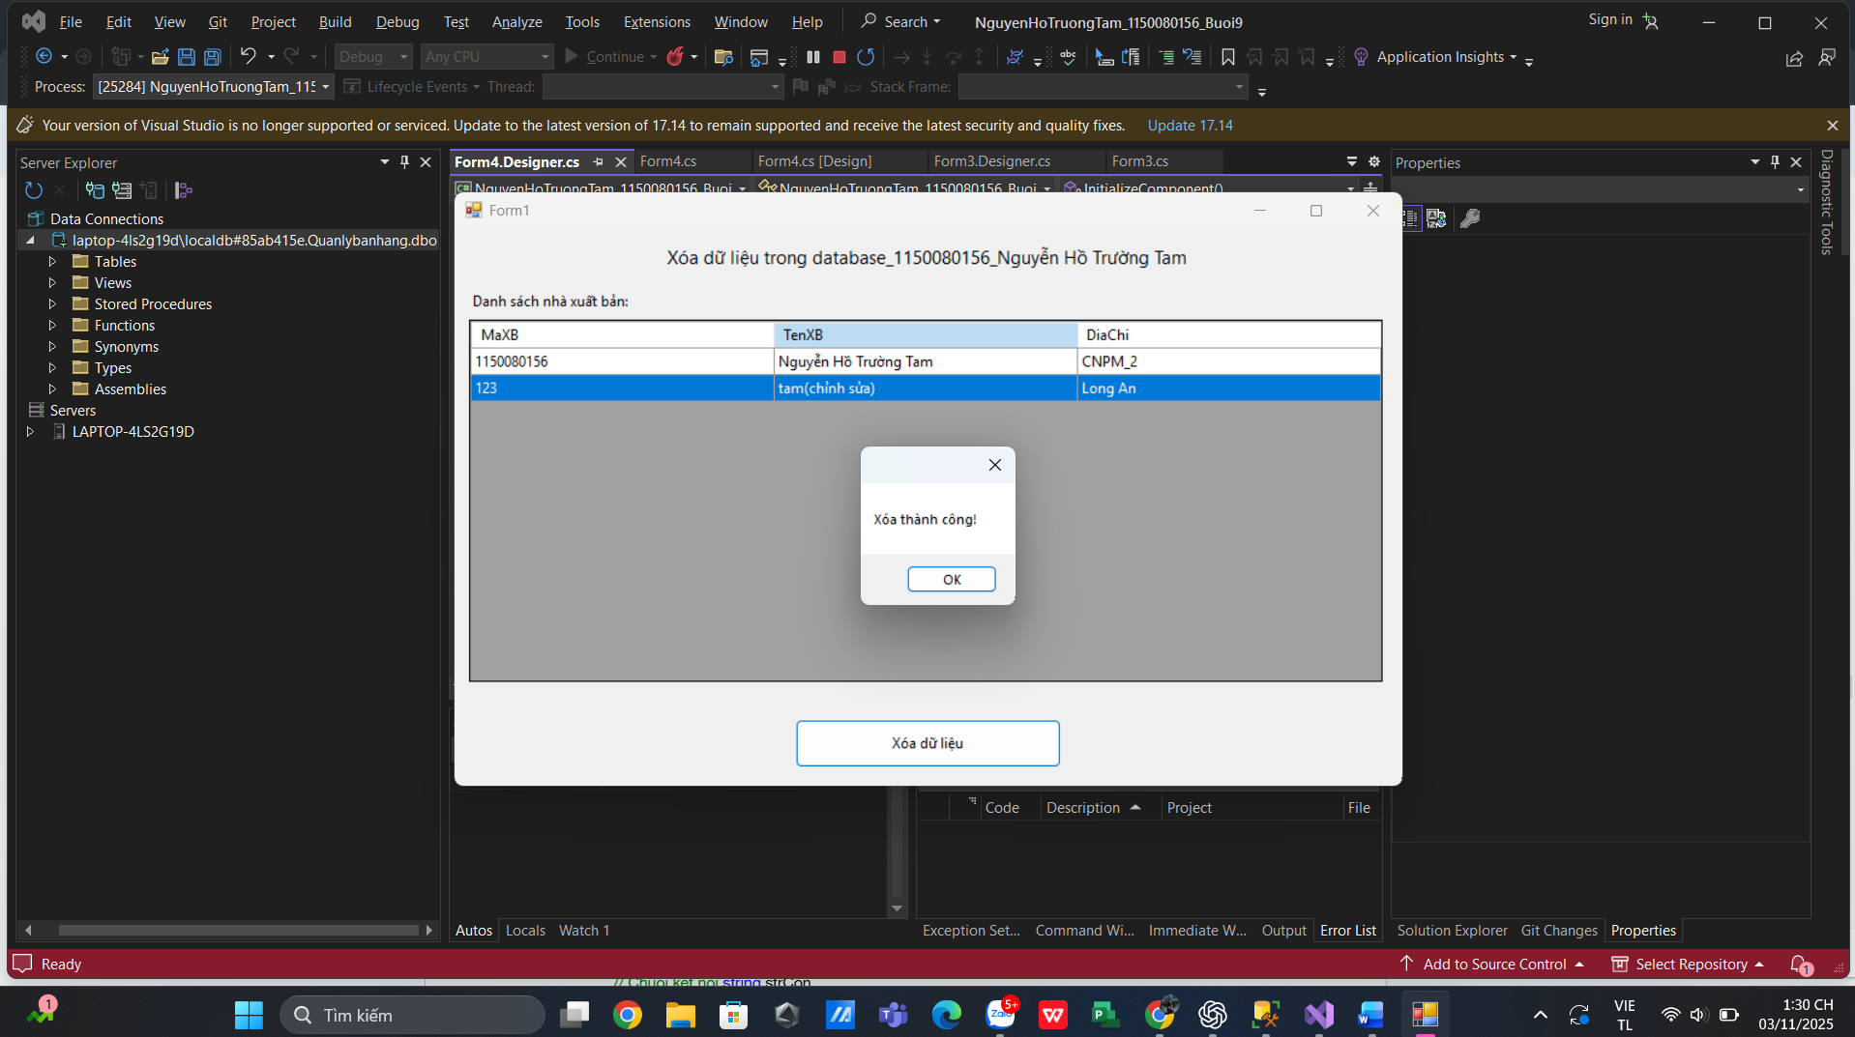

Form4.cs
using System;
using System.Collections.Generic;
using System.ComponentModel;
using System.Data;
using System.Data.SqlClient;
using System.Drawing;
using System.Linq;
using System.Text;
using System.Threading.Tasks;
using System.Windows.Forms;

namespace NguyenHoTruongTam_1150080156_Buoi9
{
public partial class Form4 : Form
{
private readonly string _strCon =
@"Data Source=(LocalDB)\MSSQLLocalDB;Initial Catalog=QuanLyBanSach;Integrated Security=True;Connect Timeout=30";
// Hoặc dùng file .mdf:
// private readonly string _strCon =
// @"Data Source=(LocalDB)\MSSQLLocalDB;AttachDbFilename=D:\SQL\QuanLyBanSach.mdf;Integrated Security=True;Connect Timeout=30";

public Form4()
{
InitializeComponent();
this.panelBottom.Resize += (_, __) => CenterDeleteButton();
}

private void Form1_Load(object sender, EventArgs e)
{
CenterDeleteButton();
NapDanhSach();
}

private void CenterDeleteButton()
{
// canh giữa nút xóa theo chiều ngang như ảnh
btnXoa.Left = (panelBottom.ClientSize.Width - btnXoa.Width) / 2;
}

private void NapDanhSach()
{
try
{
using (var conn = new SqlConnection(_strCon))
using (var adp = new SqlDataAdapter(
"SELECT MaXB, TenXB, DiaChi FROM dbo.NhaXuatBan ORDER BY MaXB", conn))
{
var tbl = new DataTable();
adp.Fill(tbl);
dgvNhaXB.DataSource = tbl;
}
}
catch (Exception ex)
{
MessageBox.Show("Không tải được danh sách.\n" + ex.Message,
"Lỗi", MessageBoxButtons.OK, MessageBoxIcon.Error);
}
}

private string GetSelectedMaXB()
{
if (dgvNhaXB.CurrentRow == null) return null;
var cell = dgvNhaXB.CurrentRow.Cells["MaXB"];
return cell?.Value?.ToString();
}

private void btnXoa_Click(object sender, EventArgs e)
{
string ma = GetSelectedMaXB();
if (string.IsNullOrEmpty(ma))
{
MessageBox.Show("Hãy chọn 1 dòng trong danh sách để xóa.");
return;
}

var confirm = MessageBox.Show($"Bạn chắc chắn xóa NXB có mã: {ma}?",
"Xác nhận xóa", MessageBoxButtons.YesNo, MessageBoxIcon.Warning);

if (confirm != DialogResult.Yes) return;

try
{
using (var conn = new SqlConnection(_strCon))
using (var cmd = new SqlCommand(
"DELETE FROM dbo.NhaXuatBan WHERE MaXB = @Ma", conn))
{
cmd.Parameters.Add("@Ma", SqlDbType.NVarChar, 10).Value = ma;
conn.Open();
int n = cmd.ExecuteNonQuery();
conn.Close();

if (n > 0)
{
MessageBox.Show("Xóa thành công!");
NapDanhSach();
}
else
{
MessageBox.Show("Không tìm thấy bản ghi để xóa.");
}
}
}
catch (SqlException ex) when (ex.Number == 547)
{
// Ràng buộc khóa ngoại
MessageBox.Show("Không thể xóa do dữ liệu đang được tham chiếu ở bảng khác.");
}
catch (Exception ex)
{
MessageBox.Show("Lỗi xóa dữ liệu:\n" + ex.Message,
"Lỗi", MessageBoxButtons.OK, MessageBoxIcon.Error);
}
}
}
}

Form4.Designer.cs
using System.Windows.Forms;

namespace NguyenHoTruongTam_1150080156_Buoi9
{
partial class Form4
{
/// <summary>
/// Required designer variable.
/// </summary>
private System.ComponentModel.IContainer components = null;

private Label lblTitle;
private Label lblDanhSach;
private DataGridView dgvNhaXB;
private Panel panelBottom;
private Button btnXoa;

protected override void Dispose(bool disposing)
{
if (disposing && (components != null)) components.Dispose();
base.Dispose(disposing);
}

#region Windows Form Designer generated code
private void InitializeComponent()
{
this.lblTitle = new System.Windows.Forms.Label();
this.lblDanhSach = new System.Windows.Forms.Label();
this.dgvNhaXB = new System.Windows.Forms.DataGridView();
this.panelBottom = new System.Windows.Forms.Panel();
this.btnXoa = new System.Windows.Forms.Button();
((System.ComponentModel.ISupportInitialize)(this.dgvNhaXB)).BeginInit();
this.panelBottom.SuspendLayout();
this.SuspendLayout();
//
// lblTitle
//
this.lblTitle.Dock = System.Windows.Forms.DockStyle.Top;
this.lblTitle.Font = new System.Drawing.Font("Segoe UI", 11F);
this.lblTitle.Location = new System.Drawing.Point(0, 0);
this.lblTitle.Name = "lblTitle";
this.lblTitle.Padding = new System.Windows.Forms.Padding(0, 10, 0, 10);
this.lblTitle.Size = new System.Drawing.Size(780, 46);
this.lblTitle.TabIndex = 0;
this.lblTitle.Text = "Xóa dữ liệu trong database_1150080156_Nguyễn Hồ Trường Tam";
this.lblTitle.TextAlign = System.Drawing.ContentAlignment.MiddleCenter;
//
// lblDanhSach
//
this.lblDanhSach.AutoSize = true;
this.lblDanhSach.Location = new System.Drawing.Point(12, 52);
this.lblDanhSach.Name = "lblDanhSach";
this.lblDanhSach.Size = new System.Drawing.Size(153, 20);
this.lblDanhSach.TabIndex = 1;
this.lblDanhSach.Text = "Danh sách nhà xuất bản:";
//
// dgvNhaXB
//
this.dgvNhaXB.AllowUserToAddRows = false;
this.dgvNhaXB.AllowUserToDeleteRows = false;
this.dgvNhaXB.Anchor = ((System.Windows.Forms.AnchorStyles)((((System.Windows.Forms.AnchorStyles.Top | System.Windows.Forms.AnchorStyles.Bottom)
| System.Windows.Forms.AnchorStyles.Left)
| System.Windows.Forms.AnchorStyles.Right)));
this.dgvNhaXB.AutoSizeColumnsMode = System.Windows.Forms.DataGridViewAutoSizeColumnsMode.Fill;
this.dgvNhaXB.BackgroundColor = System.Drawing.SystemColors.ControlDark; // xám như ảnh
this.dgvNhaXB.ColumnHeadersHeightSizeMode = System.Windows.Forms.DataGridViewColumnHeadersHeightSizeMode.AutoSize;
this.dgvNhaXB.Location = new System.Drawing.Point(12, 75);
this.dgvNhaXB.MultiSelect = false;
this.dgvNhaXB.Name = "dgvNhaXB";
this.dgvNhaXB.ReadOnly = true;
this.dgvNhaXB.RowHeadersVisible = false;
this.dgvNhaXB.SelectionMode = System.Windows.Forms.DataGridViewSelectionMode.FullRowSelect;
this.dgvNhaXB.Size = new System.Drawing.Size(756, 300);
this.dgvNhaXB.TabIndex = 2;
//
// panelBottom
//
this.panelBottom.Controls.Add(this.btnXoa);
this.panelBottom.Dock = System.Windows.Forms.DockStyle.Bottom;
this.panelBottom.Location = new System.Drawing.Point(0, 387);
this.panelBottom.Name = "panelBottom";
this.panelBottom.Padding = new System.Windows.Forms.Padding(0, 10, 0, 10);
this.panelBottom.Size = new System.Drawing.Size(780, 70);
this.panelBottom.TabIndex = 3;
//
// btnXoa
//
this.btnXoa.Anchor = System.Windows.Forms.AnchorStyles.Top;
this.btnXoa.Location = new System.Drawing.Point((780 - 220) / 2, 15); // sẽ bị VS cảnh báo const; bỏ dòng này khi paste
this.btnXoa.Name = "btnXoa";
this.btnXoa.Size = new System.Drawing.Size(220, 40);
this.btnXoa.TabIndex = 0;
this.btnXoa.Text = "Xóa dữ liệu";
this.btnXoa.UseVisualStyleBackColor = true;
this.btnXoa.Click += new System.EventHandler(this.btnXoa_Click);
//
// Form1
//
this.AcceptButton = this.btnXoa;
this.AutoScaleDimensions = new System.Drawing.SizeF(8F, 20F);
this.AutoScaleMode = System.Windows.Forms.AutoScaleMode.Font;
this.ClientSize = new System.Drawing.Size(780, 457);
this.Controls.Add(this.panelBottom);
this.Controls.Add(this.dgvNhaXB);
this.Controls.Add(this.lblDanhSach);
this.Controls.Add(this.lblTitle);
this.Font = new System.Drawing.Font("Segoe UI", 9F);
this.MinimumSize = new System.Drawing.Size(800, 500);
this.Name = "Form1";
this.StartPosition = System.Windows.Forms.FormStartPosition.CenterScreen;
this.Text = "Form1";
this.Load += new System.EventHandler(this.Form1_Load);
((System.ComponentModel.ISupportInitialize)(this.dgvNhaXB)).EndInit();
this.panelBottom.ResumeLayout(false);
this.ResumeLayout(false);
this.PerformLayout();
}
#endregion
}
}

Phần 4
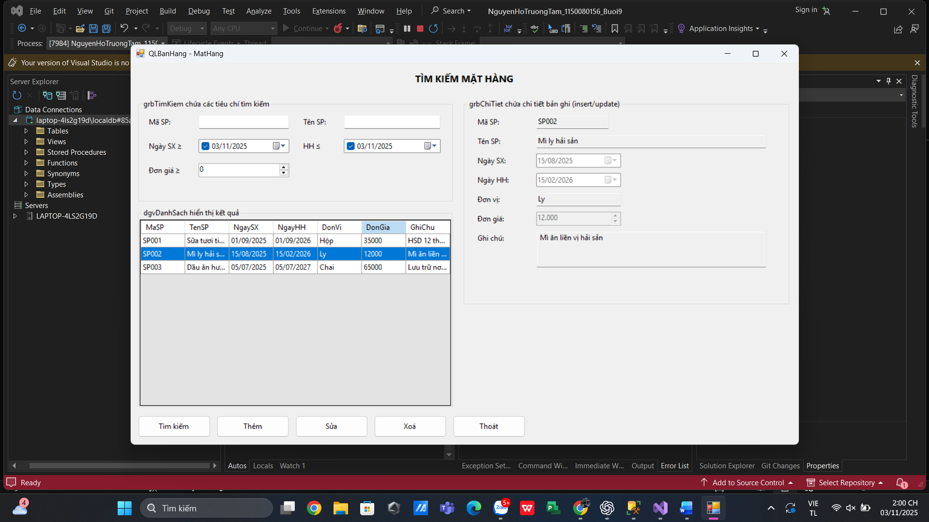

Tìm kiếm
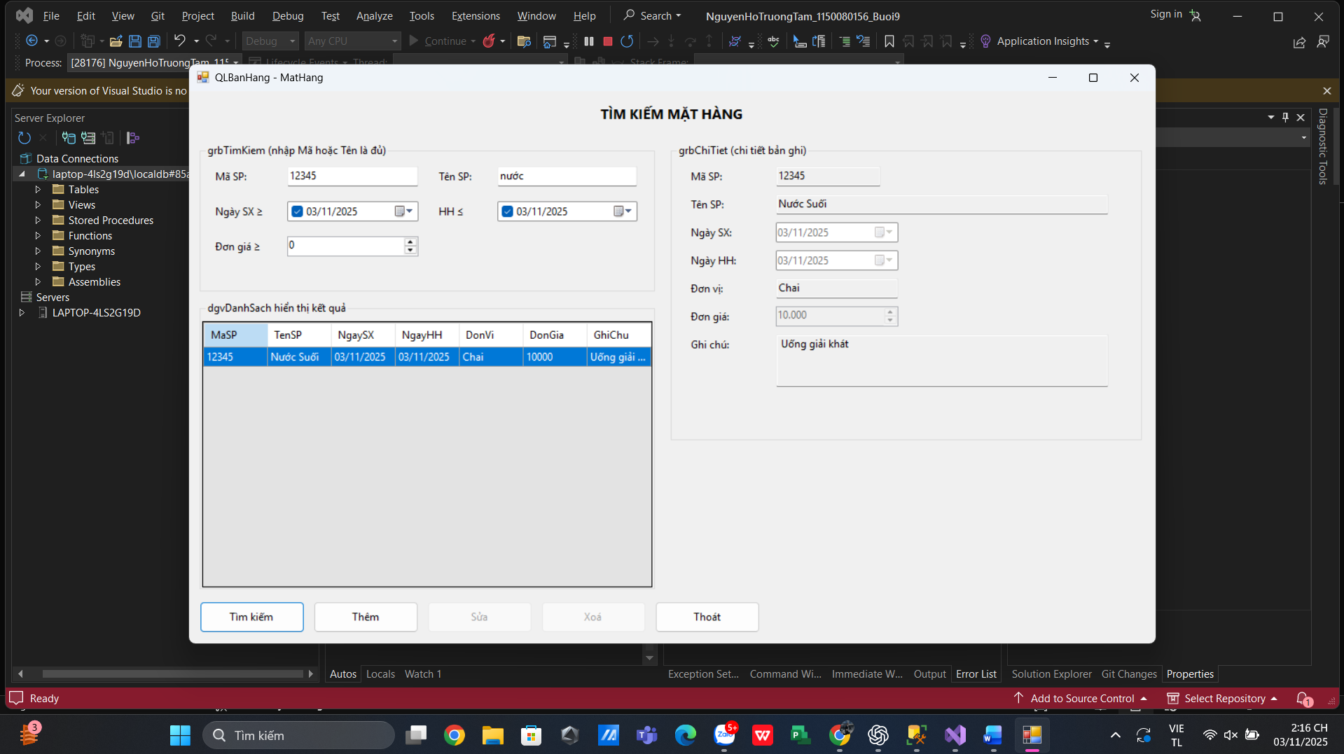

Thêm
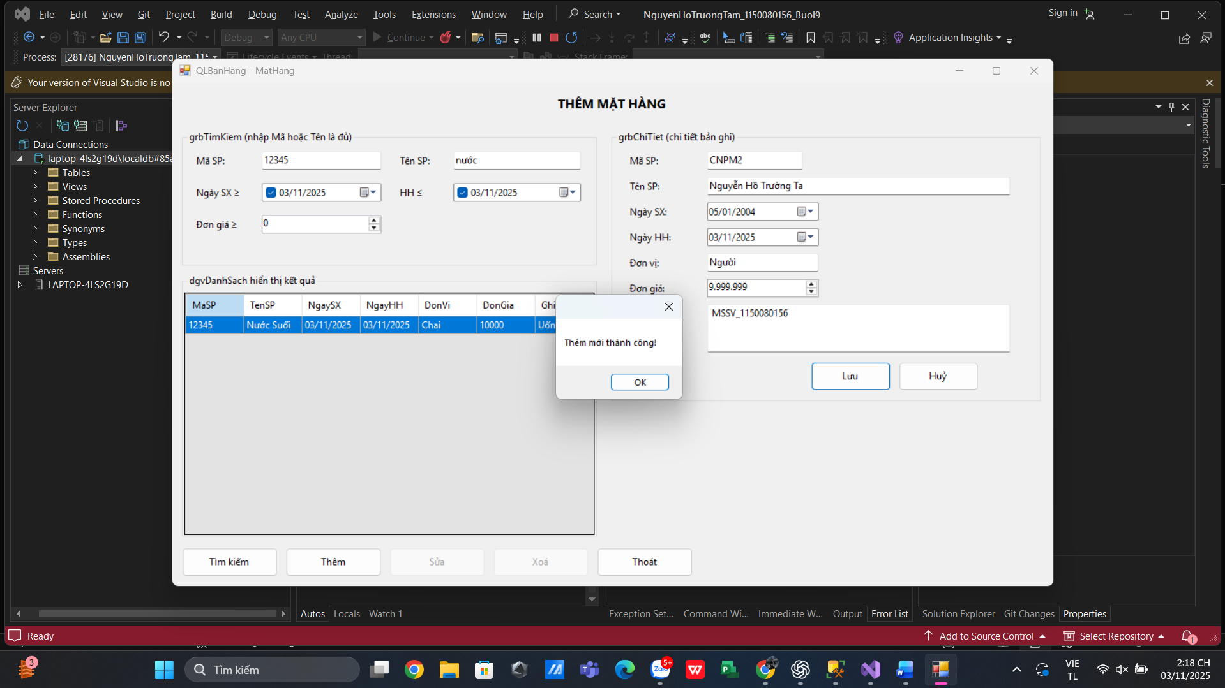
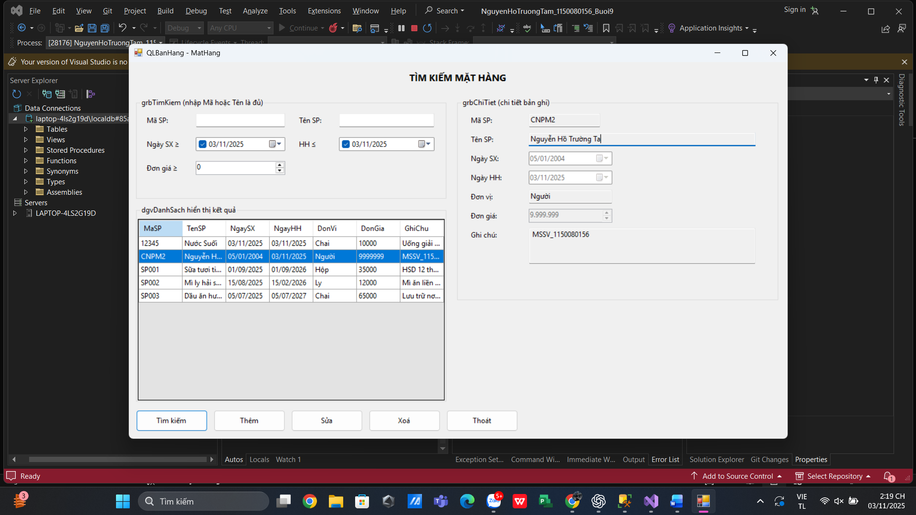

Sửa 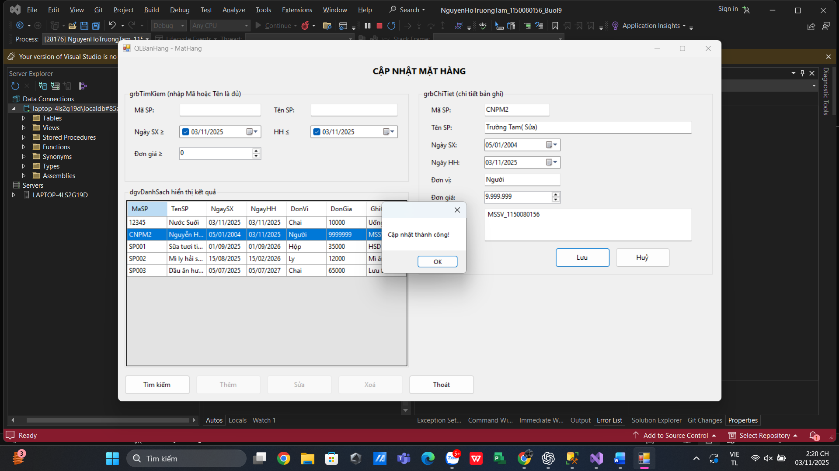

Xóa
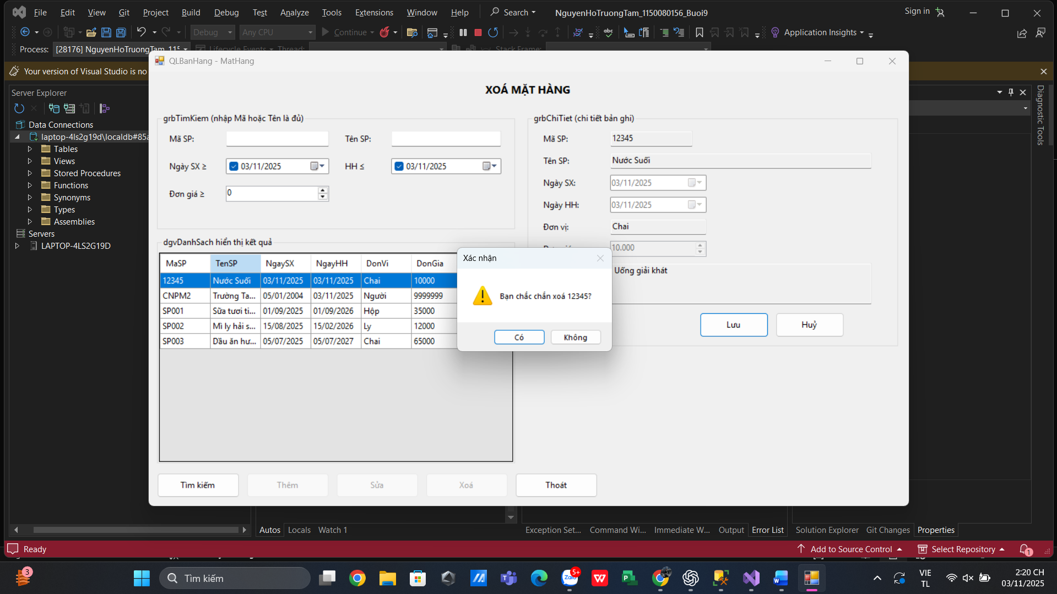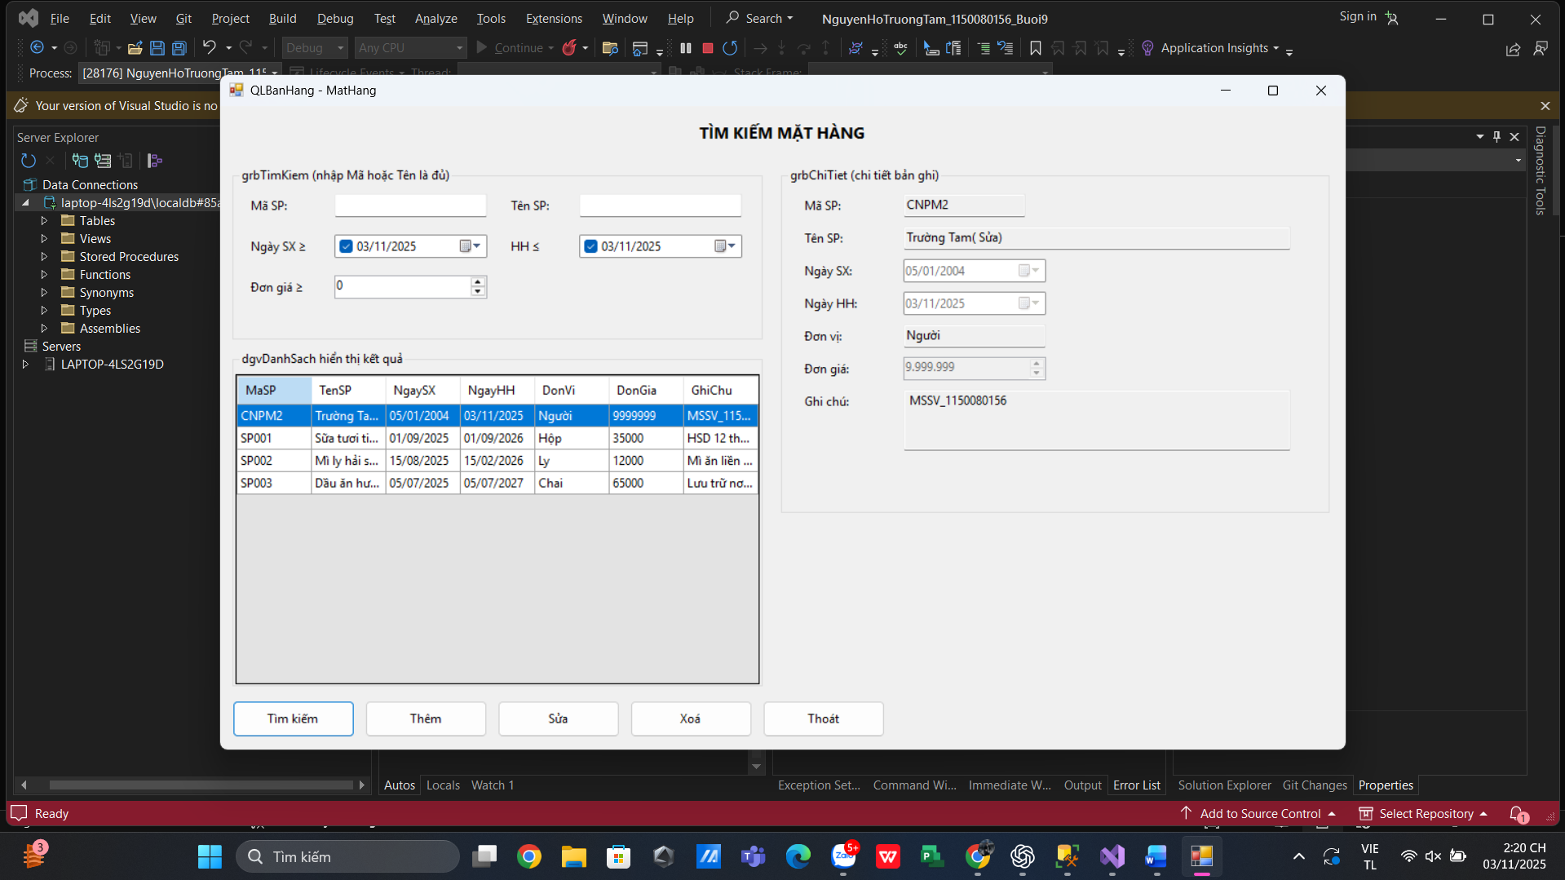

FormPhan4.cs
using System;
using System.Collections.Generic;
using System.ComponentModel;
using System.Data;
using System.Data.SqlClient;
using System.Drawing;
using System.Linq;
using System.Text;
using System.Threading.Tasks;
using System.Windows.Forms;

namespace NguyenHoTruongTam_1150080156_Buoi9
{
public partial class FormPhan4 : Form
{
// === CHUỖI KẾT NỐI: sửa cho phù hợp máy bạn ===
private readonly string _strCon =
@"Data Source=(LocalDB)\MSSQLLocalDB;Initial Catalog=QLBanHang;Integrated Security=True;Connect Timeout=30";
// Hoặc dùng .mdf:
// private readonly string _strCon =
// @"Data Source=(LocalDB)\MSSQLLocalDB;AttachDbFilename=D:\SQL\QLBanHang.mdf;Integrated Security=True;Connect Timeout=30";

private enum UIMode { Idle, Search, Add, Edit, Delete }
private UIMode _mode = UIMode.Idle;
private string _keySelected = null; // MaSP đang chọn

public FormPhan4()
{
InitializeComponent();
}

// ===== Helpers =====
private void SetTitle(string text)
{
lblTitle.Text = text;
}

private void EnableDetailInputs(bool enable)
{
txtMa.ReadOnly = !enable;
txtTen.ReadOnly = !enable;
dtNgaySX.Enabled = enable;
dtNgayHH.Enabled = enable;
txtDonVi.ReadOnly = !enable;
numDonGia.Enabled = enable;
txtGhiChu.ReadOnly = !enable;
}

private void ShowSaveCancel(bool show)
{
btnLuu.Enabled = show;
btnHuy.Enabled = show;
btnLuu.Visible = show;
btnHuy.Visible = show;
}

private void ClearDetail()
{
txtMa.Clear();
txtTen.Clear();
dtNgaySX.Value = DateTime.Today;
dtNgayHH.Value = DateTime.Today;
txtDonVi.Clear();
numDonGia.Value = 0;
txtGhiChu.Clear();
}

private void SetMode(UIMode m)
{
_mode = m;

btnTim.Enabled = true;
btnThem.Enabled = true;
btnSua.Enabled = false;
btnXoa.Enabled = false;
EnableDetailInputs(false);
ShowSaveCancel(false);

switch (m)
{
case UIMode.Search:
SetTitle("TÌM KIẾM MẶT HÀNG");
btnSua.Enabled = false;
btnXoa.Enabled = false;
EnableDetailInputs(false);
ShowSaveCancel(false);
break;

case UIMode.Add:
SetTitle("THÊM MẶT HÀNG");
btnSua.Enabled = false;
btnXoa.Enabled = false;
EnableDetailInputs(true);
ShowSaveCancel(true);
ClearDetail();
txtMa.Focus();
break;

case UIMode.Edit:
SetTitle("CẬP NHẬT MẶT HÀNG");
btnThem.Enabled = false;
btnXoa.Enabled = false;
EnableDetailInputs(true);
ShowSaveCancel(true);
break;

case UIMode.Delete:
SetTitle("XOÁ MẶT HÀNG");
btnThem.Enabled = false;
btnSua.Enabled = false;
EnableDetailInputs(false);
ShowSaveCancel(true);
break;
}
}

private void BindGrid(DataTable tbl)
{
dgvDanhSach.DataSource = tbl;
}

private void LoadAll()
{
using (var conn = new SqlConnection(_strCon))
using (var adp = new SqlDataAdapter(
"SELECT MaSP, TenSP, NgaySX, NgayHH, DonVi, DonGia, GhiChu FROM dbo.tblMatHang ORDER BY MaSP", conn))
{
var tbl = new DataTable();
adp.Fill(tbl);
BindGrid(tbl);
}
}

private void FillDetailFromGrid(int rowIndex)
{
if (rowIndex < 0 || dgvDanhSach.CurrentRow == null) return;

var r = dgvDanhSach.Rows[rowIndex];

txtMa.Text = Convert.ToString(r.Cells["MaSP"].Value);
txtTen.Text = Convert.ToString(r.Cells["TenSP"].Value);

DateTime nsx, nhh;
if (!DateTime.TryParse(Convert.ToString(r.Cells["NgaySX"].Value), out nsx)) nsx = DateTime.Today;
if (!DateTime.TryParse(Convert.ToString(r.Cells["NgayHH"].Value), out nhh)) nhh = DateTime.Today;
dtNgaySX.Value = nsx;
dtNgayHH.Value = nhh;

txtDonVi.Text = Convert.ToString(r.Cells["DonVi"].Value);

decimal dg;
if (!decimal.TryParse(Convert.ToString(r.Cells["DonGia"].Value), out dg)) dg = 0;
numDonGia.Value = dg < numDonGia.Minimum ? 0 : dg;

txtGhiChu.Text = Convert.ToString(r.Cells["GhiChu"].Value);

_keySelected = txtMa.Text;

if (_mode == UIMode.Idle || _mode == UIMode.Search)
{
btnSua.Enabled = true;
btnXoa.Enabled = true;
EnableDetailInputs(false);
ShowSaveCancel(false);
}
}

private void SaveAdd()
{
using (var conn = new SqlConnection(_strCon))
using (var cmd = new SqlCommand(
@"INSERT INTO dbo.tblMatHang(MaSP, TenSP, NgaySX, NgayHH, DonVi, DonGia, GhiChu)
VALUES (@Ma,@Ten,@NSX,@NHH,@DonVi,@DonGia,@GhiChu)", conn))
{
cmd.Parameters.Add("@Ma", SqlDbType.NChar, 5).Value = txtMa.Text.Trim();
cmd.Parameters.Add("@Ten", SqlDbType.NVarChar, 30).Value = txtTen.Text.Trim();
cmd.Parameters.Add("@NSX", SqlDbType.Date).Value = dtNgaySX.Value.Date;
cmd.Parameters.Add("@NHH", SqlDbType.Date).Value = dtNgayHH.Value.Date;
cmd.Parameters.Add("@DonVi", SqlDbType.NVarChar, 10).Value = (object)txtDonVi.Text.Trim() ?? DBNull.Value;
cmd.Parameters.Add("@DonGia", SqlDbType.Float).Value = (double)numDonGia.Value;
cmd.Parameters.Add("@GhiChu", SqlDbType.NVarChar, 200).Value = (object)txtGhiChu.Text.Trim() ?? DBNull.Value;

conn.Open();
cmd.ExecuteNonQuery();
}
}

private void SaveEdit()
{
using (var conn = new SqlConnection(_strCon))
using (var cmd = new SqlCommand(
@"UPDATE dbo.tblMatHang
SET MaSP=@MaMoi, TenSP=@Ten, NgaySX=@NSX, NgayHH=@NHH, DonVi=@DonVi, DonGia=@DonGia, GhiChu=@GhiChu
WHERE MaSP=@MaCu", conn))
{
cmd.Parameters.Add("@MaMoi", SqlDbType.NChar, 5).Value = txtMa.Text.Trim();
cmd.Parameters.Add("@Ten", SqlDbType.NVarChar, 30).Value = txtTen.Text.Trim();
cmd.Parameters.Add("@NSX", SqlDbType.Date).Value = dtNgaySX.Value.Date;
cmd.Parameters.Add("@NHH", SqlDbType.Date).Value = dtNgayHH.Value.Date;
cmd.Parameters.Add("@DonVi", SqlDbType.NVarChar, 10).Value = (object)txtDonVi.Text.Trim() ?? DBNull.Value;
cmd.Parameters.Add("@DonGia", SqlDbType.Float).Value = (double)numDonGia.Value;
cmd.Parameters.Add("@GhiChu", SqlDbType.NVarChar, 200).Value = (object)txtGhiChu.Text.Trim() ?? DBNull.Value;
cmd.Parameters.Add("@MaCu", SqlDbType.NChar, 5).Value = _keySelected;

conn.Open();
int n = cmd.ExecuteNonQuery();
if (n == 0) throw new Exception("Không tìm thấy bản ghi để cập nhật.");
}
}

private void SaveDelete()
{
using (var conn = new SqlConnection(_strCon))
using (var cmd = new SqlCommand("DELETE FROM dbo.tblMatHang WHERE MaSP=@Ma", conn))
{
cmd.Parameters.Add("@Ma", SqlDbType.NChar, 5).Value = _keySelected;
conn.Open();
int n = cmd.ExecuteNonQuery();
if (n == 0) throw new Exception("Không tìm thấy bản ghi để xoá.");
}
}

private bool ValidateDetailForSave()
{
if (string.IsNullOrWhiteSpace(txtMa.Text) || txtMa.Text.Trim().Length != 5)
{
MessageBox.Show("Mã SP phải đủ 5 ký tự.", "Cảnh báo");
txtMa.Focus();
return false;
}
if (string.IsNullOrWhiteSpace(txtTen.Text))
{
MessageBox.Show("Tên SP không được trống.", "Cảnh báo");
txtTen.Focus();
return false;
}
if (dtNgayHH.Value.Date < dtNgaySX.Value.Date)
{
MessageBox.Show("Ngày hết hạn phải >= ngày sản xuất.", "Cảnh báo");
dtNgayHH.Focus();
return false;
}
return true;
}

// ======= Cấu hình gợi ý tìm kiếm (tuỳ chọn nhưng đã bật) =======
private void SetupAutoComplete()
{
var acMa = new AutoCompleteStringCollection();
var acTen = new AutoCompleteStringCollection();

using (var conn = new SqlConnection(_strCon))
using (var cmd = new SqlCommand("SELECT MaSP, TenSP FROM dbo.tblMatHang", conn))
{
conn.Open();
using (var rd = cmd.ExecuteReader())
{
while (rd.Read())
{
acMa.Add(rd.GetString(0).Trim());
acTen.Add(rd.GetString(1));
}
}
}

txtTKMa.AutoCompleteMode = AutoCompleteMode.SuggestAppend;
txtTKMa.AutoCompleteSource = AutoCompleteSource.CustomSource;
txtTKMa.AutoCompleteCustomSource = acMa;

txtTKTên.AutoCompleteMode = AutoCompleteMode.SuggestAppend;
txtTKTên.AutoCompleteSource = AutoCompleteSource.CustomSource;
txtTKTên.AutoCompleteCustomSource = acTen;
}

// ===== Events =====
private void FormPhan4_Load(object sender, EventArgs e)
{
// Enter để tìm
this.AcceptButton = btnTim;

// Nếu dùng 2 DateTimePicker tìm nâng cao, vẫn bật checkbox
dtTKNgaySX.Format = DateTimePickerFormat.Short; dtTKNgaySX.ShowCheckBox = true;
dtTKNgayHH.Format = DateTimePickerFormat.Short; dtTKNgayHH.ShowCheckBox = true;

SetMode(UIMode.Search);
LoadAll();
SetupAutoComplete(); // gợi ý khi gõ Mã/Tên
}

private void dgvDanhSach_CellClick(object sender, DataGridViewCellEventArgs e)
{
FillDetailFromGrid(e.RowIndex);
}

// ======= TÌM KIẾM CỰC NHANH: chỉ Mã hoặc Tên =======
private void btnTim_Click(object sender, EventArgs e)
{
try
{
SetMode(UIMode.Search);

string ma = (txtTKMa.Text ?? "").Trim();
string ten = (txtTKTên.Text ?? "").Trim();

string sql = @"
SELECT MaSP, TenSP, NgaySX, NgayHH, DonVi, DonGia, GhiChu
FROM dbo.tblMatHang
WHERE (@Ma = '' AND @Ten = '')
OR (MaSP LIKE @MaLike)
OR (TenSP COLLATE Vietnamese_CI_AI LIKE N'%'+@Ten+N'%')
ORDER BY MaSP;";

using (var conn = new SqlConnection(_strCon))
using (var cmd = new SqlCommand(sql, conn))
{
cmd.Parameters.Add("@Ma", SqlDbType.NVarChar, 50).Value = ma;
cmd.Parameters.Add("@Ten", SqlDbType.NVarChar, 100).Value = ten;
cmd.Parameters.Add("@MaLike", SqlDbType.NVarChar, 50).Value =
ma == "" ? "%" : "%" + ma + "%";

using (var adp = new SqlDataAdapter(cmd))
{
var tbl = new DataTable();
adp.Fill(tbl);
dgvDanhSach.DataSource = tbl;
}
}

// Đúng yêu cầu: ở chế độ tìm → không cho sửa
btnSua.Enabled = false;
btnXoa.Enabled = false;
EnableDetailInputs(false);
ShowSaveCancel(false);
_keySelected = null;
SetTitle("TÌM KIẾM MẶT HÀNG");
}
catch (Exception ex)
{
MessageBox.Show("Lỗi tìm kiếm:\n" + ex.Message);
}
}

// b) Thêm
private void btnThem_Click(object sender, EventArgs e)
{
SetMode(UIMode.Add);
}

// c) Sửa
private void btnSua_Click(object sender, EventArgs e)
{
if (string.IsNullOrEmpty(_keySelected))
{
MessageBox.Show("Hãy chọn một bản ghi trong danh sách để sửa.");
return;
}
SetMode(UIMode.Edit);
}

// d) Xoá
private void btnXoa_Click(object sender, EventArgs e)
{
if (string.IsNullOrEmpty(_keySelected))
{
MessageBox.Show("Hãy chọn một bản ghi trong danh sách để xoá.");
return;
}
SetMode(UIMode.Delete);
}

// Lưu (tuỳ mode)
private void btnLuu_Click(object sender, EventArgs e)
{
try
{
if (_mode == UIMode.Add || _mode == UIMode.Edit)
{
if (!ValidateDetailForSave()) return;
}

switch (_mode)
{
case UIMode.Add:
SaveAdd();
MessageBox.Show("Thêm mới thành công!");
break;

case UIMode.Edit:
SaveEdit();
MessageBox.Show("Cập nhật thành công!");
break;

case UIMode.Delete:
DialogResult cf = MessageBox.Show(
"Bạn chắc chắn xoá " + _keySelected + "?",
"Xác nhận", MessageBoxButtons.YesNo, MessageBoxIcon.Warning);
if (cf != DialogResult.Yes) return;
SaveDelete();
MessageBox.Show("Xoá thành công!");
break;

default:
return;
}

LoadAll();
SetMode(UIMode.Search);
_keySelected = null;
}
catch (SqlException ex)
{
if (ex.Number == 2627 || ex.Number == 2601)
{
MessageBox.Show("Mã SP đã tồn tại, vui lòng chọn mã khác.");
}
else if (ex.Number == 547 && _mode == UIMode.Delete)
{
MessageBox.Show("Không thể xoá do bản ghi đang được tham chiếu.");
}
else
{
MessageBox.Show("Lỗi SQL:\n" + ex.Message);
}
}
catch (Exception ex)
{
MessageBox.Show("Lỗi lưu dữ liệu:\n" + ex.Message);
}
}

private void btnHuy_Click(object sender, EventArgs e)
{
SetMode(UIMode.Search);
ClearDetail();
}

private void btnThoat_Click(object sender, EventArgs e)
{
this.Close();
}

private void dgvDanhSach_CellContentClick(object sender, DataGridViewCellEventArgs e)
{

}
}
}

FormPhan4.Designer.cs
using System.Data.SqlClient;
using System.Data;
using System.Windows.Forms;
using System;
using System.Drawing;

namespace NguyenHoTruongTam_1150080156_Buoi9
{
partial class FormPhan4
{
private System.ComponentModel.IContainer components = null;

// Title
private System.Windows.Forms.Label lblTitle;

// grbTimKiem
private System.Windows.Forms.GroupBox grbTimKiem;
private System.Windows.Forms.Label lblTKMa;
private System.Windows.Forms.TextBox txtTKMa;
private System.Windows.Forms.Label lblTKTên;
private System.Windows.Forms.TextBox txtTKTên;
private System.Windows.Forms.Label lblTKNgaySX;
private System.Windows.Forms.DateTimePicker dtTKNgaySX;
private System.Windows.Forms.Label lblTKNgayHH;
private System.Windows.Forms.DateTimePicker dtTKNgayHH;
private System.Windows.Forms.Label lblTKDonGia;
private System.Windows.Forms.NumericUpDown numTKDonGia;

// grbChiTiet
private System.Windows.Forms.GroupBox grbChiTiet;
private System.Windows.Forms.Label lblMa;
private System.Windows.Forms.TextBox txtMa;
private System.Windows.Forms.Label lblTen;
private System.Windows.Forms.TextBox txtTen;
private System.Windows.Forms.Label lblNgaySX;
private System.Windows.Forms.DateTimePicker dtNgaySX;
private System.Windows.Forms.Label lblNgayHH;
private System.Windows.Forms.DateTimePicker dtNgayHH;
private System.Windows.Forms.Label lblDonVi;
private System.Windows.Forms.TextBox txtDonVi;
private System.Windows.Forms.Label lblDonGia;
private System.Windows.Forms.NumericUpDown numDonGia;
private System.Windows.Forms.Label lblGhiChu;
private System.Windows.Forms.TextBox txtGhiChu;
private System.Windows.Forms.Button btnLuu;
private System.Windows.Forms.Button btnHuy;

// grbDanhSach
private System.Windows.Forms.GroupBox grbDanhSach;
private System.Windows.Forms.DataGridView dgvDanhSach;

// Bottom buttons
private System.Windows.Forms.Panel pnlButtons;
private System.Windows.Forms.Button btnTim;
private System.Windows.Forms.Button btnThem;
private System.Windows.Forms.Button btnSua;
private System.Windows.Forms.Button btnXoa;
private System.Windows.Forms.Button btnThoat;

protected override void Dispose(bool disposing)
{
if (disposing && (components != null)) components.Dispose();
base.Dispose(disposing);
}

#region Windows Form Designer generated code
private void InitializeComponent()
{
this.lblTitle = new System.Windows.Forms.Label();
this.grbTimKiem = new System.Windows.Forms.GroupBox();
this.lblTKMa = new System.Windows.Forms.Label();
this.txtTKMa = new System.Windows.Forms.TextBox();
this.lblTKTên = new System.Windows.Forms.Label();
this.txtTKTên = new System.Windows.Forms.TextBox();
this.lblTKNgaySX = new System.Windows.Forms.Label();
this.dtTKNgaySX = new System.Windows.Forms.DateTimePicker();
this.lblTKNgayHH = new System.Windows.Forms.Label();
this.dtTKNgayHH = new System.Windows.Forms.DateTimePicker();
this.lblTKDonGia = new System.Windows.Forms.Label();
this.numTKDonGia = new System.Windows.Forms.NumericUpDown();
this.grbChiTiet = new System.Windows.Forms.GroupBox();
this.lblMa = new System.Windows.Forms.Label();
this.txtMa = new System.Windows.Forms.TextBox();
this.lblTen = new System.Windows.Forms.Label();
this.txtTen = new System.Windows.Forms.TextBox();
this.lblNgaySX = new System.Windows.Forms.Label();
this.dtNgaySX = new System.Windows.Forms.DateTimePicker();
this.lblNgayHH = new System.Windows.Forms.Label();
this.dtNgayHH = new System.Windows.Forms.DateTimePicker();
this.lblDonVi = new System.Windows.Forms.Label();
this.txtDonVi = new System.Windows.Forms.TextBox();
this.lblDonGia = new System.Windows.Forms.Label();
this.numDonGia = new System.Windows.Forms.NumericUpDown();
this.lblGhiChu = new System.Windows.Forms.Label();
this.txtGhiChu = new System.Windows.Forms.TextBox();
this.btnLuu = new System.Windows.Forms.Button();
this.btnHuy = new System.Windows.Forms.Button();
this.grbDanhSach = new System.Windows.Forms.GroupBox();
this.dgvDanhSach = new System.Windows.Forms.DataGridView();
this.pnlButtons = new System.Windows.Forms.Panel();
this.btnTim = new System.Windows.Forms.Button();
this.btnThem = new System.Windows.Forms.Button();
this.btnSua = new System.Windows.Forms.Button();
this.btnXoa = new System.Windows.Forms.Button();
this.btnThoat = new System.Windows.Forms.Button();
this.grbTimKiem.SuspendLayout();
((System.ComponentModel.ISupportInitialize)(this.numTKDonGia)).BeginInit();
this.grbChiTiet.SuspendLayout();
((System.ComponentModel.ISupportInitialize)(this.numDonGia)).BeginInit();
this.grbDanhSach.SuspendLayout();
((System.ComponentModel.ISupportInitialize)(this.dgvDanhSach)).BeginInit();
this.pnlButtons.SuspendLayout();
this.SuspendLayout();
//
// lblTitle
//
this.lblTitle.Dock = System.Windows.Forms.DockStyle.Top;
this.lblTitle.Font = new System.Drawing.Font("Segoe UI", 12F, System.Drawing.FontStyle.Bold);
this.lblTitle.Location = new System.Drawing.Point(0, 0);
this.lblTitle.Name = "lblTitle";
this.lblTitle.Padding = new System.Windows.Forms.Padding(0, 10, 0, 10);
this.lblTitle.Size = new System.Drawing.Size(1102, 50);
this.lblTitle.TabIndex = 0;
this.lblTitle.Text = "TÌM KIẾM MẶT HÀNG";
this.lblTitle.TextAlign = System.Drawing.ContentAlignment.MiddleCenter;
//
// grbTimKiem
//
this.grbTimKiem.Controls.Add(this.lblTKMa);
this.grbTimKiem.Controls.Add(this.txtTKMa);
this.grbTimKiem.Controls.Add(this.lblTKTên);
this.grbTimKiem.Controls.Add(this.txtTKTên);
this.grbTimKiem.Controls.Add(this.lblTKNgaySX);
this.grbTimKiem.Controls.Add(this.dtTKNgaySX);
this.grbTimKiem.Controls.Add(this.lblTKNgayHH);
this.grbTimKiem.Controls.Add(this.dtTKNgayHH);
this.grbTimKiem.Controls.Add(this.lblTKDonGia);
this.grbTimKiem.Controls.Add(this.numTKDonGia);
this.grbTimKiem.Location = new System.Drawing.Point(12, 60);
this.grbTimKiem.Name = "grbTimKiem";
this.grbTimKiem.Size = new System.Drawing.Size(520, 170);
this.grbTimKiem.TabIndex = 1;
this.grbTimKiem.Text = "grbTimKiem (nhập Mã hoặc Tên là đủ)";
//
// lblTKMa
//
this.lblTKMa.AutoSize = true;
this.lblTKMa.Location = new System.Drawing.Point(15, 30);
this.lblTKMa.Name = "lblTKMa";
this.lblTKMa.Size = new System.Drawing.Size(53, 20);
this.lblTKMa.TabIndex = 0;
this.lblTKMa.Text = "Mã SP:";
//
// txtTKMa
//
this.txtTKMa.Location = new System.Drawing.Point(100, 26);
this.txtTKMa.Name = "txtTKMa";
this.txtTKMa.Size = new System.Drawing.Size(150, 27);
this.txtTKMa.TabIndex = 1;
//
// lblTKTên
//
this.lblTKTên.AutoSize = true;
this.lblTKTên.Location = new System.Drawing.Point(270, 30);
this.lblTKTên.Name = "lblTKTên";
this.lblTKTên.Size = new System.Drawing.Size(55, 20);
this.lblTKTên.TabIndex = 2;
this.lblTKTên.Text = "Tên SP:";
//
// txtTKTên
//
this.txtTKTên.Location = new System.Drawing.Point(340, 26);
this.txtTKTên.Name = "txtTKTên";
this.txtTKTên.Size = new System.Drawing.Size(160, 27);
this.txtTKTên.TabIndex = 3;
//
// lblTKNgaySX
//
this.lblTKNgaySX.AutoSize = true;
this.lblTKNgaySX.Location = new System.Drawing.Point(15, 70);
this.lblTKNgaySX.Name = "lblTKNgaySX";
this.lblTKNgaySX.Size = new System.Drawing.Size(79, 20);
this.lblTKNgaySX.TabIndex = 4;
this.lblTKNgaySX.Text = "Ngày SX ≥";
//
// dtTKNgaySX
//
this.dtTKNgaySX.Format = System.Windows.Forms.DateTimePickerFormat.Short;
this.dtTKNgaySX.Location = new System.Drawing.Point(100, 66);
this.dtTKNgaySX.Name = "dtTKNgaySX";
this.dtTKNgaySX.ShowCheckBox = true;
this.dtTKNgaySX.Size = new System.Drawing.Size(150, 27);
this.dtTKNgaySX.TabIndex = 5;
//
// lblTKNgayHH
//
this.lblTKNgayHH.AutoSize = true;
this.lblTKNgayHH.Location = new System.Drawing.Point(270, 70);
this.lblTKNgayHH.Name = "lblTKNgayHH";
this.lblTKNgayHH.Size = new System.Drawing.Size(45, 20);
this.lblTKNgayHH.TabIndex = 6;
this.lblTKNgayHH.Text = "HH ≤";
//
// dtTKNgayHH
//
this.dtTKNgayHH.Format = System.Windows.Forms.DateTimePickerFormat.Short;
this.dtTKNgayHH.Location = new System.Drawing.Point(340, 66);
this.dtTKNgayHH.Name = "dtTKNgayHH";
this.dtTKNgayHH.ShowCheckBox = true;
this.dtTKNgayHH.Size = new System.Drawing.Size(160, 27);
this.dtTKNgayHH.TabIndex = 7;
//
// lblTKDonGia
//
this.lblTKDonGia.AutoSize = true;
this.lblTKDonGia.Location = new System.Drawing.Point(15, 110);
this.lblTKDonGia.Name = "lblTKDonGia";
this.lblTKDonGia.Size = new System.Drawing.Size(76, 20);
this.lblTKDonGia.TabIndex = 8;
this.lblTKDonGia.Text = "Đơn giá ≥";
//
// numTKDonGia
//
this.numTKDonGia.Location = new System.Drawing.Point(100, 106);
this.numTKDonGia.Maximum = new decimal(new int[] {
1000000000,
0,
0,
0});
this.numTKDonGia.Name = "numTKDonGia";
this.numTKDonGia.Size = new System.Drawing.Size(150, 27);
this.numTKDonGia.TabIndex = 9;
this.numTKDonGia.ThousandsSeparator = true;
//
// grbChiTiet
//
this.grbChiTiet.Controls.Add(this.lblMa);
this.grbChiTiet.Controls.Add(this.txtMa);
this.grbChiTiet.Controls.Add(this.lblTen);
this.grbChiTiet.Controls.Add(this.txtTen);
this.grbChiTiet.Controls.Add(this.lblNgaySX);
this.grbChiTiet.Controls.Add(this.dtNgaySX);
this.grbChiTiet.Controls.Add(this.lblNgayHH);
this.grbChiTiet.Controls.Add(this.dtNgayHH);
this.grbChiTiet.Controls.Add(this.lblDonVi);
this.grbChiTiet.Controls.Add(this.txtDonVi);
this.grbChiTiet.Controls.Add(this.lblDonGia);
this.grbChiTiet.Controls.Add(this.numDonGia);
this.grbChiTiet.Controls.Add(this.lblGhiChu);
this.grbChiTiet.Controls.Add(this.txtGhiChu);
this.grbChiTiet.Controls.Add(this.btnLuu);
this.grbChiTiet.Controls.Add(this.btnHuy);
this.grbChiTiet.Location = new System.Drawing.Point(550, 60);
this.grbChiTiet.Name = "grbChiTiet";
this.grbChiTiet.Size = new System.Drawing.Size(538, 340);
this.grbChiTiet.TabIndex = 2;
this.grbChiTiet.Text = "grbChiTiet (chi tiết bản ghi)";
//
// lblMa
//
this.lblMa.AutoSize = true;
this.lblMa.Location = new System.Drawing.Point(20, 30);
this.lblMa.Name = "lblMa";
this.lblMa.Size = new System.Drawing.Size(53, 20);
this.lblMa.TabIndex = 0;
this.lblMa.Text = "Mã SP:";
//
// txtMa
//
this.txtMa.Location = new System.Drawing.Point(120, 26);
this.txtMa.Name = "txtMa";
this.txtMa.Size = new System.Drawing.Size(120, 27);
this.txtMa.TabIndex = 1;
//
// lblTen
//
this.lblTen.AutoSize = true;
this.lblTen.Location = new System.Drawing.Point(20, 62);
this.lblTen.Name = "lblTen";
this.lblTen.Size = new System.Drawing.Size(55, 20);
this.lblTen.TabIndex = 2;
this.lblTen.Text = "Tên SP:";
//
// txtTen
//
this.txtTen.Location = new System.Drawing.Point(120, 58);
this.txtTen.Name = "txtTen";
this.txtTen.Size = new System.Drawing.Size(380, 27);
this.txtTen.TabIndex = 3;
//
// lblNgaySX
//
this.lblNgaySX.AutoSize = true;
this.lblNgaySX.Location = new System.Drawing.Point(20, 94);
this.lblNgaySX.Name = "lblNgaySX";
this.lblNgaySX.Size = new System.Drawing.Size(68, 20);
this.lblNgaySX.TabIndex = 4;
this.lblNgaySX.Text = "Ngày SX:";
//
// dtNgaySX
//
this.dtNgaySX.Format = System.Windows.Forms.DateTimePickerFormat.Short;
this.dtNgaySX.Location = new System.Drawing.Point(120, 90);
this.dtNgaySX.Name = "dtNgaySX";
this.dtNgaySX.Size = new System.Drawing.Size(140, 27);
this.dtNgaySX.TabIndex = 5;
//
// lblNgayHH
//
this.lblNgayHH.AutoSize = true;
this.lblNgayHH.Location = new System.Drawing.Point(20, 126);
this.lblNgayHH.Name = "lblNgayHH";
this.lblNgayHH.Size = new System.Drawing.Size(73, 20);
this.lblNgayHH.TabIndex = 6;
this.lblNgayHH.Text = "Ngày HH:";
//
// dtNgayHH
//
this.dtNgayHH.Format = System.Windows.Forms.DateTimePickerFormat.Short;
this.dtNgayHH.Location = new System.Drawing.Point(120, 122);
this.dtNgayHH.Name = "dtNgayHH";
this.dtNgayHH.Size = new System.Drawing.Size(140, 27);
this.dtNgayHH.TabIndex = 7;
//
// lblDonVi
//
this.lblDonVi.AutoSize = true;
this.lblDonVi.Location = new System.Drawing.Point(20, 158);
this.lblDonVi.Name = "lblDonVi";
this.lblDonVi.Size = new System.Drawing.Size(55, 20);
this.lblDonVi.TabIndex = 8;
this.lblDonVi.Text = "Đơn vị:";
//
// txtDonVi
//
this.txtDonVi.Location = new System.Drawing.Point(120, 154);
this.txtDonVi.Name = "txtDonVi";
this.txtDonVi.Size = new System.Drawing.Size(140, 27);
this.txtDonVi.TabIndex = 9;
//
// lblDonGia
//
this.lblDonGia.AutoSize = true;
this.lblDonGia.Location = new System.Drawing.Point(20, 190);
this.lblDonGia.Name = "lblDonGia";
this.lblDonGia.Size = new System.Drawing.Size(65, 20);
this.lblDonGia.TabIndex = 10;
this.lblDonGia.Text = "Đơn giá:";
//
// numDonGia
//
this.numDonGia.Location = new System.Drawing.Point(120, 186);
this.numDonGia.Maximum = new decimal(new int[] {
1000000000,
0,
0,
0});
this.numDonGia.Name = "numDonGia";
this.numDonGia.Size = new System.Drawing.Size(140, 27);
this.numDonGia.TabIndex = 11;
this.numDonGia.ThousandsSeparator = true;
//
// lblGhiChu
//
this.lblGhiChu.AutoSize = true;
this.lblGhiChu.Location = new System.Drawing.Point(20, 222);
this.lblGhiChu.Name = "lblGhiChu";
this.lblGhiChu.Size = new System.Drawing.Size(61, 20);
this.lblGhiChu.TabIndex = 12;
this.lblGhiChu.Text = "Ghi chú:";
//
// txtGhiChu
//
this.txtGhiChu.Location = new System.Drawing.Point(120, 218);
this.txtGhiChu.Multiline = true;
this.txtGhiChu.Name = "txtGhiChu";
this.txtGhiChu.Size = new System.Drawing.Size(380, 60);
this.txtGhiChu.TabIndex = 13;
//
// btnLuu
//
this.btnLuu.Location = new System.Drawing.Point(250, 290);
this.btnLuu.Name = "btnLuu";
this.btnLuu.Size = new System.Drawing.Size(100, 36);
this.btnLuu.TabIndex = 14;
this.btnLuu.Text = "Lưu";
this.btnLuu.UseVisualStyleBackColor = true;
this.btnLuu.Click += new System.EventHandler(this.btnLuu_Click);
//
// btnHuy
//
this.btnHuy.Location = new System.Drawing.Point(360, 290);
this.btnHuy.Name = "btnHuy";
this.btnHuy.Size = new System.Drawing.Size(100, 36);
this.btnHuy.TabIndex = 15;
this.btnHuy.Text = "Huỷ";
this.btnHuy.UseVisualStyleBackColor = true;
this.btnHuy.Click += new System.EventHandler(this.btnHuy_Click);
//
// grbDanhSach
//
this.grbDanhSach.Controls.Add(this.dgvDanhSach);
this.grbDanhSach.Location = new System.Drawing.Point(12, 240);
this.grbDanhSach.Name = "grbDanhSach";
this.grbDanhSach.Size = new System.Drawing.Size(520, 330);
this.grbDanhSach.TabIndex = 3;
this.grbDanhSach.Text = "dgvDanhSach hiển thị kết quả";
//
// dgvDanhSach
//
this.dgvDanhSach.AllowUserToAddRows = false;
this.dgvDanhSach.AllowUserToDeleteRows = false;
this.dgvDanhSach.AutoSizeColumnsMode = System.Windows.Forms.DataGridViewAutoSizeColumnsMode.Fill;
this.dgvDanhSach.BackgroundColor = System.Drawing.SystemColors.ControlLight;
this.dgvDanhSach.ColumnHeadersHeight = 29;
this.dgvDanhSach.Dock = System.Windows.Forms.DockStyle.Fill;
this.dgvDanhSach.Location = new System.Drawing.Point(3, 23);
this.dgvDanhSach.MultiSelect = false;
this.dgvDanhSach.Name = "dgvDanhSach";
this.dgvDanhSach.ReadOnly = true;
this.dgvDanhSach.RowHeadersVisible = false;
this.dgvDanhSach.RowHeadersWidth = 51;
this.dgvDanhSach.SelectionMode = System.Windows.Forms.DataGridViewSelectionMode.FullRowSelect;
this.dgvDanhSach.Size = new System.Drawing.Size(514, 304);
this.dgvDanhSach.TabIndex = 0;
this.dgvDanhSach.CellClick += new System.Windows.Forms.DataGridViewCellEventHandler(this.dgvDanhSach_CellClick);
this.dgvDanhSach.CellContentClick += new System.Windows.Forms.DataGridViewCellEventHandler(this.dgvDanhSach_CellContentClick);
//
// pnlButtons
//
this.pnlButtons.Controls.Add(this.btnTim);
this.pnlButtons.Controls.Add(this.btnThem);
this.pnlButtons.Controls.Add(this.btnSua);
this.pnlButtons.Controls.Add(this.btnXoa);
this.pnlButtons.Controls.Add(this.btnThoat);
this.pnlButtons.Dock = System.Windows.Forms.DockStyle.Bottom;
this.pnlButtons.Location = new System.Drawing.Point(0, 570);
this.pnlButtons.Name = "pnlButtons";
this.pnlButtons.Size = new System.Drawing.Size(1102, 60);
this.pnlButtons.TabIndex = 0;
//
// btnTim
//
this.btnTim.Location = new System.Drawing.Point(12, 12);
this.btnTim.Name = "btnTim";
this.btnTim.Size = new System.Drawing.Size(120, 36);
this.btnTim.TabIndex = 0;
this.btnTim.Text = "Tìm kiếm";
this.btnTim.UseVisualStyleBackColor = true;
this.btnTim.Click += new System.EventHandler(this.btnTim_Click);
//
// btnThem
//
this.btnThem.Location = new System.Drawing.Point(142, 12);
this.btnThem.Name = "btnThem";
this.btnThem.Size = new System.Drawing.Size(120, 36);
this.btnThem.TabIndex = 1;
this.btnThem.Text = "Thêm";
this.btnThem.UseVisualStyleBackColor = true;
this.btnThem.Click += new System.EventHandler(this.btnThem_Click);
//
// btnSua
//
this.btnSua.Location = new System.Drawing.Point(272, 12);
this.btnSua.Name = "btnSua";
this.btnSua.Size = new System.Drawing.Size(120, 36);
this.btnSua.TabIndex = 2;
this.btnSua.Text = "Sửa";
this.btnSua.UseVisualStyleBackColor = true;
this.btnSua.Click += new System.EventHandler(this.btnSua_Click);
//
// btnXoa
//
this.btnXoa.Location = new System.Drawing.Point(402, 12);
this.btnXoa.Name = "btnXoa";
this.btnXoa.Size = new System.Drawing.Size(120, 36);
this.btnXoa.TabIndex = 3;
this.btnXoa.Text = "Xoá";
this.btnXoa.UseVisualStyleBackColor = true;
this.btnXoa.Click += new System.EventHandler(this.btnXoa_Click);
//
// btnThoat
//
this.btnThoat.Location = new System.Drawing.Point(532, 12);
this.btnThoat.Name = "btnThoat";
this.btnThoat.Size = new System.Drawing.Size(120, 36);
this.btnThoat.TabIndex = 4;
this.btnThoat.Text = "Thoát";
this.btnThoat.UseVisualStyleBackColor = true;
this.btnThoat.Click += new System.EventHandler(this.btnThoat_Click);
//
// FormPhan4
//
this.AutoScaleDimensions = new System.Drawing.SizeF(8F, 20F);
this.AutoScaleMode = System.Windows.Forms.AutoScaleMode.Font;
this.ClientSize = new System.Drawing.Size(1102, 630);
this.Controls.Add(this.pnlButtons);
this.Controls.Add(this.grbDanhSach);
this.Controls.Add(this.grbChiTiet);
this.Controls.Add(this.grbTimKiem);
this.Controls.Add(this.lblTitle);
this.Font = new System.Drawing.Font("Segoe UI", 9F);
this.MinimumSize = new System.Drawing.Size(1120, 670);
this.Name = "FormPhan4";
this.StartPosition = System.Windows.Forms.FormStartPosition.CenterScreen;
this.Text = "QLBanHang - MatHang";
this.Load += new System.EventHandler(this.FormPhan4_Load);
this.grbTimKiem.ResumeLayout(false);
this.grbTimKiem.PerformLayout();
((System.ComponentModel.ISupportInitialize)(this.numTKDonGia)).EndInit();
this.grbChiTiet.ResumeLayout(false);
this.grbChiTiet.PerformLayout();
((System.ComponentModel.ISupportInitialize)(this.numDonGia)).EndInit();
this.grbDanhSach.ResumeLayout(false);
((System.ComponentModel.ISupportInitialize)(this.dgvDanhSach)).EndInit();
this.pnlButtons.ResumeLayout(false);
this.ResumeLayout(false);

}
#endregion
}
}

Lap8

Thực hành 1: Cài đặt tiện tích Report Viewer trên Visual Studio 2022.
Thêm Extensions Reporting.
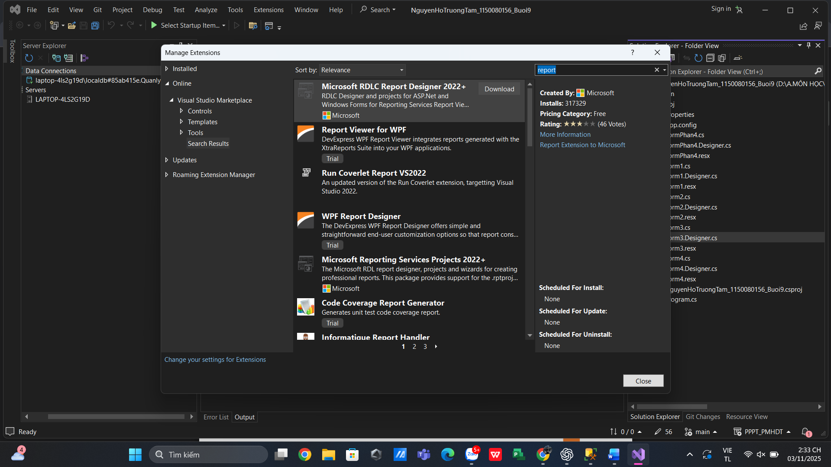
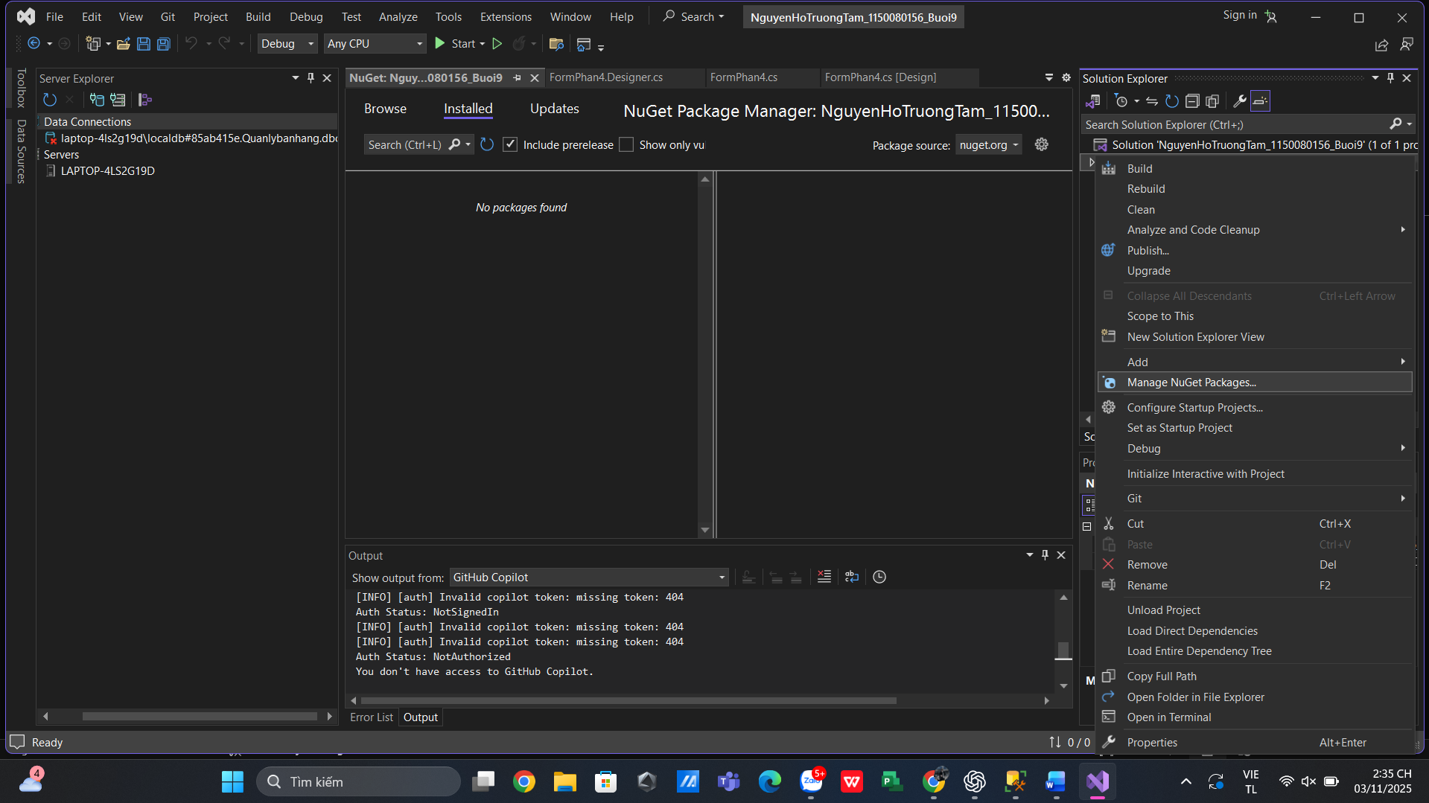
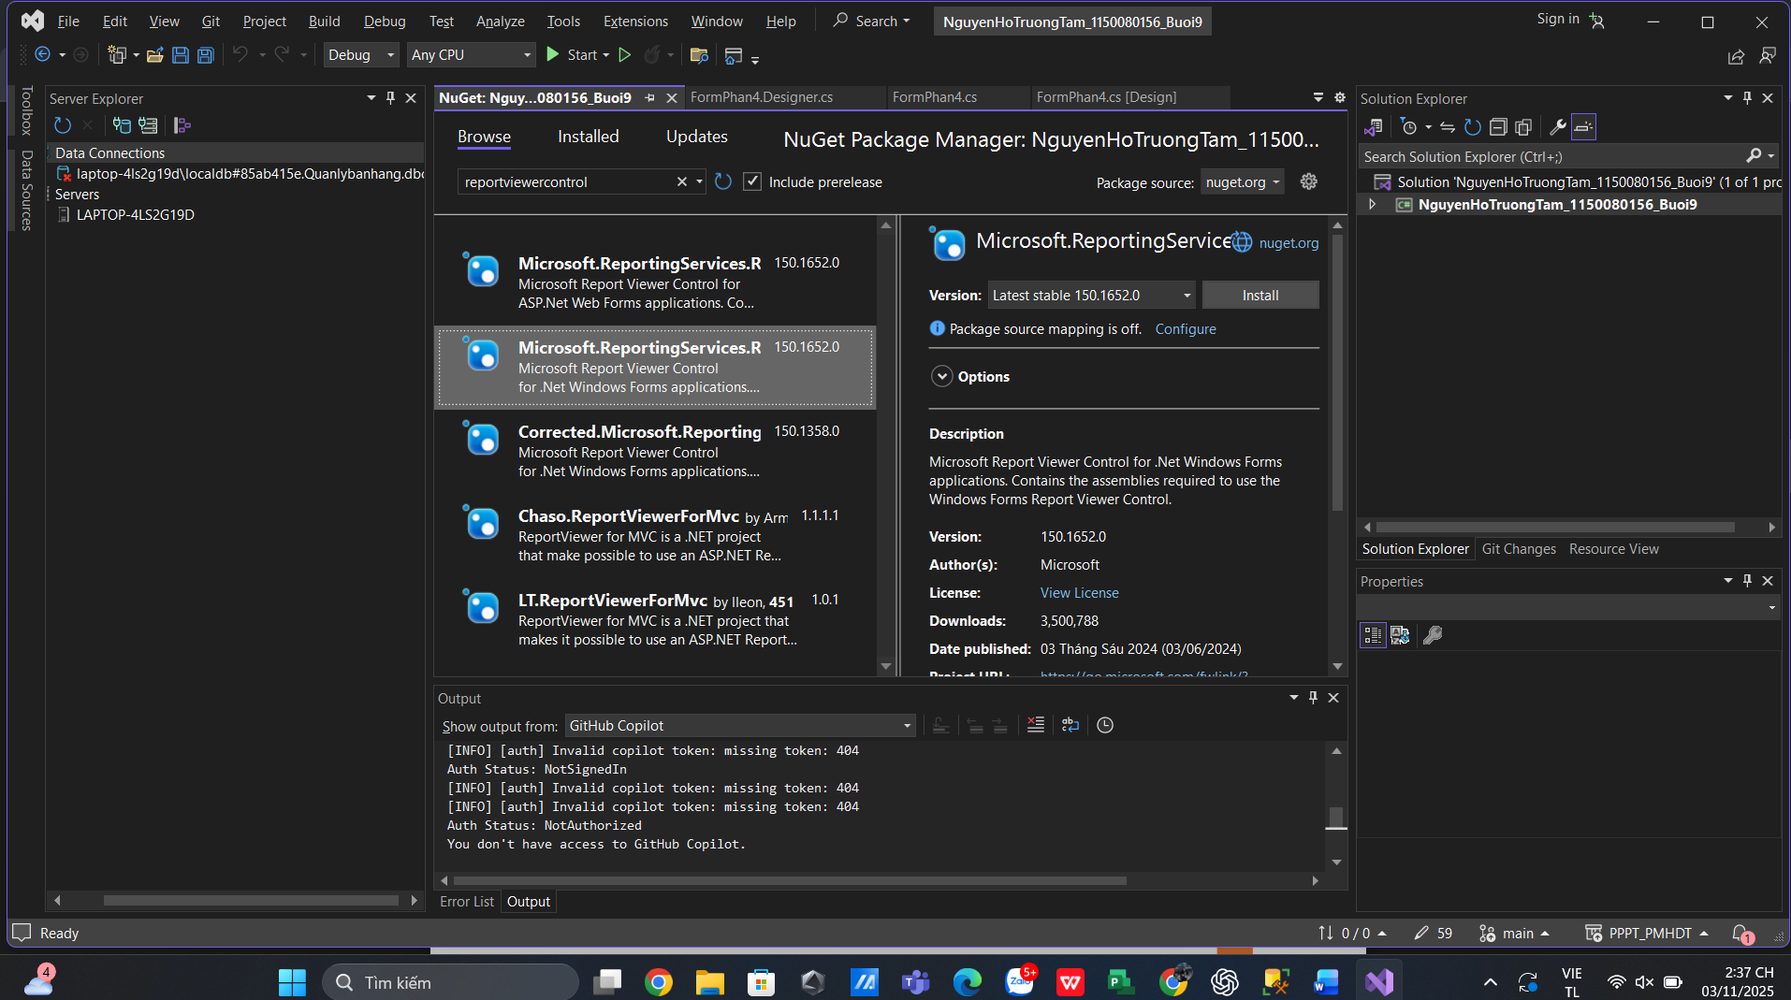

Thực hành 2: Thiết kế trang báo cáo danh sách các sinh viên được lưu trong CSDL Quản lý sinh viên.

