Nguyễn Hồ Trường Tam_1150080156_Lap3_Buổi 6

Thực hành 1
- Tạo Project
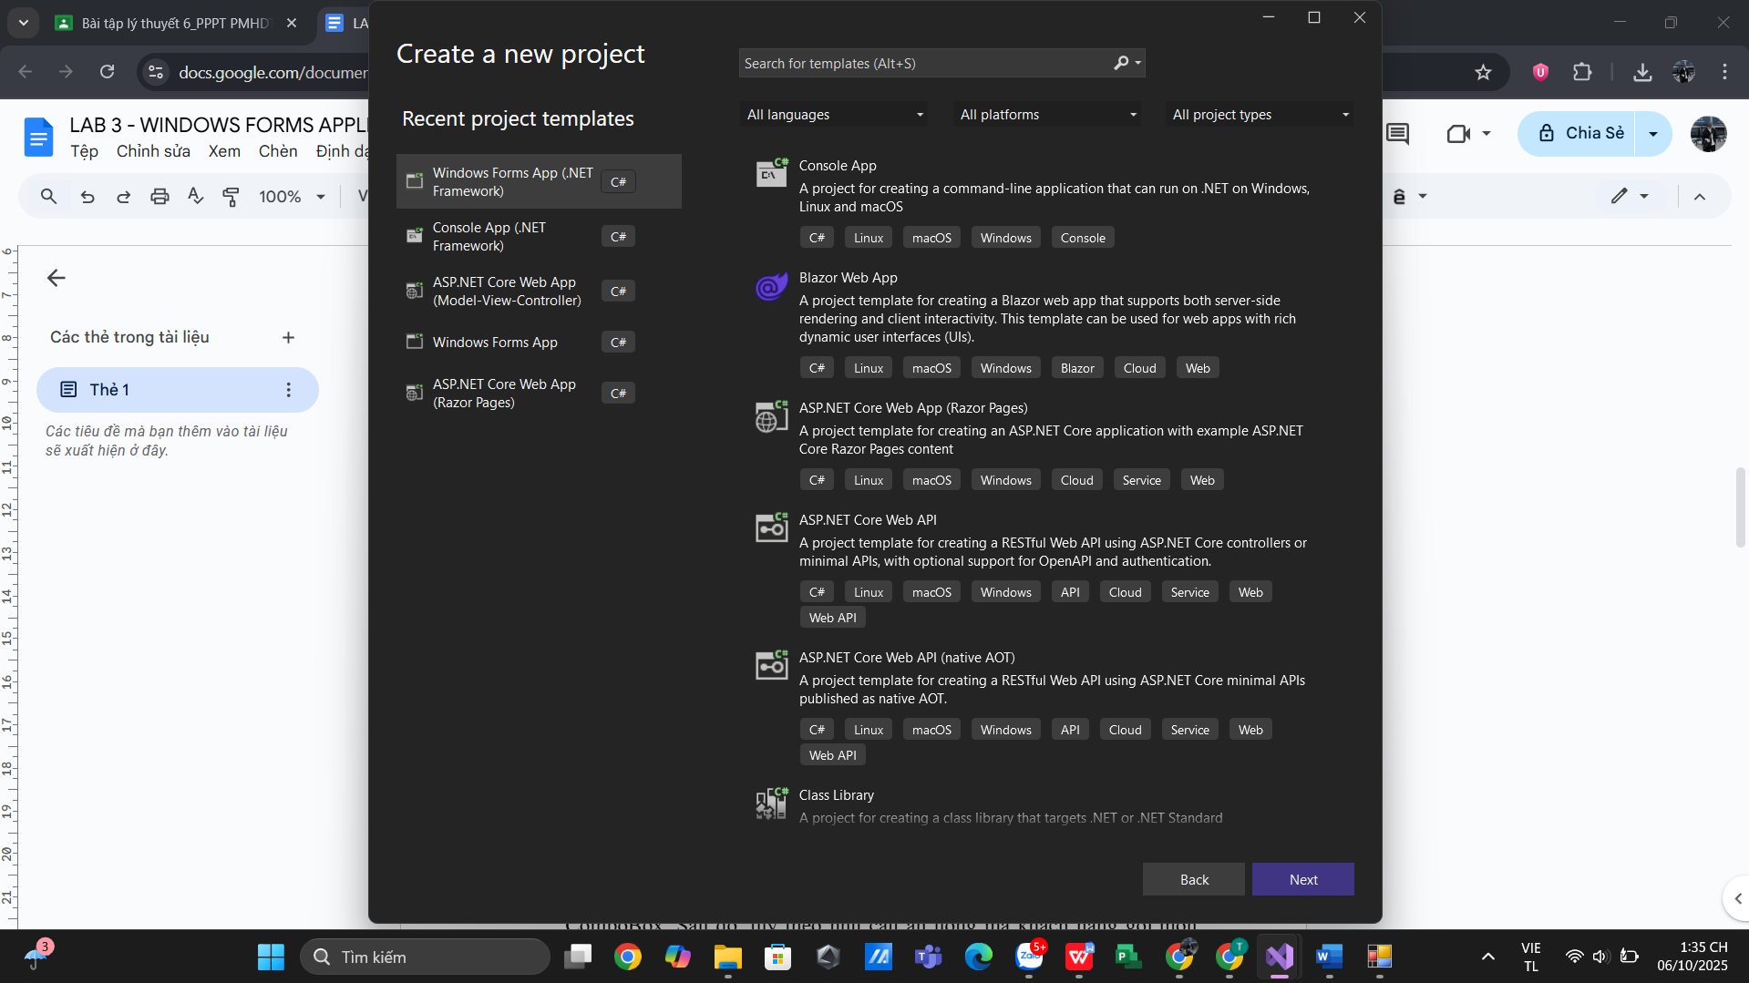
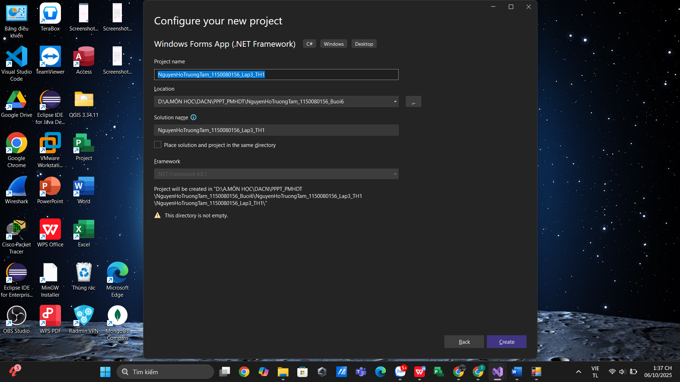

- Thêm ảnh hamburger (LOGO1_64.png)
Vào Solution Explorer → Properties → Resources.resx→ Chọn Add Resource → Add Existing File… → chọn LOGO1_64.png
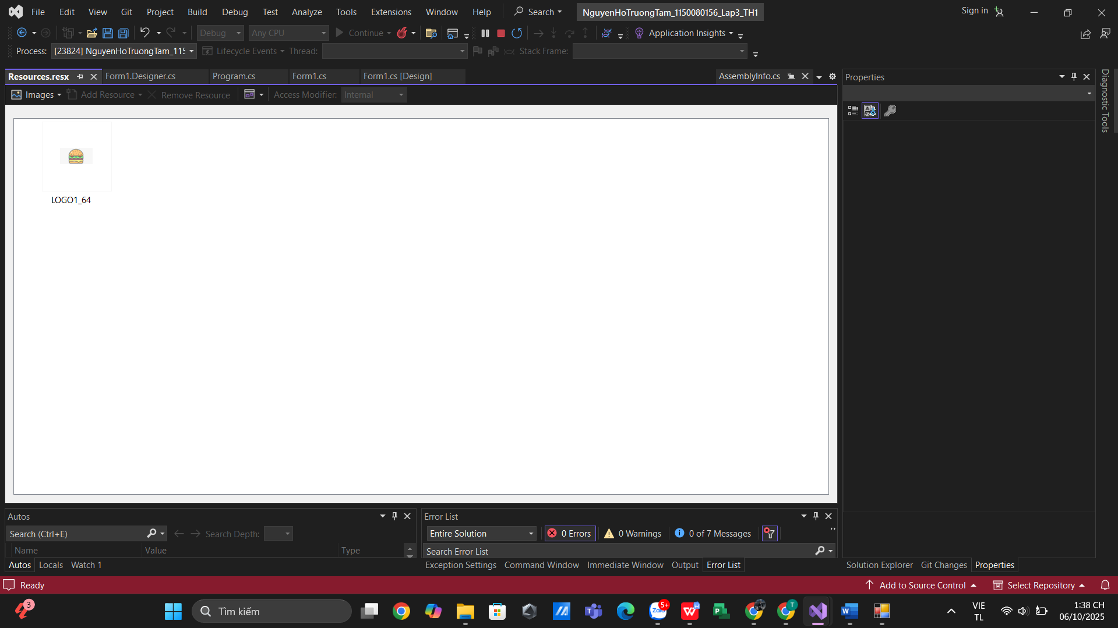
- Form1.cs
using System;
using System.Collections.Generic;
using System.Data;
using System.IO;
using System.Linq;
using System.Windows.Forms;
using System.Drawing;

namespace NguyenHoTruongTam_1150080156_Lap3_TH1
{
public partial class Form1 : Form
{
private readonly Dictionary<string, decimal> _menu = new Dictionary<string, decimal>()
{
{"Cơm chiên trứng", 30000},
{"Bánh mì ốp la", 25000},
{"Coca", 15000},
{"Lipton", 15000},
{"Ốc rang muối", 45000},
{"Khoai tây chiên", 25000},
{"7 up", 15000},
{"Cam", 15000},
{"Mỳ xào hải sản", 50000},
{"Cá viên chiên", 25000},
{"Pepsi", 15000},
{"Cafe", 20000},
{"Buger bò nướng", 55000},
{"Đùi gà rán", 45000},
{"Bún bò Huế", 40000}
};

private readonly Dictionary<string, Tuple<int, decimal>> _cart =
new Dictionary<string, Tuple<int, decimal>>();

public Form1()
{
InitializeComponent();
// Nếu không dùng Resource trong Designer, có thể gán ở đây:
// picLogo.Image = Properties.Resources.LOGO1;

BuildMenuButtons();
cbBan.Items.AddRange(Enumerable.Range(1, 20).Select(i => "Bàn " + i).ToArray());
cbBan.SelectedIndex = 0;
BindGrid();
}

private void BuildMenuButtons()
{
flpMon.Controls.Clear();
foreach (var kv in _menu)
{
var b = new Button();
b.Text = kv.Key;
b.Width = 150;
b.Height = 36;
b.Margin = new Padding(10, 8, 10, 8);
b.BackColor = Color.Gainsboro;
b.FlatStyle = FlatStyle.Standard;
b.Tag = kv.Key;
b.Click += (s, e) => AddItem((string)((Button)s).Tag);
flpMon.Controls.Add(b);
}
}

private void AddItem(string name)
{
decimal price = _menu[name];
if (_cart.ContainsKey(name))
{
var cur = _cart[name];
_cart[name] = Tuple.Create(cur.Item1 + 1, price);
}
else
{
_cart[name] = Tuple.Create(1, price);
}
BindGrid();
}

private void BindGrid()
{
var dt = new DataTable();
dt.Columns.Add("Món", typeof(string));
dt.Columns.Add("Số lượng", typeof(int));
dt.Columns.Add("Đơn giá", typeof(decimal));
dt.Columns.Add("Thành tiền", typeof(decimal));

decimal total = 0;
foreach (var kv in _cart)
{
decimal thanhTien = kv.Value.Item1 * kv.Value.Item2;
total += thanhTien;
dt.Rows.Add(kv.Key, kv.Value.Item1, kv.Value.Item2, thanhTien);
}

dgvOrder.DataSource = dt;
lblTotal.Text = "Tổng: " + total.ToString("n0") + " đ";
}

private void btnXoa_Click(object sender, EventArgs e)
{
if (dgvOrder.CurrentRow == null) return;
var name = Convert.ToString(dgvOrder.CurrentRow.Cells[0].Value);
if (!string.IsNullOrWhiteSpace(name) && _cart.ContainsKey(name))
{
_cart.Remove(name);
BindGrid();
}
}

private void btnOrder_Click(object sender, EventArgs e)
{
if (_cart.Count == 0)
{
MessageBox.Show("Chưa có món nào.", "Thông báo",
MessageBoxButtons.OK, MessageBoxIcon.Information);
return;
}

string ban = cbBan.SelectedItem != null ? cbBan.SelectedItem.ToString() : "Bàn ?";
string ts = DateTime.Now.ToString("yyyyMMdd_HHmmss");
string file = "Order_" + ban.Replace(' ', '_') + "_" + ts + ".txt";

using (var sw = new StreamWriter(file))
{
sw.WriteLine("Quán ăn nhanh Trường Tam - " + ban);
sw.WriteLine("Thời gian: " + DateTime.Now.ToString("dd/MM/yyyy HH:mm:ss"));
sw.WriteLine(new string('-', 48));
decimal total = 0;
foreach (var kv in _cart)
{
decimal tt = kv.Value.Item1 * kv.Value.Item2;
total += tt;
sw.WriteLine(string.Format("{0,-25} x{1,2} {2,8:n0} => {3,10:n0}",
kv.Key, kv.Value.Item1, kv.Value.Item2, tt));
}
sw.WriteLine(new string('-', 48));
sw.WriteLine("TỔNG: " + total.ToString("n0") + " đ");
}

MessageBox.Show("Đã ghi " + file + " cạnh file .exe", "Order thành công");
_cart.Clear();
BindGrid();
}

private void flpMon_Paint(object sender, PaintEventArgs e) { }

private void pnlBottom_Paint(object sender, PaintEventArgs e)
{

}

private void lblTotal_Click(object sender, EventArgs e)
{

}

private void lblTitle_Click(object sender, EventArgs e)
{

}
}
}
- Form1.Designer.cs
using System.Drawing;
using System.Windows.Forms;

namespace NguyenHoTruongTam_1150080156_Lap3_TH1
{
partial class Form1
{
private System.ComponentModel.IContainer components = null;

private PictureBox picLogo;
private Panel pnlHeader;
private Label lblTitle;
private GroupBox gbMenu;
private FlowLayoutPanel flpMon;
private Panel pnlBottom;
private Button btnXoa;
private Label lblChonBan;
private ComboBox cbBan;
private Button btnOrder;
private DataGridView dgvOrder;
private Label lblTotal;

protected override void Dispose(bool disposing)
{
if (disposing && (components != null)) components.Dispose();
base.Dispose(disposing);
}

private void InitializeComponent()
{
this.picLogo = new System.Windows.Forms.PictureBox();
this.pnlHeader = new System.Windows.Forms.Panel();
this.lblTitle = new System.Windows.Forms.Label();
this.gbMenu = new System.Windows.Forms.GroupBox();
this.flpMon = new System.Windows.Forms.FlowLayoutPanel();
this.pnlBottom = new System.Windows.Forms.Panel();
this.btnXoa = new System.Windows.Forms.Button();
this.lblChonBan = new System.Windows.Forms.Label();
this.cbBan = new System.Windows.Forms.ComboBox();
this.btnOrder = new System.Windows.Forms.Button();
this.dgvOrder = new System.Windows.Forms.DataGridView();
this.lblTotal = new System.Windows.Forms.Label();
((System.ComponentModel.ISupportInitialize)(this.picLogo)).BeginInit();
this.pnlHeader.SuspendLayout();
this.gbMenu.SuspendLayout();
this.pnlBottom.SuspendLayout();
((System.ComponentModel.ISupportInitialize)(this.dgvOrder)).BeginInit();
this.SuspendLayout();
//
// picLogo
//
this.picLogo.Image = global::NguyenHoTruongTam_1150080156_Lap3_TH1.Properties.Resources.LOGO1_64;
this.picLogo.Location = new System.Drawing.Point(12, 10);
this.picLogo.Name = "picLogo";
this.picLogo.Size = new System.Drawing.Size(70, 60);
this.picLogo.SizeMode = System.Windows.Forms.PictureBoxSizeMode.Zoom;
this.picLogo.TabIndex = 0;
this.picLogo.TabStop = false;
//
// pnlHeader
//
this.pnlHeader.BackColor = System.Drawing.Color.ForestGreen;
this.pnlHeader.Controls.Add(this.lblTitle);
this.pnlHeader.Location = new System.Drawing.Point(88, 10);
this.pnlHeader.Name = "pnlHeader";
this.pnlHeader.Size = new System.Drawing.Size(740, 60);
this.pnlHeader.TabIndex = 1;
//
// lblTitle
//
this.lblTitle.Dock = System.Windows.Forms.DockStyle.Fill;
this.lblTitle.Font = new System.Drawing.Font("Segoe UI", 18F, System.Drawing.FontStyle.Bold);
this.lblTitle.ForeColor = System.Drawing.Color.White;
this.lblTitle.Location = new System.Drawing.Point(0, 0);
this.lblTitle.Name = "lblTitle";
this.lblTitle.Size = new System.Drawing.Size(740, 60);
this.lblTitle.TabIndex = 0;
this.lblTitle.Text = "Quán ăn nhanh Trường Tam";
this.lblTitle.TextAlign = System.Drawing.ContentAlignment.MiddleCenter;
this.lblTitle.Click += new System.EventHandler(this.lblTitle_Click);
//
// gbMenu
//
this.gbMenu.Controls.Add(this.flpMon);
this.gbMenu.Location = new System.Drawing.Point(12, 78);
this.gbMenu.Name = "gbMenu";
this.gbMenu.Size = new System.Drawing.Size(816, 299);
this.gbMenu.TabIndex = 2;
this.gbMenu.TabStop = false;
this.gbMenu.Text = "Danh sách món ăn:";
//
// flpMon
//
this.flpMon.Location = new System.Drawing.Point(10, 22);
this.flpMon.Name = "flpMon";
this.flpMon.Padding = new System.Windows.Forms.Padding(8);
this.flpMon.Size = new System.Drawing.Size(796, 298);
this.flpMon.TabIndex = 0;
//
// pnlBottom
//
this.pnlBottom.Controls.Add(this.btnXoa);
this.pnlBottom.Controls.Add(this.lblChonBan);
this.pnlBottom.Controls.Add(this.cbBan);
this.pnlBottom.Controls.Add(this.btnOrder);
this.pnlBottom.Location = new System.Drawing.Point(12, 404);
this.pnlBottom.Name = "pnlBottom";
this.pnlBottom.Size = new System.Drawing.Size(816, 44);
this.pnlBottom.TabIndex = 3;
this.pnlBottom.Paint += new System.Windows.Forms.PaintEventHandler(this.pnlBottom_Paint);
//
// btnXoa
//
this.btnXoa.Location = new System.Drawing.Point(10, 8);
this.btnXoa.Name = "btnXoa";
this.btnXoa.Size = new System.Drawing.Size(84, 28);
this.btnXoa.TabIndex = 0;
this.btnXoa.Text = "Xóa";
this.btnXoa.UseVisualStyleBackColor = true;
this.btnXoa.Click += new System.EventHandler(this.btnXoa_Click);
//
// lblChonBan
//
this.lblChonBan.AutoSize = true;
this.lblChonBan.Location = new System.Drawing.Point(128, 12);
this.lblChonBan.Name = "lblChonBan";
this.lblChonBan.Size = new System.Drawing.Size(75, 20);
this.lblChonBan.TabIndex = 1;
this.lblChonBan.Text = "Chọn bàn:";
//
// cbBan
//
this.cbBan.DropDownStyle = System.Windows.Forms.ComboBoxStyle.DropDownList;
this.cbBan.Location = new System.Drawing.Point(196, 8);
this.cbBan.Name = "cbBan";
this.cbBan.Size = new System.Drawing.Size(170, 28);
this.cbBan.TabIndex = 2;
//
// btnOrder
//
this.btnOrder.Location = new System.Drawing.Point(720, 8);
this.btnOrder.Name = "btnOrder";
this.btnOrder.Size = new System.Drawing.Size(84, 28);
this.btnOrder.TabIndex = 3;
this.btnOrder.Text = "Order";
this.btnOrder.UseVisualStyleBackColor = true;
this.btnOrder.Click += new System.EventHandler(this.btnOrder_Click);
//
// dgvOrder
//
this.dgvOrder.AllowUserToAddRows = false;
this.dgvOrder.AutoSizeColumnsMode = System.Windows.Forms.DataGridViewAutoSizeColumnsMode.Fill;
this.dgvOrder.BackgroundColor = System.Drawing.Color.Silver;
this.dgvOrder.ColumnHeadersHeight = 29;
this.dgvOrder.Location = new System.Drawing.Point(12, 454);
this.dgvOrder.Name = "dgvOrder";
this.dgvOrder.ReadOnly = true;
this.dgvOrder.RowHeadersWidth = 51;
this.dgvOrder.SelectionMode = System.Windows.Forms.DataGridViewSelectionMode.FullRowSelect;
this.dgvOrder.Size = new System.Drawing.Size(816, 231);
this.dgvOrder.TabIndex = 4;
//
// lblTotal
//
this.lblTotal.AutoSize = true;
this.lblTotal.Font = new System.Drawing.Font("Segoe UI", 10F, System.Drawing.FontStyle.Bold);
this.lblTotal.Location = new System.Drawing.Point(728, 688);
this.lblTotal.Name = "lblTotal";
this.lblTotal.Size = new System.Drawing.Size(87, 23);
this.lblTotal.TabIndex = 5;
this.lblTotal.Text = "Tổng: 0 đ";
this.lblTotal.Click += new System.EventHandler(this.lblTotal_Click);
//
// Form1
//
this.AutoScaleMode = System.Windows.Forms.AutoScaleMode.None;
this.ClientSize = new System.Drawing.Size(840, 720);
this.Controls.Add(this.picLogo);
this.Controls.Add(this.pnlHeader);
this.Controls.Add(this.gbMenu);
this.Controls.Add(this.pnlBottom);
this.Controls.Add(this.dgvOrder);
this.Controls.Add(this.lblTotal);
this.Font = new System.Drawing.Font("Segoe UI", 9F);
this.MaximizeBox = false;
this.Name = "Form1";
this.StartPosition = System.Windows.Forms.FormStartPosition.CenterScreen;
this.Text = "Form1";
((System.ComponentModel.ISupportInitialize)(this.picLogo)).EndInit();
this.pnlHeader.ResumeLayout(false);
this.gbMenu.ResumeLayout(false);
this.pnlBottom.ResumeLayout(false);
this.pnlBottom.PerformLayout();
((System.ComponentModel.ISupportInitialize)(this.dgvOrder)).EndInit();
this.ResumeLayout(false);
this.PerformLayout();

}
}
}

- Kết quả
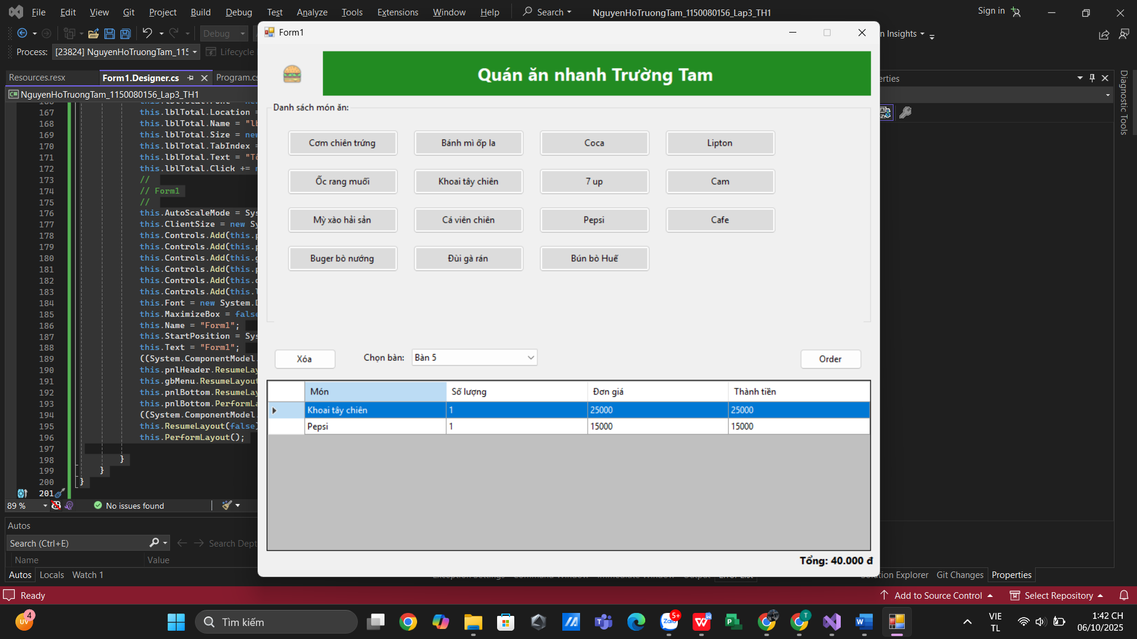

Thực hành 2
- Tạo Project
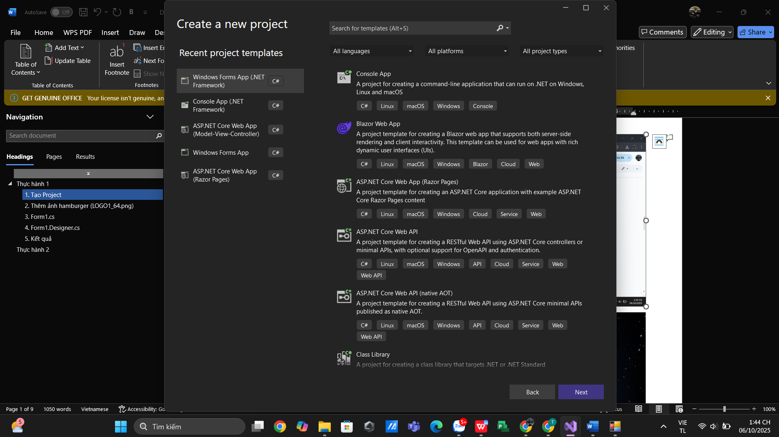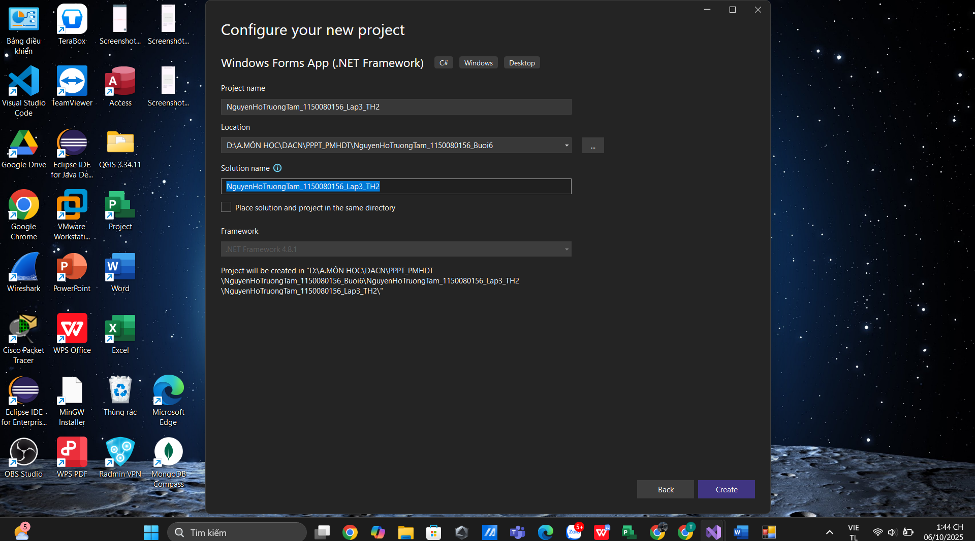
- Form1.cs
using System;
using System.Data;
using System.Windows.Forms;

namespace NguyenHoTruongTam_1150080156_Lap3_TH2
{
public partial class Form1 : Form
{
private DataTable dt;

public Form1()
{
InitializeComponent();
KhoiTaoBang();
}

private void KhoiTaoBang()
{
dt = new DataTable();
dt.Columns.Add("Họ tên");
dt.Columns.Add("Ngày sinh");
dt.Columns.Add("Lớp");
dt.Columns.Add("Địa chỉ");
dgvSinhVien.DataSource = dt;
}

private void btnThem_Click(object sender, EventArgs e)
{
dt.Rows.Add(txtHoTen.Text, dtNgaySinh.Value.ToShortDateString(),
txtLop.Text, txtDiaChi.Text);
ClearFields();
}

private void btnSua_Click(object sender, EventArgs e)
{
if (dgvSinhVien.CurrentRow != null)
{
dgvSinhVien.CurrentRow.Cells[0].Value = txtHoTen.Text;
dgvSinhVien.CurrentRow.Cells[1].Value = dtNgaySinh.Value.ToShortDateString();
dgvSinhVien.CurrentRow.Cells[2].Value = txtLop.Text;
dgvSinhVien.CurrentRow.Cells[3].Value = txtDiaChi.Text;
ClearFields();
}
}

private void btnXoa_Click(object sender, EventArgs e)
{
if (dgvSinhVien.CurrentRow != null)
dgvSinhVien.Rows.Remove(dgvSinhVien.CurrentRow);
}

private void btnThoat_Click(object sender, EventArgs e)
{
this.Close();
}

private void ClearFields()
{
txtHoTen.Clear();
txtLop.Clear();
txtDiaChi.Clear();
txtHoTen.Focus();
}
}
}

- Form1.Designer.cs
using System.Drawing;
using System.Windows.Forms;

namespace NguyenHoTruongTam_1150080156_Lap3_TH2
{
partial class Form1
{
private Label lblTitle;
private GroupBox gbThongTin;
private TextBox txtHoTen, txtLop, txtDiaChi;
private Label lblHoTen, lblNgaySinh, lblLop, lblDiaChi;
private DateTimePicker dtNgaySinh;
private GroupBox gbChucNang;
private Button btnThem, btnSua, btnXoa, btnThoat;
private GroupBox gbDanhSach;
private DataGridView dgvSinhVien;

private void InitializeComponent()
{
this.lblTitle = new Label();
this.gbThongTin = new GroupBox();
this.txtHoTen = new TextBox();
this.txtLop = new TextBox();
this.txtDiaChi = new TextBox();
this.lblHoTen = new Label();
this.lblNgaySinh = new Label();
this.lblLop = new Label();
this.lblDiaChi = new Label();
this.dtNgaySinh = new DateTimePicker();
this.gbChucNang = new GroupBox();
this.btnThem = new Button();
this.btnSua = new Button();
this.btnXoa = new Button();
this.btnThoat = new Button();
this.gbDanhSach = new GroupBox();
this.dgvSinhVien = new DataGridView();

// === FORM ===
this.Text = "Danh sách sinh viên";
this.ClientSize = new Size(800, 600);
this.StartPosition = FormStartPosition.CenterScreen;
this.Font = new Font("Segoe UI", 10F);

// === TIÊU ĐỀ ===
this.lblTitle.Text = "DANH MỤC SINH VIÊN";
this.lblTitle.Font = new Font("Segoe UI", 18F, FontStyle.Bold);
this.lblTitle.ForeColor = Color.RoyalBlue;
this.lblTitle.TextAlign = ContentAlignment.MiddleCenter;
this.lblTitle.Dock = DockStyle.Top;
this.lblTitle.Height = 60;

// === THÔNG TIN SINH VIÊN ===
this.gbThongTin.Text = "Thông tin sinh viên";
this.gbThongTin.Location = new Point(20, 70);
this.gbThongTin.Size = new Size(760, 130);

// Họ tên
this.lblHoTen.Text = "Họ tên:";
this.lblHoTen.Location = new Point(20, 30);
this.txtHoTen.Location = new Point(90, 27);
this.txtHoTen.Size = new Size(220, 27);

// Lớp
this.lblLop.Text = "Lớp:";
this.lblLop.Location = new Point(400, 30);
this.txtLop.Location = new Point(450, 27);
this.txtLop.Size = new Size(200, 27);

// Ngày sinh
this.lblNgaySinh.Text = "Ngày sinh:";
this.lblNgaySinh.Location = new Point(20, 70);
this.dtNgaySinh.Location = new Point(90, 67);
this.dtNgaySinh.Size = new Size(220, 27);

// Địa chỉ
this.lblDiaChi.Text = "Địa chỉ:";
this.lblDiaChi.Location = new Point(400, 70);
this.txtDiaChi.Location = new Point(450, 67);
this.txtDiaChi.Size = new Size(280, 27);

this.gbThongTin.Controls.AddRange(new Control[]
{
lblHoTen, txtHoTen, lblLop, txtLop,
lblNgaySinh, dtNgaySinh, lblDiaChi, txtDiaChi
});

// === CHỨC NĂNG ===
this.gbChucNang.Text = "Chức năng";
this.gbChucNang.Location = new Point(20, 210);
this.gbChucNang.Size = new Size(760, 70);

this.btnThem.Text = "Thêm";
this.btnThem.Location = new Point(90, 25);
this.btnThem.Click += new System.EventHandler(this.btnThem_Click);

this.btnSua.Text = "Sửa";
this.btnSua.Location = new Point(220, 25);
this.btnSua.Click += new System.EventHandler(this.btnSua_Click);

this.btnXoa.Text = "Xóa";
this.btnXoa.Location = new Point(350, 25);
this.btnXoa.Click += new System.EventHandler(this.btnXoa_Click);

this.btnThoat.Text = "Thoát";
this.btnThoat.Location = new Point(480, 25);
this.btnThoat.Click += new System.EventHandler(this.btnThoat_Click);

this.gbChucNang.Controls.AddRange(new Control[] { btnThem, btnSua, btnXoa, btnThoat });

// === DANH SÁCH ===
this.gbDanhSach.Text = "Thông tin chung sinh viên";
this.gbDanhSach.Location = new Point(20, 290);
this.gbDanhSach.Size = new Size(760, 280);

this.dgvSinhVien.Location = new Point(10, 25);
this.dgvSinhVien.Size = new Size(740, 240);
this.dgvSinhVien.AutoSizeColumnsMode = DataGridViewAutoSizeColumnsMode.Fill;
this.dgvSinhVien.SelectionMode = DataGridViewSelectionMode.FullRowSelect;
this.dgvSinhVien.AllowUserToAddRows = false;

this.gbDanhSach.Controls.Add(dgvSinhVien);

// === ADD CONTROLS ===
this.Controls.AddRange(new Control[] {
lblTitle, gbThongTin, gbChucNang, gbDanhSach
});
}
}
}
- Kết quả
