Buổi8_Nguyễn Hồ Trường Tam_1150080156

Thực hành 1: Hiển thị danh sách nhà xuất bản sách.
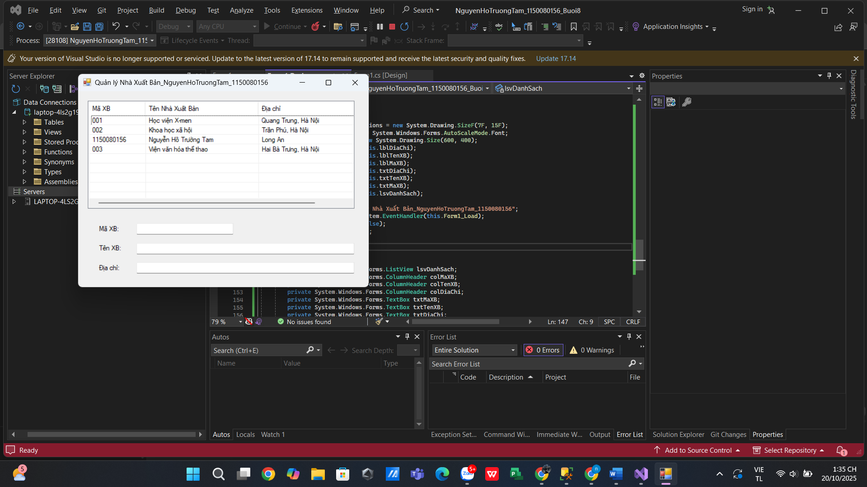

Form1.cs
using System;
using System.Collections.Generic;
using System.ComponentModel;
using System.Data;
using System.Data.SqlClient;
using System.Drawing;
using System.Linq;
using System.Text;
using System.Threading.Tasks;
using System.Windows.Forms;

namespace NguyenHoTruongTam_1150080156_Buoi8
{
public partial class Form1 : Form
{
// --- Chuỗi kết nối ---
// CÁCH 1: dùng tên database (nếu DB đã attach trong LocalDB)
private readonly string strCon =
@"Data Source=(LocalDB)\MSSQLLocalDB;Initial Catalog=QuanLyBanSach;Integrated Security=True;Connect Timeout=30";

// CÁCH 2 (thay cho CÁCH 1 nếu muốn đính kèm file .mdf):
// private readonly string strCon =
// @"Data Source=(LocalDB)\MSSQLLocalDB;AttachDbFilename=|DataDirectory|\QuanLyBanSach.mdf;Integrated Security=True;Connect Timeout=30";

// Đối tượng kết nối dùng lại trong form
private SqlConnection sqlCon;

public Form1()
{
InitializeComponent();
}

// --- MỞ KẾT NỐI ---
private void MoKetNoi()
{
if (sqlCon == null)
sqlCon = new SqlConnection(strCon);

if (sqlCon.State == ConnectionState.Closed)
sqlCon.Open();
}

// --- ĐÓNG KẾT NỐI ---
private void DongKetNoi()
{
if (sqlCon != null && sqlCon.State == ConnectionState.Open)
sqlCon.Close();
}

// --- HIỂN THỊ DANH SÁCH NHÀ XUẤT BẢN ---
// Yêu cầu bạn đã tạo SP: CREATE PROCEDURE HienThiXB AS SELECT MaXB, TenXB, DiaChi FROM NhaXuatBan;
private void HienThiDanhSachXB()
{
try
{
MoKetNoi();

using (var cmd = new SqlCommand("HienThiXB", sqlCon))
{
cmd.CommandType = CommandType.StoredProcedure;

using (var reader = cmd.ExecuteReader())
{
lsvDanhSach.Items.Clear();

while (reader.Read())
{
string maXB = reader.GetString(0);
string tenXB = reader.GetString(1);
string diaChi = reader.GetString(2);

var lvi = new ListViewItem(maXB);
lvi.SubItems.Add(tenXB);
lvi.SubItems.Add(diaChi);
lsvDanhSach.Items.Add(lvi);
}
}
}
}
catch (Exception ex)
{
MessageBox.Show("Lỗi hiển thị danh sách: " + ex.Message);
}
finally
{
DongKetNoi();
}
}

// --- FORM LOAD: gọi hiển thị danh sách ---
private void Form1_Load(object sender, EventArgs e)
{
HienThiDanhSachXB();
}

// --- SỰ KIỆN CHỌN DÒNG TRONG LISTVIEW: hiển thị chi tiết ---
private void lsvDanhSach_SelectedIndexChanged(object sender, EventArgs e)
{
if (lsvDanhSach.SelectedItems.Count == 0) return;

ListViewItem lvi = lsvDanhSach.SelectedItems[0];
string maXB = lvi.SubItems[0].Text;

HienThiThongTinXBTheoMa(maXB);
}

// --- HIỂN THỊ THÔNG TIN CHI TIẾT THEO MÃ ---
// Yêu cầu bạn đã tạo SP:
// CREATE PROCEDURE HienThiChiTietXB @maXB CHAR(10) AS SELECT MaXB, TenXB, DiaChi FROM NhaXuatBan WHERE MaXB=@maXB;
private void HienThiThongTinXBTheoMa(string maXB)
{
try
{
MoKetNoi();

using (var cmd = new SqlCommand("HienThiChiTietXB", sqlCon))
{
cmd.CommandType = CommandType.StoredProcedure;
cmd.Parameters.Add(new SqlParameter("@maXB", SqlDbType.Char, 10) { Value = maXB });

using (var reader = cmd.ExecuteReader())
{
// Clear trước
txtMaXB.Text = txtTenXB.Text = txtDiaChi.Text = string.Empty;

if (reader.Read())
{
string _maXB = reader.GetString(0);
string tenXB = reader.GetString(1);
string diaChi = reader.GetString(2);

txtMaXB.Text = _maXB;
txtTenXB.Text = tenXB;
txtDiaChi.Text = diaChi;
}
}
}
}
catch (Exception ex)
{
MessageBox.Show("Lỗi hiển thị chi tiết: " + ex.Message);
}
finally
{
DongKetNoi();
}
}
}
}

Form1.Designer.cs
namespace NguyenHoTruongTam_1150080156_Buoi8
{
partial class Form1
{
/// <summary>
/// Required designer variable.
/// </summary>
private System.ComponentModel.IContainer components = null;

/// <summary>
/// Clean up any resources being used.
/// </summary>
protected override void Dispose(bool disposing)
{
if (disposing && (components != null))
{
components.Dispose();
}
base.Dispose(disposing);
}

#region Windows Form Designer generated code

private void InitializeComponent()
{
this.lsvDanhSach = new System.Windows.Forms.ListView();
this.colMaXB = new System.Windows.Forms.ColumnHeader();
this.colTenXB = new System.Windows.Forms.ColumnHeader();
this.colDiaChi = new System.Windows.Forms.ColumnHeader();
this.txtMaXB = new System.Windows.Forms.TextBox();
this.txtTenXB = new System.Windows.Forms.TextBox();
this.txtDiaChi = new System.Windows.Forms.TextBox();
this.lblMaXB = new System.Windows.Forms.Label();
this.lblTenXB = new System.Windows.Forms.Label();
this.lblDiaChi = new System.Windows.Forms.Label();
this.SuspendLayout();

//
// lsvDanhSach
//
this.lsvDanhSach.Columns.AddRange(new System.Windows.Forms.ColumnHeader[] {
this.colMaXB,
this.colTenXB,
this.colDiaChi});
this.lsvDanhSach.FullRowSelect = true;
this.lsvDanhSach.GridLines = true;
this.lsvDanhSach.HideSelection = false;
this.lsvDanhSach.Location = new System.Drawing.Point(20, 20);
this.lsvDanhSach.Name = "lsvDanhSach";
this.lsvDanhSach.Size = new System.Drawing.Size(550, 220);
this.lsvDanhSach.TabIndex = 0;
this.lsvDanhSach.UseCompatibleStateImageBehavior = false;
this.lsvDanhSach.View = System.Windows.Forms.View.Details;
this.lsvDanhSach.SelectedIndexChanged += new System.EventHandler(this.lsvDanhSach_SelectedIndexChanged);

//
// colMaXB
//
this.colMaXB.Text = "Mã XB";
this.colMaXB.Width = 100;

//
// colTenXB
//
this.colTenXB.Text = "Tên Nhà Xuất Bản";
this.colTenXB.Width = 200;

//
// colDiaChi
//
this.colDiaChi.Text = "Địa chỉ";
this.colDiaChi.Width = 230;

//
// txtMaXB
//
this.txtMaXB.Location = new System.Drawing.Point(120, 270);
this.txtMaXB.Name = "txtMaXB";
this.txtMaXB.Size = new System.Drawing.Size(200, 23);
this.txtMaXB.TabIndex = 1;

//
// txtTenXB
//
this.txtTenXB.Location = new System.Drawing.Point(120, 310);
this.txtTenXB.Name = "txtTenXB";
this.txtTenXB.Size = new System.Drawing.Size(450, 23);
this.txtTenXB.TabIndex = 2;

//
// txtDiaChi
//
this.txtDiaChi.Location = new System.Drawing.Point(120, 350);
this.txtDiaChi.Name = "txtDiaChi";
this.txtDiaChi.Size = new System.Drawing.Size(450, 23);
this.txtDiaChi.TabIndex = 3;

//
// lblMaXB
//
this.lblMaXB.AutoSize = true;
this.lblMaXB.Location = new System.Drawing.Point(40, 273);
this.lblMaXB.Name = "lblMaXB";
this.lblMaXB.Size = new System.Drawing.Size(45, 15);
this.lblMaXB.TabIndex = 4;
this.lblMaXB.Text = "Mã XB:";

//
// lblTenXB
//
this.lblTenXB.AutoSize = true;
this.lblTenXB.Location = new System.Drawing.Point(40, 313);
this.lblTenXB.Name = "lblTenXB";
this.lblTenXB.Size = new System.Drawing.Size(49, 15);
this.lblTenXB.TabIndex = 5;
this.lblTenXB.Text = "Tên XB:";

//
// lblDiaChi
//
this.lblDiaChi.AutoSize = true;
this.lblDiaChi.Location = new System.Drawing.Point(40, 353);
this.lblDiaChi.Name = "lblDiaChi";
this.lblDiaChi.Size = new System.Drawing.Size(50, 15);
this.lblDiaChi.TabIndex = 6;
this.lblDiaChi.Text = "Địa chỉ:";

//
// Form1
//
this.AutoScaleDimensions = new System.Drawing.SizeF(7F, 15F);
this.AutoScaleMode = System.Windows.Forms.AutoScaleMode.Font;
this.ClientSize = new System.Drawing.Size(600, 400);
this.Controls.Add(this.lblDiaChi);
this.Controls.Add(this.lblTenXB);
this.Controls.Add(this.lblMaXB);
this.Controls.Add(this.txtDiaChi);
this.Controls.Add(this.txtTenXB);
this.Controls.Add(this.txtMaXB);
this.Controls.Add(this.lsvDanhSach);
this.Name = "Form1";
this.Text = "Quản lý Nhà Xuất Bản_NguyenHoTruongTam_1150080156";
this.Load += new System.EventHandler(this.Form1_Load);
this.ResumeLayout(false);
this.PerformLayout();
}

#endregion

private System.Windows.Forms.ListView lsvDanhSach;
private System.Windows.Forms.ColumnHeader colMaXB;
private System.Windows.Forms.ColumnHeader colTenXB;
private System.Windows.Forms.ColumnHeader colDiaChi;
private System.Windows.Forms.TextBox txtMaXB;
private System.Windows.Forms.TextBox txtTenXB;
private System.Windows.Forms.TextBox txtDiaChi;
private System.Windows.Forms.Label lblMaXB;
private System.Windows.Forms.Label lblTenXB;
private System.Windows.Forms.Label lblDiaChi;
}
}

Thực hành 2: Thêm dữ liệu cho bảng Nhà xuất bản
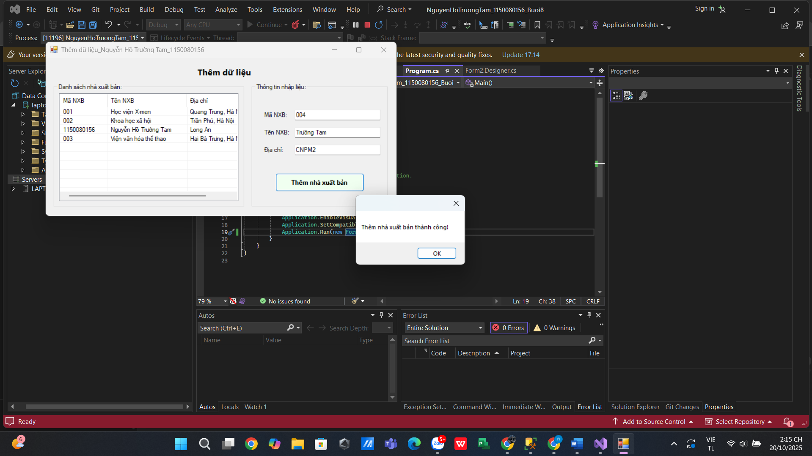
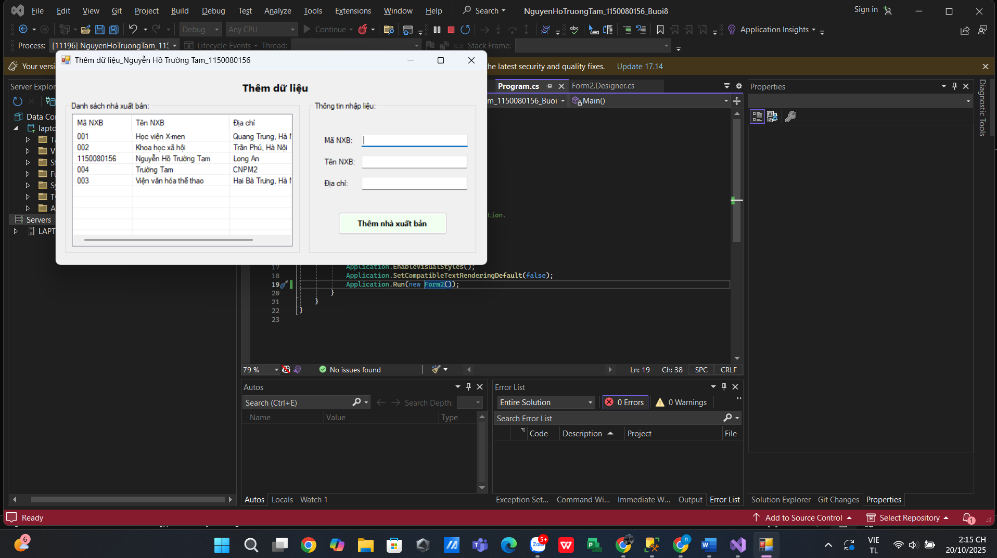

Form2.cs
using System;
using System.Collections.Generic;
using System.ComponentModel;
using System.Data;
using System.Data.SqlClient;
using System.Drawing;
using System.Linq;
using System.Text;
using System.Threading.Tasks;
using System.Windows.Forms;

namespace NguyenHoTruongTam_1150080156_Buoi8
{
public partial class Form2 : Form
{
// Chuỗi kết nối: đổi Initial Catalog nếu DB của bạn khác
private readonly string strCon =
@"Data Source=(LocalDB)\MSSQLLocalDB;Initial Catalog=QuanLyBanSach;Integrated Security=True;Connect Timeout=30";

private SqlConnection sqlCon;

public Form2()
{
InitializeComponent();
}

// --- Kết nối ---
private void MoKetNoi()
{
if (sqlCon == null) sqlCon = new SqlConnection(strCon);
if (sqlCon.State == ConnectionState.Closed) sqlCon.Open();
}
private void DongKetNoi()
{
if (sqlCon != null && sqlCon.State == ConnectionState.Open) sqlCon.Close();
}

// --- Form load ---
private void Form2_Load(object sender, EventArgs e)
{
HienThiDanhSachXB();
txtMaXB.Focus();
}

// --- Hiển thị danh sách NXB ---
// Yêu cầu SP:
// CREATE OR ALTER PROCEDURE dbo.HienThiXB AS
// BEGIN SET NOCOUNT ON; SELECT MaXB, TenXB, DiaChi FROM dbo.NhaXuatBan ORDER BY TenXB; END
private void HienThiDanhSachXB()
{
try
{
MoKetNoi();
using (var cmd = new SqlCommand("HienThiXB", sqlCon))
{
cmd.CommandType = CommandType.StoredProcedure;
using (var reader = cmd.ExecuteReader())
{
lsvDanhSach.Items.Clear();
while (reader.Read())
{
string ma = reader.GetString(0);
string ten = reader.GetString(1);
string diachi = reader.IsDBNull(2) ? "" : reader.GetString(2);

var lvi = new ListViewItem(ma);
lvi.SubItems.Add(ten);
lvi.SubItems.Add(diachi);
lsvDanhSach.Items.Add(lvi);
}
}
}
}
catch (Exception ex)
{
MessageBox.Show("Lỗi hiển thị danh sách: " + ex.Message);
}
finally { DongKetNoi(); }
}

// --- Chọn dòng trong danh sách để đổ vào ô nhập ---
private void lsvDanhSach_SelectedIndexChanged(object sender, EventArgs e)
{
if (lsvDanhSach.SelectedItems.Count == 0) return;
var it = lsvDanhSach.SelectedItems[0];
txtMaXB.Text = it.SubItems[0].Text;
txtTenXB.Text = it.SubItems[1].Text;
txtDiaChi.Text = it.SubItems[2].Text;
}
private void btnThem_Click(object sender, EventArgs e)
{
if (string.IsNullOrWhiteSpace(txtMaXB.Text) ||
string.IsNullOrWhiteSpace(txtTenXB.Text))
{
MessageBox.Show("Vui lòng nhập đầy đủ Mã NXB và Tên NXB.");
return;
}

try
{
MoKetNoi();
using (var cmd = new SqlCommand("ThemNhaXuatBan", sqlCon))
{
cmd.CommandType = CommandType.StoredProcedure;
cmd.Parameters.Add(new SqlParameter("@MaXB", SqlDbType.Char, 10)).Value = txtMaXB.Text.Trim();
cmd.Parameters.Add(new SqlParameter("@TenXB", SqlDbType.NVarChar, 100)).Value = txtTenXB.Text.Trim();
cmd.Parameters.Add(new SqlParameter("@DiaChi", SqlDbType.NVarChar, 500)).Value =
string.IsNullOrWhiteSpace(txtDiaChi.Text) ? (object)DBNull.Value : txtDiaChi.Text.Trim();

// Do NOCOUNT ON, dùng ExecuteScalar lấy @@ROWCOUNT
object scalar = cmd.ExecuteScalar();
int rows = 0;
if (scalar != null && int.TryParse(scalar.ToString(), out var r)) rows = r;

if (rows > 0)
{
MessageBox.Show("Thêm nhà xuất bản thành công!");
HienThiDanhSachXB(); // refresh danh sách
txtMaXB.Clear(); txtTenXB.Clear(); txtDiaChi.Clear();
txtMaXB.Focus();
}
else
{
MessageBox.Show("Không thêm được dữ liệu!");
}
}
}
catch (SqlException sqlex)
{
// Bắt lỗi RAISERROR từ SP (ví dụ trùng mã)
MessageBox.Show("SQL Error: " + sqlex.Message);
}
catch (Exception ex)
{
MessageBox.Show("Lỗi khi thêm dữ liệu: " + ex.Message);
}
finally { DongKetNoi(); }
}
}
}

Form2.Designer.cs
namespace NguyenHoTruongTam_1150080156_Buoi8
{
partial class Form2
{
private System.ComponentModel.IContainer components = null;

protected override void Dispose(bool disposing)
{
if (disposing && (components != null))
components.Dispose();
base.Dispose(disposing);
}

#region Windows Form Designer generated code

private void InitializeComponent()
{
this.lblTieuDe = new System.Windows.Forms.Label();
this.groupDanhSach = new System.Windows.Forms.GroupBox();
this.lsvDanhSach = new System.Windows.Forms.ListView();
this.colMa = new System.Windows.Forms.ColumnHeader();
this.colTen = new System.Windows.Forms.ColumnHeader();
this.colDiaChi = new System.Windows.Forms.ColumnHeader();
this.groupNhap = new System.Windows.Forms.GroupBox();
this.btnThem = new System.Windows.Forms.Button();
this.txtDiaChi = new System.Windows.Forms.TextBox();
this.txtTenXB = new System.Windows.Forms.TextBox();
this.txtMaXB = new System.Windows.Forms.TextBox();
this.lblDiaChi = new System.Windows.Forms.Label();
this.lblTen = new System.Windows.Forms.Label();
this.lblMa = new System.Windows.Forms.Label();
this.groupDanhSach.SuspendLayout();
this.groupNhap.SuspendLayout();
this.SuspendLayout();
//
// lblTieuDe
//
this.lblTieuDe.AutoSize = true;
this.lblTieuDe.Font = new System.Drawing.Font("Segoe UI", 12F, System.Drawing.FontStyle.Bold, System.Drawing.GraphicsUnit.Point);
this.lblTieuDe.Location = new System.Drawing.Point(330, 18);
this.lblTieuDe.Name = "lblTieuDe";
this.lblTieuDe.Size = new System.Drawing.Size(111, 21);
this.lblTieuDe.TabIndex = 0;
this.lblTieuDe.Text = "Thêm dữ liệu";
//
// groupDanhSach
//
this.groupDanhSach.Controls.Add(this.lsvDanhSach);
this.groupDanhSach.Location = new System.Drawing.Point(18, 55);
this.groupDanhSach.Name = "groupDanhSach";
this.groupDanhSach.Size = new System.Drawing.Size(420, 270);
this.groupDanhSach.TabIndex = 1;
this.groupDanhSach.TabStop = false;
this.groupDanhSach.Text = "Danh sách nhà xuất bản:";
//
// lsvDanhSach
//
this.lsvDanhSach.Columns.AddRange(new System.Windows.Forms.ColumnHeader[] {
this.colMa,
this.colTen,
this.colDiaChi});
this.lsvDanhSach.FullRowSelect = true;
this.lsvDanhSach.GridLines = true;
this.lsvDanhSach.HideSelection = false;
this.lsvDanhSach.Location = new System.Drawing.Point(12, 22);
this.lsvDanhSach.Name = "lsvDanhSach";
this.lsvDanhSach.Size = new System.Drawing.Size(395, 235);
this.lsvDanhSach.TabIndex = 0;
this.lsvDanhSach.UseCompatibleStateImageBehavior = false;
this.lsvDanhSach.View = System.Windows.Forms.View.Details;
this.lsvDanhSach.SelectedIndexChanged += new System.EventHandler(this.lsvDanhSach_SelectedIndexChanged);
//
// colMa
//
this.colMa.Text = "Mã NXB";
this.colMa.Width = 90;
//
// colTen
//
this.colTen.Text = "Tên NXB";
this.colTen.Width = 150;
//
// colDiaChi
//
this.colDiaChi.Text = "Địa chỉ";
this.colDiaChi.Width = 150;
//
// groupNhap
//
this.groupNhap.Controls.Add(this.btnThem);
this.groupNhap.Controls.Add(this.txtDiaChi);
this.groupNhap.Controls.Add(this.txtTenXB);
this.groupNhap.Controls.Add(this.txtMaXB);
this.groupNhap.Controls.Add(this.lblDiaChi);
this.groupNhap.Controls.Add(this.lblTen);
this.groupNhap.Controls.Add(this.lblMa);
this.groupNhap.Location = new System.Drawing.Point(454, 55);
this.groupNhap.Name = "groupNhap";
this.groupNhap.Size = new System.Drawing.Size(300, 270);
this.groupNhap.TabIndex = 2;
this.groupNhap.TabStop = false;
this.groupNhap.Text = "Thông tin nhập liệu:";
//
// btnThem
//
this.btnThem.BackColor = System.Drawing.Color.Honeydew;
this.btnThem.Font = new System.Drawing.Font("Segoe UI", 9F, System.Drawing.FontStyle.Bold, System.Drawing.GraphicsUnit.Point);
this.btnThem.Location = new System.Drawing.Point(52, 196);
this.btnThem.Name = "btnThem";
this.btnThem.Size = new System.Drawing.Size(196, 40);
this.btnThem.TabIndex = 6;
this.btnThem.Text = "Thêm nhà xuất bản";
this.btnThem.UseVisualStyleBackColor = false;
this.btnThem.Click += new System.EventHandler(this.btnThem_Click);
//
// txtDiaChi
//
this.txtDiaChi.Location = new System.Drawing.Point(95, 134);
this.txtDiaChi.Name = "txtDiaChi";
this.txtDiaChi.Size = new System.Drawing.Size(190, 23);
this.txtDiaChi.TabIndex = 5;
//
// txtTenXB
//
this.txtTenXB.Location = new System.Drawing.Point(95, 96);
this.txtTenXB.Name = "txtTenXB";
this.txtTenXB.Size = new System.Drawing.Size(190, 23);
this.txtTenXB.TabIndex = 4;
//
// txtMaXB
//
this.txtMaXB.Location = new System.Drawing.Point(95, 58);
this.txtMaXB.Name = "txtMaXB";
this.txtMaXB.Size = new System.Drawing.Size(190, 23);
this.txtMaXB.TabIndex = 3;
//
// lblDiaChi
//
this.lblDiaChi.AutoSize = true;
this.lblDiaChi.Location = new System.Drawing.Point(25, 137);
this.lblDiaChi.Name = "lblDiaChi";
this.lblDiaChi.Size = new System.Drawing.Size(50, 15);
this.lblDiaChi.TabIndex = 2;
this.lblDiaChi.Text = "Địa chỉ:";
//
// lblTen
//
this.lblTen.AutoSize = true;
this.lblTen.Location = new System.Drawing.Point(25, 99);
this.lblTen.Name = "lblTen";
this.lblTen.Size = new System.Drawing.Size(56, 15);
this.lblTen.TabIndex = 1;
this.lblTen.Text = "Tên NXB:";
//
// lblMa
//
this.lblMa.AutoSize = true;
this.lblMa.Location = new System.Drawing.Point(25, 61);
this.lblMa.Name = "lblMa";
this.lblMa.Size = new System.Drawing.Size(51, 15);
this.lblMa.TabIndex = 0;
this.lblMa.Text = "Mã NXB:";
//
// Form2
//
this.AutoScaleDimensions = new System.Drawing.SizeF(7F, 15F);
this.AutoScaleMode = System.Windows.Forms.AutoScaleMode.Font;
this.ClientSize = new System.Drawing.Size(774, 345);
this.Controls.Add(this.groupNhap);
this.Controls.Add(this.groupDanhSach);
this.Controls.Add(this.lblTieuDe);
this.Name = "Form2";
this.Text = "Thêm dữ liệu";
this.Load += new System.EventHandler(this.Form2_Load);
this.groupDanhSach.ResumeLayout(false);
this.groupNhap.ResumeLayout(false);
this.groupNhap.PerformLayout();
this.ResumeLayout(false);
this.PerformLayout();
}

#endregion

private System.Windows.Forms.Label lblTieuDe;
private System.Windows.Forms.GroupBox groupDanhSach;
private System.Windows.Forms.ListView lsvDanhSach;
private System.Windows.Forms.ColumnHeader colMa;
private System.Windows.Forms.ColumnHeader colTen;
private System.Windows.Forms.ColumnHeader colDiaChi;
private System.Windows.Forms.GroupBox groupNhap;
private System.Windows.Forms.Button btnThem;
private System.Windows.Forms.TextBox txtDiaChi;
private System.Windows.Forms.TextBox txtTenXB;
private System.Windows.Forms.TextBox txtMaXB;
private System.Windows.Forms.Label lblDiaChi;
private System.Windows.Forms.Label lblTen;
private System.Windows.Forms.Label lblMa;
}
}

Thực hành 3: Sửa dữ liệu cho bảng Nhà Xuất bản.
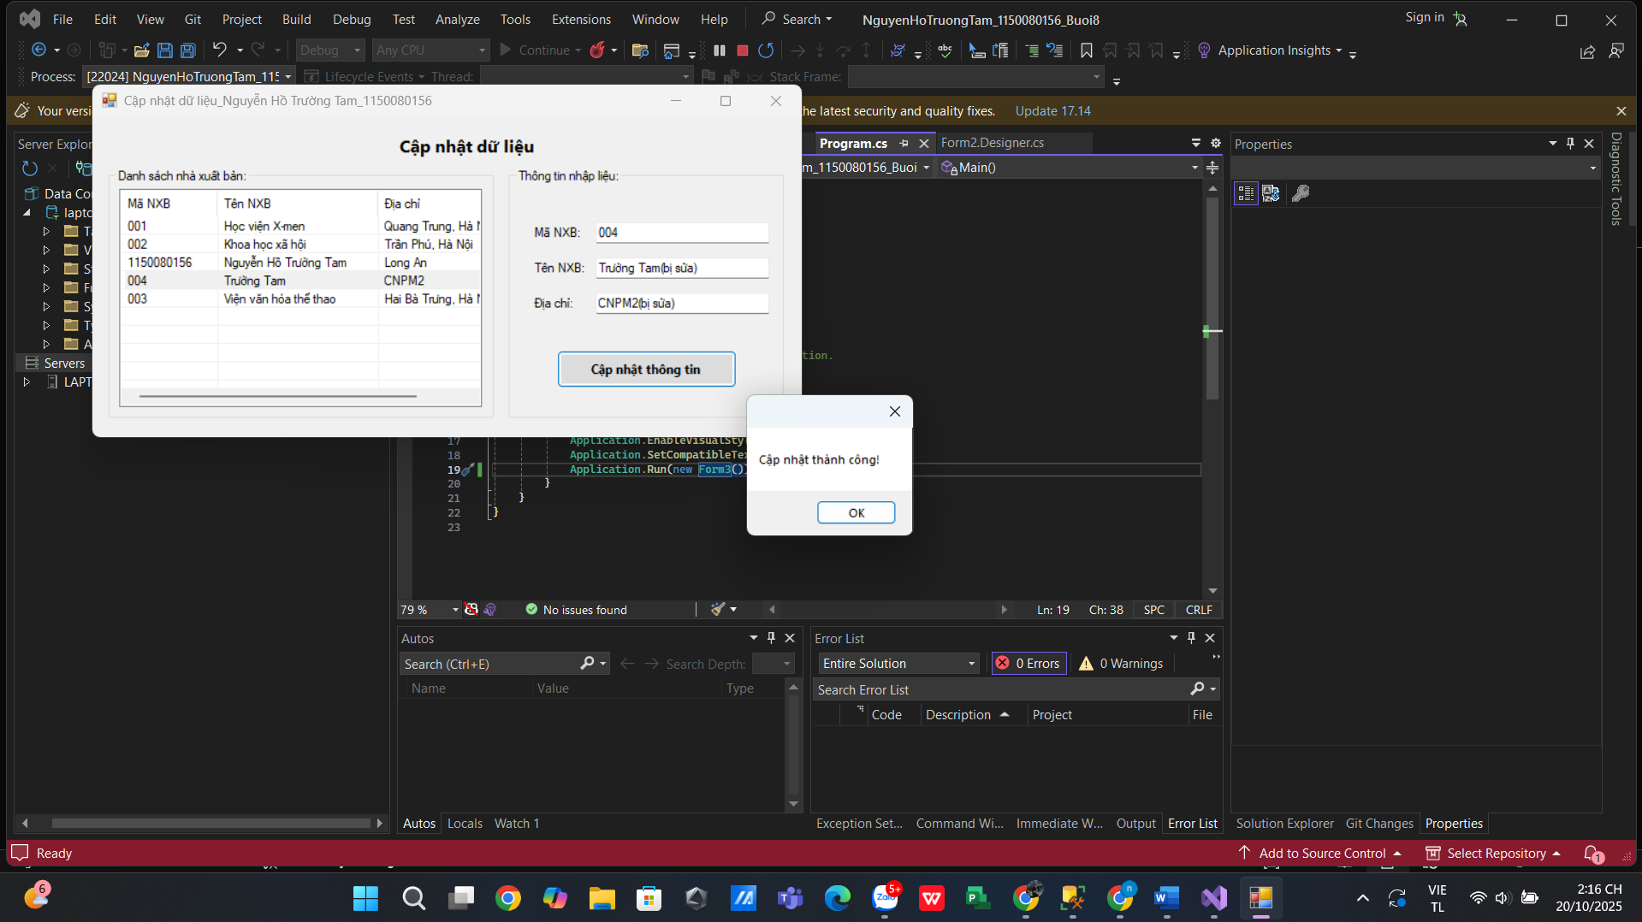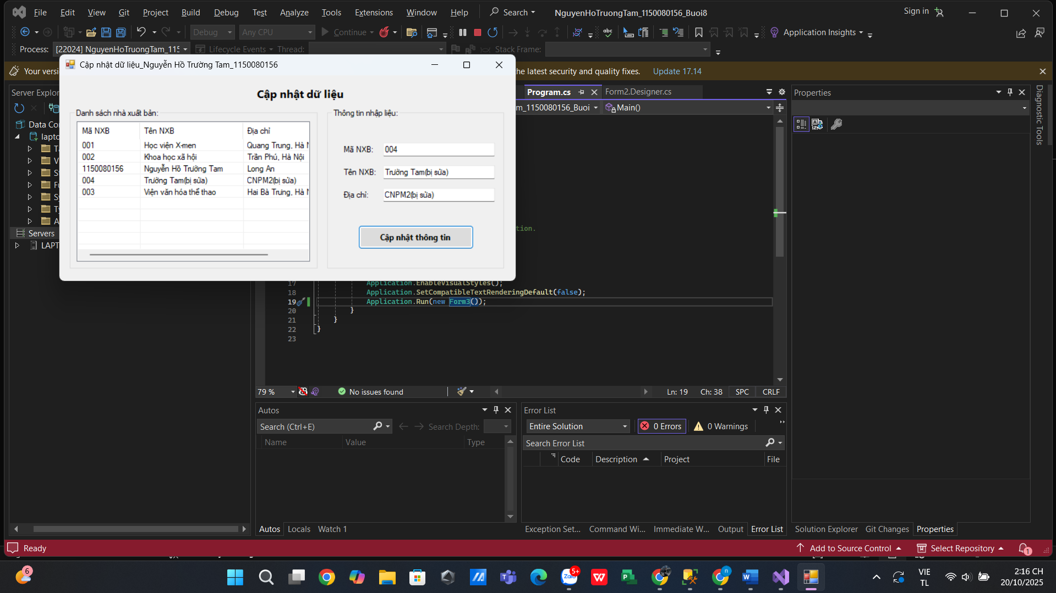

Form3.cs
using System;
using System.Collections.Generic;
using System.ComponentModel;
using System.Data;
using System.Data.SqlClient;
using System.Drawing;
using System.Linq;
using System.Text;
using System.Threading.Tasks;
using System.Windows.Forms;

namespace NguyenHoTruongTam_1150080156_Buoi8
{
public partial class Form3 : Form
{
private readonly string strCon =
@"Data Source=(LocalDB)\MSSQLLocalDB;Initial Catalog=QuanLyBanSach;Integrated Security=True;Connect Timeout=30";

private SqlConnection sqlCon;

public Form3()
{
InitializeComponent();
}

// --- KẾT NỐI ---
private void MoKetNoi()
{
if (sqlCon == null) sqlCon = new SqlConnection(strCon);
if (sqlCon.State == ConnectionState.Closed) sqlCon.Open();
}
private void DongKetNoi()
{
if (sqlCon != null && sqlCon.State == ConnectionState.Open) sqlCon.Close();
}

// --- LOAD FORM ---
private void Form3_Load(object sender, EventArgs e)
{
NapDanhSach();
txtMaXB.Focus();
}

// --- NẠP DANH SÁCH BÊN TRÁI ---
// SP yêu cầu: HienThiXB (SELECT MaXB, TenXB, DiaChi FROM NhaXuatBan ORDER BY TenXB)
private void NapDanhSach()
{
try
{
MoKetNoi();
using (var cmd = new SqlCommand("HienThiXB", sqlCon))
{
cmd.CommandType = CommandType.StoredProcedure;
using (var r = cmd.ExecuteReader())
{
lsvDanhSach.Items.Clear();
while (r.Read())
{
string ma = r.GetString(0);
string ten = r.GetString(1);
string dia = r.IsDBNull(2) ? "" : r.GetString(2);

var it = new ListViewItem(ma);
it.SubItems.Add(ten);
it.SubItems.Add(dia);
lsvDanhSach.Items.Add(it);
}
}
}
}
catch (Exception ex)
{
MessageBox.Show("Lỗi tải danh sách: " + ex.Message);
}
finally { DongKetNoi(); }
}

// --- CHỌN MỘT DÒNG → ĐỔ LÊN Ô BÊN PHẢI ---
private void lsvDanhSach_SelectedIndexChanged(object sender, EventArgs e)
{
if (lsvDanhSach.SelectedItems.Count == 0) return;
var it = lsvDanhSach.SelectedItems[0];
txtMaXB.Text = it.SubItems[0].Text; // KHÔNG cho sửa mã khi cập nhật
txtTenXB.Text = it.SubItems[1].Text;
txtDiaChi.Text = it.SubItems[2].Text;
}

// --- NÚT CẬP NHẬT ---
// Gọi SP: CapNhatThongTin (trả về @@ROWCOUNT → ExecuteScalar)
private void btnCapNhat_Click(object sender, EventArgs e)
{
if (string.IsNullOrWhiteSpace(txtMaXB.Text))
{
MessageBox.Show("Vui lòng chọn Mã NXB từ danh sách (hoặc nhập chính xác).");
return;
}

try
{
MoKetNoi();
using (var cmd = new SqlCommand("CapNhatThongTin", sqlCon))
{
cmd.CommandType = CommandType.StoredProcedure;
cmd.Parameters.Add(new SqlParameter("@maNXB", SqlDbType.Char, 10)).Value = txtMaXB.Text.Trim();
cmd.Parameters.Add(new SqlParameter("@tenNXB", SqlDbType.NVarChar, 100)).Value = txtTenXB.Text.Trim();
cmd.Parameters.Add(new SqlParameter("@diaChi", SqlDbType.NVarChar, 500)).Value =
string.IsNullOrWhiteSpace(txtDiaChi.Text) ? (object)DBNull.Value : txtDiaChi.Text.Trim();

object scalar = cmd.ExecuteScalar(); // do NOCOUNT ON
int rows = 0;
if (scalar != null && int.TryParse(scalar.ToString(), out var r)) rows = r;

if (rows > 0)
{
MessageBox.Show("Cập nhật thành công!");
NapDanhSach(); // refresh lại danh sách
}
else
{
MessageBox.Show("Không có bản ghi nào được cập nhật.");
}
}
}
catch (SqlException sqlex)
{
MessageBox.Show("SQL error: " + sqlex.Message);
}
catch (Exception ex)
{
MessageBox.Show("Lỗi cập nhật: " + ex.Message);
}
finally { DongKetNoi(); }
}
}
}

Form3.Designer.cs
namespace NguyenHoTruongTam_1150080156_Buoi8
{
partial class Form3
{
private System.ComponentModel.IContainer components = null;

protected override void Dispose(bool disposing)
{
if (disposing && (components != null))
components.Dispose();
base.Dispose(disposing);
}

#region Windows Form Designer generated code

private void InitializeComponent()
{
this.lblTieuDe = new System.Windows.Forms.Label();
this.groupDanhSach = new System.Windows.Forms.GroupBox();
this.lsvDanhSach = new System.Windows.Forms.ListView();
this.colMa = new System.Windows.Forms.ColumnHeader();
this.colTen = new System.Windows.Forms.ColumnHeader();
this.colDia = new System.Windows.Forms.ColumnHeader();
this.groupNhap = new System.Windows.Forms.GroupBox();
this.btnCapNhat = new System.Windows.Forms.Button();
this.txtDiaChi = new System.Windows.Forms.TextBox();
this.txtTenXB = new System.Windows.Forms.TextBox();
this.txtMaXB = new System.Windows.Forms.TextBox();
this.lblDiaChi = new System.Windows.Forms.Label();
this.lblTenXB = new System.Windows.Forms.Label();
this.lblMaXB = new System.Windows.Forms.Label();
this.groupDanhSach.SuspendLayout();
this.groupNhap.SuspendLayout();
this.SuspendLayout();
//
// lblTieuDe
//
this.lblTieuDe.AutoSize = true;
this.lblTieuDe.Font = new System.Drawing.Font("Segoe UI", 12F, System.Drawing.FontStyle.Bold, System.Drawing.GraphicsUnit.Point);
this.lblTieuDe.Location = new System.Drawing.Point(330, 18);
this.lblTieuDe.Name = "lblTieuDe";
this.lblTieuDe.Size = new System.Drawing.Size(142, 21);
this.lblTieuDe.TabIndex = 0;
this.lblTieuDe.Text = "Cập nhật dữ liệu";
//
// groupDanhSach
//
this.groupDanhSach.Controls.Add(this.lsvDanhSach);
this.groupDanhSach.Location = new System.Drawing.Point(18, 55);
this.groupDanhSach.Name = "groupDanhSach";
this.groupDanhSach.Size = new System.Drawing.Size(420, 270);
this.groupDanhSach.TabIndex = 1;
this.groupDanhSach.TabStop = false;
this.groupDanhSach.Text = "Danh sách nhà xuất bản:";
//
// lsvDanhSach
//
this.lsvDanhSach.Columns.AddRange(new System.Windows.Forms.ColumnHeader[] {
this.colMa,
this.colTen,
this.colDia});
this.lsvDanhSach.FullRowSelect = true;
this.lsvDanhSach.GridLines = true;
this.lsvDanhSach.HideSelection = false;
this.lsvDanhSach.Location = new System.Drawing.Point(12, 22);
this.lsvDanhSach.Name = "lsvDanhSach";
this.lsvDanhSach.Size = new System.Drawing.Size(395, 235);
this.lsvDanhSach.TabIndex = 0;
this.lsvDanhSach.UseCompatibleStateImageBehavior = false;
this.lsvDanhSach.View = System.Windows.Forms.View.Details;
this.lsvDanhSach.SelectedIndexChanged += new System.EventHandler(this.lsvDanhSach_SelectedIndexChanged);
//
// colMa
//
this.colMa.Text = "Mã NXB";
this.colMa.Width = 90;
//
// colTen
//
this.colTen.Text = "Tên NXB";
this.colTen.Width = 150;
//
// colDia
//
this.colDia.Text = "Địa chỉ";
this.colDia.Width = 150;
//
// groupNhap
//
this.groupNhap.Controls.Add(this.btnCapNhat);
this.groupNhap.Controls.Add(this.txtDiaChi);
this.groupNhap.Controls.Add(this.txtTenXB);
this.groupNhap.Controls.Add(this.txtMaXB);
this.groupNhap.Controls.Add(this.lblDiaChi);
this.groupNhap.Controls.Add(this.lblTenXB);
this.groupNhap.Controls.Add(this.lblMaXB);
this.groupNhap.Location = new System.Drawing.Point(454, 55);
this.groupNhap.Name = "groupNhap";
this.groupNhap.Size = new System.Drawing.Size(300, 270);
this.groupNhap.TabIndex = 2;
this.groupNhap.TabStop = false;
this.groupNhap.Text = "Thông tin nhập liệu:";
//
// btnCapNhat
//
this.btnCapNhat.BackColor = System.Drawing.Color.Gainsboro;
this.btnCapNhat.Font = new System.Drawing.Font("Segoe UI", 9F, System.Drawing.FontStyle.Bold, System.Drawing.GraphicsUnit.Point);
this.btnCapNhat.Location = new System.Drawing.Point(52, 196);
this.btnCapNhat.Name = "btnCapNhat";
this.btnCapNhat.Size = new System.Drawing.Size(196, 40);
this.btnCapNhat.TabIndex = 6;
this.btnCapNhat.Text = "Cập nhật thông tin";
this.btnCapNhat.UseVisualStyleBackColor = false;
this.btnCapNhat.Click += new System.EventHandler(this.btnCapNhat_Click);
//
// txtDiaChi
//
this.txtDiaChi.Location = new System.Drawing.Point(95, 134);
this.txtDiaChi.Name = "txtDiaChi";
this.txtDiaChi.Size = new System.Drawing.Size(190, 23);
this.txtDiaChi.TabIndex = 5;
//
// txtTenXB
//
this.txtTenXB.Location = new System.Drawing.Point(95, 96);
this.txtTenXB.Name = "txtTenXB";
this.txtTenXB.Size = new System.Drawing.Size(190, 23);
this.txtTenXB.TabIndex = 4;
//
// txtMaXB
//
this.txtMaXB.Location = new System.Drawing.Point(95, 58);
this.txtMaXB.Name = "txtMaXB";
this.txtMaXB.Size = new System.Drawing.Size(190, 23);
this.txtMaXB.TabIndex = 3;
//
// lblDiaChi
//
this.lblDiaChi.AutoSize = true;
this.lblDiaChi.Location = new System.Drawing.Point(25, 137);
this.lblDiaChi.Name = "lblDiaChi";
this.lblDiaChi.Size = new System.Drawing.Size(50, 15);
this.lblDiaChi.TabIndex = 2;
this.lblDiaChi.Text = "Địa chỉ:";
//
// lblTenXB
//
this.lblTenXB.AutoSize = true;
this.lblTenXB.Location = new System.Drawing.Point(25, 99);
this.lblTenXB.Name = "lblTenXB";
this.lblTenXB.Size = new System.Drawing.Size(56, 15);
this.lblTenXB.TabIndex = 1;
this.lblTenXB.Text = "Tên NXB:";
//
// lblMaXB
//
this.lblMaXB.AutoSize = true;
this.lblMaXB.Location = new System.Drawing.Point(25, 61);
this.lblMaXB.Name = "lblMaXB";
this.lblMaXB.Size = new System.Drawing.Size(51, 15);
this.lblMaXB.TabIndex = 0;
this.lblMaXB.Text = "Mã NXB:";
//
// Form3
//
this.AutoScaleDimensions = new System.Drawing.SizeF(7F, 15F);
this.AutoScaleMode = System.Windows.Forms.AutoScaleMode.Font;
this.ClientSize = new System.Drawing.Size(774, 345);
this.Controls.Add(this.groupNhap);
this.Controls.Add(this.groupDanhSach);
this.Controls.Add(this.lblTieuDe);
this.Name = "Form3";
this.Text = "Cập nhật dữ liệu";
this.Load += new System.EventHandler(this.Form3_Load);
this.groupDanhSach.ResumeLayout(false);
this.groupNhap.ResumeLayout(false);
this.groupNhap.PerformLayout();
this.ResumeLayout(false);
this.PerformLayout();
}

#endregion

private System.Windows.Forms.Label lblTieuDe;
private System.Windows.Forms.GroupBox groupDanhSach;
private System.Windows.Forms.ListView lsvDanhSach;
private System.Windows.Forms.ColumnHeader colMa;
private System.Windows.Forms.ColumnHeader colTen;
private System.Windows.Forms.ColumnHeader colDia;
private System.Windows.Forms.GroupBox groupNhap;
private System.Windows.Forms.Button btnCapNhat;
private System.Windows.Forms.TextBox txtDiaChi;
private System.Windows.Forms.TextBox txtTenXB;
private System.Windows.Forms.TextBox txtMaXB;
private System.Windows.Forms.Label lblDiaChi;
private System.Windows.Forms.Label lblTenXB;
private System.Windows.Forms.Label lblMaXB;
}
}

Thực hành 4: Xóa dữ liệu cho bảng Nhà xuất bản.
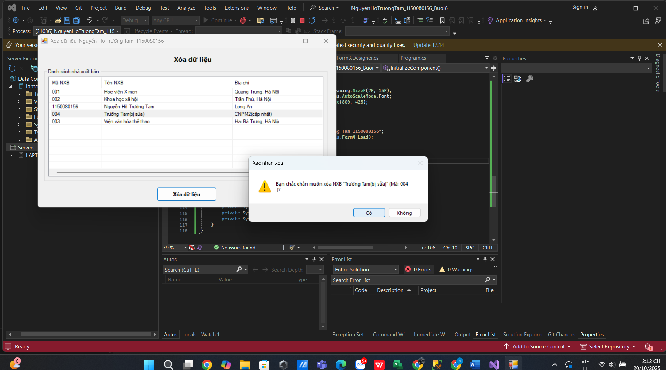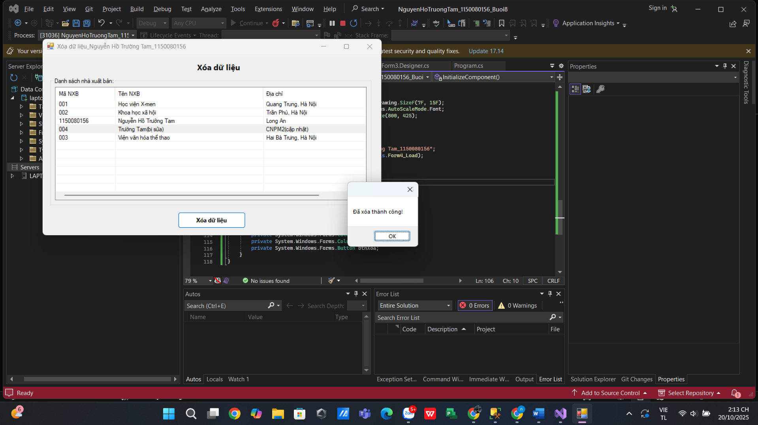
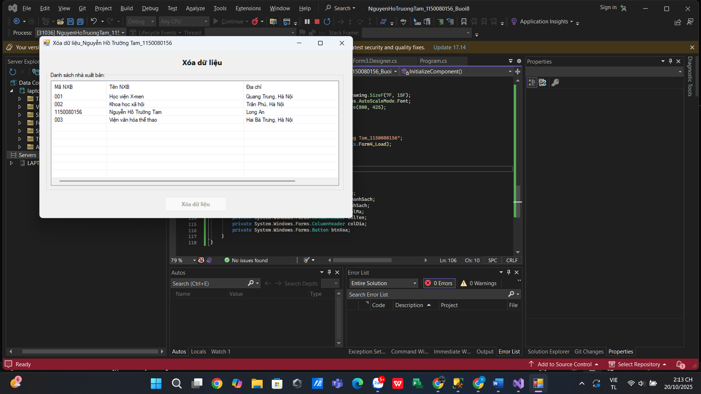

Form4.cs
using System;
using System.Collections.Generic;
using System.ComponentModel;
using System.Data;
using System.Data.SqlClient;
using System.Drawing;
using System.Linq;
using System.Text;
using System.Threading.Tasks;
using System.Windows.Forms;

namespace NguyenHoTruongTam_1150080156_Buoi8
{
public partial class Form4 : Form
{
private readonly string strCon =
@"Data Source=(LocalDB)\MSSQLLocalDB;Initial Catalog=QuanLyBanSach;Integrated Security=True;Connect Timeout=30";

private SqlConnection sqlCon;

public Form4()
{
InitializeComponent();
}

// --- Kết nối ---
private void MoKetNoi()
{
if (sqlCon == null) sqlCon = new SqlConnection(strCon);
if (sqlCon.State == ConnectionState.Closed) sqlCon.Open();
}
private void DongKetNoi()
{
if (sqlCon != null && sqlCon.State == ConnectionState.Open) sqlCon.Close();
}

// --- Load ---
private void Form4_Load(object sender, EventArgs e)
{
btnXoa.Enabled = false;
NapDanhSach();
}

// --- Nạp danh sách (SP: HienThiXB) ---
private void NapDanhSach()
{
try
{
MoKetNoi();
using (var cmd = new SqlCommand("HienThiXB", sqlCon))
{
cmd.CommandType = CommandType.StoredProcedure;
using (var r = cmd.ExecuteReader())
{
lsvDanhSach.Items.Clear();
while (r.Read())
{
string ma = r.GetString(0);
string ten = r.GetString(1);
string dia = r.IsDBNull(2) ? "" : r.GetString(2);

var it = new ListViewItem(ma);
it.SubItems.Add(ten);
it.SubItems.Add(dia);
lsvDanhSach.Items.Add(it);
}
}
}
}
catch (Exception ex)
{
MessageBox.Show("Lỗi tải danh sách: " + ex.Message);
}
finally { DongKetNoi(); }
}

// --- Chọn dòng ---
private void lsvDanhSach_SelectedIndexChanged(object sender, EventArgs e)
{
btnXoa.Enabled = lsvDanhSach.SelectedItems.Count > 0;
}

// --- Xóa (SP: XoaNXB, trả @@ROWCOUNT) ---
private void btnXoa_Click(object sender, EventArgs e)
{
if (lsvDanhSach.SelectedItems.Count == 0) return;

var it = lsvDanhSach.SelectedItems[0];
string maXB = it.SubItems[0].Text;
string ten = it.SubItems[1].Text;

var confirm = MessageBox.Show(
$"Bạn chắc chắn muốn xóa NXB \"{ten}\" (Mã: {maXB})?",
"Xác nhận xóa", MessageBoxButtons.YesNo, MessageBoxIcon.Warning);

if (confirm != DialogResult.Yes) return;

try
{
MoKetNoi();
using (var cmd = new SqlCommand("XoaNXB", sqlCon))
{
cmd.CommandType = CommandType.StoredProcedure;

// Nếu SP dùng tham số @MaNXB (biến thể B) thì đổi tên tham số ở đây
cmd.Parameters.Add(new SqlParameter("@MaXB", SqlDbType.Char, 10)).Value = maXB;

object scalar = cmd.ExecuteScalar(); // do NOCOUNT ON
int rows = 0;
if (scalar != null && int.TryParse(scalar.ToString(), out var r)) rows = r;

if (rows > 0)
{
MessageBox.Show("Đã xóa thành công!");
NapDanhSach();
btnXoa.Enabled = false;
}
else
{
MessageBox.Show("Không tìm thấy bản ghi để xóa.");
}
}
}
catch (SqlException sqlex)
{
MessageBox.Show("SQL error: " + sqlex.Message);
}
catch (Exception ex)
{
MessageBox.Show("Lỗi xóa dữ liệu: " + ex.Message);
}
finally { DongKetNoi(); }
}
}
}

Form4.Designer.cs
namespace NguyenHoTruongTam_1150080156_Buoi8
{
partial class Form4
{
private System.ComponentModel.IContainer components = null;

protected override void Dispose(bool disposing)
{
if (disposing && (components != null))
components.Dispose();
base.Dispose(disposing);
}

#region Windows Form Designer generated code

private void InitializeComponent()
{
this.lblTieuDe = new System.Windows.Forms.Label();
this.groupDanhSach = new System.Windows.Forms.GroupBox();
this.lsvDanhSach = new System.Windows.Forms.ListView();
this.colMa = new System.Windows.Forms.ColumnHeader();
this.colTen = new System.Windows.Forms.ColumnHeader();
this.colDia = new System.Windows.Forms.ColumnHeader();
this.btnXoa = new System.Windows.Forms.Button();
this.groupDanhSach.SuspendLayout();
this.SuspendLayout();
//
// lblTieuDe
//
this.lblTieuDe.AutoSize = true;
this.lblTieuDe.Font = new System.Drawing.Font("Segoe UI", 12F, System.Drawing.FontStyle.Bold, System.Drawing.GraphicsUnit.Point);
this.lblTieuDe.Location = new System.Drawing.Point(360, 18);
this.lblTieuDe.Name = "lblTieuDe";
this.lblTieuDe.Size = new System.Drawing.Size(98, 21);
this.lblTieuDe.TabIndex = 0;
this.lblTieuDe.Text = "Xóa dữ liệu";
//
// groupDanhSach
//
this.groupDanhSach.Controls.Add(this.lsvDanhSach);
this.groupDanhSach.Location = new System.Drawing.Point(18, 55);
this.groupDanhSach.Name = "groupDanhSach";
this.groupDanhSach.Size = new System.Drawing.Size(760, 300);
this.groupDanhSach.TabIndex = 1;
this.groupDanhSach.TabStop = false;
this.groupDanhSach.Text = "Danh sách nhà xuất bản:";
//
// lsvDanhSach
//
this.lsvDanhSach.Columns.AddRange(new System.Windows.Forms.ColumnHeader[] {
this.colMa,
this.colTen,
this.colDia});
this.lsvDanhSach.FullRowSelect = true;
this.lsvDanhSach.GridLines = true;
this.lsvDanhSach.HideSelection = false;
this.lsvDanhSach.Location = new System.Drawing.Point(12, 22);
this.lsvDanhSach.Name = "lsvDanhSach";
this.lsvDanhSach.Size = new System.Drawing.Size(735, 265);
this.lsvDanhSach.TabIndex = 0;
this.lsvDanhSach.UseCompatibleStateImageBehavior = false;
this.lsvDanhSach.View = System.Windows.Forms.View.Details;
this.lsvDanhSach.SelectedIndexChanged += new System.EventHandler(this.lsvDanhSach_SelectedIndexChanged);
//
// colMa
//
this.colMa.Text = "Mã NXB";
this.colMa.Width = 120;
//
// colTen
//
this.colTen.Text = "Tên NXB";
this.colTen.Width = 300;
//
// colDia
//
this.colDia.Text = "Địa chỉ";
this.colDia.Width = 300;
//
// btnXoa
//
this.btnXoa.Enabled = false;
this.btnXoa.Font = new System.Drawing.Font("Segoe UI", 9F, System.Drawing.FontStyle.Bold, System.Drawing.GraphicsUnit.Point);
this.btnXoa.Location = new System.Drawing.Point(320, 370);
this.btnXoa.Name = "btnXoa";
this.btnXoa.Size = new System.Drawing.Size(160, 38);
this.btnXoa.TabIndex = 2;
this.btnXoa.Text = "Xóa dữ liệu";
this.btnXoa.UseVisualStyleBackColor = true;
this.btnXoa.Click += new System.EventHandler(this.btnXoa_Click);
//
// Form4
//
this.AutoScaleDimensions = new System.Drawing.SizeF(7F, 15F);
this.AutoScaleMode = System.Windows.Forms.AutoScaleMode.Font;
this.ClientSize = new System.Drawing.Size(800, 425);
this.Controls.Add(this.btnXoa);
this.Controls.Add(this.groupDanhSach);
this.Controls.Add(this.lblTieuDe);
this.Name = "Form4";
this.Text = "Xóa dữ liệu_Nguyễn Hồ Trường Tam_1150080156";
this.Load += new System.EventHandler(this.Form4_Load);
this.groupDanhSach.ResumeLayout(false);
this.ResumeLayout(false);
this.PerformLayout();
}

#endregion

private System.Windows.Forms.Label lblTieuDe;
private System.Windows.Forms.GroupBox groupDanhSach;
private System.Windows.Forms.ListView lsvDanhSach;
private System.Windows.Forms.ColumnHeader colMa;
private System.Windows.Forms.ColumnHeader colTen;
private System.Windows.Forms.ColumnHeader colDia;
private System.Windows.Forms.Button btnXoa;
}
}

