# índice marca_UPV_principal_color300

# FPGA based design and implementation of a chroma key processing system for video

Final Project proposal for Co diseño hardware and software course

# Masters degree in telecommunications engineering

Patricia Valcárcel Manzano(1), Johnatan Bryan Vargas Negrete(2), Alejandro Azorín Caballero(3)

Universidad Politécnica de Valencia

e-mail: [patvalma@teleco.upv.es (1)](mailto:patvalma@teleco.upv.es%20(1)), [jhovarne@teleco.upv.es (2)](mailto:jhovarne@teleco.upv.es%20(2)), [alazca1@teleco.upv.es](mailto:alazca1@teleco.upv.es) (3)

**Abstract**. The design proposed in this course consists of the realization of a chroma key in real time. Chroma or color key is an audiovisual technique widely used in both cinema, television and photography, which consists of extracting a color from an image or video (usually green) and replacing the area that occupied that color with another image or video, with the help of a specialized team. In our particular case, a character will be inserted on a photograph. The photo will be stored in Flash memory and will act as background of the image displayed on the MTL2 display. The character will be on a green background, to be able to replace the green background with the image of the photograph. The character image will be captured with a camera that will connect to the DE2 board

## 1. Chroma key state of art and introduction

### 1.1 History of the Chroma Key technology

### The blue chroma method was developed in the 1930s by RKO Radio Pictures. At the RKO, Linwood Dunn used a first-time version of matte, which was the creation of "handkerchiefs" with which layer transitions were carried out, as if it were a windshield wiper. A few years later, in 1950, Arthur Widmer, working for the Warner Bros, began to investigate the overlay of layers by means of an ultraviolet light. He also began to develop the use of blue chroma: one of his first films where he did it was in the 1958 adaptation of the novel The Old Man and the Sea by Ernest Hemingway.

It was not until 1964 that Petro Vlahos was awarded an Academy Award for the finesse with which he made use of these techniques. His in particular stands out for taking advantage of the fact that most real objects emit a similar intensity of blue and green colors, which allows to use it with translucent elements and improves the edges of the overlapping elements.

In the early 1990s, both British and American television began to use green chroma instead of blue one because image sensors in digital video cameras are more sensitive to green, due to the Bayer pattern:

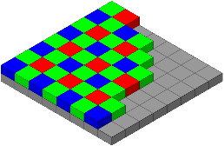

Ilustración 1- Bayer pattern,, used to explain digital cameras sensitivity to green color

as they assign more pixels in the green channel, mimicking the increased sensitivity of the human eye to light of this color. Therefore, the green camera channel contains less noise and can produce a cleaner mask.

In addition, less light is needed to illuminate the green color, again due to the higher sensitivity of this in image sensors. The use of the curtains of this specific color has increased because the blue background may match the color of the subject’s eyes or common items, such as pants

### 1.2 Nowadays Chroma key implementation techniques

The Chroma key effect can be done in post-production, which achieves better results using less resources, or in real time. In post-production this technique is widely implemented via software. However, in real-time it is commonly implemented as a Chroma-key device to connect or include in a camera.

In this particular case, the used technique is real-time implementation using the laboratory resources given by the professors: the Altera Cyclone IV FPGA and a wide angle camera.

Nevertheless, other interesting and innovative ways to implement it have been studied in order ton understand the process and use available resources.

Some common Chroma key methods use the YCbCr color space to process image. This is widely use because it can be considered simple to only examine the Cb and Cr dimensions of this space as those can represent the presence of green in a pixel. In both, RGB and YCbCr techniques the euclidean distance equation is used to determine the distance among the desired green and the diferent tones and undertones of blue and red.

$$d\left(A,B\right)= \sqrt{{(X_{B}-X_{A})}^{2}}$$

Equation 2- Euclidean distamce using only 2 dimensions

In this project a simplified version of other algorithms investigated is proposed because, for instance, the use of operators such as the square root in verilog is complex and can damage the speed of the entire system as well as disrupt its response.

### 1.3 Common difficulties in designing, implementing and processing.

**1.3.1.** *Lighting*.

The biggest challenge when setting up a blue screen or green screen is still lighting and avoiding shade, because it is better to have as narrow a range of colors as possible to be replaced. A shadow would present itself as a darker color to the camera and might not register for replacement. This can sometimes be seen on low budget or live streams where errors cannot be repaired manually. The material used affects the quality and ease of being evenly. Materials that are bright will be much less successful than those that are not. A bright surface will have areas that reflect the lights making them appear pale, while other areas may be darkened.

A matte surface will diffuse reflected light and have a more uniform color range. In order to get the clean key to record the green screen you need to create a value difference between the subject and the green screen. To differentiate the theme from the screen, a difference of two stops can be used, either making the screen green two stops higher than the subject, or vice versa.

**1.3.2.** *Exposure*.

Another challenge for the blue or green screen is to get a correct exposure for the camera. Underexposure or overexposure of a chroma curtain can lead to poor saturation levels. In the case of video cameras, underexposed images may contain high amounts of noise. The chroma should be bright enough to allow the camera to create a bright, saturated image.

## 2. Implemented Chroma-key

### In the present paper, the hardware implementation schema proposed in the documentation prior to the start of the project has been followed.

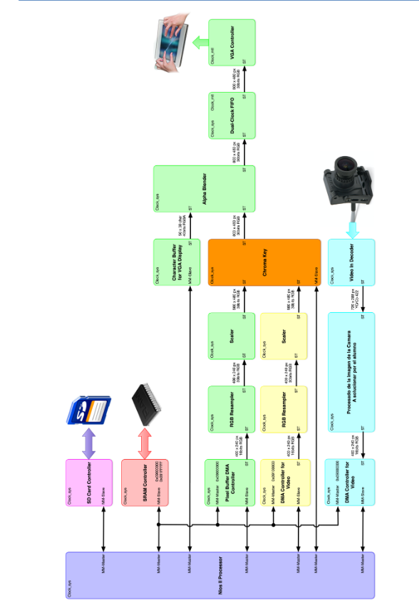

Ilustración 3- Complete system implementation scheme

Where the green path represents the implemented incoming video processing blocks, the yellow one the image processing line and the blue one the processing video blocks, which comes to further explanation in the next sections.

Moreover, a chroma-key IP has been designed and used (it can be seen represented by an orange block).

### 2.1. Image processing (blue path).

The image incoming video images processing path was implemented following a simple structure

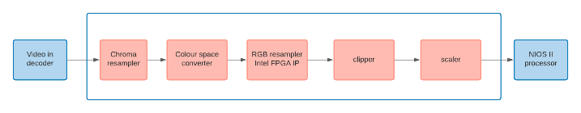

Ilustración 4- Incoming video image processing line

### 2.2 Abreviaturas y Acrónimos

Defina las abreviaturas y acrónimos la primera vez que se

## 3 Conclusiones

El seguimiento de las normas indicadas permitirá que su trabajo no sólo se destaque por su contenido, sino que también resulte visualmente atractivo.

## Apéndice I

En caso de ser necesario, los apéndices irán ubicados después de las Conclusiones, y antes de los Agradecimientos y las Referencias. Se numerarán con números romanos, tal como en el título de esta sección.

## Agradecimientos

Si los hay, los agradecimientos deberán ubicarse al final del trabajo, justo antes de las referencias. Esta sección no llevará numeración.

Utilice el formato estándar de *IEEE Computer* o *Communications of the ACM* para las referencias, es decir, una lista numerada, ordenada alfabéticamente por apellido del primer autor y referenciada en el texto por un número entre corchetes (ejem., “[1]”).

Todas las referencias deben ser documentos accesibles públicamente.

Finalmente, note que el título de esta sección no lleva numeración. Considere el siguiente ejemplo:

## Referencias

[1] Anderson, R.E. Social impacts of computing: Codes of professional ethics. *Social Science Computing Review*. Vol. 10, No. 2, (Winter 1992), pp.453-469.

[2] Harmon, J.E. The Structure of Scientific and Engineering Papers: A Historical Perspective. *IEEE Trans. On Professional Communication*. Vol 32, No. 2, (September, 1989), pp. 132-138.

[3] Pierson, M.M. and Pierson, B.L. Beginnings and Endings: Keys to Better Engineering Technical Writing. *IEEE Trans. On Professional Communication*. Vol 40, No. 4, (December, 1997), pp. 299-304.

[4] Strunk, W. and White, E.B. *The Elements of Style*. Fourth Edition, Boston: Allyn and Bacon. 2000.