Recruitment User Manual

1. System Overview
Recruitment is a JavaFX desktop application for teaching assistant recruitment in an international school context. It supports job posting, job applications, resume upload, AI-assisted screening, account management, and administrative statistics.
Role | Main Functions
APPLICANT | Edit profile, browse jobs, favorite jobs, submit applications, and view application status.
TEACHER | Edit account name, post jobs, manage own jobs, and screen applications.
ADMIN | View dashboard statistics, manage user accounts, and manage job status and job details.

2. Login and Registration
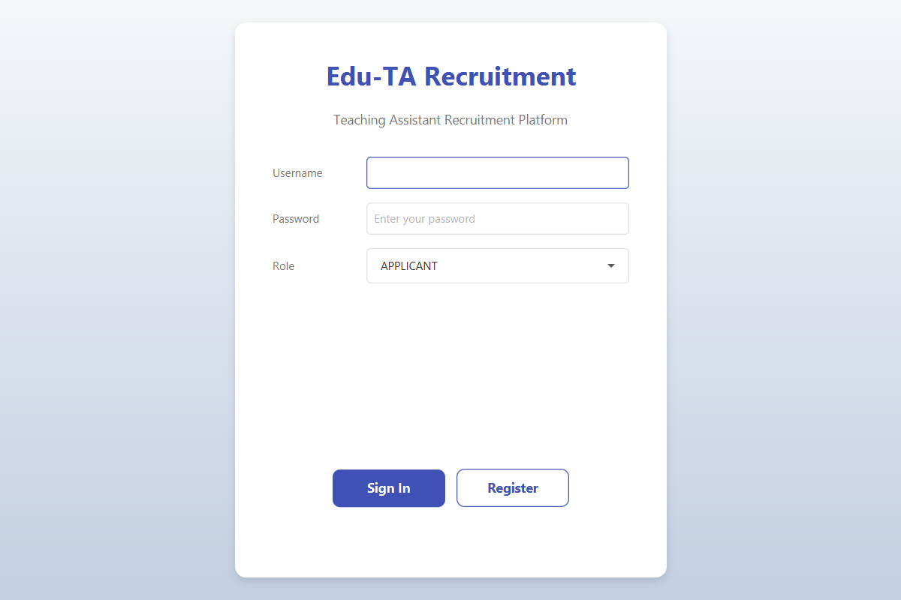
Figure 1 Login and Registration Screen
• Enter the username and password, select the correct role, and click Sign In.
• To register, enter a username, password, select a role, and click Register.
• Username and password cannot be blank or contain spaces.
• The selected role must match the actual role of the account.

3. Main Interface
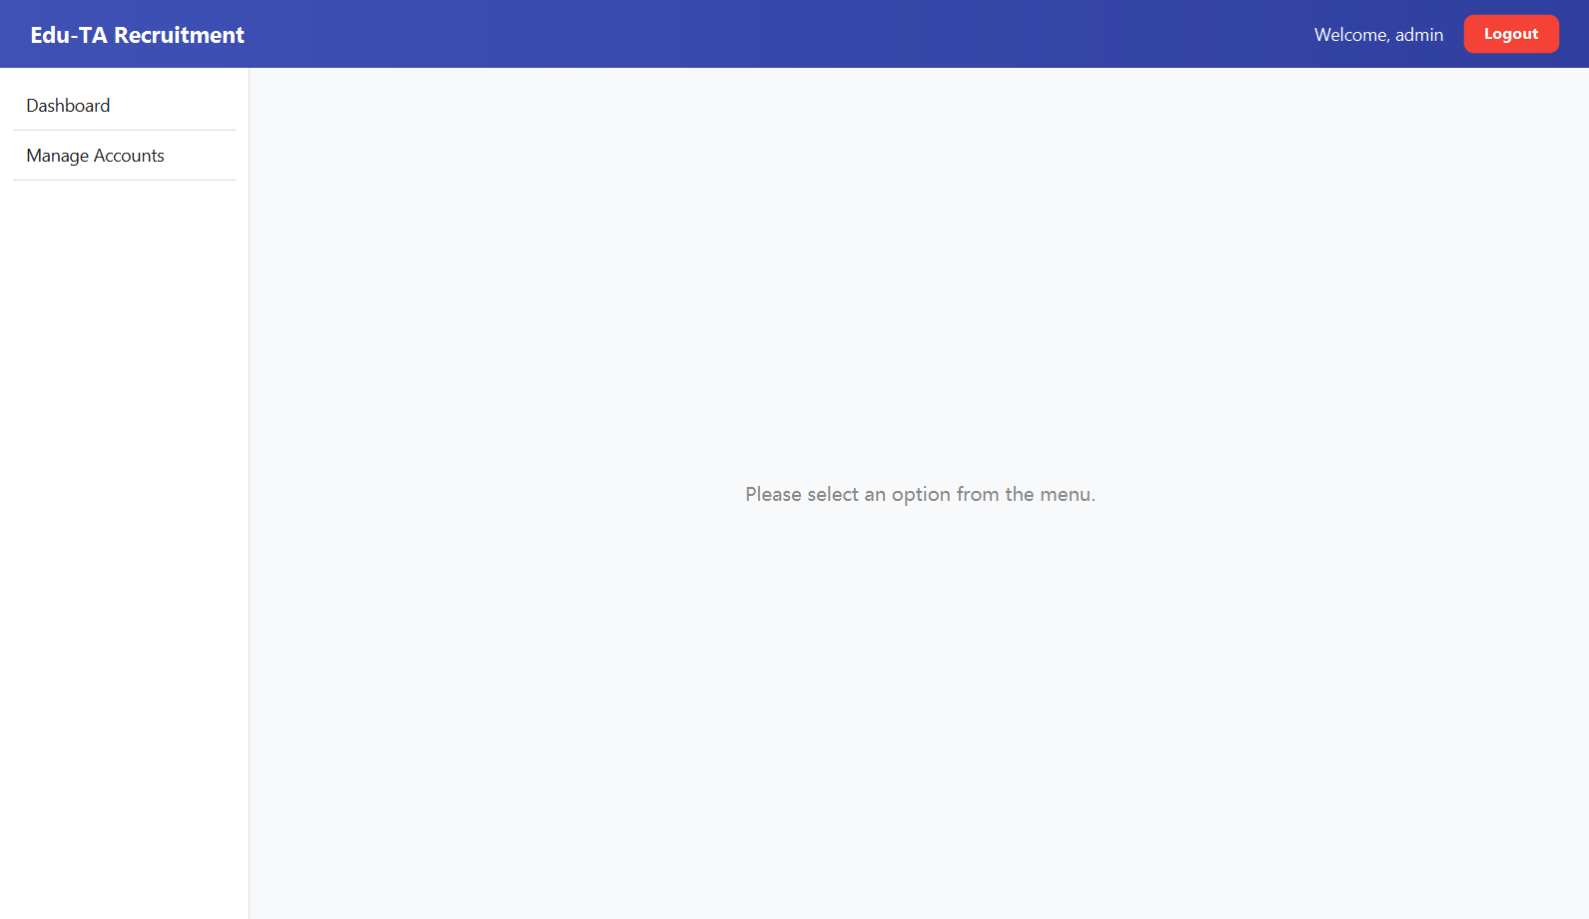
Figure 2 Main Application Shell
Role | Sidebar Menu
APPLICANT | My Profile, Available Jobs, My Favorites, My Applications
TEACHER | My Account, Post a Job, Manage My Jobs, Screening
ADMIN | Dashboard, Manage Accounts

4. Applicant Guide
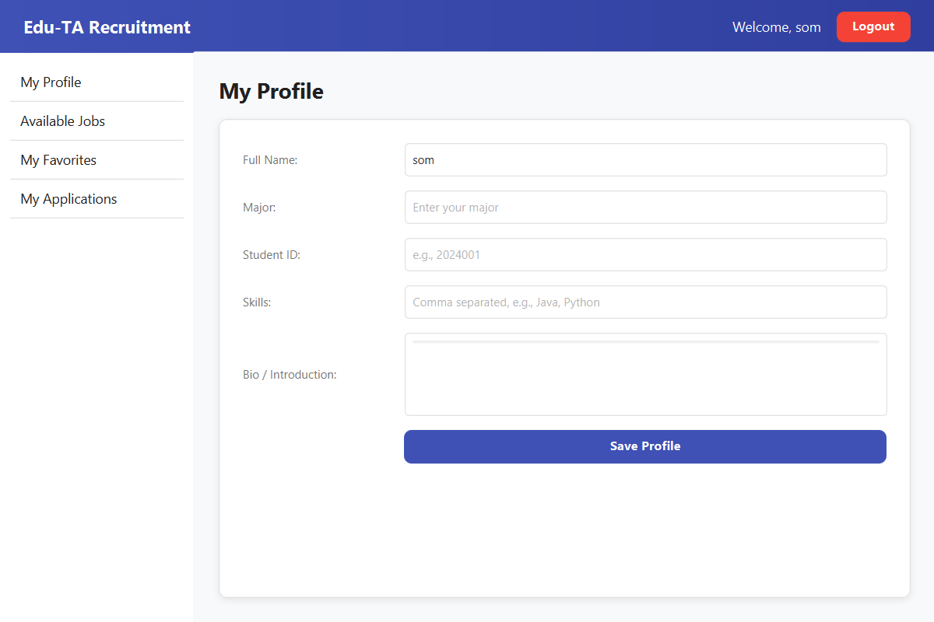
Figure 3 My Profile Page
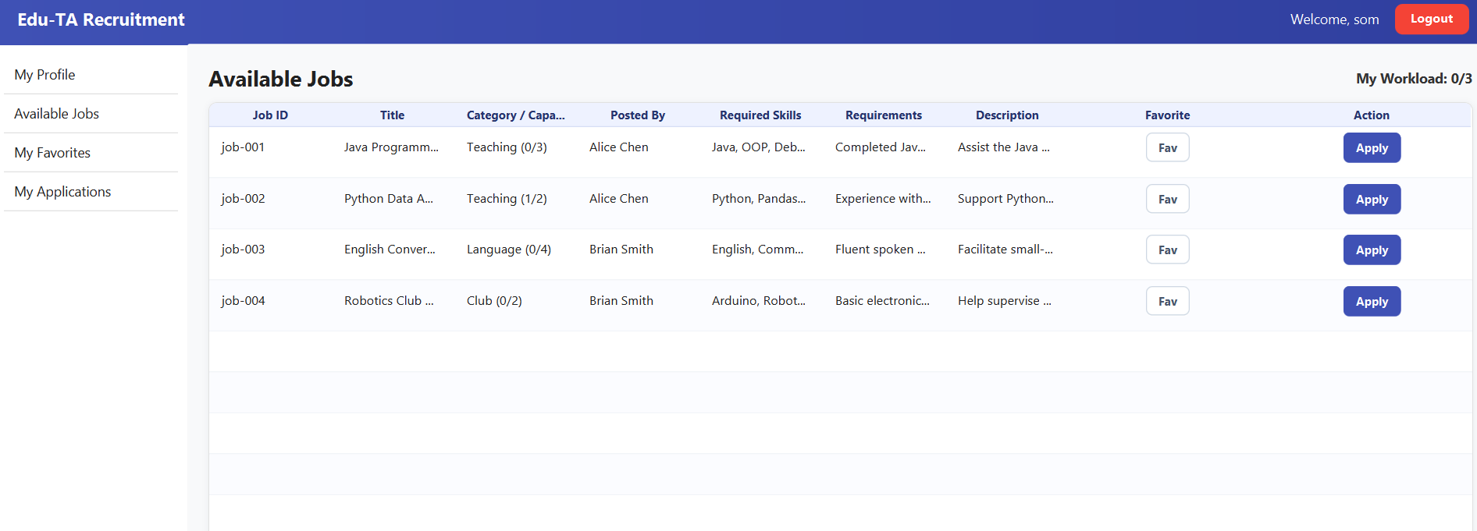
Figure 4 Available Jobs Page
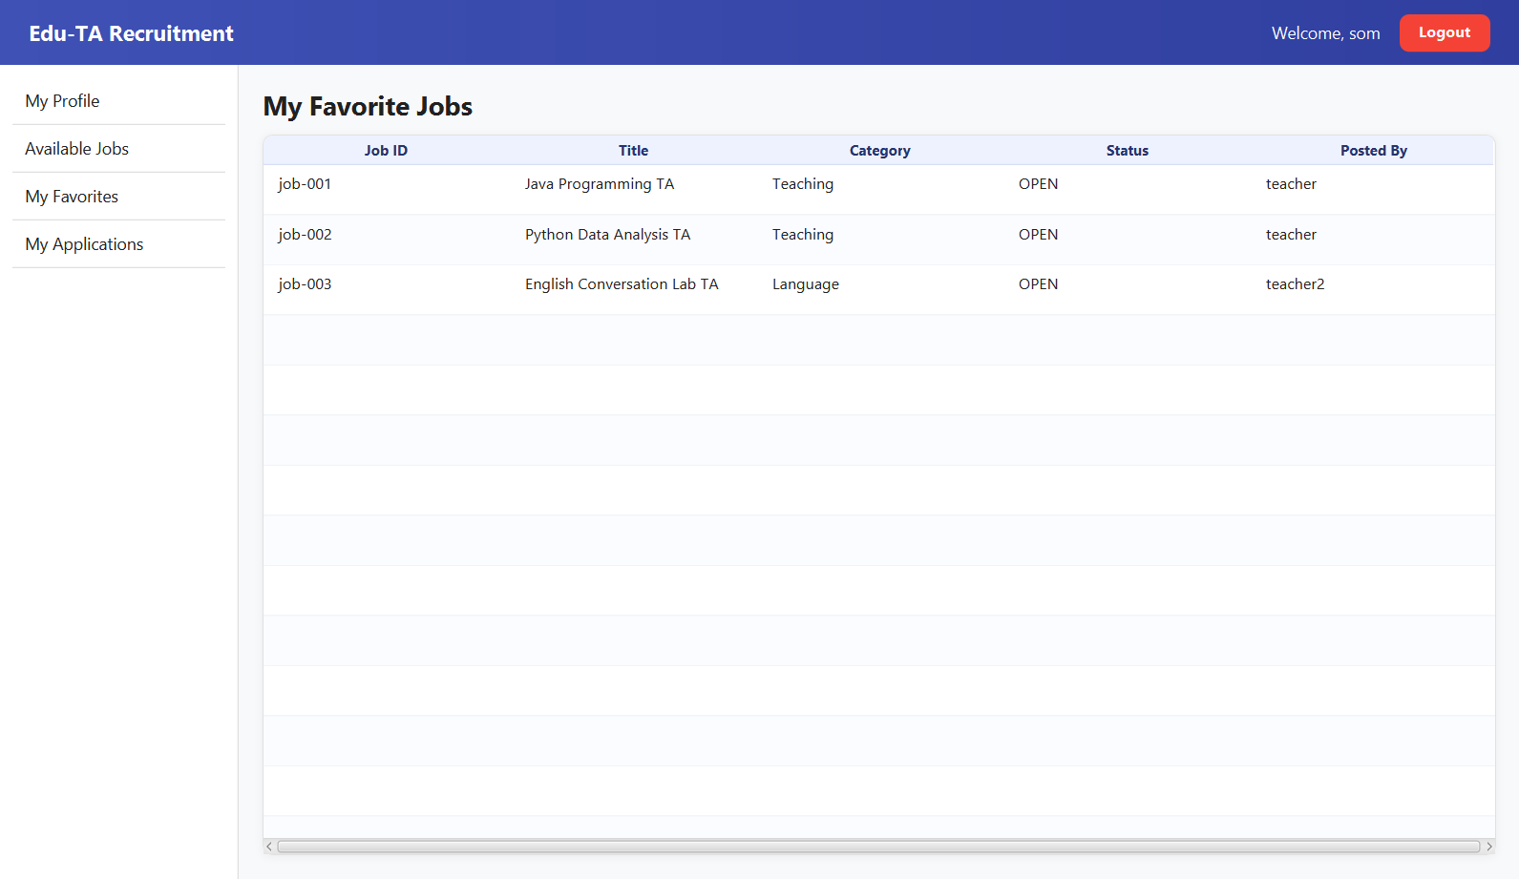
Figure 5 My Favorites Page
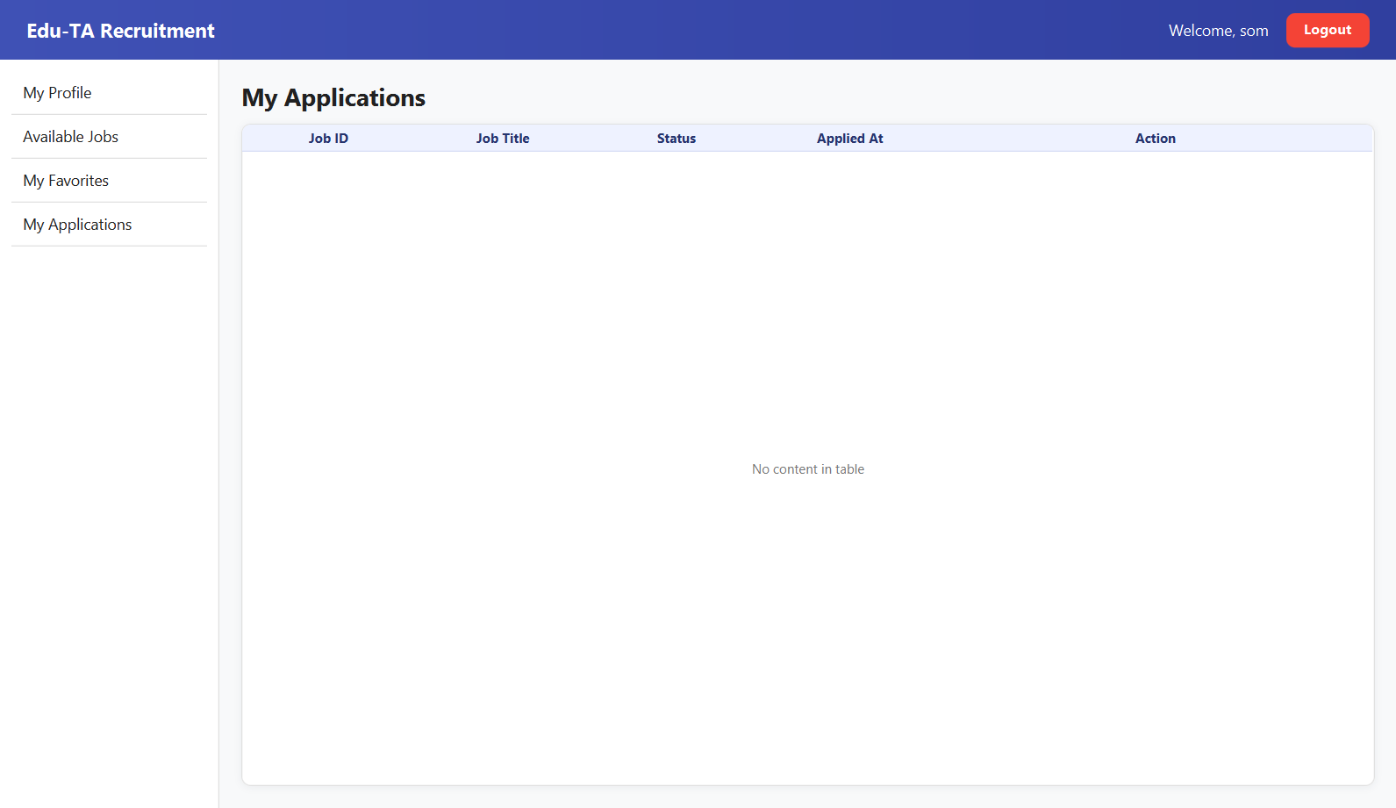
Figure 6 My Applications Page

5. Teacher Guide
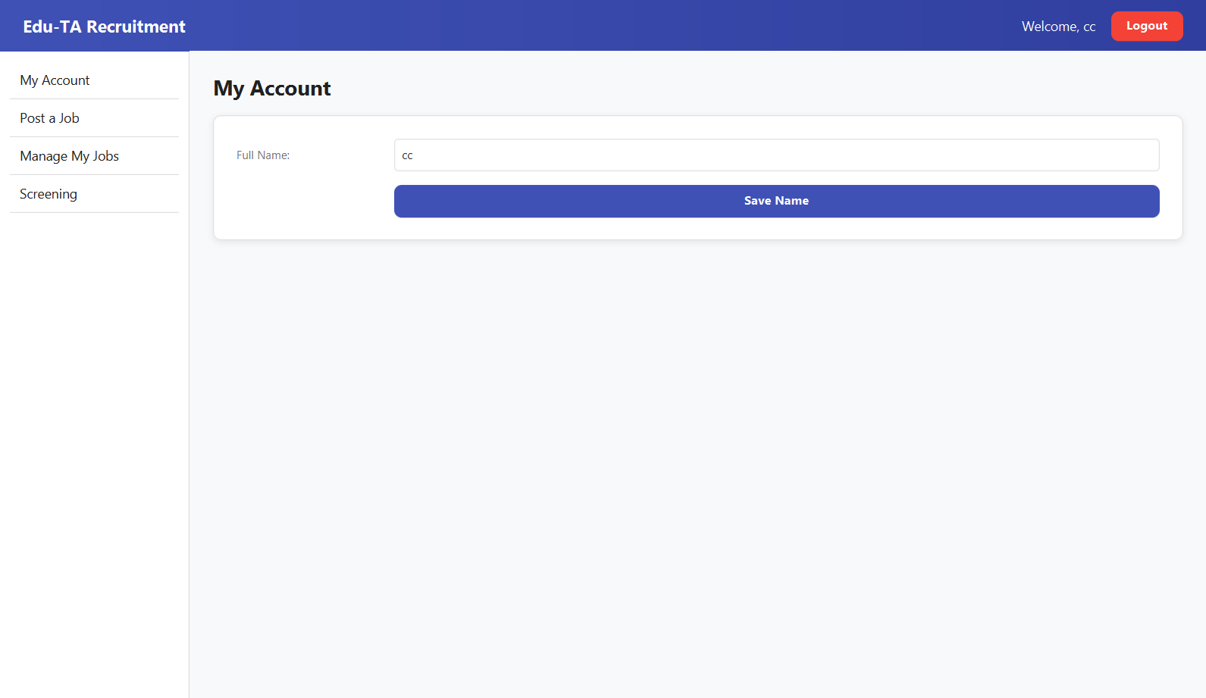Figure 7 My Account Page
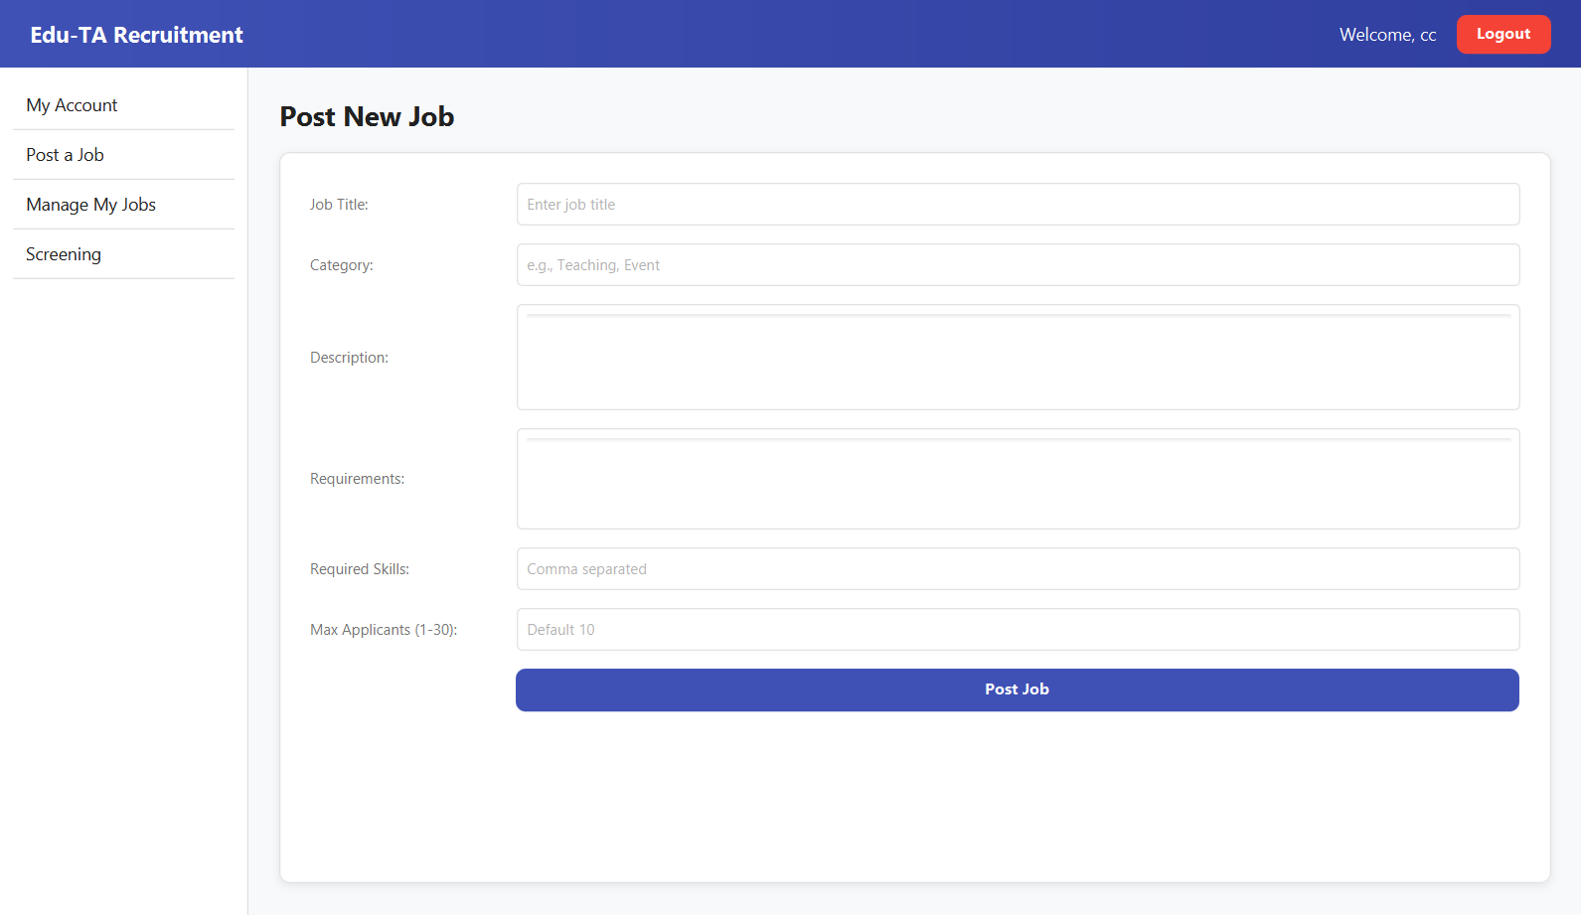Figure 8 Post a Job Page
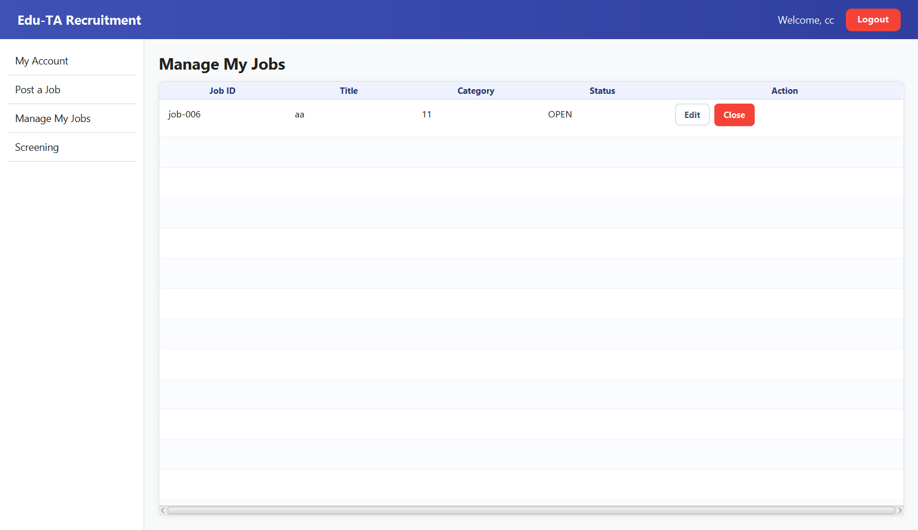Figure 9 Manage My Jobs Page
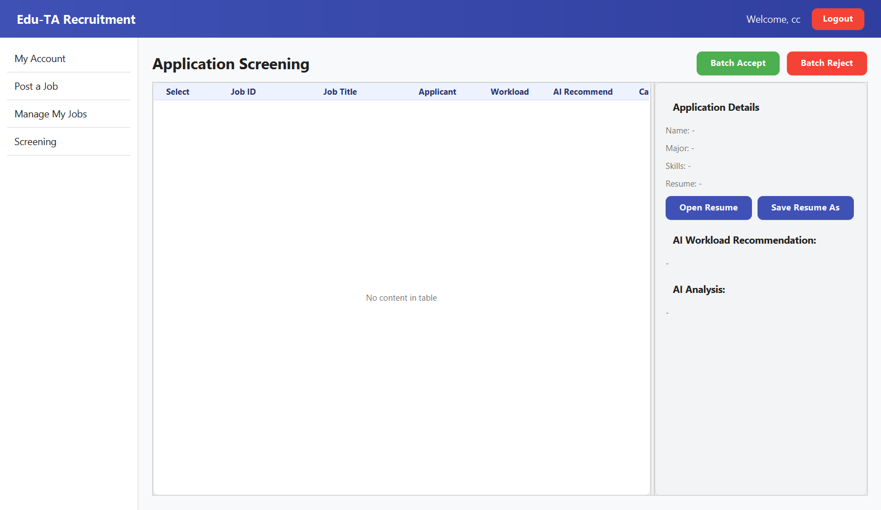Figure 10 Screening Page

6. Administrator Guide
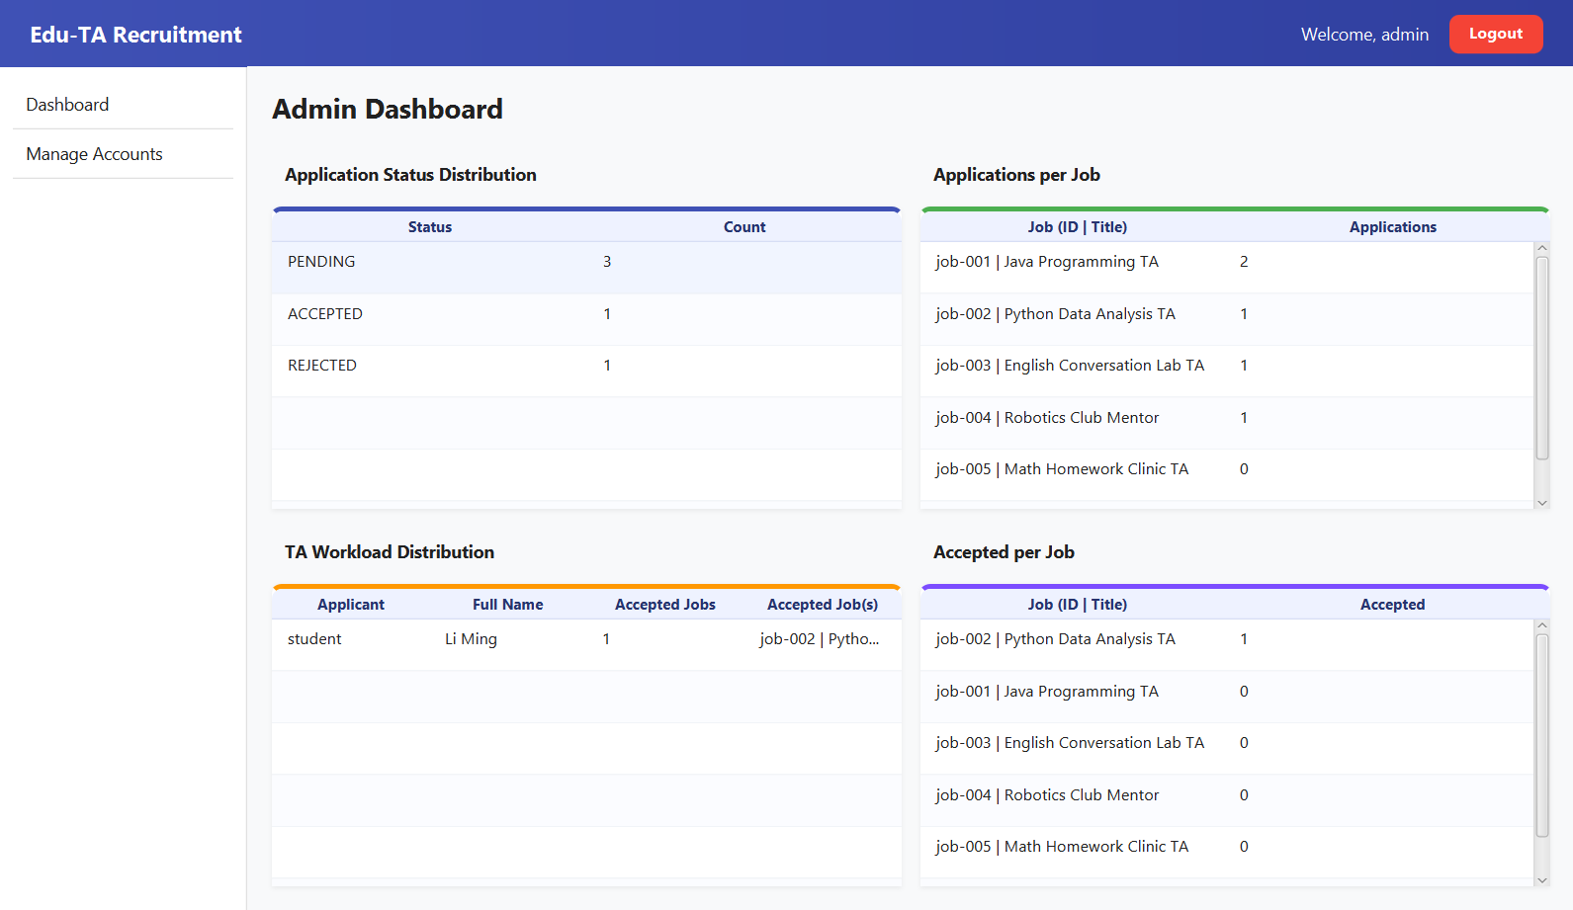Figure 11 Dashboard Page
Section | Description
Application Status Distribution | Shows counts for each application status.
Applications per Job | Shows the number of applications received by each job.
TA Workload Distribution | Shows accepted job counts and job lists for applicants.
Accepted per Job | Shows the accepted applicant count for each job.
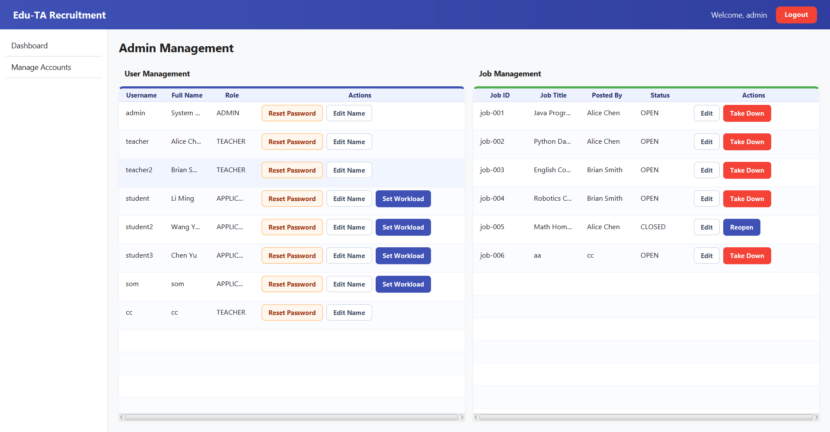Figure 12 Manage Accounts Page

7. Status and Rules
Status | Meaning | Available Actions
PENDING | Submitted and waiting for review. | Applicant can withdraw or update resume; teacher can accept or reject.
ACCEPTED | Application has been accepted. | Normally no further processing is required.
REJECTED | Application has been rejected. | Normally no further processing is required.
WITHDRAWN | Applicant has withdrawn the application. | No longer enters screening.

8. FAQ
• Login fails when username, password, or selected role is incorrect.
• Application may fail because of duplicate application, full job capacity, full workload, or missing resume file.
• Only PENDING applications can be withdrawn or updated.
• Teachers can only see applications for jobs they posted.
• Acceptance may fail because capacity, workload, account, or permission checks do not pass.

