**Date Submitted: 11/21/18**

**------------------------------------------------------------------------------------**

**Task 01 : Set up Project in SCS**

Youtube Link: N/A

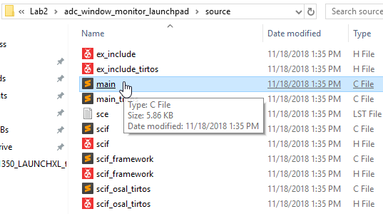

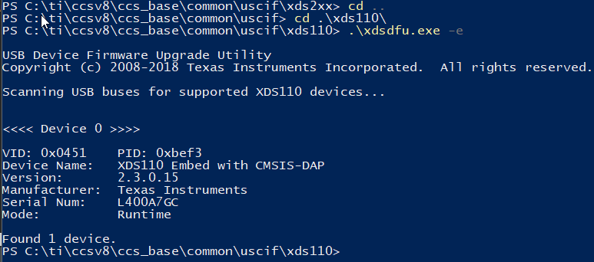

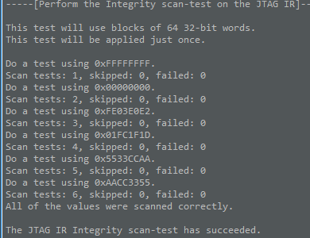 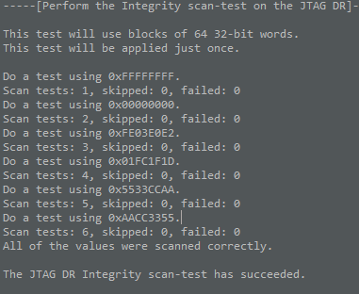

**------------------------------------------------------------------------------------**

**Task 02 : Download and Debug with CCS**

Youtube Link: N/A

**Pot full CCW**

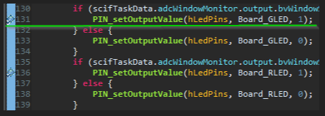

**Pot full Centered**

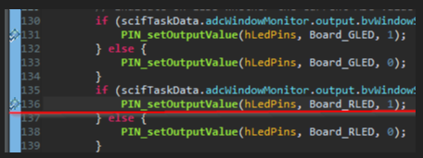

**Pot full CW no breaks**

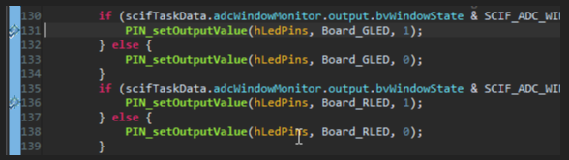

**------------------------------------------------------------------------------------**

**Task 03 : - Download and Debug with SCS**

Youtube Link: N/A

**Here from the break point you see that the adcValue is setting at 249, taking one step after adjusting the potentiometer, adcValue changes.**

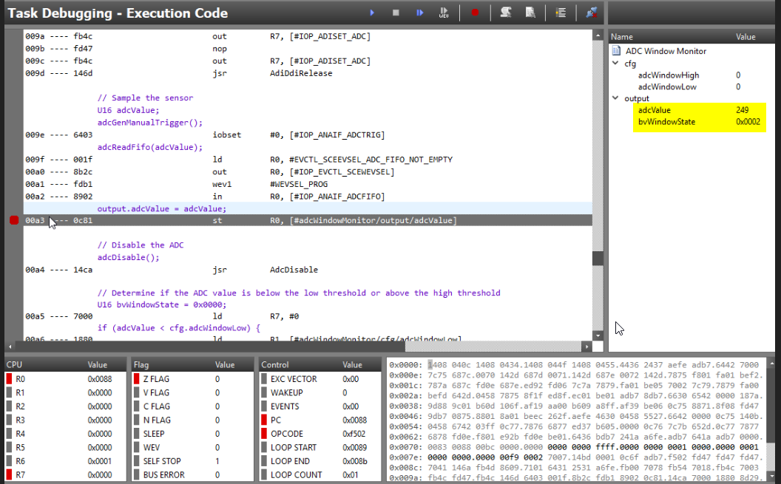

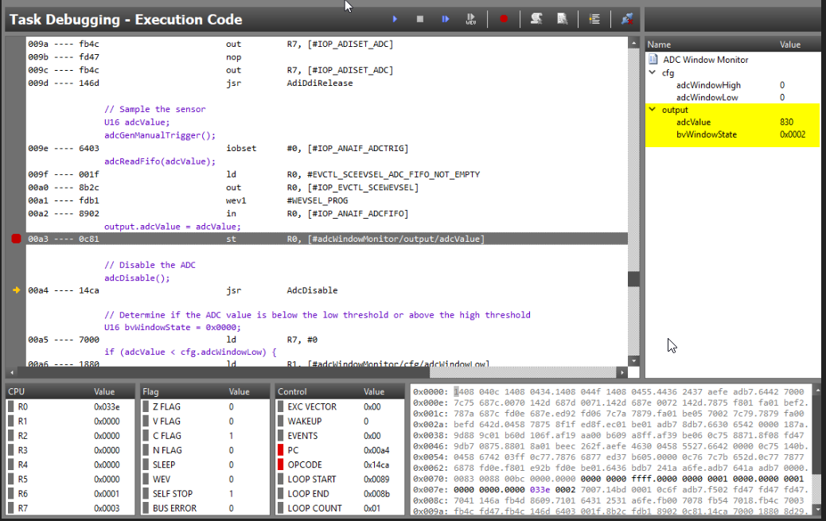

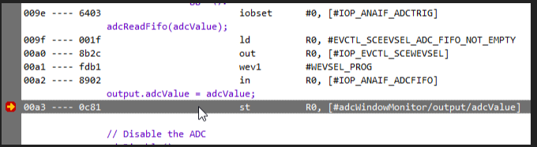

Here you can see the adcValue changing with changes in the potentiometer.

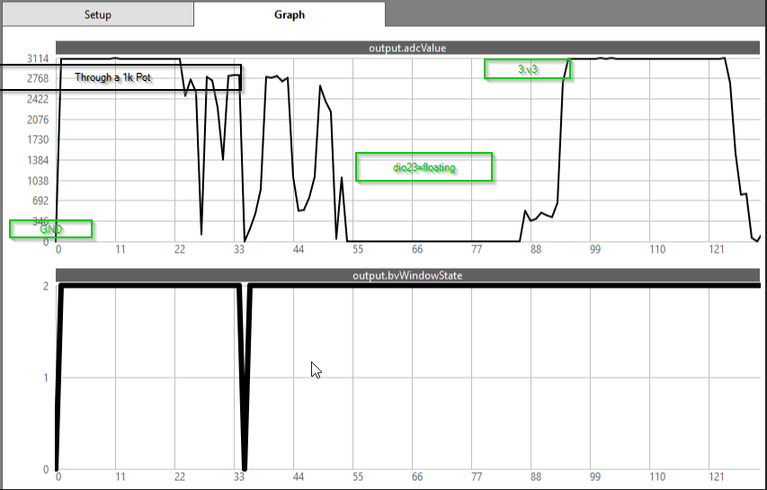

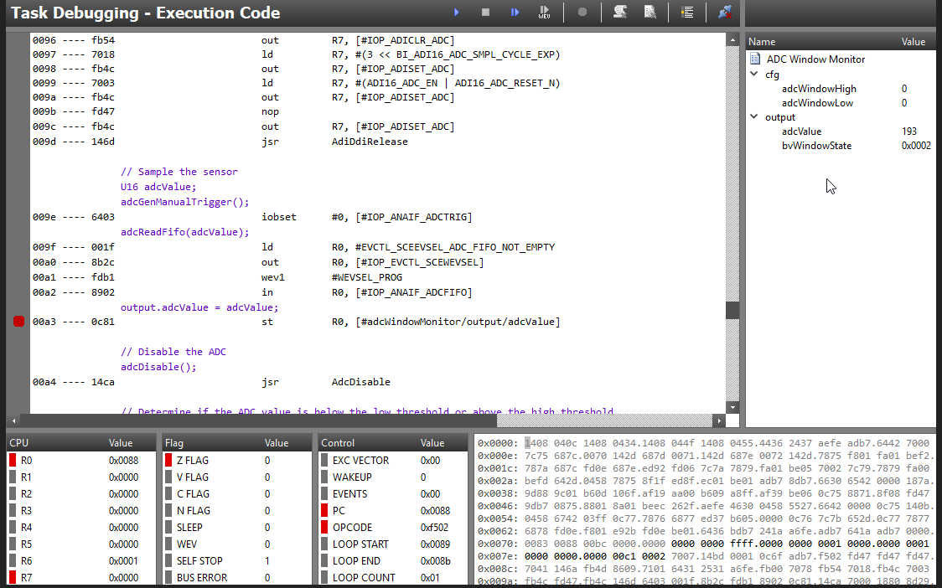

**------------------------------------------------------------------------------------**

**Task 04 : Understand**

Youtube Link:

**Modified Code:**

**------------------------------------------------------------------------------------**