**Date Submitted: 11/18/18**

**------------------------------------------------------------------------------------**

**Task 00 : Label your LaunchPads**

Nothing to show.

**------------------------------------------------------------------------------------**

**Task 01 : Building and loading the collector example**

Nothing to show. Just building projects from project explorer.

**------------------------------------------------------------------------------------**

**Task 02 : Building and loading the sensor example**

Nothing to show. Just building the sensor project.

**------------------------------------------------------------------------------------**

**Task 03 : Task 3: Using the Collector and Sensor**

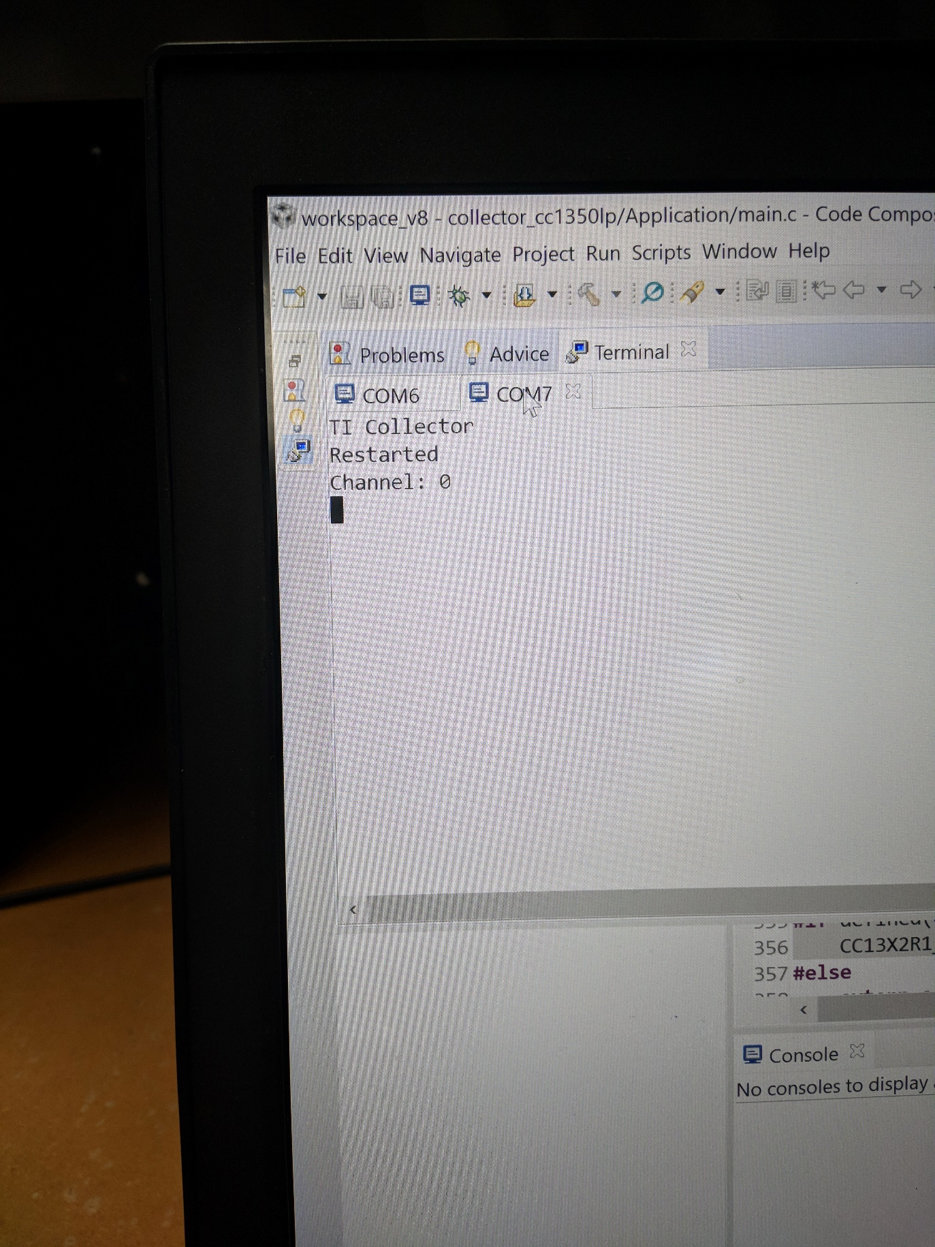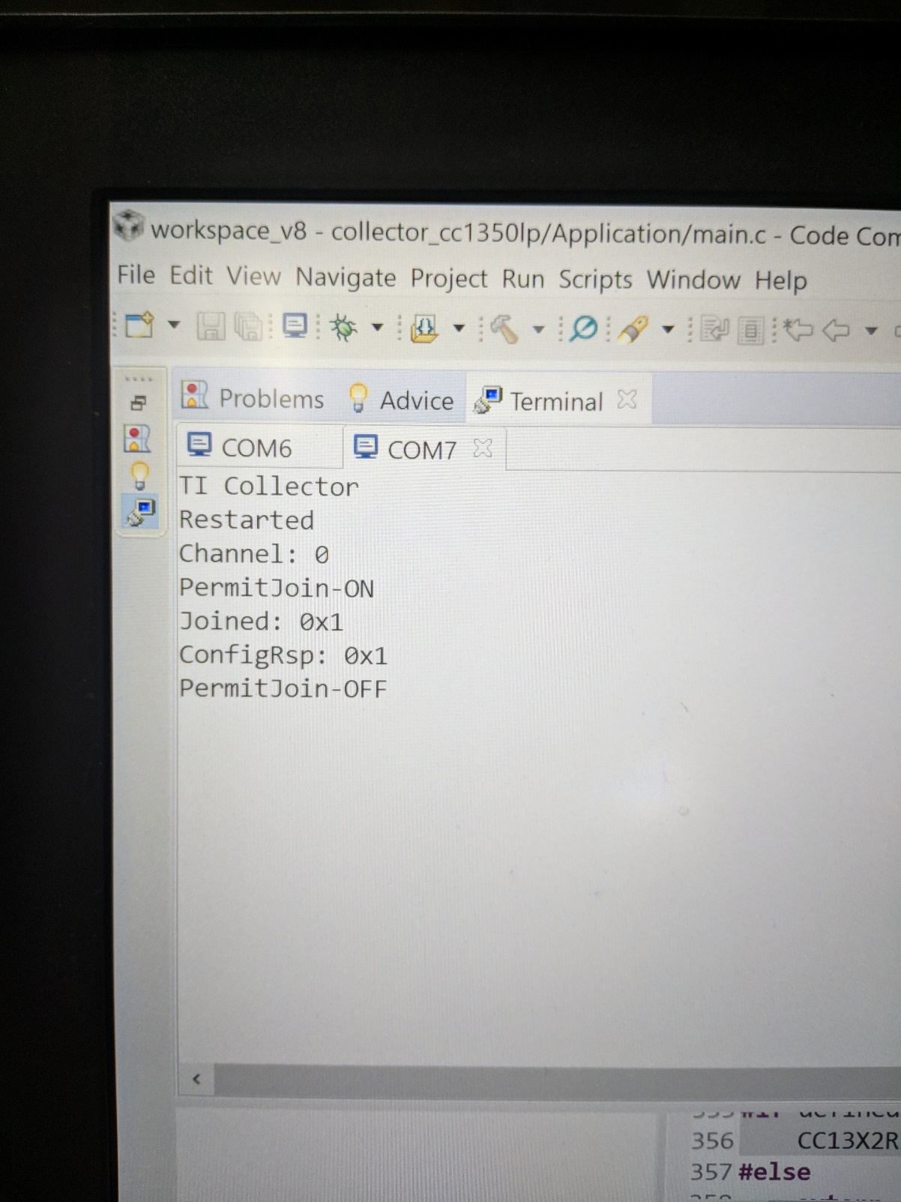

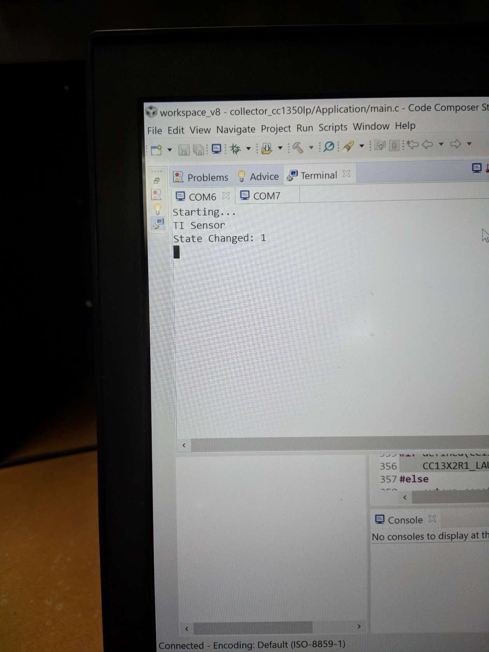

**------------------------------------------------------------------------------------**

**Task 04 : Updating the sensor's reporting rate**

Changed the config_reporting_interval from 180000 to 500 in the config.h file of the sensor project. Changed the config_reporting_intercal from 90000 to 1000 in the sensor project. Changed the config_polling_interval to 100 instead of 60000 in the collector project. Changed the min_polling_interval from 1000 to 100 in the sensor project.

**------------------------------------------------------------------------------------**

**We did not have the booster packs so this part of the lab was not possible to do.**

**------------------------------------------------------------------------------------**

**Task 00 : Label your LaunchPads**

**------------------------------------------------------------------------------------**

**Task 01 : Building and loading the portable app**

**------------------------------------------------------------------------------------**

**Task 02 : Combine the portable app with the TI 15.4-Stack app**

.

**------------------------------------------------------------------------------------**

**Task 03 : Using the Stack to send temperature from the portable app**