**Date Submitted: 11/18/18**

**------------------------------------------------------------------------------------**

**Task 00 : Getting started**

Youtube Link:

**Modified Code:**

**------------------------------------------------------------------------------------**

**Task 01 : - Update CC1350 LaunchPad firmware**

Youtube Link

**Modified Code:**

**------------------------------------------------------------------------------------**

**Task 02 : OAD download sub-1GHz firmware images**

Youtube Link

**Modified Code:**

**------------------------------------------------------------------------------------**

**Task 03 : - Running the sub-1GHz firmware images**

Youtube Link

**Modified Code:**

**------------------------------------------------------------------------------------**

**Task 01 : Importing the WSN Examples**

Nothing to show.

**------------------------------------------------------------------------------------**

**Task 02 : Putting it all to work**

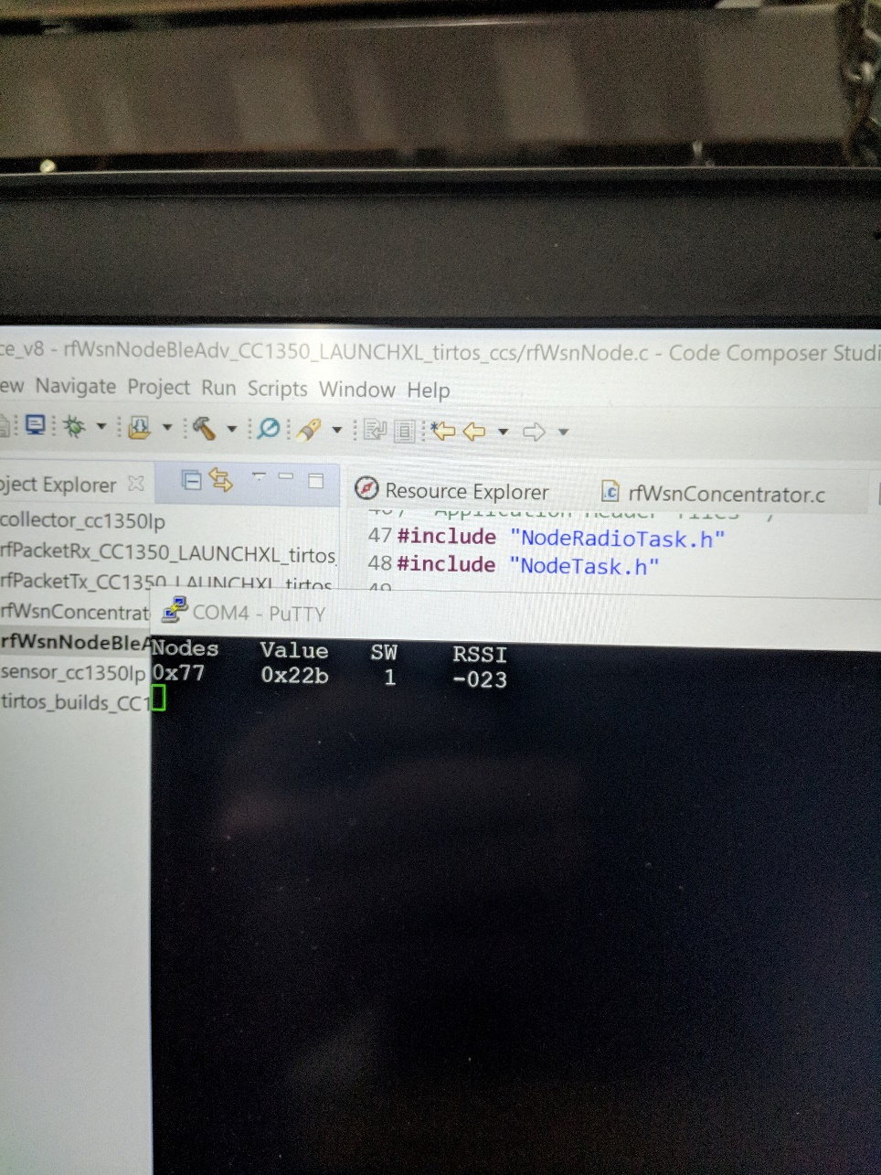

Value of SW is 1 when button is pressed.

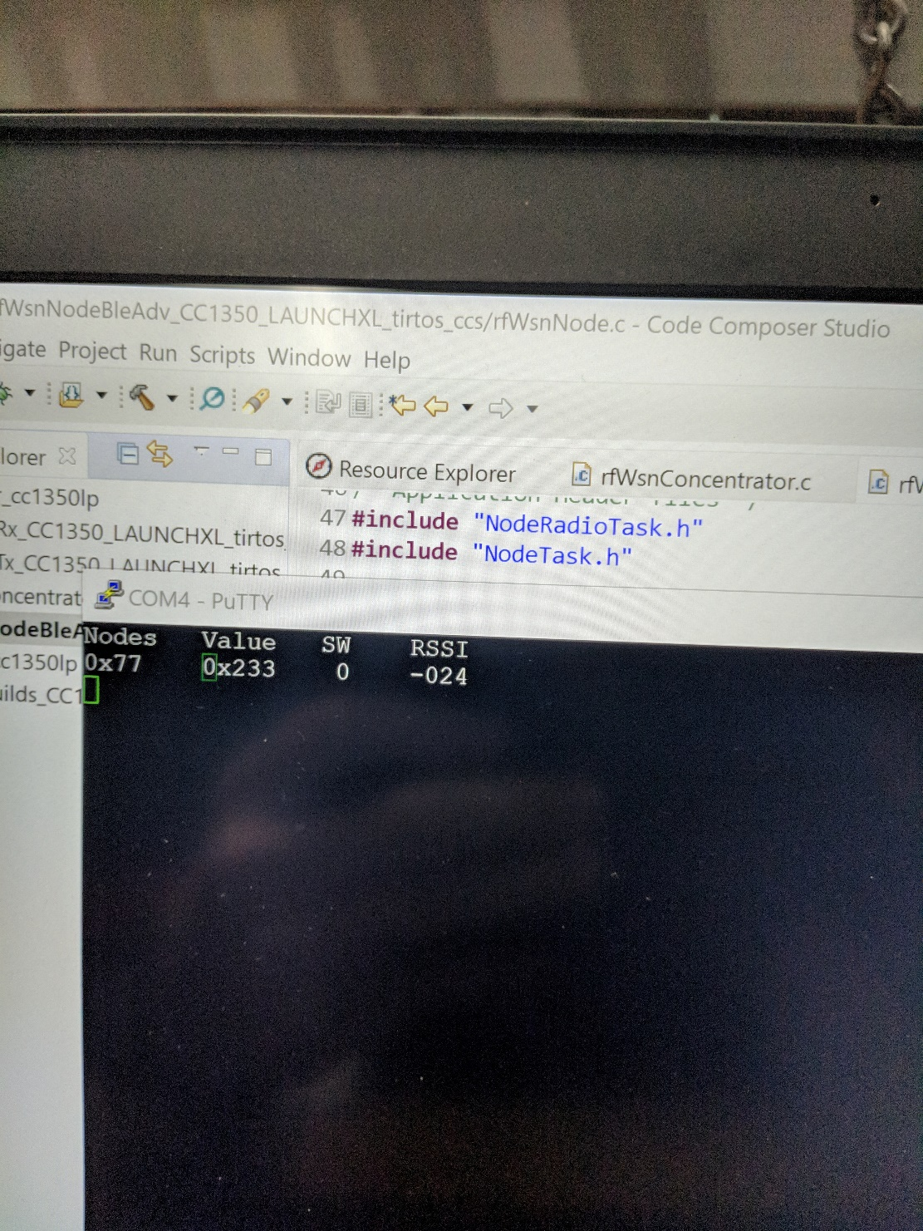

Value of SW is 0 when button is not pressed.

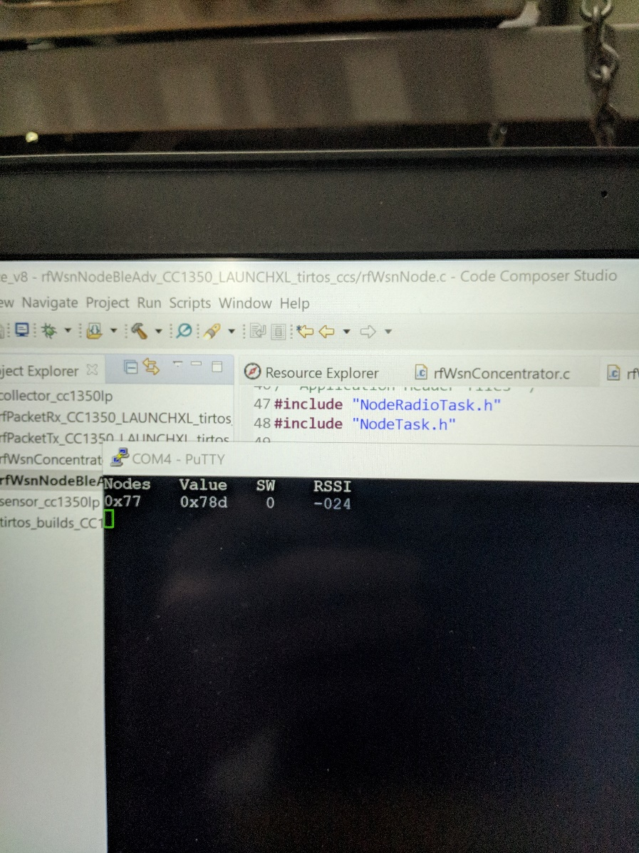

Value increased a lot when touching ADC pin.

**------------------------------------------------------------------------------------**

**Task 03 : Change RF Channel**

Changed RF channels to 915. Nothing to show.

**------------------------------------------------------------------------------------**

**Task 04 : Switch from 2-GFSK 50 kbps to Long Range Mode (LRM)**

Nothing to show. Just changed to long range mode.

**------------------------------------------------------------------------------------**

**Task 05 : Measure Power consumption on the node**

Youtube Link

**Modified Code:**

**------------------------------------------------------------------------------------**

**Task 06 : Modify Code Running on the Sensor Controller**

Youtube Link

**Modified Code:**

**------------------------------------------------------------------------------------**