Trace Stewart

CpE 403

12.11.2018

Linux Gateway zero (Final Project)

Problem Statement:

Goal: to implement a Weather Sensor Network (WSN) platform using the 2x TI CC1350 Launch Pads and a BeagleBoneBlack (BBB)

Objectives: Establish a gateway and collector application on BBB. Setup up CoProcessor on one CC1350. Use separate CC1350’s to collect ambient data. To ssh into BBB the FTDI interface was first used to determine the IP address of BBB.

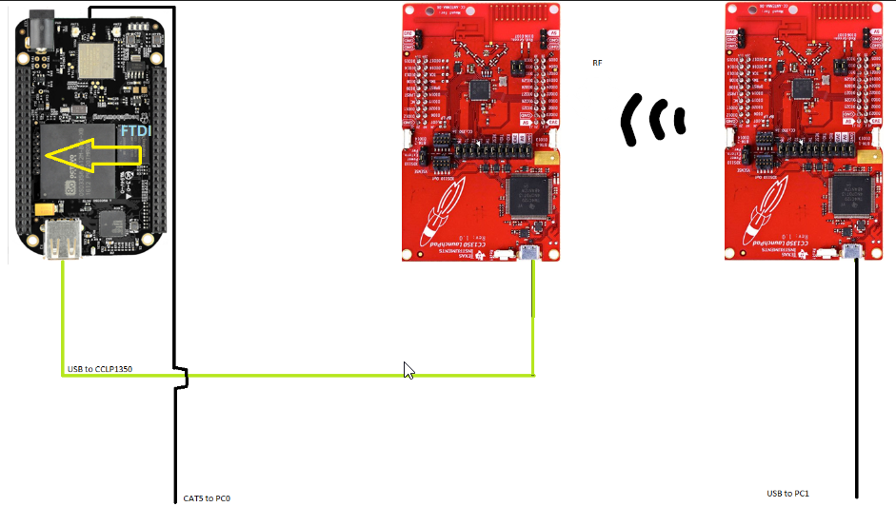PC1 just provided power

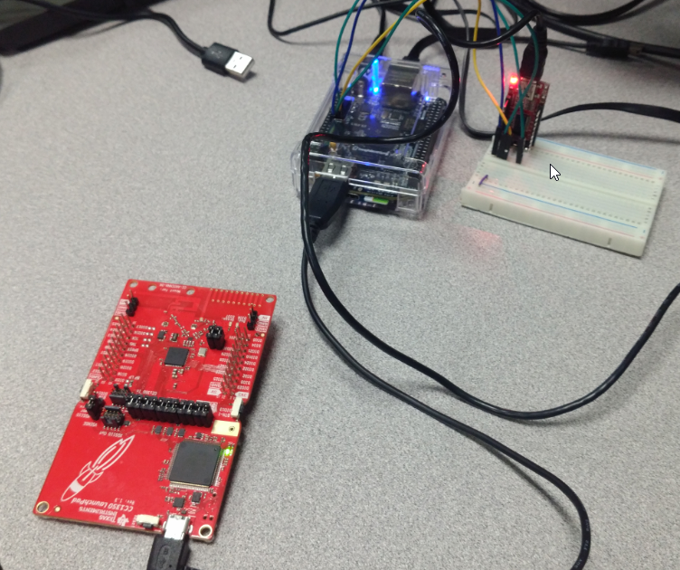Didn’t have the adapter that day

pre-requisites:

Components: 2x CC1350 Launch Pads, BBB, FTDI, jumper wires

Tools: needle nose pliers, Laptops, other misc accessories

Software: CCS8, VM, Ubuntu Linux, TI15.4 Stack SDK, TI UniFlash

implementation details:

1. Built collector/sensor programs on CCS, generated hex files
2. Used UniFlash to FLASH hex files into CC1350’s

Sensor

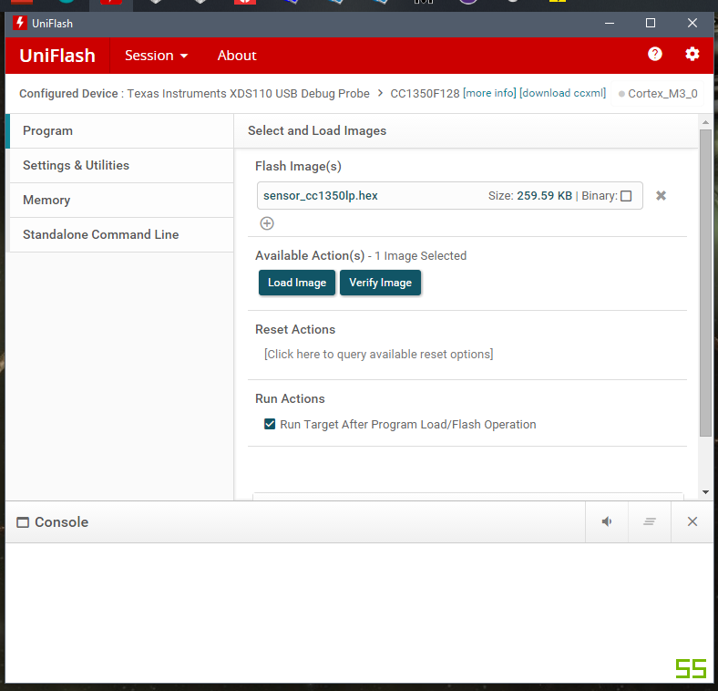 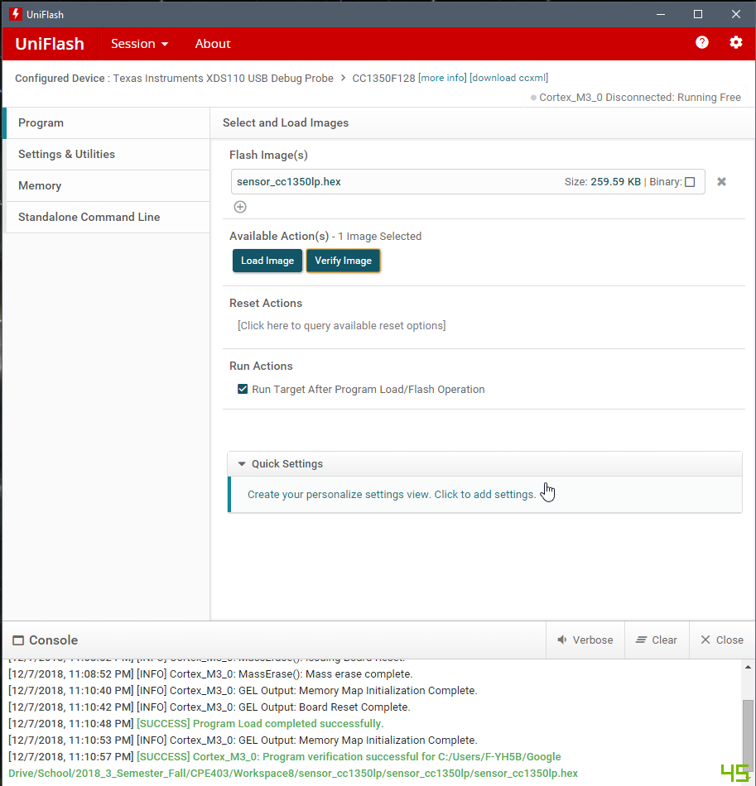



Collector

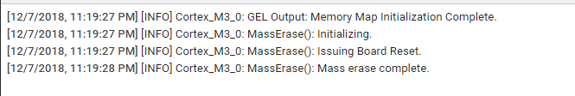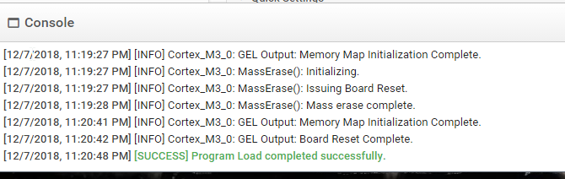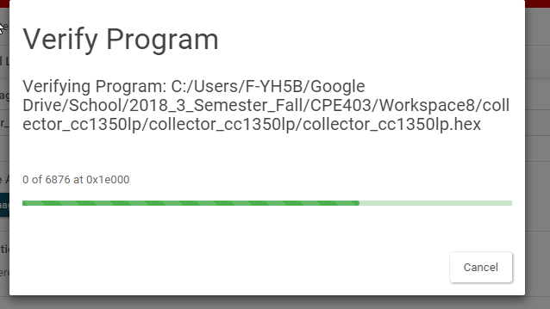\

1. Flashed TI 15.4 Stack SDK on to microSD card for BBB

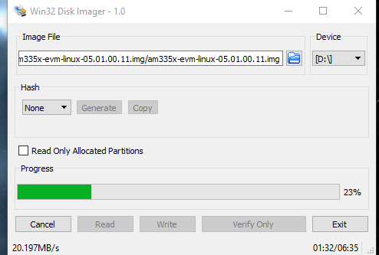

1. Interfaced with BBB using FTDI to obtain the IP address, then switched to ssh to run gateway and interfaced through Ethernet.

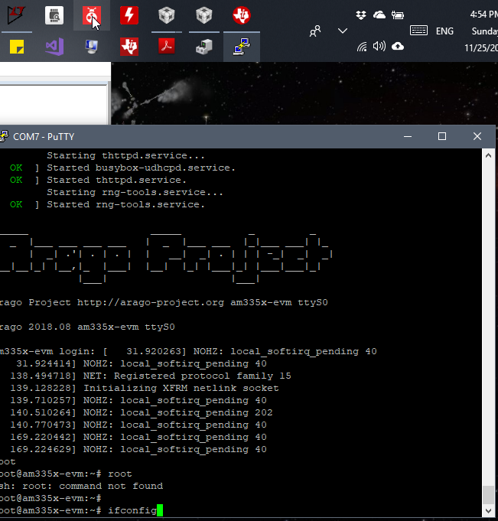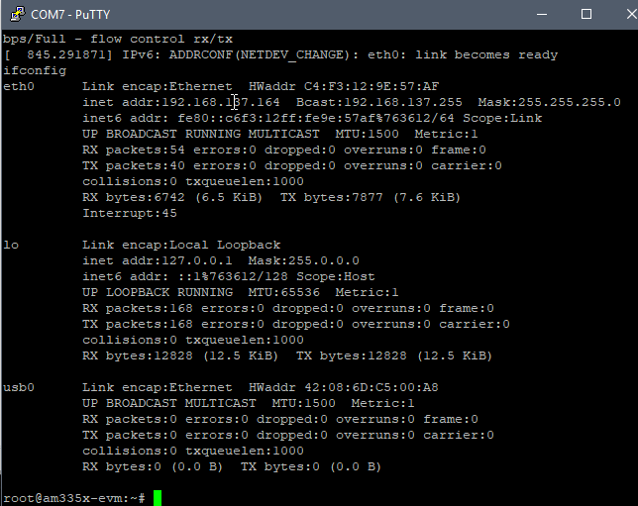

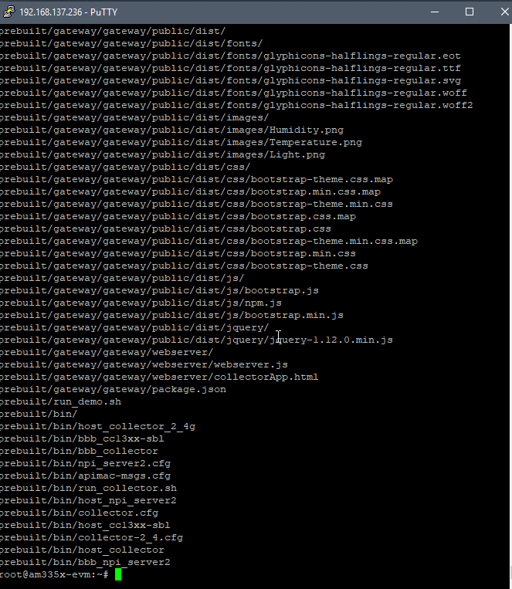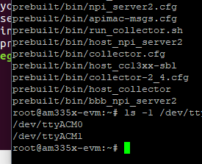

1. Ran gateway

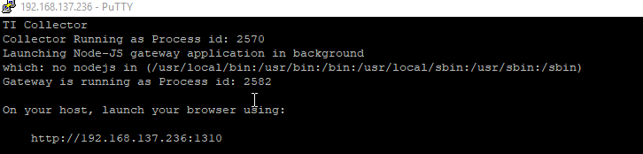

Given Hex files

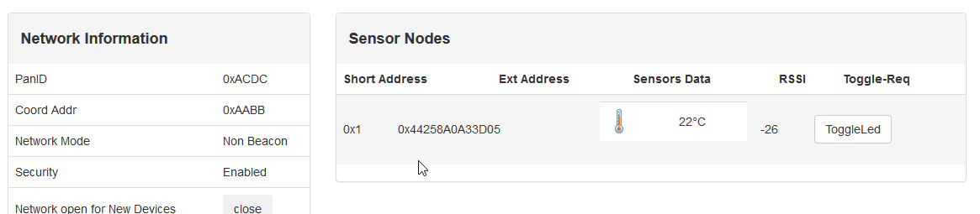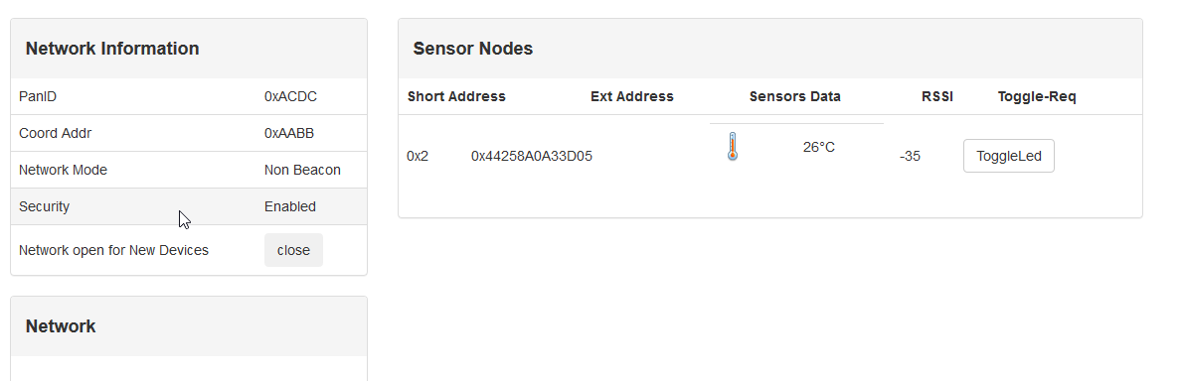

CCS Hex files

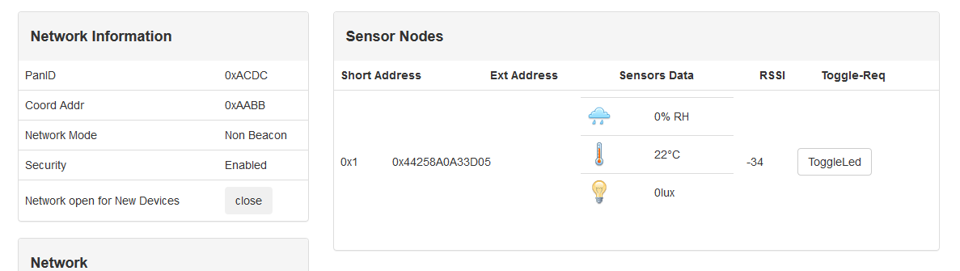

outcomes, results, and conclusions:

Only the temperature data is available from a CC1350 however, with the booster sensor pack you

the gateway is already set up to receive and display data for a humidity sensor and lux sensor. A way to get past this only using CC1350s would be to modify the function the reports the temp data. After flashing one device the code in this function could be modified to get information from the ADC input for another CC1350 presumably connected to another type of sensor it doesn’t necessary have to be a lux or humidity sensor however, the proper changes in the gateway would have to be made in that to make it know what type of data is being displayed.

**static** void readSensors(void)

{

#if defined(TEMP_SENSOR)

*/* Read the temp sensor values */*

tempSensor.ambienceTemp = Ssf_readTempSensor();

tempSensor.objectTemp = tempSensor.ambienceTemp;

#endif

}

|  | Sensors | Co-Processor | Gateway |
| --- | --- | --- | --- |
| Temp | CC1350 onboard | CC1350 | BBB |
| Humidity | N/A | CC1350 | BBB |
| Lux | N/A | CC1350 | BBB |

reference:

Google

StackOverflow

TI website and forum