**Date Submitted: 10/04/18**

**------------------------------------------------------------------------------------**

**Task 01:**

Youtube Link: https://www.youtube.com/watch?v=aKIMFpzEUNM

**Modified Code:**

**// Insert code here**

**int** **main**(**void**)

{

.

.

.

ui32Period = (**SysCtlClockGet**() / 6) // Changed Hz from 10 to 2

//ui32Period = (SysCtlClockGet() / 10) / 2;

.

}

**void** **Timer0IntHandler**(**void**)

{

**GPIOPinWrite**(GPIO_PORTF_BASE, GPIO_PIN_2, 4);

**SysCtlDelay**(5000000);

}

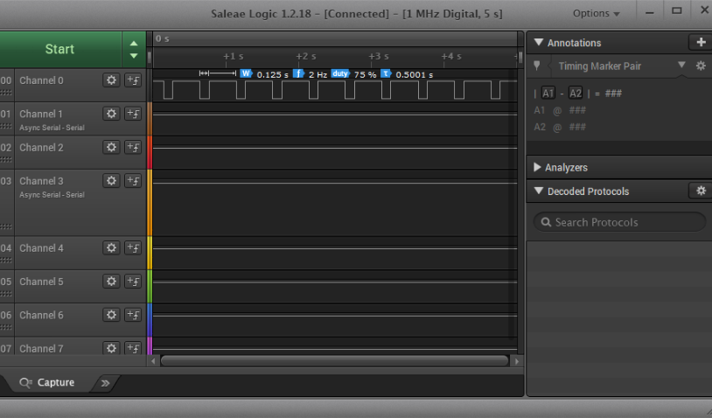

**------------------------------------------------------------------------------------**

**Task 02:**

Youtube Link: https://www.youtube.com/watch?v=bAh3QGPBISw

**Modified Code:**

**int** **main**(**void**)

{

uint32_t ui32Period, delay; // timer setup variables

**SysCtlClockSet**(SYSCTL_SYSDIV_5|SYSCTL_USE_PLL|SYSCTL_XTAL_16MHZ|SYSCTL_OSC_MAIN);

/* Switch and LED Interrupt SETUP */

**SysCtlPeripheralEnable**(SYSCTL_PERIPH_GPIOF);

// Unlock GPIO F pin 0 (PF0)

HWREG(GPIO_PORTF_BASE + GPIO_O_LOCK) = GPIO_LOCK_KEY;

HWREG(GPIO_PORTF_BASE + GPIO_O_CR) = 0x1;

// buttons and led GPIO setup

**GPIOPinTypeGPIOInput**(GPIO_PORTF_BASE, GPIO_PIN_0);

**GPIOPinTypeGPIOOutput**(GPIO_PORTF_BASE, GPIO_PIN_1|GPIO_PIN_2|GPIO_PIN_3);

// sets button interrupt to rising edge and enable interrupt

**GPIOIntTypeSet**(GPIO_PORTF_BASE, GPIO_INT_PIN_0, GPIO_RISING_EDGE);

**GPIOIntEnable**(GPIO_PORTF_BASE, GPIO_INT_PIN_0);

**IntEnable**(INT_GPIOF);

/* Timer 0 Interrupt SETUP */

**SysCtlPeripheralEnable**(SYSCTL_PERIPH_TIMER0);

**TimerConfigure**(TIMER0_BASE, TIMER_CFG_PERIODIC);

ui32Period = (**SysCtlClockGet**() / 6); Change for 2 Hz with 75% duty cycle

**TimerLoadSet**(TIMER0_BASE, TIMER_A, ui32Period-1);

**IntEnable**(INT_TIMER0A);

**TimerIntEnable**(TIMER0_BASE, TIMER_TIMA_TIMEOUT);

/* Timer 1 Interrupt SETUP */

**SysCtlPeripheralEnable**(SYSCTL_PERIPH_TIMER1);

**TimerConfigure**(TIMER1_BASE, TIMER_CFG_PERIODIC);

delay = **SysCtlClockGet**() * (3/2);

// multiply clock by 3/2 to get 1.5 second delay

**TimerLoadSet**(TIMER1_BASE, TIMER_A, delay-1);

**IntEnable**(INT_TIMER1A);

**TimerIntEnable**(TIMER1_BASE, TIMER_TIMA_TIMEOUT);

/* Enable master interrupt and start timer 0 */

**IntMasterEnable**();

**TimerEnable**(TIMER0_BASE, TIMER_A);

**while**(1)

{

}

}

**void** **Timer0IntHandler**(**void**)

{

// Clear the timer 0 interrupt

**TimerIntClear**(TIMER0_BASE, TIMER_TIMA_TIMEOUT);

**if**(**GPIOPinRead**(GPIO_PORTF_BASE, GPIO_PIN_2))

{

**GPIOPinWrite**(GPIO_PORTF_BASE, GPIO_PIN_1|GPIO_PIN_2|GPIO_PIN_3, 0);

}

**else**

{

**GPIOPinWrite**(GPIO_PORTF_BASE, GPIO_PIN_2, 4);

**SysCtlDelay**(5000000);

}

}

/* Added two interrupts/ISRs to handle LED turn on for 1.5 seconds: */

**void** **PortFPin0IntHandler**(**void**)

{

// Turn on LED

**GPIOPinWrite**(GPIO_PORTF_BASE, GPIO_PIN_1|GPIO_PIN_2|GPIO_PIN_3, 4);

// Clear the GPIO interrupt

**GPIOIntClear**(GPIO_PORTF_BASE, GPIO_INT_PIN_0);

// Disable Timer 0 interrupt

**TimerIntDisable**(TIMER0_BASE, TIMER_TIMA_TIMEOUT);

// Enable Timer 1 for LED's 1.5 second delay

**TimerEnable**(TIMER1_BASE, TIMER_A);

}

**void** **Timer1IntHandler**(**void**)

{

// Clear the timer 1 interrupt

**TimerIntClear**(TIMER1_BASE, TIMER_TIMA_TIMEOUT);

// Disable Timer 1

**TimerDisable**(TIMER1_BASE, TIMER_A);

// Re-enable Timer 0 Interrupt

**TimerIntEnable**(TIMER0_BASE, TIMER_TIMA_TIMEOUT);

}

**------------------------------------------------------------------------------------**