Malware Analysis Report – Zeus Banking Trojan

**Author**: Mihir Sathvara

**Date**: 06 September 2025

**Version:** 1.0

# Executive Summary

# This report documents the analysis of a Zeus Banking Trojan sample. Zeus is a well-known banking Trojan used to steal sensitive financial information by capturing keystrokes, performing form-grabbing in browsers, and injecting malicious code into banking websites.

# The analyzed sample masqueraded as a PDF but was actually an executable file. Analysis revealed its use of multiple Windows API calls for keylogging, file manipulation, and persistence. It also dropped a malicious DLL, attempted network communication with a known C2, and modified registry keys for startup persistence.

# Impact: Successful infection may result in credential theft, unauthorized access to banking applications, and long-term persistence inside corporate environments.

**Table of Contents**

1. Executive Summary
2. Fingerprint / Sample Information
3. Static Analysis
   * Suspicious API Calls
   * Suspected Function Calls
   * Libraries Used
   * CAPA Output
4. Dynamic Analysis
   * Process & Registry Activity
   * Suspicious Activity
   * Network Behavior
   * Dropped Files
5. Indicators of Compromise (IOCs)
6. YARA Rule
7. MITRE ATT&CK Mapping
8. Mitigation & Recommendations
9. References

# Fingerprint

| **Attribute** | **Value** |
| --- | --- |
| **File Name** | invoice_2318362983713_823931342io.pdf.exe |
| **File Type** | Windows Executable (PE) |
| **MD5** | ea039a854d20d7734c5add48f1a51c34 |
| **SHA-1** | 9615dca4c0e46b8a39de5428af7db060399230b2 |
| **SHA-256** | 69e966e730557fde8fd84317cdef1ece00a8bb3470c0b58f3231e170168af169 |

**VirusTotal Output:**

* 63/72 security vendors flagged this file as malicious.
* Detection names include: Trojan.Win32.ZAccess, Backdoor.Win32.Access, Win32:Malware-gen, Exe.trojan.zaccess, etc.
* See attached screenshot for full details.

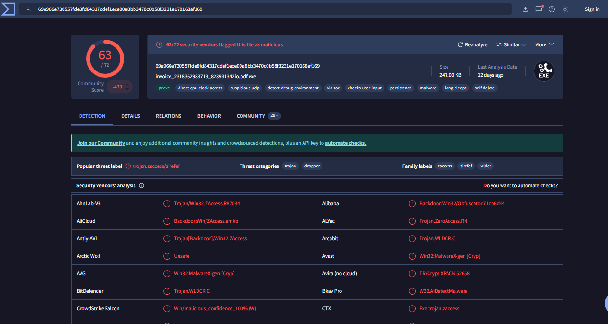

# Static Analysis

The sample is a 32-bit Windows executable (PE format).

PE header and file info:

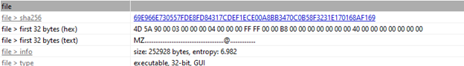

Suspicious API Calls (grouped):

**API Calls**

The malware leverages a wide range of Windows API calls, including but not limited to:

* AllowSetForegroundWindow, CallWindowProc, CreateFileMapping, DeleteCriticalSection, DestroyCursor, EnumClipboardFormats, FindNextFile, FlashWindowEx, FreeLibrary, GetAsyncKeyState, GetClipboardData, GetCurrentThread, GetEnvironmentVariable, HeapFree, IsBadReadPtr, LoadBitmap, LocalAlloc, PathAddExtension, PathCombine, PathMakeSystemFolder, PathMatchSpec, PathRemoveArgs, PathRenameExtension, VirtualQueryEx, VkKeyScan, WinExec, WriteFile, etc.

**Suspected Function Calls**

The following Windows API and function calls were observed or suspected during analysis. These are commonly leveraged by Zeus for persistence, data theft, and evasion:

* KERNEL32.SetCurrentDirectory
* KERNEL32.VirtualQuery
* USER32.CreateCaret
* KERNEL32.CreateFile
* SHLWAPI.PathRemoveFileSpec
* USER32.DestroyIcon
* USER32.SetDlgItemText
* SHLWAPI.PathMakeSystemFolder
* KERNEL32.FindFirstFile
* KERNEL32.GetWindowsDirectory
* KERNEL32.DeleteFile
* KERNEL32.GlobalHandle
* KERNEL32.WriteFile
* KERNEL32.GetAsyncKeyState
* KERNEL32.LoadLibraryA
* KERNEL32.GetProcAddress
* KERNEL32.GetModuleHandleA
* KERNEL32.GetEnvironmentVariableA
* KERNEL32.LocalAlloc
* KERNEL32.FreeLibrary
* KERNEL32.WinExec
* USER32.FlashWindowEx
* USER32.CallWindowProc
* USER32.EnumClipboardFormats
* USER32.GetClipboardData
* USER32.SetForegroundWindow
* SHLWAPI.PathAddExtension
* SHLWAPI.PathCombine
* SHLWAPI.PathMatchSpec
* SHLWAPI.PathRemoveArgs
* SHLWAPI.PathRenameExtension
* SHLWAPI.PathMakeSystemFolder
* SHLWAPI.PathMatchSpec
* SHLWAPI.PathCombine

**Libraries Used**

* SHLWAPI.dll
* KERNEL32.dll
* USER32.dll

**CAPA Output**

* The sample exhibits defense evasion, virtualization/sandbox evasion, and anti-behavioral analysis techniques.
* It checks for virtual machine environments and uses resources for anti-analysis.

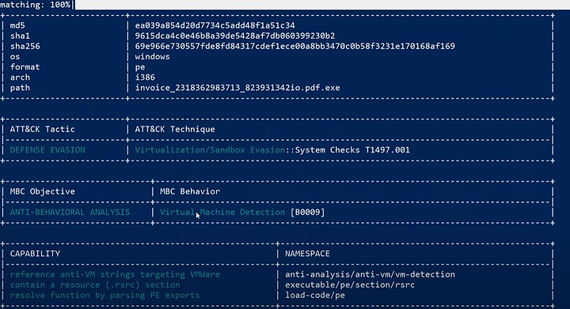

# Dynamic Analysis

# Process & Registry Activity

# The malware spawns child processes such as cmd.exe and conhost.exe for command execution.

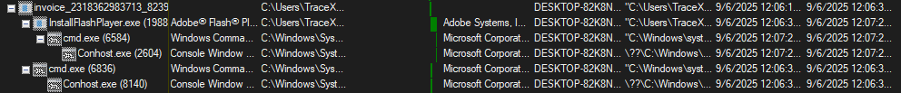

Some sort of commands run during execution, see attached image

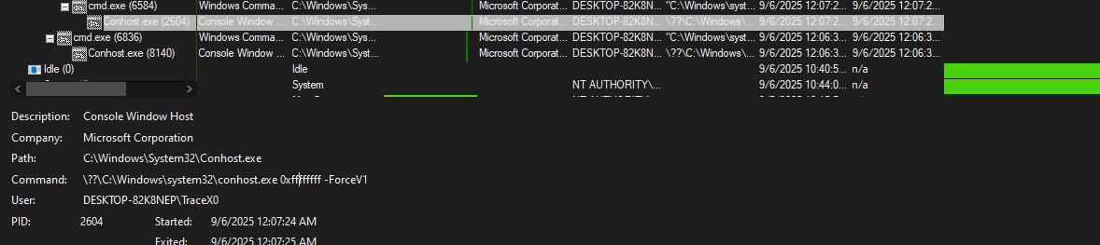

Registry modifications are made for persistence, especially in startup keys.

# Suspicious Activity

# A GoogleUpdate.exe process was observed, which may indicate masquerading or abuse of legitimate processes.

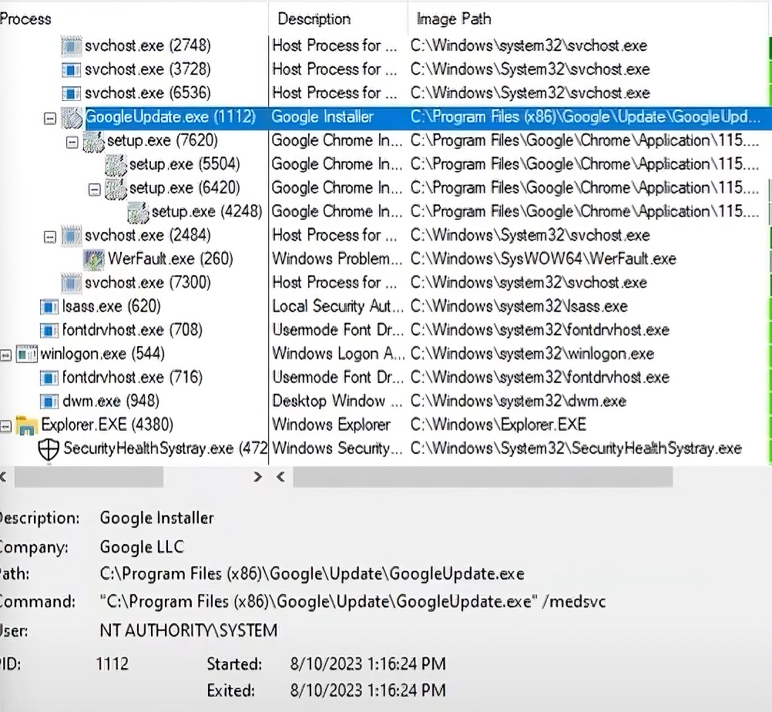

# Network Activity

# The malware attempts to download from fpdownload.macromedia.com using a fake Flash Player install request.

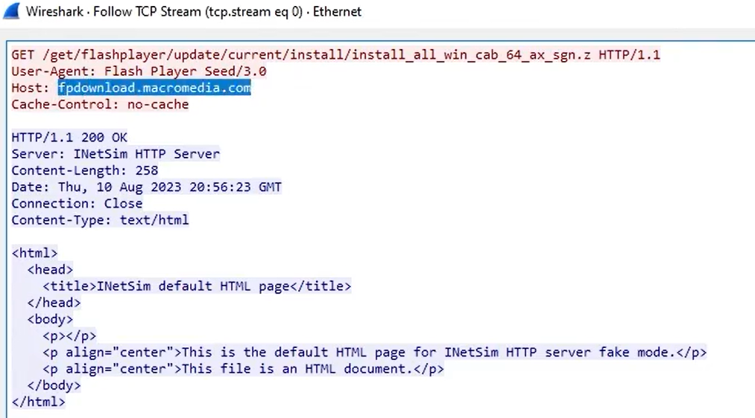

# Malicious DLL Discovery

# During execution, msimg32.dll was dropped and flagged as malicious by 61/72 security vendors.

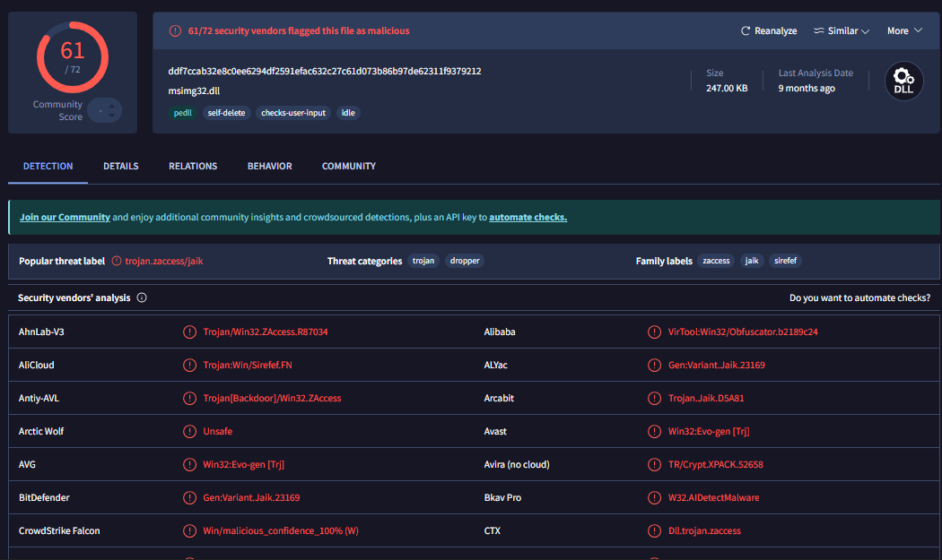

# Indicators of Compromise (IOCs)

# File hashes:

# MD5: ea039a854d20d7734c5add48f1a51c34

# SHA-1: 9615dca4c0e46b8a39de5428af7db060399230b2

# SHA-256: 69e966e730557fde8fd84317cdef1ece00a8bb3470c0b58f3231e170168af169File name: invoice_2318362983713_823931342io.pdf.exe

# Dropped DLL: msimg32.dll

# C2 URL: fpdownload[.]macromedia[.]com

**Suspicious domain found in PEInfo (role unconfirmed)::** corect[.]com

# Registry keys for persistence:

# HKCU\Software\Microsoft\Windows\CurrentVersion\Run

# HKCU\Software\Microsoft\Windows\CurrentVersion\RunOnce

# HKLM\Software\Microsoft\Windows\CurrentVersion\Run

# HKLM\Software\Microsoft\Windows\CurrentVersion\RunOnce

# HKLM\Software\Microsoft\Windows\CurrentVersion\RunOnce

# YARA Rule

rule ZeusBankingVersion_26Nov2013  
{  
 meta:  
 author = "Mihir Sathvara"  
 description = "A detection rule against ZeusBankingVersion_26Nov2013"  
  
 strings:  
 $file_name = "invoice_2318362983713_823931342io.pdf.exe" ascii  
 $function_name_KERNEL32_CreateFileA = "CellrotoCrudUntohighCols" ascii  
 $PE_magic_byte = "MZ"  
 $hex_string = {43 61 6D 65 56 61 6C 65 57 61 75 6C 65 72}  
  
 condition:  
 $PE_magic_byte at 0 and $file_name and $function_name_KERNEL32_CreateFileA or $hex_string  
}

**Result:**

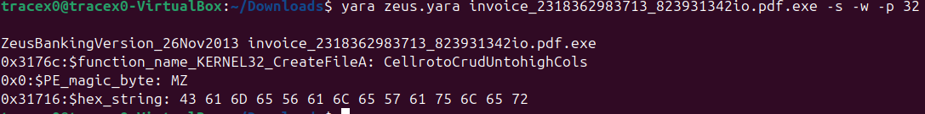

**MITRE ATT&CK Mapping**

This sample exhibits behaviors aligning with multiple MITRE ATT&CK tactics and techniques. The following table summarizes observed mappings.

| **Tactic (ATT&CK)** | **Technique ID** | **Technique Name** | **Evidence from Analysis** |
| --- | --- | --- | --- |
| **Persistence** | T1547.001 | Registry Run Keys / Startup Folder | Modifies HKCU\Software\Microsoft\Windows\CurrentVersion\Run |
| **Credential Access** | T1056.001 | Keylogging | Uses API GetAsyncKeyState for keylogging |
| **Defense Evasion** | T1497 | Virtualization/Sandbox Evasion | CAPA output showed VM/analysis evasion |
| **Execution** | T1204.002 | User Execution: Malicious File | Masqueraded as invoice.pdf.exe |
| **Command & Control (C2)** | T1071.001 | Application Layer Protocol: Web Traffic | Connects to fpdownload.macromedia[.]com |
| **Persistence / Defense Evasion** | T1036.005 | Masquerading: Match Legitimate Name | Spawned GoogleUpdate.exe as disguise |
| **Discovery** | T1082 | System Information Discovery | Uses Windows API calls to query environment variables |
| **Impact** | T1539 | Steal Web Session Cookie / Banking Injection | Zeus family known for form grabbing & injection (implied) |

Mitigation & Recommendations

- Deploy the above YARA rule for early detection of this malware family.  
- Monitor API calls associated with keylogging (e.g., GetAsyncKeyState, SetWindowsHookEx).  
- Restrict execution of suspicious files from email attachments and enforce strict attachment filtering.  
- Ensure EDR/AV solutions are updated to detect Zeus variants.  
- Educate users against opening suspicious email attachments disguised as invoices.

# References

- https://attack.mitre.org/ (for mapping tactics & techniques)  
- https://virustotal.com/