FLOWCHARTS
MAIN LOGIC

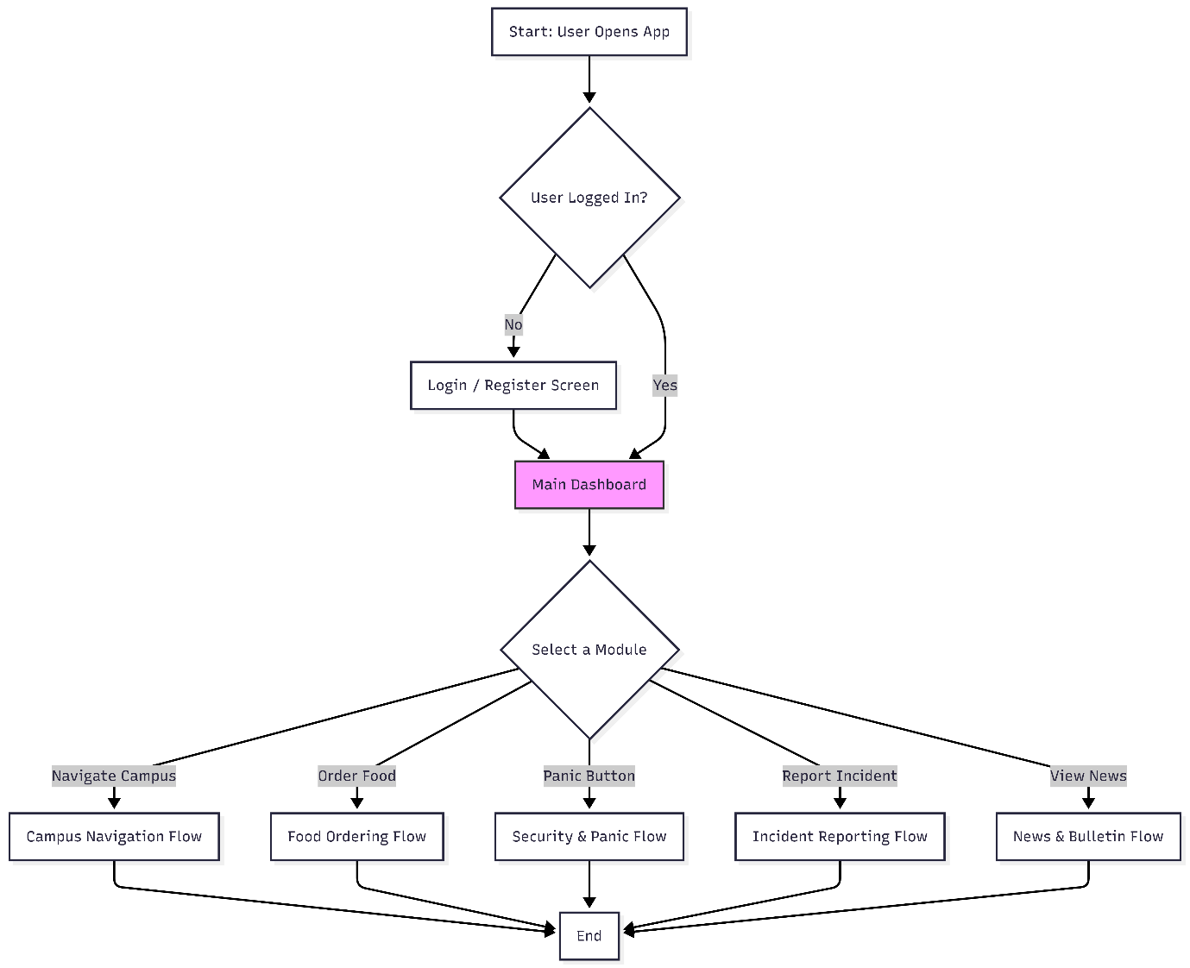
- The user opens the application and is prompted to log int if they aren’t already.
- From the main dashboard, they can choose any of the system’s core modules.
- Selecting a module takes them into that feature’s specific workflow.
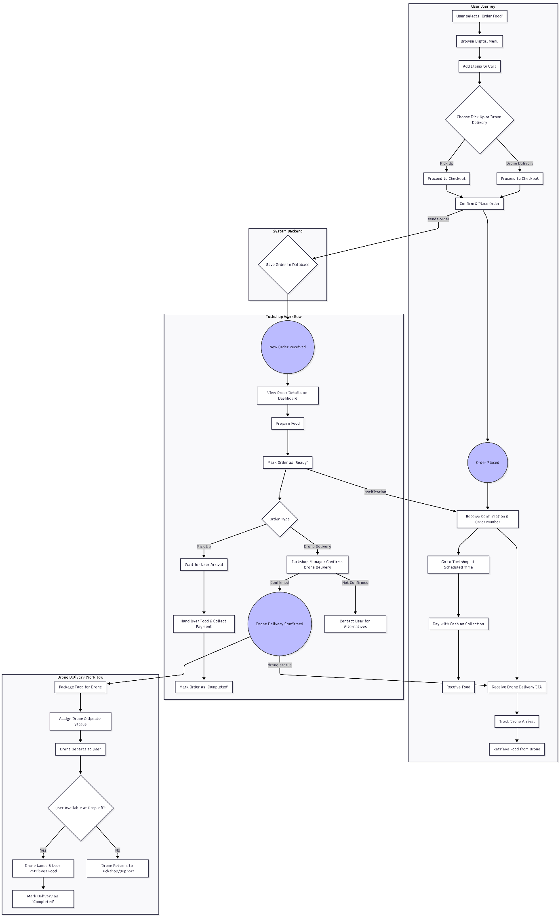
- User Journey: The student browses the menu, build their order, and schedules a pick time. A confirmation is sent to them.
- Tuckshop workflow: The tuckshop receives the order on their dashboard, prepares the meal, and marks it as ready. When the user arrives, they complete the transaction.
- System Backend: The system acts the intermediary, saving the order to the database, notifying the tuckshop of a new order, and notifying the user when their order is ready for pickup.

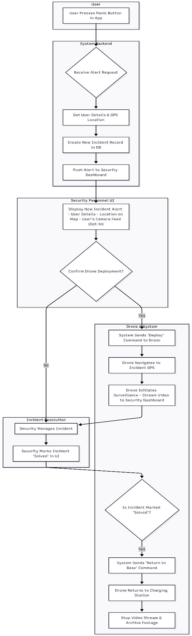 BC Alert
This method involves programming the room number directly into each button.
How it works: During the physical installation in a room, a technician uses a laptop, a special configuration tool, or a mobile app to connect to the button and save the room number (e.g., "101") into its internal memory. When pressed, the button sends this pre-configured room number in its alert message.
Pros:
- Simple Logic: The button itself knows its location; no database lookup is needed.
Cons:
- Inflexible: If a button is moved to a new room, it must be completely reprogrammed.
- Labour-Intensive: Can be slow and tedious to set up hundreds of rooms one by one.
Here are several enhancements to the system that add robustness, safety, and accountability:
1. User-Side "Accidental Press" Confirmation:
Enhancement: After the initial press, the user's app shows a 5-second countdown with a "Cancel" button. If not cancelled, the alert proceeds.
Justification: This significantly reduces false alarms caused by accidental button presses, ensuring that security and drone resources are only dispatched for genuine emergencies.
2. User-Side Live Camera Feed (Opt-In):
Enhancement: Upon alert confirmation, the user is prompted: "Share your phone's camera feed with security?". The feed would be shown on the security dashboard.
Justification: This provides immediate visual context to the security team before the drone arrives, allowing for faster and more accurate assessment of the situation's severity. It makes the user an active participant in their own safety.
3. Drone Pre-Flight Checks & No-Fly Zone Awareness:
Enhancement: Before deploying, the system checks the drone's battery level and the incident location against a pre-defined campus map of no-fly zones (e.g., near sensitive labs, indoor-only areas). If checks fail, security is notified that drone deployment is not possible.
Justification: Ensures operational safety and compliance. It prevents deploying a drone that cannot complete its mission and avoids flying into restricted or unsafe areas.

4. Two-Way Communication & Status Updates:
Enhancement: The user's app receives status updates: "Alert received by security," "Drone has been dispatched," and "Help is on the way." The app could also feature a text/voice link to the security dashboard.
Justification: Reduces panic and uncertainty for the person in distress. Knowing that their alert has been acknowledged and that help is coming can be critically reassuring.
5. "Lost Signal" Protocol:
Enhancement: If the drone loses its connection to the system, it is programmed to automatically return to its last known safe point or home base.
Justification: This is a critical safety feature to prevent a "rogue" or unresponsive drone. It ensures the asset is not lost and does not become a hazard.
BC Alert System: Pseudocode
// ACTORS: UserApp, SystemBackend, PrimarySecurityUI, OtherSecurityUI, DroneSystem
2
3 // -- Part 1: Incident Initiation & Escalation --
4 FUNCTION onPanicButtonPressed(user_id)
5 SystemBackend.handle_alert(user_id, GPS_location)
6 END FUNCTION
7
8 FUNCTION handle_alert(user_id, location)
9 user_details = Database.find_user(user_id)
10 new_incident = Database.create_incident(
11 user: user_details,
12 location: location,
13 status: "new",
14 timestamp: NOW(),
15 primary_security_acknowledged: FALSE
16 )
17
18 PrimarySecurityUI.display_new_alert(new_incident)
19
20 // Start a timer for primary security response
21 START_TIMER(5_minutes, incident_id: new_incident.id, onTimeout: escalate_alert)
22 END FUNCTION
23
24 FUNCTION escalate_alert(incident_id)
25 incident = Database.find_incident(incident_id)
26 IF incident.primary_security_acknowledged == FALSE THEN
27 // Trigger alarm on user's device
28 UserApp.sound_alarm(incident.user_id) // NEW
29
30 // Alert all other campus security
31 OtherSecurityUI.display_escalated_alert(incident) // NEW
32 END IF
33 END FUNCTION
34
35 // -- Part 2: Security UI and Decision (Primary) --
36 FUNCTION display_new_alert(incident)
37 UI.show(
38 title: "New Panic Alert!",
39 details: incident.user,
40 map_location: incident.location,
41 options: ["Deploy Drone", "Acknowledge Only"]
42 )
43 END FUNCTION
44
45 FUNCTION onPrimarySecurityAcknowledged(incident_id)
46 Database.update_incident_field(incident_id, "primary_security_acknowledged", TRUE)
47 STOP_TIMER(incident_id) // Stop the escalation timer
48 // Security now proceeds with managing the incident, potentially deploying drone
49 END FUNCTION
50
51 FUNCTION onDroneDeployButtonPressed(incident_id)
52 incident = Database.find_incident(incident_id)
53 DroneSystem.deploy_drone(incident.location, incident_id)
54 END FUNCTION
55
56 // -- Part 2.1: Security UI and Decision (Other Campus Security - NEW) --
57 FUNCTION display_escalated_alert(incident)
58 UI.show(
59 title: "ESCALATED PANIC ALERT!",
60 details: incident.user,
61 map_location: incident.location,
62 options: ["Acknowledge & Take Over"]
63 )
64 END FUNCTION
65
66 FUNCTION onOtherSecurityAcknowledged(incident_id, security_id)
67 Database.update_incident_field(incident_id, "responsible_security", security_id)
68 Database.update_incident_field(incident_id, "status", "escalated_acknowledged")
69 // Other security now manages the incident
70 END FUNCTION
71
72
73 // -- Part 3: Drone System Operation --
74 FUNCTION deploy_drone(target_location, incident_id)
75 drone = Drone.get_available_drone()
76 drone.set_mission(target_location)
77 drone.take_off()
78
79 WHILE drone.is_at(target_location) == FALSE:
80 WAIT(1_second)
81
82 drone.start_video_stream(to: SecurityUI, incident_id: incident_id)
83
84 WHILE Database.get_incident_status(incident_id) != "solved":
85 WAIT(5_seconds)
86
87 drone.stop_video_stream()
88 drone.return_to_base()
89 DroneSystem.archive_video_footage(incident_id)
90 END FUNCTION
91
92 // -- Part 4: Incident Resolution --
93 FUNCTION onIncidentSolvedButtonPressed(incident_id)
94 Database.update_incident_status(incident_id, "solved")
95 END FUNCTION

