XXXX report
Project Reference 23.0000.1 |Month DD, 20YY

BUILDING NAME
ADDRESS LINE 1
ADDRESS LINE 2
TSCC NO. ####

Table of Contents

1. Executive Summary 1
2. Introduction 1
3. Methodology 2
4. Observations 2
4.1 Parking Garage 2
4.1.1 General 2
4.1.2 Entrance Vestibules 2
4.2 Penthouse Levels 2
4.3 Ground Level 3
4.3.1 Tower 2 South 3
5. Analysis 3
5.1 Stack Effect 3
5.2 Wind Effect 3
6. Discussion 4
6.1 Stack Effect 4
7. Recommendations 4
7.1 Phase 1 : Immediate Measures 5
7.1.1 Stack Effect – Resolve Performance Audit Deficiencies 5
7.1.2 Stack Effect – Review Service Room and Ground Level Operating Practices 5
7.1.3 Wind Effect – Retrofit Targeted Garage Areas 5
7.2 Phase 2 : High Priority Measures 6
7.2.1 Detailed Stack Effect Investigation 6
7.2.2 Make-Up Air and Mechanical Pressurization 6
7.3 Phase 3: Further Investigation 6
7.3.1 Building Envelope 6
8. Limitations 8
9. Appendix 1 : Photographs A1-1

Executive Summary
Trace Consulting Group Ltd. (TCG) was retained to review and document conditions within the open garage structure to determine the effects of exposure to wind and precipitation on mechanical systems and equipment, particularly during the cold weather season. In addition, we reviewed the condition and arrangement of mechanical systems and equipment serving the complex to determine whether they may play a role in the transmission of stack effect pressures and air flow through the buildings.
Our investigation found numerous locations where wind and wind-driven precipitation conditions in the open garage structure resulted in hazardous accumulations of snow and ice on garage, affected the performance of the HVAC equipment located within it, and contributed to the failure of the door operators to close doors between the garage and the building.
Our report recommends the retrofit of windscreens or baffles in targeted locations to mitigate wind in the areas where it is having significant negative effects. This retrofit is intended to compliment ongoing efforts to achieve adequate door closing performance.
Our investigation also found that stack effect plays an important role in many of the airflow issues within the building itself, and makes recommendations for further measures if stack effect issues persist after wind mitigation measures are in place and building door closing is addressed.

Introduction
Trace Consulting Group Ltd. (TCG) was retained by ICC Property Management Inc., Agents for and on behalf of York Regional Condominium Corporation (YRCC) 1441, to investigate and make recommendations with regard to a number of issues with the mechanical and other systems of the Transit City 1 & 2 complex, which are believed to be related to the open parking garage structure and stack effect.
YRCC 1441, also known as Transit City 1 & 2, is a complex consisting of two (2) fifty-five storey high-rise buildings with total of approximately one thousand one hundred and ten (1,110) residential suites. Transit City 1 (North Tower) is located at 898 Portage Pkwy., and Transit City 2 (South Tower) is 5 Buttermill Ave. The towers are connected by an eight-storey parking garage structure above grade which is open to the elements. We understand that the parking structure consists of a mix of commercial (Ground – 5th) and residential (5th – 8th) levels. The complex is approximately one year old.
We understand that there have been ongoing issues in the two buildings regarding pressurization and the effects of wind and stack pressure since they were constructed. There are many symptoms of stack effect throughout the complex, such as doors being held open by airflow, cold and drafty areas due to unconditioned outdoor air being drawn into the building, and odour transfer from garbage rooms. Additionally, there are issues with wind and wind-driven precipitation within the garage itself, including snow and ice accretion on floors and HVAC equipment.
TCG staff conducted a site visit on March 15th, 2022 to review the site conditions. Our staff were accompanied by property management as well as the superintendents within both buildings.
Base building mechanical drawings prepared by ABLE Engineering dated May 24th, 2018, a wind pressure study prepared by GradientWind Engineering Inc. dated February 6th, 2018, and the buildings’ performance audit prepared by Building Sciences Inc. dated June 28th, 2021, were made available for us to review.
All comments in this report have been made from a visual review as well as available information, with no destructive examination or performance testing. No calculations were performed to validate the sufficiency of the base building design. Recommendations are our opinion.

Methodology
During the course of our review, TCG completed the following steps:
- Met with building management and the buildings’ HVAC service contractor to get a thorough understanding of the issues experienced;
- Reviewed available information including building drawings, performance audit, and wind pressure study; and
- Completed a site visit on a typical winter day to review mechanical systems, stack effects, and the existing conditions within the garage.

Observations

Parking Garage

General
The parking garage has eight (8) levels. It is open to the outdoors on all elevations, and is clad with a series of widely spaced angled decorative metal panels.

Entrance Vestibules
The garage is connected to each of the residential towers via vestibules on the 2nd through 8th storeys. Each of the interior and exterior vestibule doors is equipped with an automatic door operator and electric strike. It was generally noted that the closing force of the door operator was not sufficient to close the doors against the stack effect airflow through them.
In all cases observed during the course of the site visit, the vestibule doors were not latched because they were being held open by airflow despite the closing force exerted by the automatic door operators. Several cases of damaged or missing door strikes and hardware were noted, as well as several instances where the doors were open by an inch or more, or did not close under the force of the operator after the other door was fully shut to interrupt air flow through the vestibule.

Penthouse Levels
The towers each have a mechanical penthouse, which contains the chiller room, boiler room, diesel generator room, elevator machine room, and among other HVAC equipment, the high zone corridor air handling unit. There are also shafts, plenums, ducts, and louvres which connect the air handling equipment with outdoors and the buildings. The stairs are connected to the MPH level via a vestibule that separates the penthouse mechanical room from the roof.

Ground Level
Second level text for formatting purposes
This is a Typical 2nd Level Table | With a Second Column
Mechanical | Doesn’t always have to have bullets
Electrical | Sometimes just numbers
Fire Protection | $1,000,000.00
Building Envelope | 12345

Tower 2 South
Third level text for formatting purposes
This is a Typical 3rd Level Table | With a Second Column
Mechanical | Doesn’t always have to have bullets
Electrical | Sometimes just numbers
Fire Protection | $1,000,000.00
Building Envelope | 12345

Doors
This is random 4th level text for formatting purposes.
Typical 4th Level Table | With a Second Column
Mechanical | Doesn’t always have to have bullets
Electrical | Sometimes just numbers
Fire Protection | $1,000,000.00
Building Envelope | 12345

Automatic Doors
This building has two automatic sliding doors on either side of the main lobby vestibule, and a third sliding door between the main lobby and the elevator lobby. We understand that the third sliding door was previously a swing door, but was retrofit by the builder because of issues with closing. The main entrance doors appeared to be operating as intended. When either set of doors was closed, they appeared to provide an adequate barrier to the flow of air from the outdoors. However, it was observed that when all three doors are open, there significant stack-driven outdoor airflow into the building. The cold outdoor air mixes with the indoor air adjacent to the vestibule and results in cooler indoor air temperature in the lobby area
This is a Typical 5th level Table | With a Second Column
Mechanical | Doesn’t always have to have bullets
Electrical | Sometimes just numbers
Fire Protection | $1,000,000.00
Building Envelope | 12345
.

Analysis

Stack Effect
High-rise buildings have many vertical pathways for air to travel relatively unimpeded within them, such as stair shafts, elevator shafts, or garbage chutes. These pathways act like chimneys in which buoyancy-driven airflow exhausts a large amount of air up through them, hence the common name “Chimney Effect”.
Where there is an obstruction to the buoyancy-driven airflow, such as a door or the building envelope, the buoyancy force creates a pressure differential across the obstacle. The severity of the effects of the stack pressure varies widely even between buildings of roughly the same height under the same climactic conditions based on the effectiveness of the stack pressure controls.

Wind Effect
Wind also exerts pressures on building which, when oriented in a complementary direction, can further drive stack effect airflows. While these are not directly representative of the wind pressures that would act on, for example, the garage vestibule doors, the design net wind pressures provided in the Cladding Pressure Study provided for our review help to understand the magnitude of these pressures. Figure 18 on page 31 of this study indicates pressures in the 750-1,000 Pa range on the east and west elevations of the garage, and 1,250-2,000 Pa range on the north and south elevations. Differences between the elevations are due to the direction of the strongest winds relative to the orientation of the fins; elevations with lower pressures may instead experience wind acceleration under certain conditions.
We note that wind pressures are several times higher the stack pressure differential, which for these 55 storey buildings would be on the order of 325 Pa, and would certainly be expected to contribute to airflow through and around doors and other openings in the lower levels of the building. We further note that that strong wind effects act on the buildings year-round, rather than being limited to the coldest winter days.
In addition to sometimes magnifying stack effect air flows, as noted in the observations above, wind has a deleterious effect within the open garage structure and on the equipment it contains. These include, but are not limited to :
- Wind blowing directly on the equipment, in violation of the manufacturer’s installation instructions for the VRF outdoor units, which directs that they should not be installed in locations where “the unit will be exposed to direct, strong winds”. The building’s HVAC service contractor reported that the resulting accumulation of ice on the VRF outdoor unit coils reduces their heat transfer effectiveness directly, and furthermore requires more frequent defrost cycles which reduce the overall efficiency of this equipment, resulting in increased energy consumption.
- Wind-borne precipitation enters through the open metal panel cladding and accumulates on garage surfaces as both ice and snow, creating a slipping hazard for pedestrian and vehicular traffic. Large amounts of salt are needed to control this hazard, which results in damage to building interior floor finishes from salt being tracked in, and an increase risk of damage to the garage itself.

Discussion

Stack Effect
Well-designed and constructed buildings are built with many barriers to stack-driven airflow, such as doors, dampers, and the building envelope itself. While there are always openings and gaps which permit small amounts of air to pass, and indeed vents and other systems which deliberately permit a measured airflow, the barriers are intended to work together as a system, along with mechanical pressurization of certain areas by the building’s HVAC equipment, to reduce the effects stack-driven pressure and air flow. Closures at the top and the bottom of the building work in concert with each other: when less air flows into the bottom of the building, this also lessens the flow of air out the top.

Recommendations
We have phased our recommendations for a corrective action in an effort to address stack effect issues in a timely and cost-effective way. We prioritize mitigation strategies which can be quickly and easily implemented at relatively low cost, as well as those most likely to result significant improvement, before moving onto more expensive and invasive measures. We recommend that for all phases a consulting mechanical engineering firm, such as TCG, be retained to review the corrective actions and provide design and technical guidance as required.
Phase 1 are actions which we believe will provide the greatest impact, can be executed quickly, and have minimal cost. These measures could be put into place, and their effect verified, within a trial period of a day or two.
Phase 2 measures are also expected to offer significant improvement of the stack effect issues experienced by the building, but require more extensive design, more intensive implementation effort, or are higher cost than Phase 1 items.
Phase 3 items are the most complicated and expensive measures or are lower priority because of lesser expected benefit. Phase 3 items should be explored only after the higher priority (Phase 1 and 2) measures are complete and an assessment of their impact has been undertaken.

Phase 1 : Immediate Measures

Stack Effect – Resolve Performance Audit Deficiencies
Many of the straightforward measures which would normally be recommended to be addressed immediately, such as inadequate closing force and damaged hardware on the garage vestibule doors, or insufficient / missing weatherstripping, have been captured in the buildings’ performance audit. As these items should be addressed by the developer at their expense, it is recommended to pursue this course of action wherever possible, in an effort to reduce the number (and cost) of deficiencies which require to be addressed.
Review of corrective actions related the performance audit items should take into account stack pressure, for example ensuring that vestibule doors are closing under stack pressure conditions and high-performance weatherstripping is installed which is rated to withstand the pressure generated by the stack effect. Therefore, in addition to the professional team which conducts the 2nd Year Warranty Audit, the Board should consider retaining a consulting mechanical engineering firm to provide specialist review and direction with regard to deficiencies which result in pathways for stack effect airflow.

Stack Effect – Review Service Room and Ground Level Operating Practices
Especially during the winter months, doors and dampers between service rooms and the outdoors should be fully closed as much as, and wherever, possible. This is especially true for service rooms which are connected to both the building exterior as well as a vertical shaft (elevator, stair, waste chute) which runs up through the building. Doors which are frequently open, such as vestibules, as well as those which are regularly held open such as moving room and compactor doors should be reviewed, and procedures established minimize the amount of time they are held open during winter months.

Wind Effect – Retrofit Targeted Garage Areas
It is clear from conditions observed during the site visit that wind conditions in the open garage structure have a significant deleterious effect on the HVAC equipment located within, and result in hazardous accumulations of wind-driven precipitation in certain areas. We recommend that a consulting mechanical engineering firm should be retained to provide a design to retrofit windscreens or baffles to mitigate wind in the areas where it is having significant negative effects.
The intent of this design would not be to fully enclose the garage, but to provide a targeted installation to address issues at and around the building entrances and with VRF unit performance.

Phase 2 : High Priority Measures
If Phase 1 measures do not provide sufficient improvement to achieve the ultimate goals of proper closing of the vestibule doors and reduced odour transfer in the high-rise towers, and reduced wind-driven airflow and infiltration of precipitation into the garage, additional measures are warranted.

Detailed Stack Effect Investigation
If Phase 1 improvements do not sufficiently address symptoms of stack-driven airflow in one or both buildings, a more intensive investigation into the pathways for stack effect may be warranted. TCG would work with contractors to conduct a review of the spaces where stack effect airflow is suspected to occur, and make recommendations for corrective action which may require modification or upgrades to mechanical systems and equipment, to building components such as door closers, thresholds, and weatherstripping, as well as.

Make-Up Air and Mechanical Pressurization
In conjunction with the intensive stack effect investigation, an in-depth review of make-up air system performance and its role in pressurizing key areas of the building should be considered.
This investigation would first review the actual as-built layout of the make-up air handling system, which would then be re-commissioned, including air balancing and functional performance testing of the control system.
Once baseline performance of the make-up air system is established, TCG would work with an air balancing contractor to identify areas which would benefit from additional mechanical pressurization to help mitigate stack effect pressure, and make recommendations for retrofit to achieve this pressurization.

Phase 3: Further Investigation
If Phase 1 and 2 do not provide the required improvement, additional investigation is warranted to identify and address the active paths for stack-driven air flow.

Building Envelope
Although many of the recommendations touch on other building elements, the intended focus of this investigation and report were the mechanical systems of the Transit City complex.
The building envelope itself represents the largest barrier between outdoor and indoor areas and plays arguably the most significant role in the stack effect overall in high-rise buildings. TCG would work in conjunction with a specialist building science firm to determine whether there are specific building envelope issues which make a significant contribution to the stack effect in the residential towers.
If wind effects within the garage persist after the Phase 1 retrofit, TCG would also work in conjunction with the building science specialists to develop further recommendations with regard to mechanical and building systems to permanently resolve these issues.
We trust the above is satisfactory. Should you have further questions please do not hesitate to contact the undersigned.
Trace Consulting Group Ltd.
Report by:
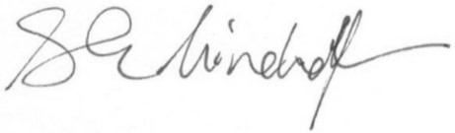
Sarah Hinchcliffe, P.Eng.
Associate Director – Mechanical Engineering

Reviewed by: | Reviewed by:  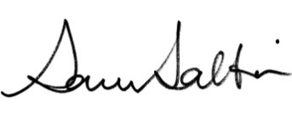
Sarah Hinchcliffe, P.Eng.  Associate Director – Mechanical Engineering | Sam Soltani, P.Eng. LEED®AP  President

Limitations
- This report reflects our best professional assessment and opinion based on our visual inspection of the above property only. There is no expressed or implied warranty or a compliance with past or present regulations.
- This report is only for the Mechanical and Electrical systems and does not reflect on any other systems, structures or items other than those described in the report.
- This report is meant to be used in its entirety. Any use by a third party, or any reliance on or decisions to be made based on this letter, is the responsibility of said third party.
- This report does not eliminate uncertainties regarding the potential costs for the present and in the future.
- No physical testing has been performed.
- No design calculations have been performed.
- TCG does not accept any responsibility for any decisions made or actions taken as a result of this report unless we are specifically advised of and participate in such action, in which case our responsibility will not exceed our fees paid for professional services.
- This site report is valid only for that work which was specifically requested and is subject to review should additional information become available.
- TCG is not responsible for any views or opinions expressed by employees performing the site review.
- TCG will not be responsible for deviation within the normal limits of accuracy in accordance with standard practices.

Appendix 1 : Photographs
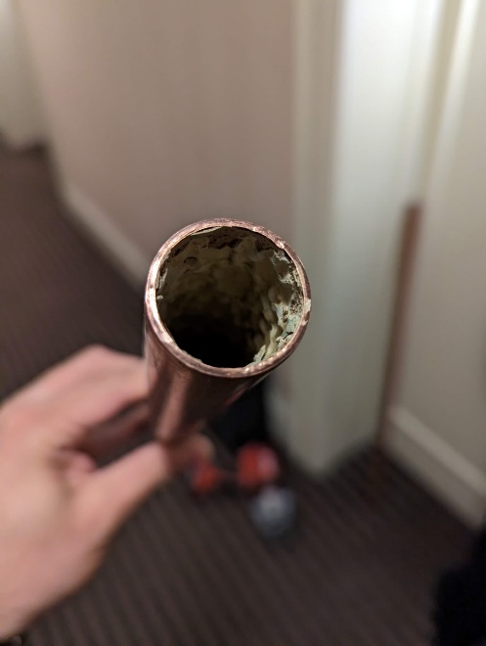 | 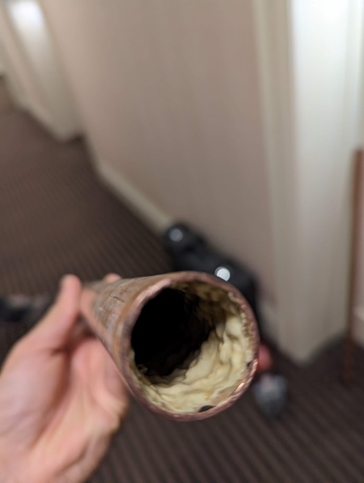
Figure 1: Suite 502 piping sample with epoxy coating within. | Figure 2: Suite 502 Piping Sample with epoxy coating within.
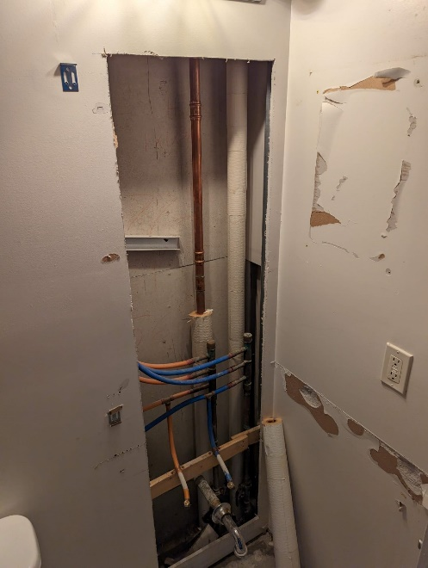 | 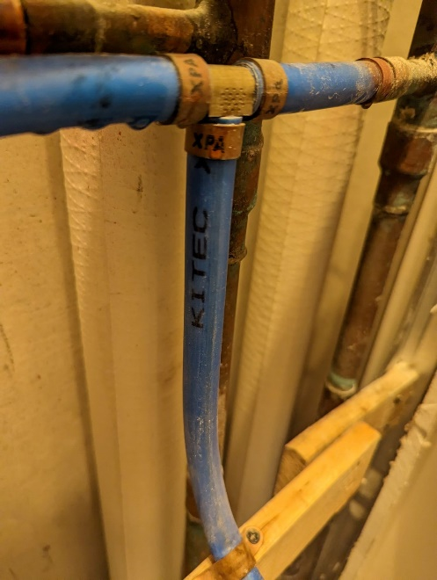
Figure 3: Suite 502 with Kitec® in-suite distribution piping. | Figure 4: Kitec® markings within piping in suite 502.

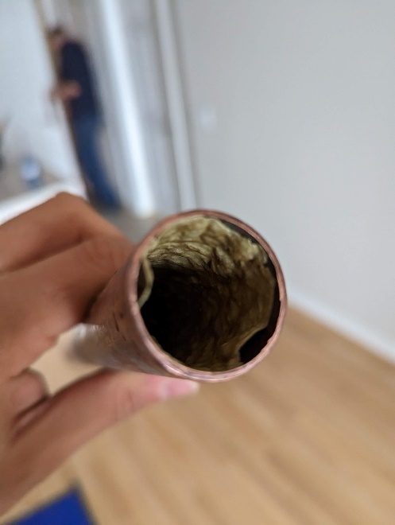 | 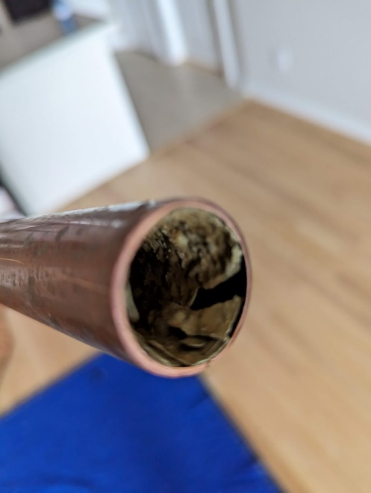
Figure 5: Suite 602 piping sample with epoxy coating within. | Figure 6: Suite 602 Piping Sample with epoxy coating within.
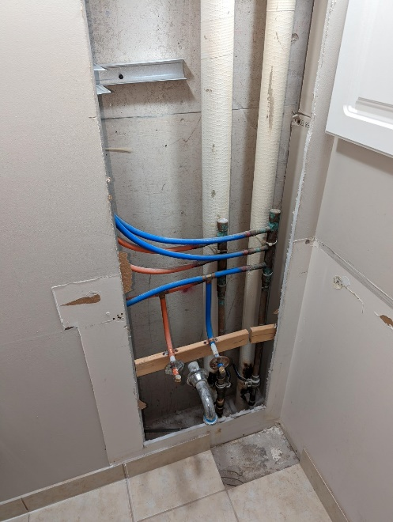 | 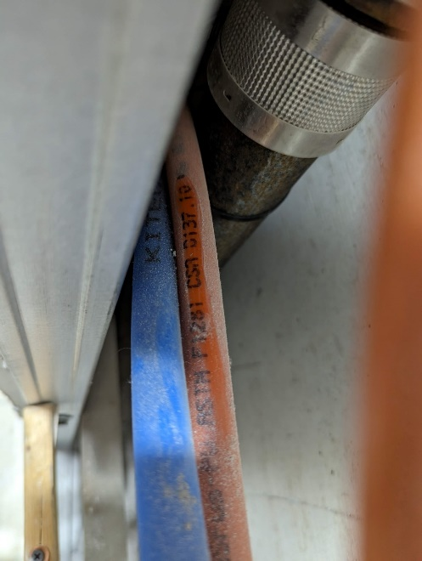
Figure 7: Suite 602 with Kitec® in-suite distribution piping. | Figure 8: Kitec® markings within piping in suite 602.

