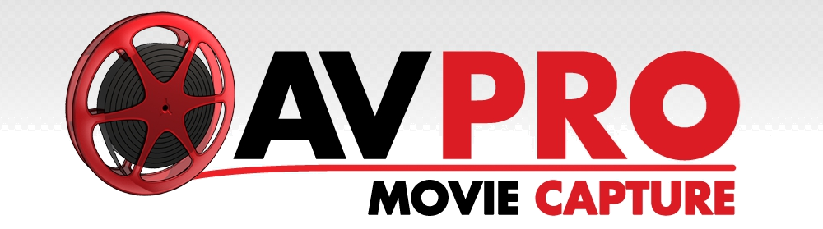

AVPro Movie Capture

Unity Plugin

Realtime capture of Unity Camera to AVI/MP4 file.

Version 2.72

Released 15 June 2015


1 / 27

AVPro Movie Capture Unity Plugin © 20122015 RenderHeads Ltd

Contents

- Introduction

- Features

- System Requirements

- Installation

- Codec Setup

  - Lagarith Codec

  - x264 Codec

  - Xvid Codec

  - MagicYuv Codec

- Usage

  - InEditor Capture

  - InGame Capture

  - Offline Rendering

- Components

- Custom Usage

- Tips

- Support

- About RenderHeads Ltd

  - Services

  - Our Unity Plugins

- Appendix A FAQ

- Appendix B Version History

2 / 27

AVPro Movie Capture Unity Plugin © 20122015 RenderHeads Ltd

1. Introduction

“AVPro Movie Capture” is a plugin for Unity that allows recording video directly to disk as an AVI file.
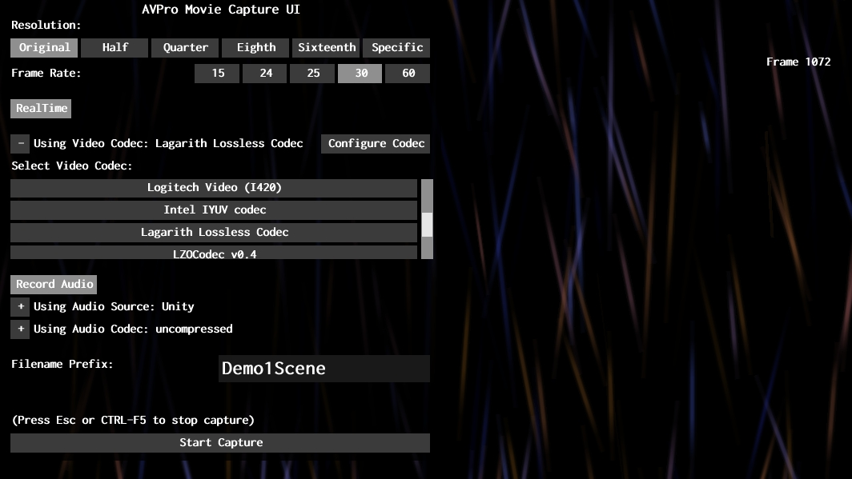

Whether we’re just testing out an idea for a new effect, playing around with some parameters or producing demos for our clients, we often find it useful to be able to quickly and easily capture a video from within Unity. Previously we used screenshots and captured videos using tools like Fraps, however we wanted something completely integrated into Unity and so AVPro Movie Capture was born.

The asset package consists of the following elements:

3 / 27

AVPro Movie Capture Unity Plugin © 20122015 RenderHeads Ltd
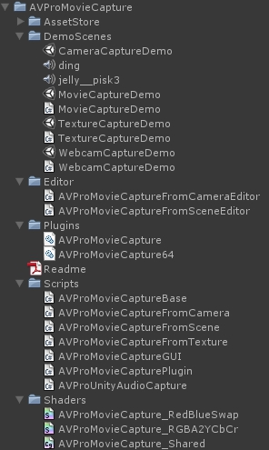

- DemoScenes

  - CameraCaptureDemo.unity ​A simple demo showing how to use the AVProMovieCaptureFromCamera component.

  - MovieCaptureDemo.unity​A simple demo scene showing how to use the AVProMovieCaptureFromScene component.

  - TextureCaptureDemo.unity​A simple demo scene showing how to use the AVProMovieCaptureFromTexture component.

  - WebcamCaptureDemo.unity​A simple demo scene showing how to use the AVProMovieCaptureFromTexture component.

- Plugins

  - AVProMovieCapture.dll ​The main plugin DLL that talks to DirectShow.

  - AVProMovieCapture64.dll ​The main 64bit plugin DLL that talks to DirectShow.

- Scripts

  - AVProMovieCapturePlugin.cs​Wrapper interface to access capture functions in the DLL.

  - AVProMovieCaptureBase.cs ​Base class

  - AVProMovieCaptureGUI.cs​Helper component that displays a GUI exposing the capture options of AVProMovieCaptureBase

  - AVProMovieCaptureFromCamera.cs ​Drag ‘n drop component to allow

4 / 27

AVPro Movie Capture Unity Plugin © 20122015 RenderHeads Ltd
easy capturing from a camera but not GUI.

  - AVProMovieCaptureFromScene.cs ​Drag ‘n drop component to allow easy capturing of the entire scene including GUI.

  - AVProMovieCaptureFromTexture.cs ​Drag ‘n drop component to allow easy capturing of a dynamic texture.

  - AVProUnityAudioCapture.cs​Drag ‘n drop component for capturing Unity audio into a buffer for saving to the AVI file.

- Shaders

  - AVProMovieCapture_RedBlueSwap.shader​Internal shader used to swap red and blue channels.

  - AVProMovieCapture_RGBA2YCbCr.shader​Internal shader used to convert RGBA to YCbCr YUY2 format.

5 / 27

AVPro Movie Capture Unity Plugin © 20122015 RenderHeads Ltd

