Mike Sumner’s IDL stuff

HOW TO FILTER YOUR DATA

Get the data into the CSV format (if .dat files see ARGOS2CSV).

Type

FILTCELLARC, ‘filename’, filt, cell, max_speed = <km/hr>, scale = <km>, min_class = <ZBA0123>, /arc

Quick and dirty:E.G.

IDL> filtcellarc, ‘G:\mydata\allmydata.csv’, filt, cell, max_speed = 12.5, scale = 350.0, /arc

That will give me all the data in the file as gridded time spent in 350.0 km squares (cell) and filtered data (no faster than 12.5 km/hr, filt) and the grid corners (grid) in ARC files in G:\mydata\.

This will automatically determine how many animals are in the file, filter all the locations over the entire period and grid the data to (scale, scale) squares (at the mid lat, see PRO-JECTIONS) and print to file the time spent values and grid of lons and lats (print to file is controlled by /arc). If class is specified in the file (always 3 for geolocation, but one of Z,B,A,0,1,2,3 for ARGOS data – this must be in quotes e.g ‘Z’ or ‘3’) anything less than the min_class is not included. You can pick a time period with time0 and time1 = ‘yyyymmddhhss’ e.g. time0 = ‘20001203000000’, time1 = ‘20010117000000’ for the period from 12:00:00 3Dec2000 to 12:00:00 17Jan20001, otherwise you get it all.
Rectangular grid cells (at the mid lat, see PRO-JECTIONS) may be specified by inputting scale = [x_scale, yscale]. Particular individuals or groups of beasts may be specified as a string array of their IDs in the file with the keyword BEASTS. E.g. beasts = [‘C933’, ‘B123’, ‘E666’]. Other options include LIMITS = [nlat, slat, wlon, elon] (lats run N to S 90.0 to –90.0, lons run W to E 0.0 to 359.0) to set an absolute area (the area won’t correspond exactly to these, as the precision is dictated by SCALE. These limits better be greater than the max extent of the filtered locations or CELL_MULTI will fall down.
Then there are the keywords MCSST, COLOUR and TOPEX05 to return relevant sst, colour and height data.
Default (as of 1Nov01) is to return the SST (daytime MCSST G:\satdata\mcsst\day\) and colour (weekly SeaWiFS L3 SMI G:\satdata\SW_chla\weekly) average between time0 and time1, as well as the previous year’s colour and the surface height anomaly (WOCE G:\satdata\topex\halfdegree\ ) data for the middle time. Look in the G:\satdata\ folders for info relevant to each of these datasets.

CSV FORMAT

This is the format for the .csv file, each column is separated by a comma. Don’t change the order of the date format, class is optional , just leave this column empty if not applicable.
ID |  |  |  |  |  | CLASS | TIME | DATE | LON | LAT
Beast1 |  |  |  |  |  | 0 | 8:54:26 | 24/11/2000 | 158.686 | -54.739
Beast1 |  |  |  |  |  | A | 16:09:23 | 24/11/2000 | 158.788 | -54.759

SATELLITE DATA

See examples below.
MCSST, SeaWiFS Level-3 standard mapped images (SMI) and WOCE sea-surface anomaly data can be easily extracted and averaged for input with SSEXT, SWEXT and SSA_EXT respectively. SSTEXT is a stripped-down version of KJM’s original version, the NASA program within it was sort of pathetic. The first two will return mask arrays and colour palettes appropriate for display of these data which are accepted by MAP_ARRAY and GLOBE_MAP. LOADCT, 1 is good for the anomaly data. Please beware of averaging anomaly data, it is provided as so many millimetres plus or minus from the average sea level – see HEIGHT2ARC. Also beware of averaging the SeaWiFS SMI – it was never intended for this purpose but is probably OK over short times and small areas – get the Level-3 binned data for serious statistics on ocean colour. (More importantly- use the yearly or monthly SeaWiFS for longer periods and handle spatial scale in ARCinfo).
The combination of these extraction programs, the mapping program MAP_ARRAY, the area subsetting program LIM_AREA and the output program SAT_FILE do a good job of flipping the array and creating the lons and lats in the right order and printing out the right values with the right location – BEWARE ANY WHO PLAY WITH THIS STUFF! It’s always good to have some land in your satellite output data, as you can tell if it’s upside down.
By default, land and non-data values in the satellite data are assigned the value –9999, which is handled by map_array and sat_file as a non-value. These are not the internal values in the datasets, see their documentation.
FILTCELLARC uses SAT_SUM to create files of MCSST and SeaWiFS for ARC info, this can be used for any group of files you like.

I recommend using the WOCE data set for both SST and ocean height (TOPEX/POSEIDON) from

http://podaac.jpl.nasa.gov/cdrom/woce2_avhrr/ (sst)
http://podaac.jpl.nasa.gov/cdrom/woce2_topex/ (height)

The programs HEIGHT2ARC and WOCE_SST2ARC take in an array of file names and output ARC files for the area specified – these are either 10 day/0.5 degree or 5 day/1.0 degree (height) or 5 day 1.0/0.5 degree (sst) files. The 1.0 degree stuff is interpolated (missing values filled in). The height data is very different in that it consists of swaths at 0.5 degrees, this can be smoothed nicely to produce a filled image (this is what HEIGHT2ARC does). Smoothing doesn’t work as well with the SST (especially in winter when coverage is less) so I recommend using the 1.0 degree SST. HEIGHT2ARC2 was an attempt to to averages of this stuff but hey!

Other useful sites:

http://podaac.jpl.nasa.gov/mcsst/ (MCSST)
http://seawifs.gsfc.nasa.gov/SEAWIFS.html (SeaWiFS ocean colour) http://www.ngdc.noaa.gov/mgg/global/seltopo.html (bathymetry)
http://www-ccar.colorado.edu/~realtime/global_data_ssh/ssh.html (ocean height anomaly)
http://podaac.jpl.nasa.gov (lots of stuff)
http://picasso.oce.orst.edu/ORSOO/southocean/fronts/ (fronts)

EXAMPLES
;*************************************************************************************
Here is an example to extract data from a TOPEX file, smooth it and output for GIS.
;*************************************************************************************

;define the file name and the limits you want and the file name label and the data value label
file = ‘G:\satdata\topex\halfdegree\ssh05d19991219.nc.gz’
limits = [-45, -65, 145, 195]
labl = 'G:\aleks\arcview\height\ssh_05_19Dec99.txt'
val = ‘height’

;extract the data into the array with info about where land is
ssa_ext, file, arr, lons, lats, land = land

;copy the array so we can mess with it
array = arr

;find the non-data values (missing or land)
bad = where(array LE -9998)

;Not-a-Number out the non values
array(bad) = !values.f_nan
;you will get this error, don’t worry: “% Program caused arithmetic error: Floating illegal operand”

;smooth the global array with a 5*5 boxcar average (this fills in the missing stuff
array = smooth(array, 5, /nan)

;now assign this value to the land areas
array(land) = -9999

;cut out the section you want
lim_area, array, lons, lats, area, alons, alats, limits = limits

;write this section to ARC file with the labels defined above
sat_file, area, alons, alats, lab, val = val

;to produce gradient values of this data (which I think is the most important value here)
;after assigning NAN values, then smooth the data (this prepares it so it’s OK for gradient)

array = smooth(array, 5, /nan)
array = sobel(array) ;SOBEL is the gradient operator, ROBERTS works much the same

array(land) = -9999
labl = 'G:\aleks\arcview\height\ssh_05_19Dec99_grad.txt'
sat_file, area, alons, alats, labl, val = val

;*************************************************************************************
Another for WOCE sst data
;*************************************************************************************

file = findfile('G:\satdata\woce_avhrr\halfdegree\*nc*')
file = file(0)
print, file
G:\satdata\woce_avhrr\halfdegree\sst05d19900113.nc.gz
woce_sstext, file, arr, lons, lats
lim_area, arr, lons, lats, area, alons, alats, limits = [-45, -65, 145, 195]
sat_file, area, alons, alats, labl = 'G:\test\sst_', val = ‘sst’

;that’s it! The next line will do that for a list of separate files (don’t use the G:\mikes’ directory!)

woce_sst2arc, files, limits = [-45, -65, 145, 195], labl = 'G:\test\ssttst_'

height2arc, files, limits = [-45, -65, 145, 195], labl = 'G:\test\sshtst_', val = ‘height’

;*************************************************************************************
And one for SeaWiFS data
;*************************************************************************************
;define the file name
file = findfile('G:\satdata\SW_chla\monthly\*CHLO*')
file = file(0) ;make sure it’s not an array of 1

;let’s check we got the file we wanted
print, file
;G:\satdata\SW_chla\monthly\S19980911998120.L3m_MO_CHLO.gz
;cool

;extract the data from the file, for seawifs, conv must be set to get the converted values (else byte-
;scaled)
swext, file, arr, lons, lats, conv = conv

;we get some messages
;preparing to uncompress G:\satdata\SW_chla\monthly\S19980911998120.L3m_MO_CHLO.gz
;file uncompressed
;preparing to compress G:\satdata\SW_chla\monthly\S19980911998120.L3m_MO_CHLO
;file compressed
;Use arr output to maintain colour for input to map_array
;Bad values now -9999 in conv array
;Display properties set by set_display.pro, the Seawifs color table is loaded, MDS4Sep01

;cut out the section we want, into area, alons, and alats
lim_area, conv, lons, lats, area, alons, alats, limits = [-45, -65, 145, 195]

;now write this to an ARC file, ‘G:\mikes…..’ is the file name we want
;val is the header we want at the top of the chla concentration column

sat_file, area, alons, alats, 'G:\mikes\day91_day1201998CHLO.csv', val = 'chlA'
;now you can bung 'G:\mikes\day91_day1201998CHLO.csv' into ARCinfo

;*************************************************************************************
And another one for MCSST data

file = findfile('G:\satdata\mcsst\day\*hdf*')
file = file(0)

sstext, file, arr, lons, lats, /orig ;or /intp or /flag but must be specified

lim_area, arr, lons, alats, area, alons, alats, limits = [-45, -65, 145, 195]
sat_file, area, alons, alats, ‘G:\test\mcsst_’, val = ‘mcsst’

;*************************************************************************************

Programs grouped by operation

The when the action described by the underlined heading is performed, the following programs are compiled and run.

Start IDL – A batch file runs automatically

SET_DISPLAY
COLTBL_LOAD

run filtering program with all options

UNDEFINE
GL2PTT
STR_SEP
YMDS2JS
YMD2JD
UNIQ
READ_FILTPTT (MDSREAD_FILT)
LL2RB
POLREC3D
POLREC
ROT_3D
RECPOL3D
RECPOL
CELL_MULTI
JS2YMDS
JD2YMD
CELL_FILE
FILT_FILE
GRID_FILE
MAP_ARRAY
GET_SCREEN_SIZE
MAP_SET
CROSSP
MAP_IMAGE
IMDISP
MAP_CONTINENTS
MAP_GRID
RESOLVE_ALL
LEGEND
COLORBAR
CONGRID
OPLOT_FRONTS
FIND_SAT_FILES
DT_TM_TOJS
YDNS2JS
SAT_SUM
SWEXT
ZIP
HDF_SD_READSLICE
SET_DISPLAY
LIM_AREA
SAT_FILE
SSTEXT
SSA_EXT

run satellite suite of programs for SST

FIND_SAT_FILES
SAT_DAY
UNDEFINE
UNIQ
SAT_SUM
SSTEXT
ZIP
SAT_FILE

for SeaWiFS suite

FIND_SAT_FILES
SAT_SUM
SAT_DAY
UNDEFINE
UNIQ
SWEXT
ZIP
HDF_SD_READSLICE
SAT_FILE

For topex suite

HEIGHT2ARC
MONTHNAMES
SSA_EXT
ZIP
LIM_AREA
SAT_FILE

convert .dat files to one .csv file

ARGOS2CSV

drift routines

RUNDRIFT
GET_DIVE_DATA
CELL_DRIFT

bootstrapping

STORECELLSMOD (this takes the location data and makes structures for seals/fnights/combos from
which to sample)
SPATBOOT - samples from these structures

Brief description of programs
Written by (MDS) unless otherwise specified (see the programs for more detail on their operation)

ARGOS2CSV - convert ARGOS .DAT files to one .CSV file
CELL_DRIFT - gridding program for drift
CELL_FILE - writes time spent data to ARC file (cell centres)
CELL_MULTI - (Dave Watts - DJW) gridding program for location data, time spent cells, crossing data
COLORBAR - (David Fanning, www.dfanning.com), draws a colorbar
COLTBL_LOAD - (CSIRO C. Rathbone), loads SeaWiFS color table from file (pc28.pse, look in
\IDL52\resource\datafile)

CONGRID - (IDL) program to resize an array
CROSSP - (IDL) calculates cross product of vectors
DT_TM_TOJS -(JHU) converts date or time string to julian seconds
FILT_FILE - writes filtered data to file (adds new columns to copy of original data)
FILT2CELLS - combo program of READFILTPTT and CELL_MULTI
FILTCELLARC - master program to filter data and return time spent, grid and oceanographic data to ARC
Files

FILTER_FIXES - (DJW) calculates RMS for speed filtering for READ_FILTPTT
(MDSREAD_FILTPTT)
FIND_SAT_FILES - gets the appropriate sat. files for FILTCELLARC, probably better to do this
manually for specific runs of SAT_SUM (put copies of the files wanted in a different directory)

GET_DIVE_DATA - (DJW, K. Michael - KJM, MDS) extracts dive data from file (/drift if a 5
column drift file)

GET_SCREEN_SIZE - (IDL) determines size of terminal for MAP_ARRAY
GL2PTT - (DJW, KJM) extracts location data from .CSV file (handles output files from
ARGOS2CSV with extra 'classes' column)

GRID_FILE - writes grid corners (from CELL_MULTI) to file for ARC
HEIGHT2ARC - extract topex data from a series of files for GIS input
HDF_SD_READSLICE- (IDL, NASA) reads from SeaWiFS file
IMDISP - (Liam Gumley - www.dfanning.com) display program for graphical relief
JD2YMD - (John Hopkins University - JHU) - convert julian day to year, month, day
JS2YMDS - (JHU) converts julian seconds to yy, mm, dd, ss
LEGEND - adds a legend to display with COLORBAR (doesn't work perfectly - don't
believe it)

LIM_AREA - extracts an area from a larger array, using the corresponding lons and lats
LL2RB - (JHU) convert lon/lat to range/bearing (for READ_FILTPTT)
MAP_ARRAY - display an array with map coordinates
MAP_CONTINENTS - (IDL) adds continents to map display
MAP_GRID - (IDL) adds grid to map display
MAP_IMAGE - (IDL) converts image to map display
MAP_SET - (IDL) sets display for map
MDSCELL_MULTI – my version of cell_multi for FILTCELLARC (see Kelvin Michael for originals)
MDSREAD_FILTPTT – my version of read_filtptt to differentiate it from KJM’s in FILTCELLARC
OPLOT_FRONTS - (DJW, MDS) adds fronts to map display
PLACE_NAMES -(MDS) adds a bunch of place names to a map (in our corner of the world)
POLREC - (JHU) polar to rectangular coords
POLREC3D - (JHU) ditto in 3D
READ_FILTPTT - (KJM, DJW) the location filtering program (this used to be READ_ARGOS_DATA
and see MDSREAD_FILTPTT)
RECPOL - (JHU) rectangular to polar coords
RECPOL3D - (JHU) ditto in 3D
RESOLVE_ALL - (IDL) a clean up program(?) for user defined stuff (DJW calls it)
ROT_3D - (JHU) rotate 3D coord system
RUNDRIFT - run the drift analysis (uses its own inbuilt FILT2CELLS)
SAT_FILE - write satellite data to file for ARC
SAT_SUM - average satellite data from a bunch of files
SET_DISPLAY - run some display set up stuff (called on IDL start up)
SPATBOOT - run the spatial extent bootstrapping (composed of other routines, see for more info)
SSA_EXT - extract height anomaly data from NCDF files
SSTEXT - extract MCSST data
START - a batch run called at start up
START_DISP - more start up stuff
STORECELLSMOD - this saves location data as structures in different combos of beast/fortnight
STR_SEP - (IDL) breaks a string up
SWEXT - extract SeaWiFS data
UNDEFINE - (www.dfanning.com) undefine variables, used for clean up (particularly to avoid
appending new data from READ_FILTPTT)

UNIQ - (IDL) this finds unique members in an array (only if they are in order, used in
conjunction with SORT for other times)

YDN2JS - (JHU) year, day-of-year to julian second
YDNS2JS - (JHU) year, day-of-year, seconds to julian seconds
YMD2JD - (JHU) yy, mm, dd to julian day
YMDS2JS - (JHU) yy, mm, dd, ss to julian second
ZIP - my version of using gzip for both Windoze and UNIX (have gzip.exe in the \IDL52\
directory for Windoze)

More stuff about IDL programs

THE CORE PROGRAMS

READ_FILTPTT is the core filtering program written by David J. Watts (well, it was originally READ_ARGOS_DATA but Kelvin Michael modified it to filter geolocation data). This uses FILTER_FIXES to mask out dodgy locations, using a running mean method (see the Antarctic Division web page – DJW). CELL_MULTI takes the filtered data as a structure and outputs a structure with the time spent map at a given spatial scale. M.D. Sumner restored the append feature to READ_FILTPTT which had been lost when modified, and included a limits option for CELL_MULTI so that an absolute area could be defined and maintained for a group of beasts’ locations (see below under PRO-JECTIONS).
DJW’s stuff is really good, much respect to the ARGOS system, but it was written in a VMS environment (the Ant Div server) with options for MAC, and WIN in that establishment. The WIN and UNIX IDL available at the uni, (well not really WIN anyway . . .) have trouble as there is no GIF license at the CRC and other issues arise such as with DJW’s DEFINE_COLOURS.

ABOUT INPUT/OUTPUT

ARGOS data files may be read directly - this is probably the safest and simplest method, but people are going to want to play with this stuff in Windoze and so there is a set format for an Excel CSV (comma-delimited) file. Also there is merit to this method as an ARGOS file may have data from one instrument that has been stuck to more than one beast. This CSV format consists of a string identifying the animal or tracker, a longitude (0.0, 359.999 OR -179.999, 179.999), a latitude (-89.999, 89.999), a date string (mm/dd/yy), a time string (hh:mm:ss). Other details will include the columns which these values should occupy, but it is crucial that the date and time are in this format. Things will go wrong if Excel changes your dd/mm order, but it won't matter (for example) if the year is a four numeral or two numeral value (which makes me think I could automate the detection of the month/day distinction in a quick sample before they are converted to universal time).
The file is read as a set of strings, one line at a time, by splitting the line at every comma, then selecting the string from the appropriate column and converting it to a number or (in the case of date and time) splitting that string at the /'s or the :'s and converting to julian seconds in universal time.

PROJECTIONS: MAPPING AN OBLATE SPHEROID

The cell grids produced are not true to scale and the actual area represented by each cell will be as close to true as possilbe at the mid latitude, with area reducing by the cosine of the change in latitude to the north and south. This is negligible for small areas, but contributes something like 10% difference when looking a scales of thousands of kilometres such as the elephant seal range from TAS and NZ to the Ross Sea. By including a limits option to CELL_MULTI this area can be kept constant, with constant distortion from the mid latitude. Using lons and lats solves many problems if you can deal with the globe as a rectangle.

MAPPING A 2-D ARRAY WITH LON AND LAT VALUES

MAP_ARRAY and GLOBE_MAP will accept a 2-D array (either the whole globe or just a part thereof) and corresponding lons and lats (centres of cells, so that there are the same numbers of lon values and the x-dimension of the array and etc.) and map it up. They will also accept a 3-D palette of colour values to get the scaling right. LEGEND however does not work perfectly, so don’t believe it.

ABOUT COLOUR: 24-BIT

Why stop at 256? The SeaWiFS data is supplied with a colour table ‘pc28.pse’ and a loading program, COLTBL_LOAD, but the routine SET_DISPLAY will load this (and cope with the arse-about colour gun system present in the LINUX boxes in the CRC). SWEXT will return this as a 3-D palette for effortless displaying of ocean colour data (or a pretty nice scale for almost anything else). SSTEXT will return the MCSST palette with the keyword PAL.
IDL will load its in-built colour table with
LOADCT, index [index = 0, 1, 2, etc] 0 = greyscale, 1 = bluescale etc.

IT MATTERS WHETHER A NUMBER IS FLOATING POINT, DOUBLE PRECISION, LONG INTEGER OR EVEN A STRING

Human cognition switches effortlessly between numerals (as strings of text), byte-scaled numbers (no negative, modulo 256), integers (no decimal), long integers (larger or smaller than +/- 32000, floating point numbers (decimal) and double precision floating points (lots of significant figures). Most programming languages don’t, but they are much better at math than most humans.

RANDOMIZATION STATISTICS

The key hurdle to these methods is computation time, so you need to store your time spent maps per animal, or per fortnight, or per season or per group of animals or all of these at once before randomly selecting them. STORE_CELLSMOD will do this for a particular file and save any or all of these options in IDL format, ready to be sampled from by the bootstrap programs which are in a file called SPATBOOT.

FAQ AND COMMON PROBLEMS

If limits are set, CELL_MULTI will crash when it tries to handle a good location outside these. Or, put another way - you can filter your data for speed and for particular times (start/end time) but you can't pick an area in space. This is set automatically by the filter, but you can set a larger absolute area. This program will also stop if it finds a negative time between subsequent locations, this is no big deal if the values are small, kick start it again by typing
.continue
but go and check your filtering specs (I think this only happens if max_speed is not set, internally the default is –1).

READ_FILTPTT will crash if the start and end time are not defined or in wrong format. If the beast ID is not correct, or doesn’t reside in the file then it won’t return any values, CELL_MULTI won’t do anything and there will be problems later.
This program is run repeatedly for multiple profiles, and appends a new PTT's data to the previous ones in the filter structure. I.e. you need to know if you need to undefine the structure, it is not redefined - just added to.

IMDISP will remove the map transformation of the display is its /axis keyword is set. You need to use the MAP_SET procedure to add titles and other graphics to map display. MAP_ARRAY does all this for you, with a 2D array input with corresponding 1D arrays of lons and lats.

When data is input, either by reading ARGOS .dat files or CSV (comma delimited) files, things will fuck up if the day and month have been mixed up by Excel - this is probably the most common problem. Care must be taken to keep an Excel file in the appropriate format.

If NaN (not-a-number) values are being used to mask out non-data or land or ice values then the data format (usually) needs to be in floating point format. NaN is a reserved value for dividing by zero. Byte or integer values will normally default to zero rather than NaN.

It is easy to get a map upside down - care must be taken when assigning lon/lat values to a data point, as machines by default read an array from the bottom up, people expect it from top to right. This is especially important for writing out values to file, much care must be taken to get the right lon/lat pair for the right data value. DJW's map_cell does it right, The satellite extraction, display and file out programs do it right.

SOME PEOPLE INVOLVED

IASOS/ANTARCTIC CRC

Michael Sumner -honours IASOS 2000, using simple sat data sets (aimed at biophysical research)
Kelvin Michael - physics legend, turned to Antarctic research, Southern Ocean
remote sensing
Verity Steptoe -honours IASOS 2001 – time spent analysis of Cindy’s royals

ANTARCTIC DIVISION

David Watts - he wrote the ARGOS filtering system
John van den Hoff - geolocation of ellies, improvements with SST data
Clive McMahon - ecology of ellies

ZOOLOGY UTAS

Aleks Terauds - Macca albatross and giant petrel research, relationship to
oceanographic parameters
Cindy Hull - penguin biologist (AWRU)
Tony Dorr - time spent analysis of Macaronis from Heard Island0
Corey Bradshaw - AWRU stats head, elephant seals and oceanographic parameters
Mark Hindell - AWRU boss

MATHEMATICS UTAS

Simon Wotherspoon - stats and programming legend, ecological modeling (fish)
Greg Leidreiter - eco modeling (fish)

GOOD IDL RESOURCES

www.dfanning.com
Glenn Hyland, Antarctic CRC
Katrina Hill, IASOS/Antarctic CRC

SOME CONCEPTS REGARDING ELLIE RESEARCH AND SATELLITE DATA

A database of elephant seal demographics, population characteristics and foraging behaviour was set up as a ten year project in 1993 by Harry Burton. The foraging location data consists of dates, times, depths and water temperatures measured by instruments (Time-Depth Recorders) carried by elephant seals from Macquarie Island. Some satellite location data is included, measured by the ARGOS system (GPS). The primary focus of the project is the foraging behaviour of reproductive females known (in terms of weight and demographics) from birth, and their response to variability in oceanographic conditions. With a sufficiently detailed and general analysis system in place, this location data is expected to yield information regarding the response of higher predators to oceanographic conditions (as measured by satellite or more traditional means). It is important to note the existence of similar, concurrent work at Macquarie Island and other Southern Ocean locations on other sea mammals and birds, and information on all of these may be compared in a similar manner. Question number one in this type of work is to determine at what scales such data will be analysed and compared.
The problem of scale is seen to be a unifying focus for this type of analysis for several reasons.
- Inherent error in geolocation of animals (better locations for satellite data).
- The ecological lag (both spatial and temporal) between the physical characteristics of the marine environment and higher organisms (think of a large animal as a concentration of energy from a much larger space and longer time).
- Coverage and resolution aspects of satellite measurements of the ocean surface: the poor coverage by high-resolution (1-20 km, 1 – 10 days) visible and infra-red light ksensors (SST, ocean colour) due to cloud cover, the poor resolution (100 km) but better coverage of microwave sensors (SS height, SST) and the difficulties involved in classifying images of sea-ice (infra-red and microwave).
- The sheer masses of data to be obtained from a long-term intensive study of marine organisms ranging over a wide area (up to 1000s km), and from the high-resolution and broad coverage of satellite sensors of the ocean surface.

If the appropriate scale at which to compare these data is sufficiently broad (longer time, larger space) and commensurable, then these problems become less limitations and more opportunities and advantages.
The averaging over time and space of ocean surface satellite data provides fewer data points overall, but with each containing a summary of all the original data and within which the certainty of an animal’s foraging location is assured. Large animals can be expected to respond to physical variations over large scales for ecological reasons, and this provides a convenient mechanism for summarizing the masses of data available and reducing the computational work otherwise required.

Some stuff on fronts
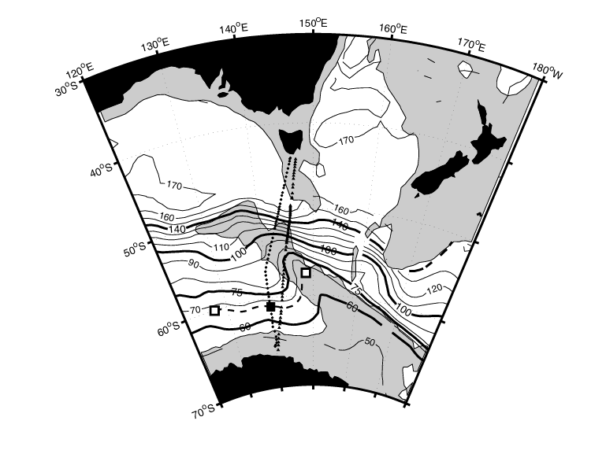
Figure 1. … bold dynamic height contours correspond with . . . fronts:

“The physical and chemical characteristics of Southern Ocean surface waters vary from north to south. These changes occur as a series of steps

across each of the fronts of the Antarctic Circumpolar Current (ACC). Between the fronts lie zones of weak flow and relatively uniform water properties. From north to south, these fronts and zones are the
Subtropical Front (STF),

Subantarctic Zone (SAZ),

Subantarctic Front (SAF), 140 dyn cm

Polar Frontal Zone (PFZ),

Polar Front (PF), 100 dyn cm northern branch (PF-N), 75 dyn cm southern (PF-S)

Antarctic Zone (AZ)
(Gordon et al., 1977; Whitworth, 1980). Further south, close to the Antarctic shelf, two additional circumpolar fronts have been identified: the southern ACC front (SACCF) and the “southern boundary” (SB) of the ACC (Orsi et al., 1995).”
From Trull, T, Rintoul, SR, Hadfield, M, and Abraham, ER, (2000). Circulation and seasonal evolution of polar waters south of Australia: implications for iron fertilization of the Southern Ocean. Journal for Deep-Sea Research II.
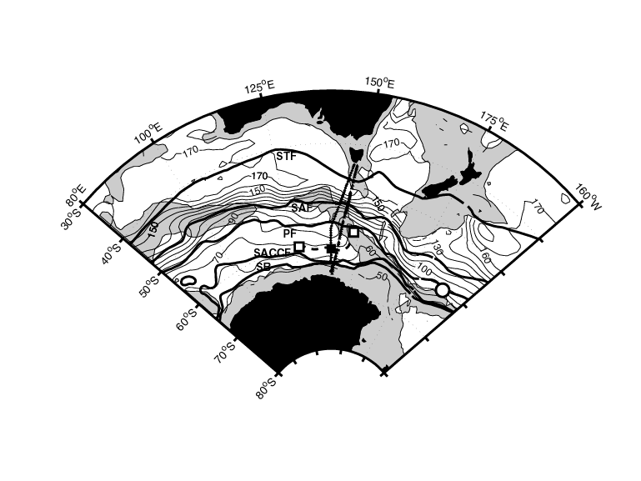
(This figure was included in an earlier draft of this paper, and modified to Figure 1 above)

“Two branches of the Polar Front have been found in each of the six CTD sections occupied south of Tasmania since 1991: the northern branch (PF-N) lies between 53°S and 54°S, and the southern branch (PF-S) is found near 59°S (Rintoul and Bullister, 1999; Rintoul and Sokolov, 2000). Two branches of the PF have also been found at other longitudes (Sievers and Nowlin, 1984; Sparrow et al., 1996). As described below, the physical and chemical characteristics differ on either side of the PF-S. To assist in the discussion, we follow Parslow et al. (2000) and call the zone between the two branches of the Polar Front the Inter-Polar Front zone (IPFZ), and call the region between the PF-S and the SACCF the southern Antarctic Zone (AZ-S). In other words, the southern branch of the PF divides the AZ south of Australia into two zones: the IPFZ between the two branches of the PF, and the AZ-S between the southern branch and the SACCF. Table 1 summarizes the definitions used to identify the individual fronts and the nomenclature used in this study. The locations of the fronts in the Australian sector are indicated in Figure 1, by highlighting of the dynamic height contours which most closely correspond to the front locations of Orsi et al. (1995), Rintoul and Bullister (1999) and Rintoul and Sokolov (2000).

The deep-reaching fronts define water mass boundaries and account for most of the eastward transport of the ACC (Nowlin and Clifford, 1982; Rintoul and Sokolov, 2000). The overturning circulation in the meridional plane (Figure 2) is also relevant to our discussion, as it plays a role in the carbon and nutrient supply to and export from the surface mixed layer. Nutrient-rich Circumpolar Deep Water (CDW) upwells south of the SAF, where the Ekman transport is divergent. Part of the upwelled CDW loses buoyancy near Antarctica to form Antarctic Bottom Water (AABW). The remainder gains bouyancy due to warming and freshwater input as surface waters are driven north in the Ekman layer, ultimately sinking to form Antarctic Intermediate Water (AAIW) and Subantarctic Mode Water (SAMW, Speer et al., 2000; Sverdrup, 1933). While the circumpolar-average view in Figure 2 is broadly accurate, the sinking of surface water into the ocean interior occurs in only a few locations. For example, Antarctic Bottom Water (AABW) forms primarily in the Weddel and Ross Seas, and along the Adelie Land coast (Orsi et al., 1999; Rintoul, 1998). SAMW is formed throughout the circumpolar extent of the SAZ (McCartney, 1977), but new oxygen-rich AAIW is formed only north of the SAF in the regions east and west of Drake Passage, where it coincides with the coldest and freshest varieties of SAMW (McCartney, 1982; McCartney, 1977; Talley, 1996). AAIW found at other locations is derived from these sources, with properties that have been slowly modified by mixing and decomposition of organic matter (which decreases the oxygen and increases the nutrient concentrations). For example, the AAIW south of Australia is relatively old (pCFC-11 ventilation age > 20 years) and low in oxygen (65% of saturation), reflecting the effects of mixing and oxygen consumption along the long sub-surface trajectory from its source in the southwest Atlantic (Rintoul and Bullister, 1999).”

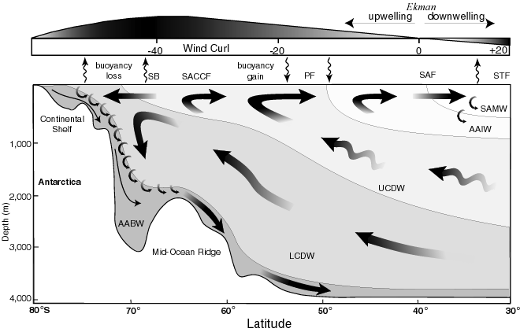

Figure 2. . . . Negative values of wind stress curl correspond to Ekman divergence and upwelling. The transition from upwelling and buoyancy gain in the south to downwelling and buoyancy loss in the north roughly coincides with the Subantarctic Front (SAF). Formation of Subantarctic Mode Water (SAMW) and Antarctic Intermediate Water (AAIW) north of the SAF, and Antarctic Bottom Water (AABW) on the Antarctic Shelf occurs only in restricted locations. Nutrients are brought to the surface from Upper and Lower Circumpolar Deep Water (UCDW and LCDW) with increasing efficiency further south as a result of the increasingly negative wind-stress curl, as well as deep winter convection associated with sea-ice formation (Gordon and Huber, 1990).

