# User Research

# References

Collamer, N. (2013, September 3). *Has LinkedIn Crossed An Ethical Line?* Retrieved from Forbes: http://www.forbes.com/sites/nextavenue/2013/09/03/has-linkedin-crossed-an-ethical-line/

Crocodilos, N. (2013, July 23). *LinkedIn Payola: Selling out employers and job hunters*. Retrieved from Crocodilos: http://corcodilos.com/blog/6547/linkedin-payola-selling-out-employers-and-job-hunters

Porta, M. (2010). How to Define Your Target Market.

Grudin, M. M. (2009). When Social Networks Cross Boundaries: A Case Study of Workplace Use of Facebook and LinkedIn. 1-9.

Robert J. McGovern, J. A. (Apr 9, 2002). Employment recruiting system and method using a computer network for posting job openings and which provides for automatic periodic searching of the posted job openings . 42-50.

SMITH, M. D. (2013, December 30). *Demographics of key social networking platforms*. Retrieved from http://www.pewinternet.org/: http://www.pewinternet.org/2013/12/30/demographics-of-key-social-networking-platforms/

# Requirements specification

The precise prioritised functions of the applications are:

|  |  |  |
| --- | --- | --- |
| **Essential** | **Desirable** | **Cosmetic** |
| Invite button to add new associate | Notification icon displaying adding users name, with a accept & decline button |  |
| Ability to send messages | Ability to send instant messages to connected associates | Pop up chat system |
|  | Notifications for each message user receives | Icon in right navigation bar |
|  | Should only show the last 20 messages before showing "load more" message |  |
|  | Popup chat will automatically load messages as user scrolls up |  |

1. Invite button to add new associate
   1. Notification icon displaying adding users name, with a accept & decline button
2. Ability to send instant messages to connected associates
   1. Pop up chat system
3. Notifications for each message user receives
   1. Icon in top navigation bar
4. Should only show the last 20 messages before showing "load more" message
   1. Only for the full messaging service
   2. Popup chat will automatically load messages as user scrolls up

# Test plan

**Scope**

Testing the functionality of the project.

**Objectives**

Finding, analysing and fixing errors that might occur from the functionality of the system, checking the fluidity and coherence of the data input into the database.

**Solving Errors**

To be considered error:

* All MySQL error generated messages
* All PHP error generated messages
* Message not sending
* Notifications not appearing

**Testing Conditions**

The tests will be done in various browsers in order to make sure that the design aligns properly. The browsers will include: Internet Explorer 11.0, Mozilla Firefox 41.0, Chrome 47.0.

|  |  |  |  |
| --- | --- | --- | --- |
| **Test no.** | **Test Description** | **Purpose of test** | **Expected result** |
| 1. | Input message to test friend with intent to send the message for the other user to view | * + To test that once a message has been sent it is received by the required user | The receiving user receives the test message sent |
| 2. | Notification appears once you’ve received a message | * To test that the icon popups when a user receives a message | Popup alert appears and user is able to click and view |
| 3. | User is able to view all of the messages received by user | * To make sure that the users messages are group by friend | All messages to be grouped by friend |
|  |  |  |  |

# Wireframes

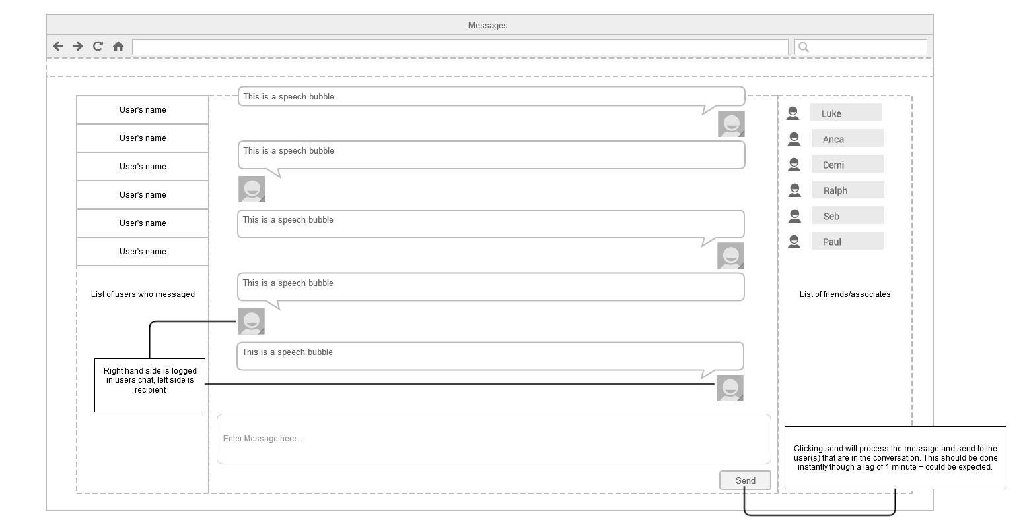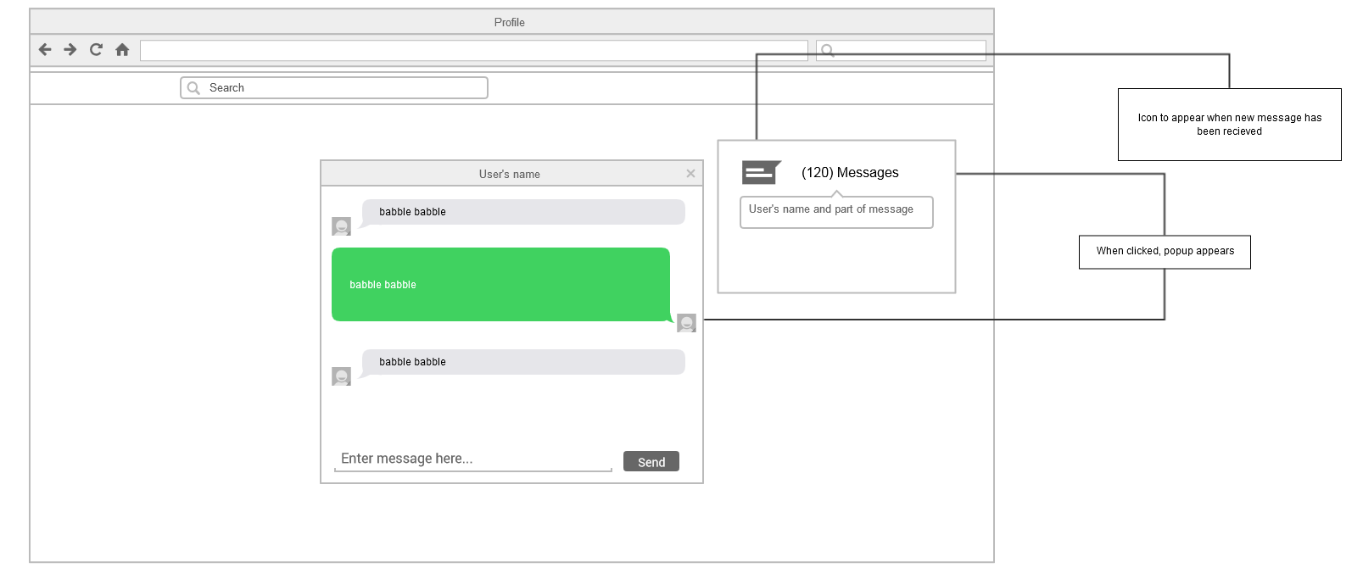

**Sending messages Use case**

|  |  |
| --- | --- |
| **Use case name** | Messaging |
| **Actor(s)** | Jobseeker + Friend |
| **Brief Description** | Sending messages to each other |
| **Post condition** | User is registered in the database |
| **Normal Flow** | |
| * + 1. The user inputs the test and presses send or enter     2. Friend receives notification saying new message received     3. Friend replies to message     4. Repeat (1-4) | |
| **Exceptions** | |
| User doesn’t receive the notification or misses it. | |

**Inviting friends Use Case**

|  |  |
| --- | --- |
| **Use case name** | Inviting users to be friends |
| **Actor(s)** | Jobseeker + Potential Friend |
| **Brief Description** | User will add another user as a friend |
| **Precondition** | Users must be logged in and on the other users profile page |
| **Normal Flow** | |
| 1. User clicks invite or add as friend. 2. System generates a notification requiring the user to accept the invite or not. 3. User confirms invite, users become friends on the system | |
| **Exceptions** | |
| Other user declines, invite isn’t sent or sent in error. | |