Explore the six dimensions of the mind:

De Bono's Six Thinking Hats

Introduction

The Six Thinking Hats are a thinking tool created by Edward de Bono to help people think about problems and make decisions in a more holistic, systematic way. The model uses six different colored "thinking caps," each representing a specific thinking role or dimension, to help an individual or team look at a problem from a different perspective.

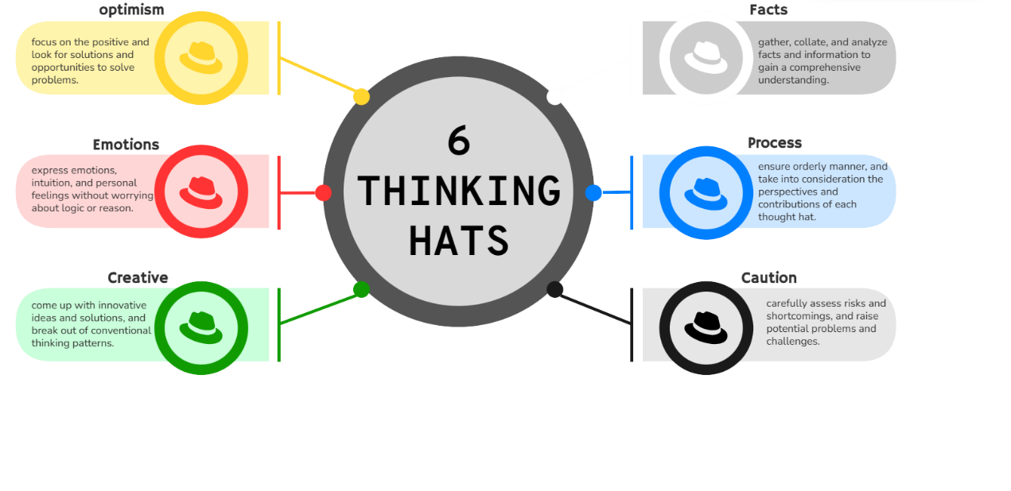

six thinking caps are not only applicable to individual thinking but can also be applied to teamwork and decision-making processes. Through the flexible use of different colored thinking caps, people can avoid one-sided thinking, thus solving problems in a more comprehensive and diversified way and improving the efficiency and quality of thinking.

Application

six thinking hats are not only applicable to individual thinking but can also be applied to teamwork and decision-making processes. Through the flexible use of different colored thinking hats, we can avoid one-sided thinking, thus solving problems in a more comprehensive and diversified way and improving the efficiency and quality of thinking.

**Here is a typical step-by-step application of the six thinking hats in a meeting:**

1. State the problem (white hat);

2, propose a solution to the problem (green hat);

3, assess the advantages of the programme (yellow hat);

4, list the disadvantages of the programme (black hat);

5, make an intuitive judgement about the solution (red hat);

6, summarise the statement and make a decision (blue hat).

