**Introduction**

The Theory of Inventive Problem Solving, or TRIZ is a systematic and methodological approach to innovation. At the heart of TRIZ lies the principle that innovation is the resolution of contradictions. Difficult problems that demand inventive solutions often arise from conflicts between the optimization goals of technical parameters. By identifying and addressing these contradictions, innovation can be achieved. TRIZ provides tools for abstracting specific problems into more general terms, thereby identifying standard solutions, which can then be re-concretized to solve the specific issue.

The core components of TRIZ include:

1. **40 Inventive Principles**: A significant amount of innovations are based on these general solution principles.

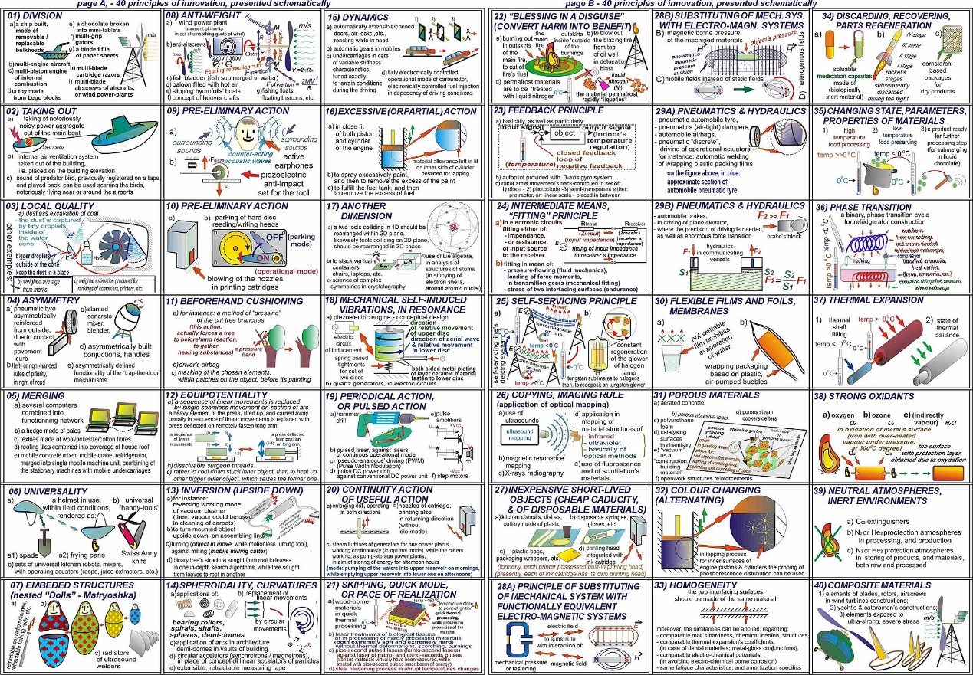

1. **39 Engineering Parameters**: Innovations are made possible by overcoming contradictions between these parameters.
2. **39x39 Contradiction Matrix**: This matrix systematically identifies and resolves technical contradictions.

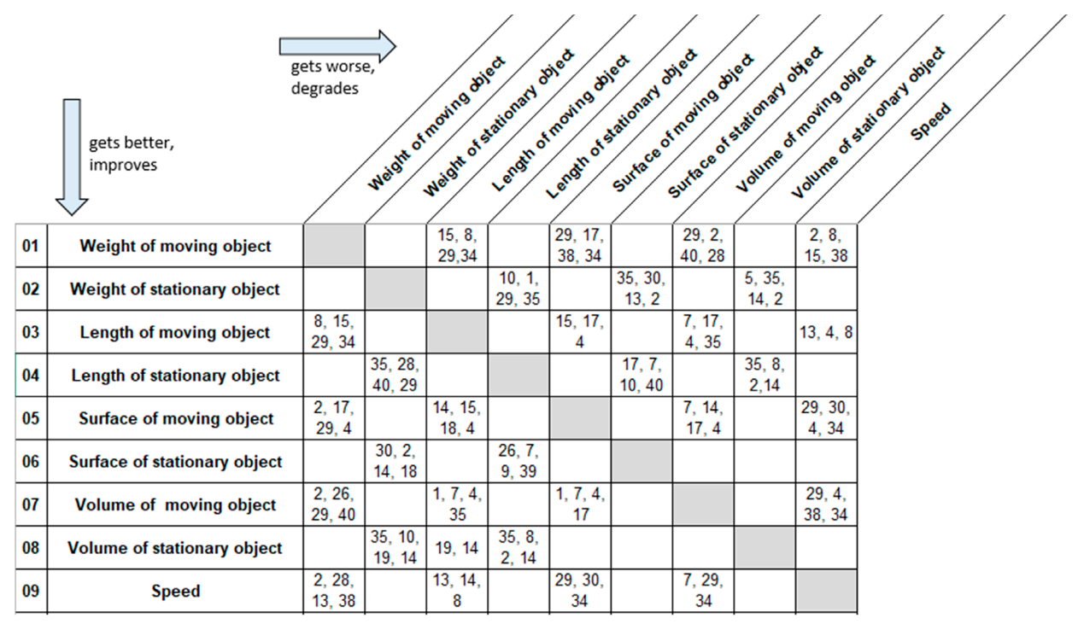

**Advantage in application**

TRIZ typically results in more advanced and robust solutions compared to those derived from traditional problem-solving methods. TRIZ's approach accelerates the development of practical knowledge and guides the problem solver to a confident decision point. This is visualized in a graph that contrasts the trajectory of knowledge development with and without TRIZ, illustrating how TRIZ quickly identifies a range of possible options before a traditional forced decision point is reached.

The TRIZ process marries creative brainstorming with a systematic, knowledge-based problem-solving method rooted in the most successful innovations throughout history. By utilizing a set of 40 inventive principles and a contradiction matrix of 39 technical parameters, TRIZ expedites the generation of conceptual solutions. These solutions are explored through standard, scientific principles that would take significantly longer to uncover and synthesize into a viable ideal solution without TRIZ.

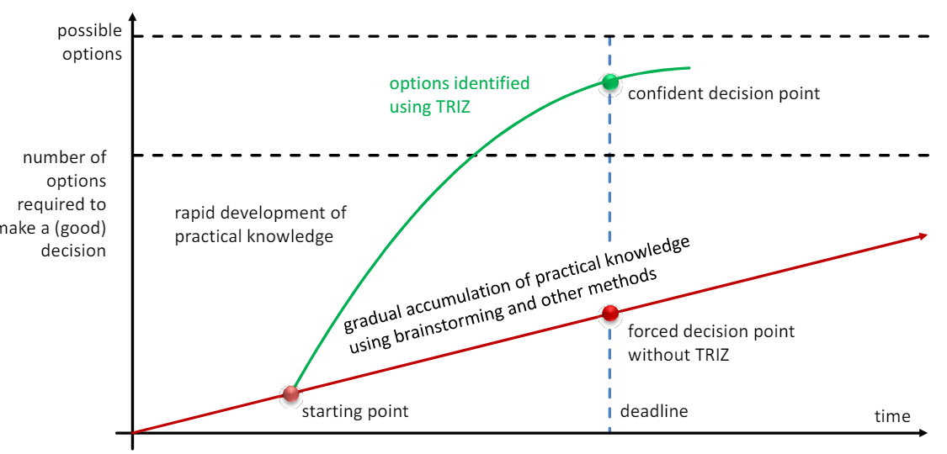

With TRIZ, teams and individuals can bypass the gradual and often haphazard accumulation of practical knowledge through traditional methods like brainstorming. Instead, they move directly towards a more innovative and confident solution space, as depicted by the steep incline in options generated through TRIZ on the graph. The systematic approach of TRIZ ensures a focused and instructionally sound journey from problem to solution, making it an invaluable tool for those seeking to innovate effectively and efficiently.