Tracy Marie Andrea Madresta BSIT 3-A March 10, 2023

**Task 1: Create Alias**

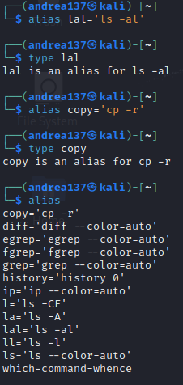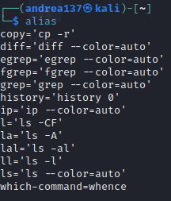

**Task 2: Use man and help**

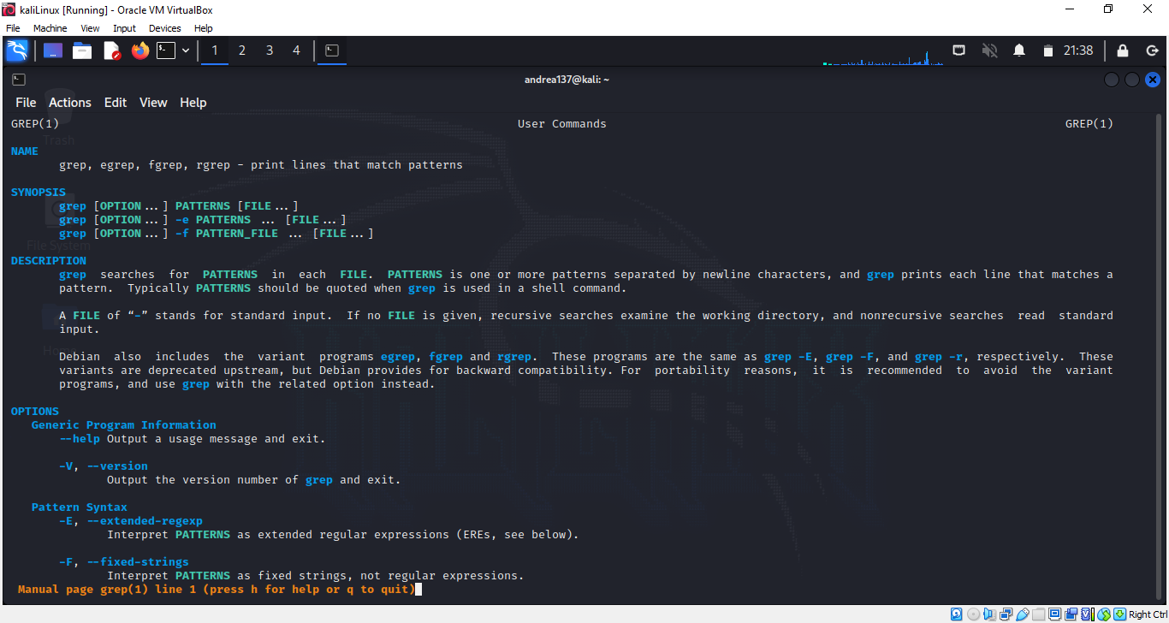

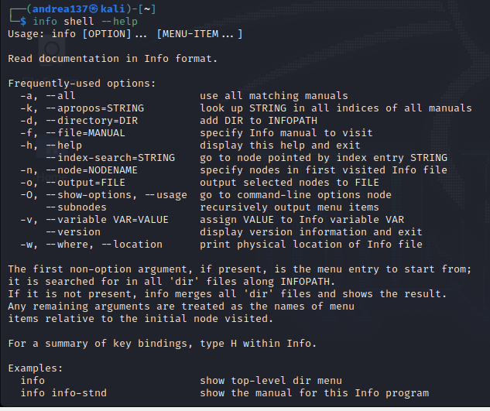

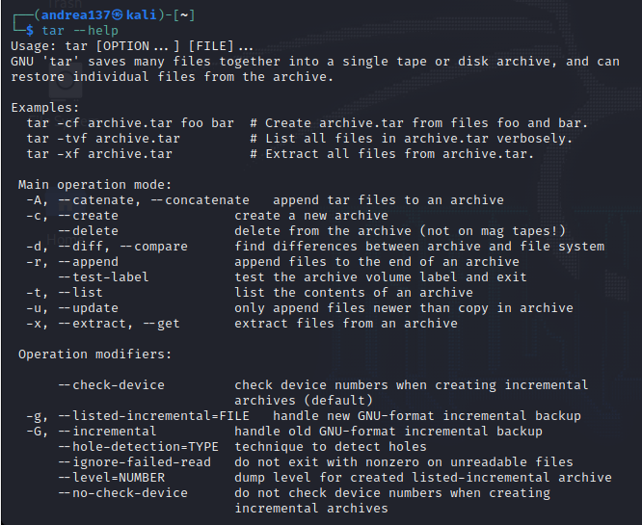

**Task 3: Use info –help**

t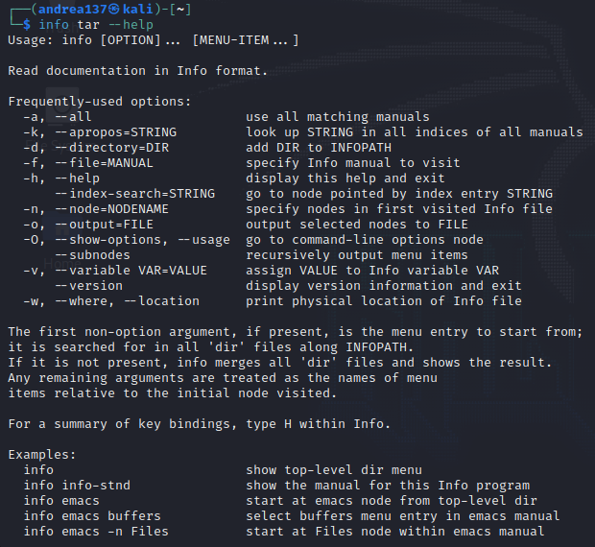

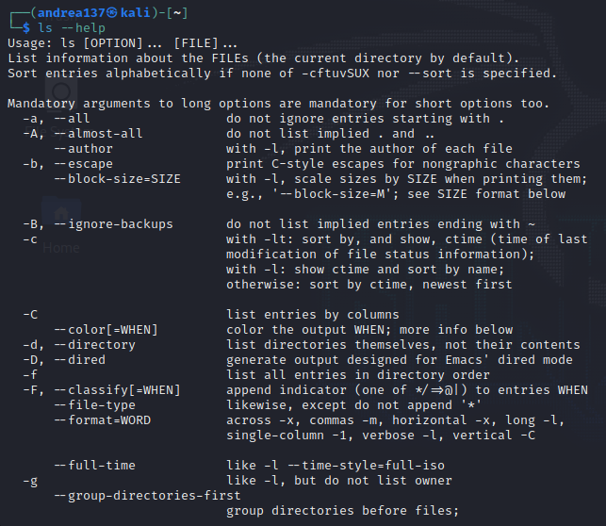

**Task 4: Create alias of a command you choose**

Working in the terminal to go over my folders and files sometimes makes me frustrated to type every single code just to be able to go into my working folder. In that case I have made an alias that will help navigate to my working folder easier and would help me keep track and see what is inside my working folder.