Tracy Marie Andrea Madresta BSIT 3-A April 16, 2023

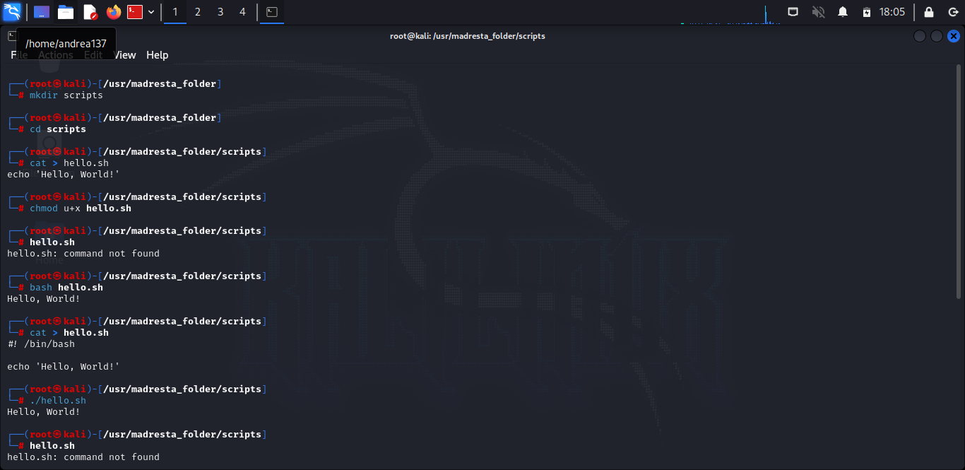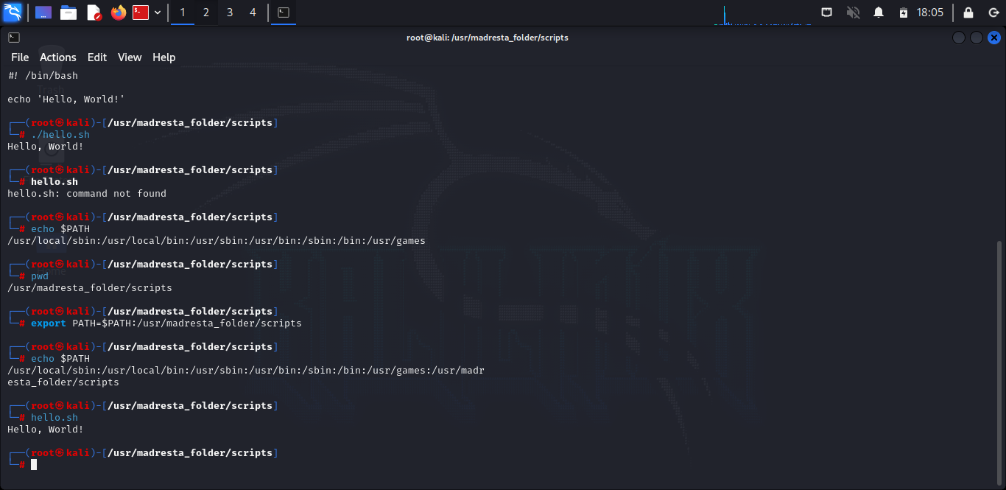**Shell Scripting**