Part 1

Question 1: Your note on my homework says that the answer must include “Linux is one of the distributions of Unix systems,” which of course aligns with what the homework key states. However, Linux is not a distribution of Unix, it is a clone.

“As Linux is a compete reimplementation, it shares no common code with any version of UNIX and therefore does not connect to the ‘family tree.’” – Graham Glass, King Ables *UNIX for Programmers and Users*, P.11

Question 4: I answered both in one sentence; “many users to use the system simultaneously” … “run multiple tasks…at the same time”

These two are almost exactly what the key says so I am unsure why it was marked as incorrect

Part 2a

Question 8: As per the instructions, questions 7-10 are basic regexes. In basic regex characters such as (, ), and ? are not meta characters. See attached screenshots

Basic regex

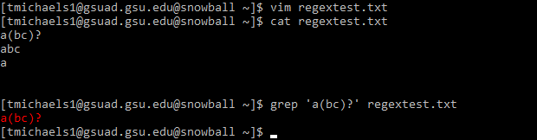

Vs extended regex

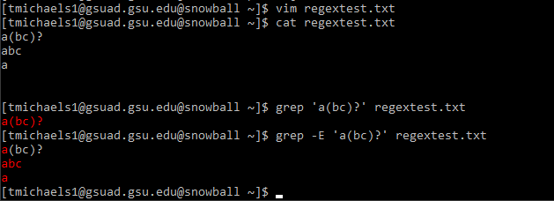

Question 10: same issue as above; this was supposed to follow the rules of basic regex in which the character ‘+’ is not a meta character

Question 11: This I don’t understand how I got wrong because it is exactly how the key describes the answer. “an expression for adding multiple variables followed by space, each letter should be represented by a lower-case letter.”

That is exactly what my answer is, one letter followed by a space, then one or more other variables added together. Even the examples in the key look similar to my answer.

Question 17 & 18: I understand that regex is language specific, so given the context of this course this specific regex example would not work in a unix shell as it would interpret the initial ‘-‘ as an attempt for a flag and would otherwise need to be escaped. Although, I do concede that this is a cheeky answer on my part. That being see, see attached screenshot

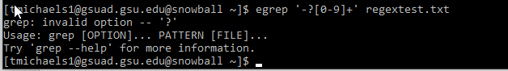

Vs no errors with escape character



Which would have the desired effect for the answers in the key

Question 19: the question prompt asked for valid urls. Which means that the domain must be between 1 and 63 characters long, and can only contain upper and lowercase letters, numbers, and the . and – characters. All these are exactly what my regex answer checks for. As well as an optional https check. Using .+ like in the key could return non-valid domain names with unsupported characters.

Question 20: my answer returns non-negative integers.

Question 21: my answer returns valid absolute paths

Question 22: I understand how this answer may include more than the prompt was asking for but should also return the same things that the key states as the answer as well.

Question 23: my answer returns phone numbers that are in the formats of the prompt

Part 3

My answer does exactly what the question asks, the prompt said to set it so that I am the only one who can edit the files while all others can only read. There are many different way in which the owner can have edit permissions and everyone else have read only. Chmod 744, chmod 644, chmod 244. As the prompt didn’t state that I couldn’t have execute permission it seems semantical to exclude chmod 744 as an answer, given that chmod 644 is acceptable.