**CSc 3320: Systems Programming**

Spring 2021

Midterm 2: Total points = 100

Assigned: 11th Apr 2021, Sunday 11:59 PM

**Submission Deadline: 18th Apr 2021, Sunday, 11.59 PM**

**(No extensions. If your submission is not received by this time then it**

**will NOT be accepted.)**

Submission instructions:

1. Create a Google doc for your submission.

2. Start your responses from page 2 of the document and copy these instructions

on page 1.

3. Fill in your name, campus ID and panther # in the fields provided. If this

information is missing TWO POINTS WILL BE DEDUCTED.

4. Keep this page 1 intact. If this *submissions instructions* page is missing in your

submission TWO POINTS WILL BE DEDUCTED.

5. Start your responses to each QUESTION on a new page.

6. If you are being asked to write code copy the code into a separate txt file and

submit that as well. The code should be executable. E.g. if asked for a C script

then provide myfile.c so that we can execute that script. In your answer to the

specific question, provide the steps on how to execute your file (like a ReadMe).

7. If you are being asked to test code or run specific commands or scripts, provide

the evidence of your outputs through a screenshot and/or screen

video-recordings and copy the same into the document.

8. Upon completion, download a .PDF version of the google doc document and

submit the same along with all the supplementary files (videos, pictures, scripts

etc).

Full Name: Tracy Michaels

Campus ID: tmichaels1

Panther #: 002430918

1)

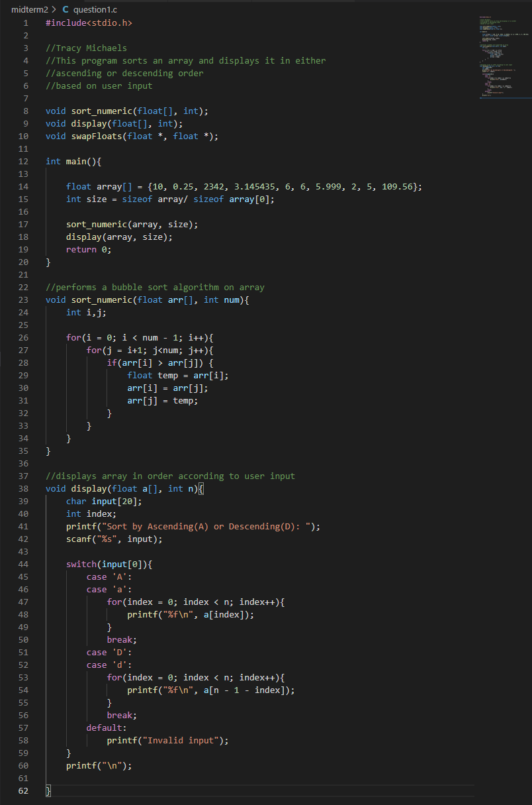

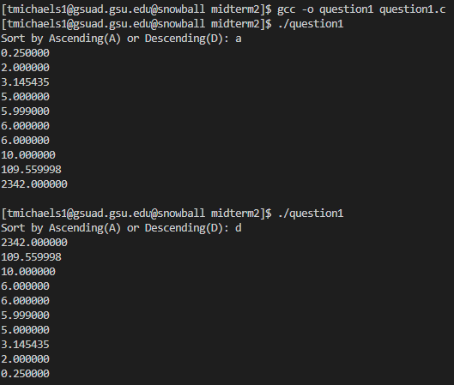

2)

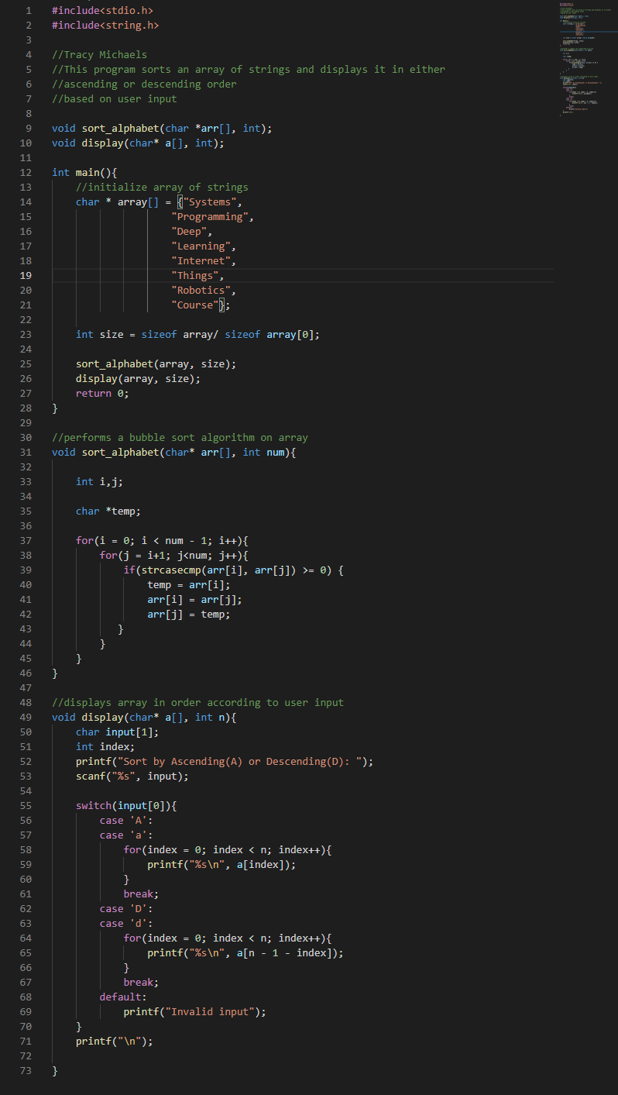

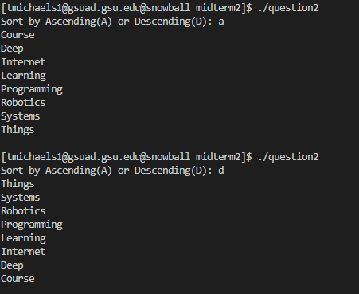

3)

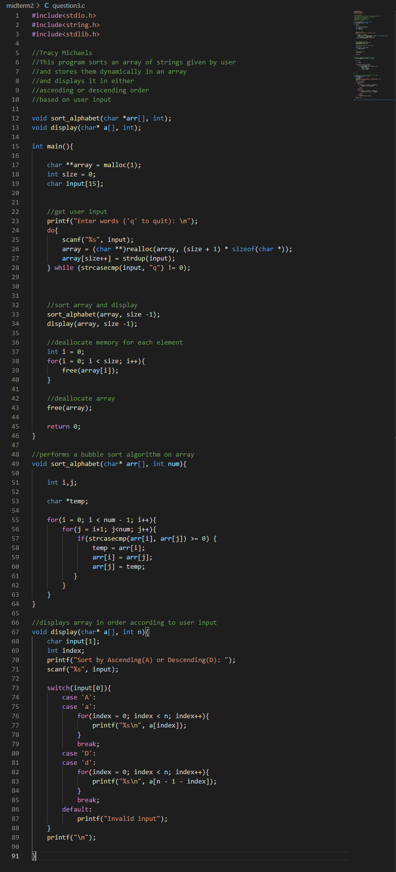

Trial 1

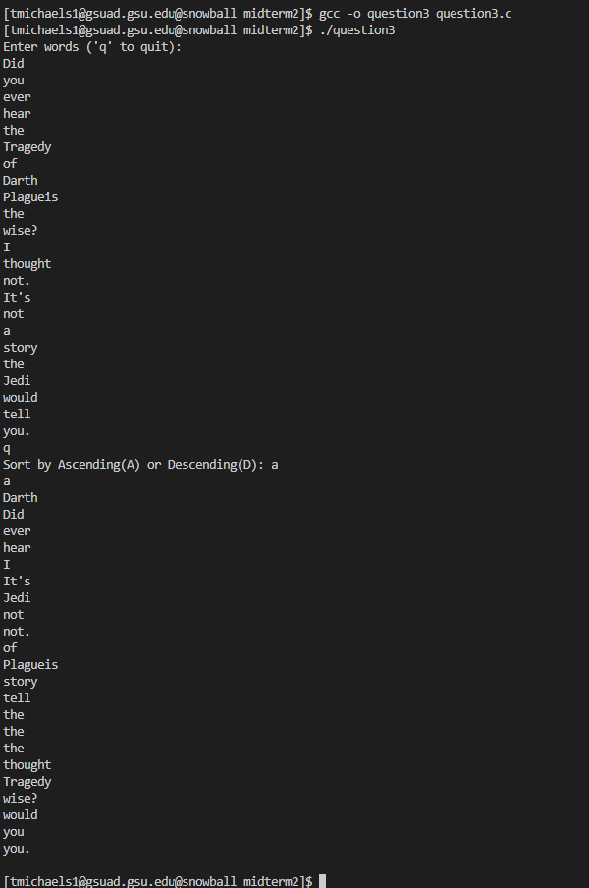

Trial 2

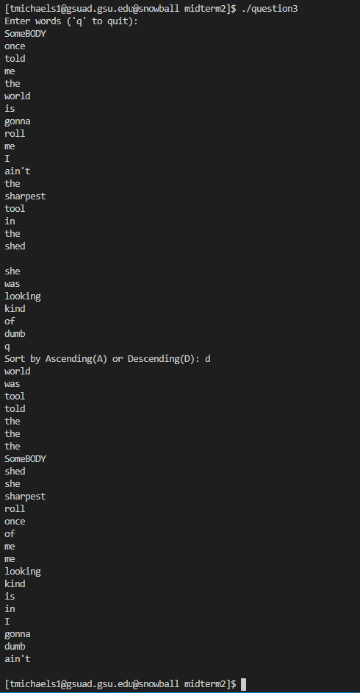

Trial 3

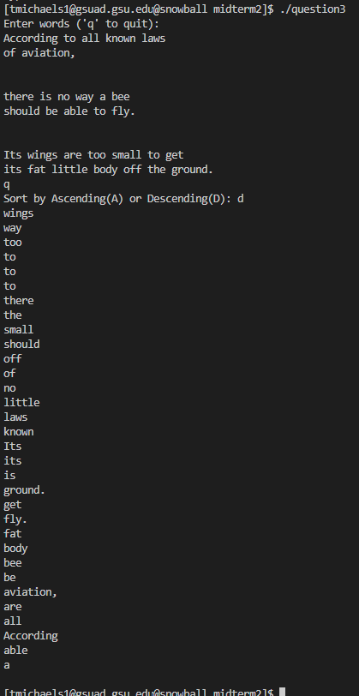

Trial 4

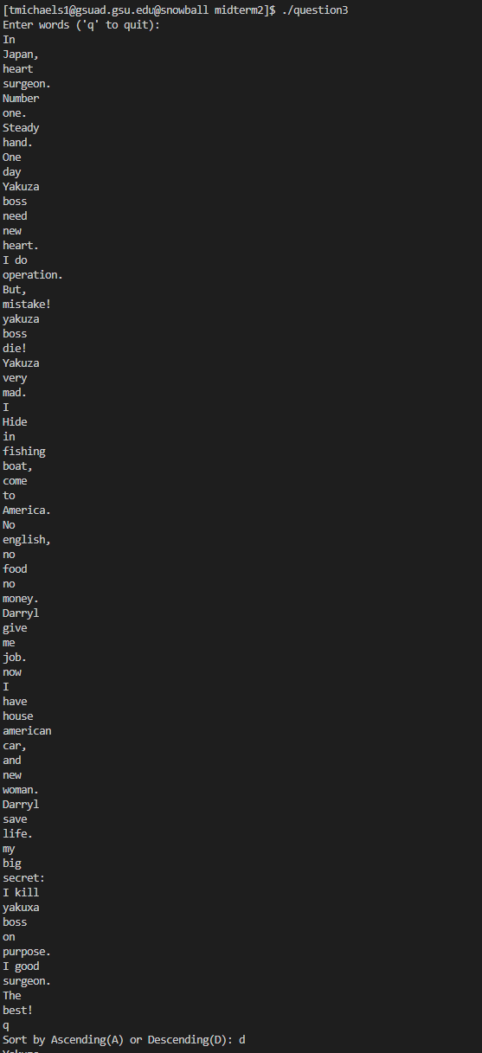

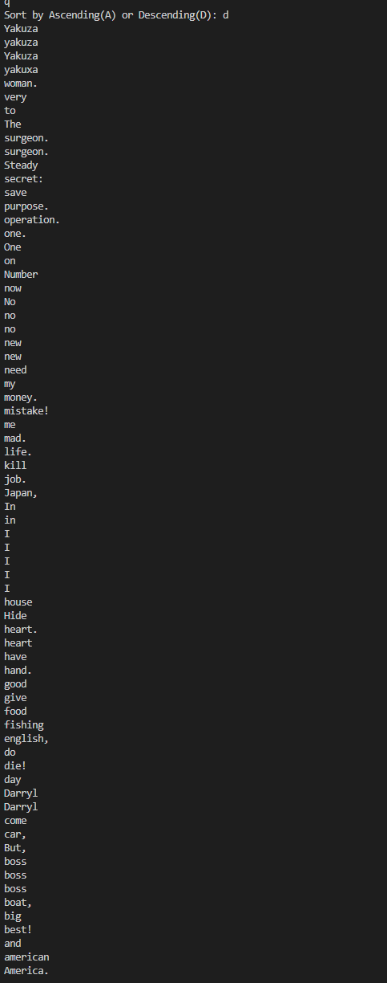

Trial 5

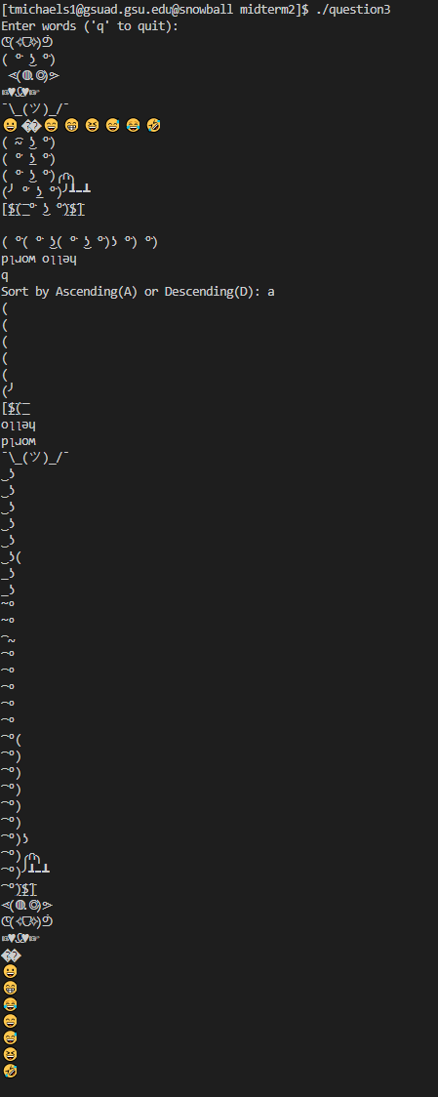

4)

